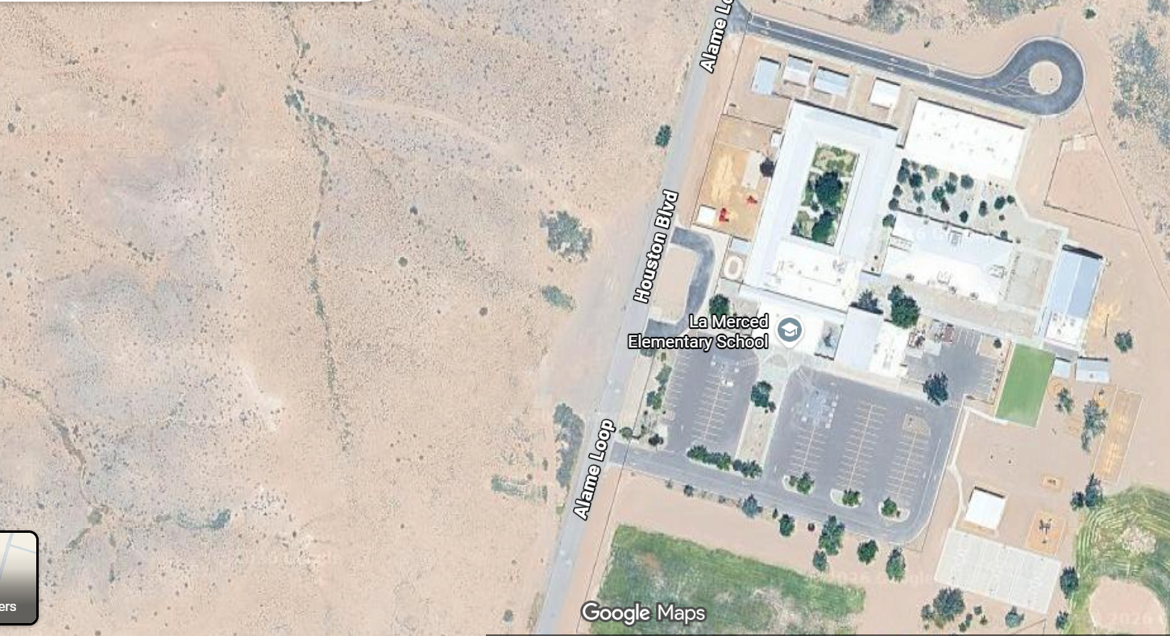
Student Drop off/ Pick up Diagram
- Parents doing drive up pick up/drop off MUST enter from Houston Blvd & Alame and exit the same way to Manzano Expy.
- Parents entering from Sherrod Blvd MUST park in the designated dirt lot and walk up your student to the school and exit the same way to Sherrod and Hwy 47.
- All buses and daycare vans MUST enter and exit from Sherrod Blvd.
No cones shall be moved for any reason
DRIVE-UP DROP OFF/PICK UP
WALK-UP DROP OFF/PICK UP
BUS DROP OOF

