PRE-K SUPPLY LIST
2026-2027

1 Box Crayons
2 Folder, plastic poly, 2 pockets w/ prongs, any colors
1 Pack Quart storage bags
1 Pack Gallon storage bags
1 Baby Wipes
1 Box Tissue
1 Paper towels
1 Black Dry Erase Markers
1 Laundry Pods
1 Blanket
1 Extra set of Clothes

KINDERGARTEN 2026 - 2027

QUANTITY | ITEM
1 | average size backpack  (a folder must fit inside)
4 boxes | 24 count CRAYOLA crayons
2 boxes | CRAYOLA WASHABLE markers
1 | water color paint set
1 | RED PLASTIC folder with BRADS
1 | BLUE PLASTIC folder with BRADS
1 package | EXPO erasable markers
1 | WIDE ruled spiral notebook
2 boxes | TICONDAROGA pencils
12 | LARGE glue sticks
1 | pencil pouch with holes  (this will go in a binder)
2 boxes | tissues
1 box | GALLON storage bags
2 packages | baby wipes
1 pair | headphones- NO EARBUDS
1 | Extra set of clothes  in case of an accident

First and Second Grade School Supply List 2026 - 2027
6- hi polymer large WHITE eraser | 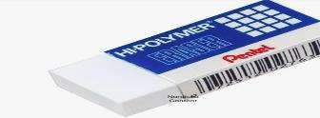
36- #2 pencils TICONDEROGA brand. TiconderogaTri-Write Preferred. (It has 3 sides that help students hold their writing form for better handwriting.  Please DO NOT BUY DIXON. They break (2nd grade does not need the triangular ones) | 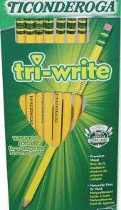
2- pencil bags with zipper and 3 holes to keep in binder. (brand does not matter) | 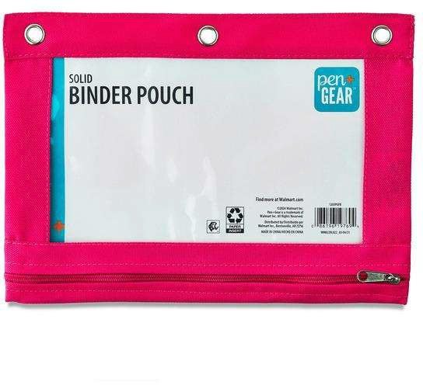
1 clear plastic ruler (2nd GRADE ONLY) | 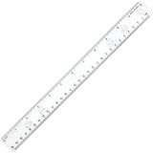
1-hole punch for 3 ring binders (stays in binder rings)  1 blunt tip 5 inch scissor (blue) | 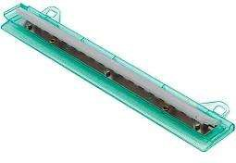

6- Creative Writing Tablet: SPARK CREATE IMAGINE brand (grades k-2)  100 sheet Primary Composition Book 9.75 9.75 x 7.5, Primary Ruled (with colored lines and dotted lines on it.) | 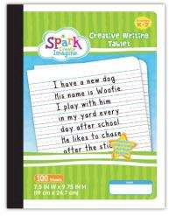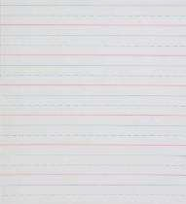
1 spiral notebook wide rule lines 100 ct (Brand does not matter) | 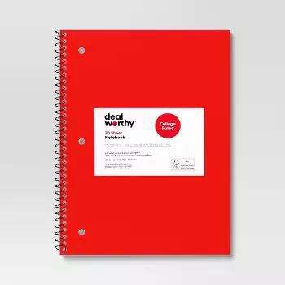
2- 2 in binder with pockets with D ring (for homework folder) heavy duty (NOT 0 ring)

(2nd Grade 2 BLACK, 1st Grade 2 dark BLUE)
1- ½ in binder with pockets with D ring (2nd Grade only)
1- pack of PLASTIC dividers with pockets 8 count
16 expo markers ultra fine tip (black) low odor
8- tissue box 100 count
1 gallon storage FREEZER bags with zipper
2 Box- 24 count Crayons
6 Elmer's washable glue sticks
1 headphones wired with jack that plugs into computer (no bluetooth or wifi)
*** This item will need to be replaced
throughout the year if broken.***

3rd Grade |  | 3rd GRADE SCHOOL SUPPLY LIST
3 | dozen | pencils #2 Ticonderogo Brand
1 | each | pencil bag, zipper
1 | each | scissors, 5 inch blunt tip
6 | boxes | Tissues
8 | each | folders, 2 pocket w/prongs, heavy weight (2 yellow, 2 green, 2 blue, 2 purple)
6 | each | 6-wide ruled composition notebooks
3 | each | eraser, pink beveled
6 | each | glue sticks, all purpose, washable, white, preferably Elmer's brand
3 | pack | colored map pencils preferably Crayola brand
1 | each | ruler, with inches and centimeters
3 | each | quart storage bags
3 | each | gallon storage bags
2 | each | ear buds or head phones
3 | pack | colored map pencils preferably Crayola brand
3 | package | expo markers
3 | each | hand sanitizer
6 | rolls | paper towels
3 | each | Disinfecting wipes (Cloros, Lysol, etc)

4th Grade |  | 4th GRADE SCHOOL SUPPLY LIST
3 | dozen | pencils #2 Ticonderogo Brand
1 | each | pencil bag, zipper
1 | each | scissors, 5 inch blunt tip
6 | boxes | Tissues
8 | each | folders, 2 pocket w/prongs, heavy weight (2 yellow, 2 green, 2 blue, 2 purple)
6 | each | 6-wide ruled composition notebooks (Math, Sci, ELA, SS)
3 | each | eraser, pink beveled
6 | each | glue sticks, all purpose, washable, white, preferably Elmer's brand
3 | pack | colored map pencils preferably Crayola brand
1 | each | ruler, with inches and centimeters
1 | each | protractor & compass set
3 | each | quart storage bags
3 | each | gallon storage bags
2 | each | ear buds or head phones
3 | package | expo markers
6 | rolls | paper towels
3 | each | Disinfecting wipes (Cloros, Lysol, etc)
3 | each | hand sanitizer

5th Grade School Supply List
QTY | School Supply

2 | 12 packs of pencils (Ticonderoga #2)
1 | Mesh pencil bag
1 | Pair of scissors (5" or 7")
2 | Pink/White bevel erasers
24 | Glue sticks
2 | Packs of colored pencils (12 colors)
4 | Wide ruled composition notebooks (Math, Sci, ELA, SS)
1 | Ruler (English and metric)
1 | 2 pack of paper towels (Science)
1 | Box of gallon zip lock bags
2 | Boxes of kleenex
2 | Pairs of earbuds or headphones
2 | Pack of Expo markers

6th Grade School Supply List
QTY | School Supply

2 | 12 packs of pencils (Ticonderoga #2)
1 | Mesh pencil bag
1 | Pair of scissors (5" or 7")
2 | Pink/White bevel erasers
24 | Glue sticks
2 | Packs of colored pencils (12 colors)
4 | Wide ruled composition notebooks (Math, Sci, ELA, SS)
1 | Ruler (English and metric)
1 | 2 pack of paper towels (Science)
1 | Box of quart zip lock bags
2 | Boxes of kleenex
2 | Pairs of earbuds or headphones
2 | Pack of Expo markers

