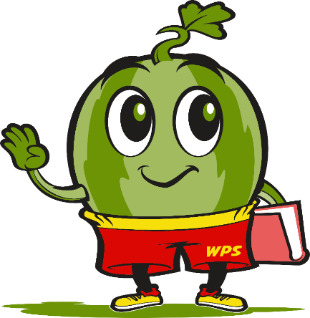
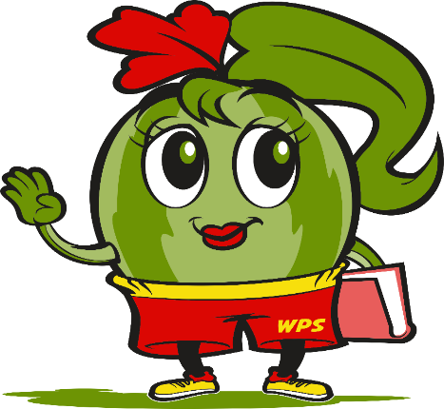
Rocky Ford Elementary School Supply List
2026-2027

_____________________________________________________________________________
Kindergarten
Headphones (No Earbuds) Girls- Quart Ziploc Bags 1 small School Box/Crayon Box
2 (24 count) Crayola Crayons 1 pair Fiskar Scissors 4 pkg. Glue Sticks
8 Black Dry Erase Fine Tip Markers 3 pkg. Clorox Wipes 3 Boxes Kleenex Boys- Gallon Ziploc Bags Elmer’s Glue-white 2 packs of 24 Pencils
1 reusable Water Bottle w/lid _________________________________________________________________________________________________
1st Grade
Headphones (No Earbuds) 3 boxes Kleenex 1 small School Box/Crayon Box
2 (24 count) Crayola Crayons 1 pair Fiskar Scissors 8 Glue Sticks
8 Black Dry Erase Fine Tip Markers 3 pkg. Clorox Wipes Girls- Quart Ziploc Bags Boys- Gallon Ziploc Bags Elmer’s Glue-white 1-1.5” Three Ring Binder w/pocket
1 Plastic 3-prong/2 pocket folder 24 pack Pencils 1 reusable Water Bottle w/lid
_________________________________________________________________________________________________
2nd Grade
Headphones (No Earbuds) 3 boxes Kleenex 1 small School Box/Crayon Box
1 (24 count) Crayola Crayons 1 pair Fiskar Scissors 6 Glue Sticks
4 Black Dry Erase Fine Tip Markers 6 pkg. Clorox Wipes 1 pkg. Pencil Top Erasers
Girls- Quart Ziploc Bags 6- 3-Prong/2 Pocket Folders 1 pkg. Washable Markers
Boys-Gallon Ziploc Bags Elmer’s Glue-white Handsanitizer
Handsoap-1 large bottle 1 reusable Water Bottle w/lid
_________________________________________________________________________________________________
3rd Grade
Headphones (No Earbuds) 3 boxes Kleenex 1 small School Box/Crayon Box
1 (24 count) Crayola Crayons 1 pair Fiskar Scissors 2 Glue Sticks
8 Black Dry Erase Fine Tip Markers 24 Pencils 3 pkg. Clorox Wipes
Girls- Quart Ziploc Bags Boys- Gallon Ziploc Bags 1 reusable Water Bottle w/lid
1- Plastic 3-Prong/2 pocket Folders 1 Composition Notebooks
_________________________________________________________________________________________________
4th Grade
Headphones (No Earbuds) 3 boxes Kleenex 2-Big Pink Erasers
1 Box of Crayons 3 Glue Sticks Quart Size Ziploc Bags
8 Dry Erase Fine Tip Markers 48 Pencils 3 pkg. Clorox Wipes
3- Plastic 3-Prong/2 pocket Folders 3 Composition Notebooks 1 reusable Water Bottle w/lid
_________________________________________________________________________________________________
5th Grade
Headphones (No Earbuds) 3 boxes Kleenex 1-3 Prong Folder
8 Black Dry EraseFine Tip Markers 24 Pencils 1 reusable Water Bottle w/lid
4 Composition Notebooks 3 pkg. Clorox Wipes
________________________________________________________________________________________________
6th Grade
Headphones (No Earbuds) 3 boxes Kleenex 2 pkg College Ruled Paper 100 Index Cards- 3x5 24 Pencils 8 Black Dry Erase Fine Tip Markers
3 pkg. Clorox Wipes 3- One Subject Notebooks 1 reusable Water Bottle w/lid
_________________________________________________________________________________________________
Any donations for the following would be greatly appreciated:
White Elmer’s Glue, 3x3 Sticky Notes, Highlighters, Cardstock, Sheet Protectors, Kleenex, Clorox Wipes, Hand Sanitizer or Dry Erase Markers.
Please Note: Supplies will be combined to share within our classroom community.

