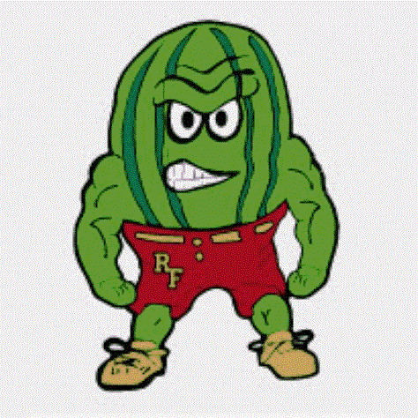
Rocky Ford Junior High School Supply List
2026-2027

____________________________________________________________________________________________________
Mrs. Bone
1 Spiral Notebook Glue Sticks Recommended Supplies
Pencils Scissors Kleenex
Pens (blue or black) Loose Leaf Notebook Paper Hand Sanitizer
Colored Pencils or Crayons 1 Two-Pocket Binder Disinfecting Wipes
Highlighters Dry Erase Markers Extra Pencils _________________________________________________________________________________________________

Mrs. Mameda
Pencils
2” Binder
Loose Leaf Paper
Highlighters
Colored Pencils
_________________________________________________________________________________________________

Ms. Apodaca
Composition Notebook
Glue Sticks
_________________________________________________________________________________________________

Any donations for the following would be greatly appreciated:

Cups, Ziplock Bags (all sizes), Markers, Colored Copy Paper

