
Trinity Lutheran School, Alma, Missouri October 28, 2026
Principal’s Pens will be electronically sent out unless you’ve requested a hard copy! Just reach out to the office if you’d like one sent home with your child. Upcoming Events can be found on the last page of this newsletter.

You Are Invited to Honor Veterans on November 11
Trinity Lutheran School is planning to host a Veterans Day program at 10:00 a.m. on Wednesday, November 11, in the school gymnasium. This program is for everyone, not just our beloved Veterans & their families. The program will be presented by Trinity Students and will include pledges, prayers, Scripture reading, a poem, patriotic music, flag ceremony, and a presentation of appreciation. Our Guest Speaker is Chaplain Craig G Muehler. Immediately following the program, a luncheon of Pork Loin w/Gravy, Roasted Red Potatoes, Corn Casserole, Fruit & Roll will be served.
Please join us in the celebration of our Veterans.

Congratulations to our Cross Country Teams! Both girls’ & boys' teams placed in the top 15 teams in the Nation! A big TIGER SHOUTOUT!
Tomorrow at 2:30 in the gym, we will be hosting a Pep Rally for our Jr. High Girls Volleyball Team as they head out to LSAM. This is Trinity’s first invitation to LSAM since 2018!! Come help us make some noise for our Lady Tigers!!

Every spring, our PTL provides every child with a FREE school yearbook. We are able to offset that expense because we have amazing and generous sponsors. If you are interested in being a yearbook sponsor, please print the Yearbook Sponsor form and mail or bring it to the school office. Contact Martha Schreiman with any questions 660-229-3127.

Mark your calendars! K - 8th Grade Choir is singing on November 8th at HOLY CROSS in Emma! Services start at 9:00 am with a brunch to follow. All donations will be used to help with tuition expenses for Holy Cross members!

2 Cherry Strudel  Yogurt  Fruit  2 Spaghetti  Veg Medley  Breadstick or Roll  Fruit | 3 French Toast  Sausage Link  Yogurt  Fruit  Taco Crunch  Spanish Rice  Refried Beans  Fruit | 4 Cereal  Bacon  Yogurt  Fruit  Vegetable Beef Soup  Mozzarella Stick  Roll  Fruit | 5 Sausage, Egg, Chz  Breakfast Sandwich  Yogurt  Fruit  Pork Roast  Sweet Potatoes  Romaine Salad  Fruit | 6 Waffles  Sausage  Yogurt  Fruit  Sloppy Joe  Tater Tots  Corn  Fruit
**Milk and fresh fruit offered daily**
Salad OR PBJ option available--sandwiches only replace the main entree
This institution is an equal opportunity provider.

Breakfast & Lunch Menus available on our app. Available on googleplay or the apple store (Trinity Lutheran Alma)PICTURES WANTED! If you have any pictures (school events, parties, sports, field trips, etc) please share them with Martha Schreiman for the yearbook! mschreiman@santafechiefs.k12.mo.us or 660-229-3127
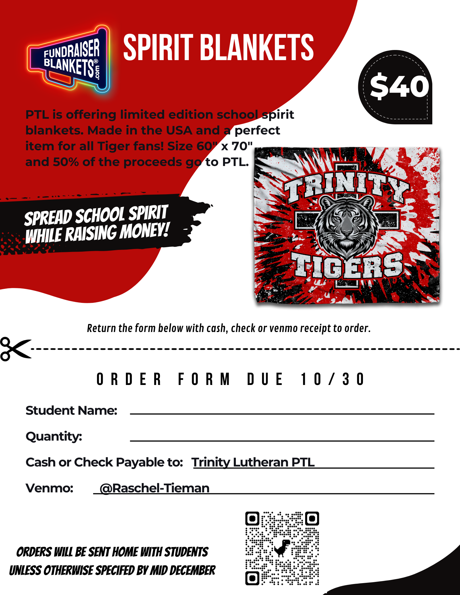
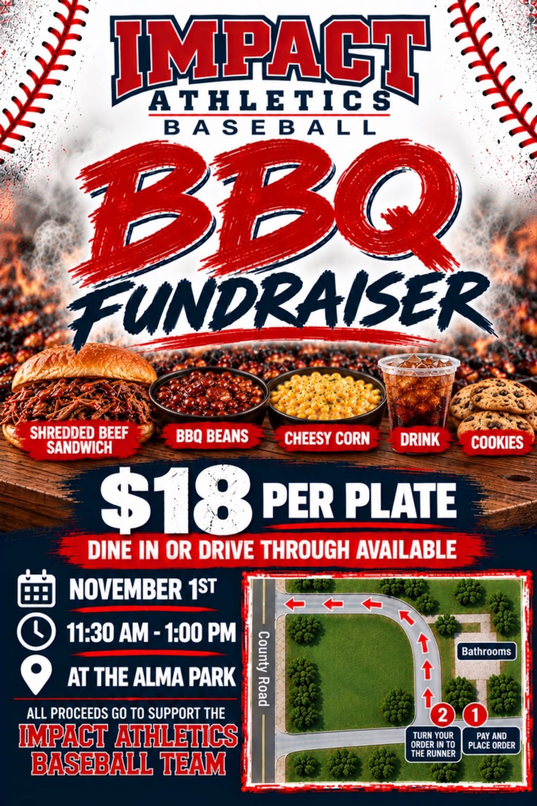

Upcoming Events
October
230 JHVB Pep Rally
29 3rd Grade to Senior Center
5th/6th Volleyball Party
30 Fall Parties

November
8 Singing at Holy Cross
11 Veteran's Day Program
16 PTL Meeting 6:00 pm
23-27 NO SCHOOL Thanksgiving Break

December
2 4th-8th Grade Choir Sings
6:30 Advent Service
22 Christmas Break Begins
10:30 Dismissal (End of Q2)
24 Christmas Eve Service
K -8 Choirs Sing
22-Jan 5 Christmas Break

