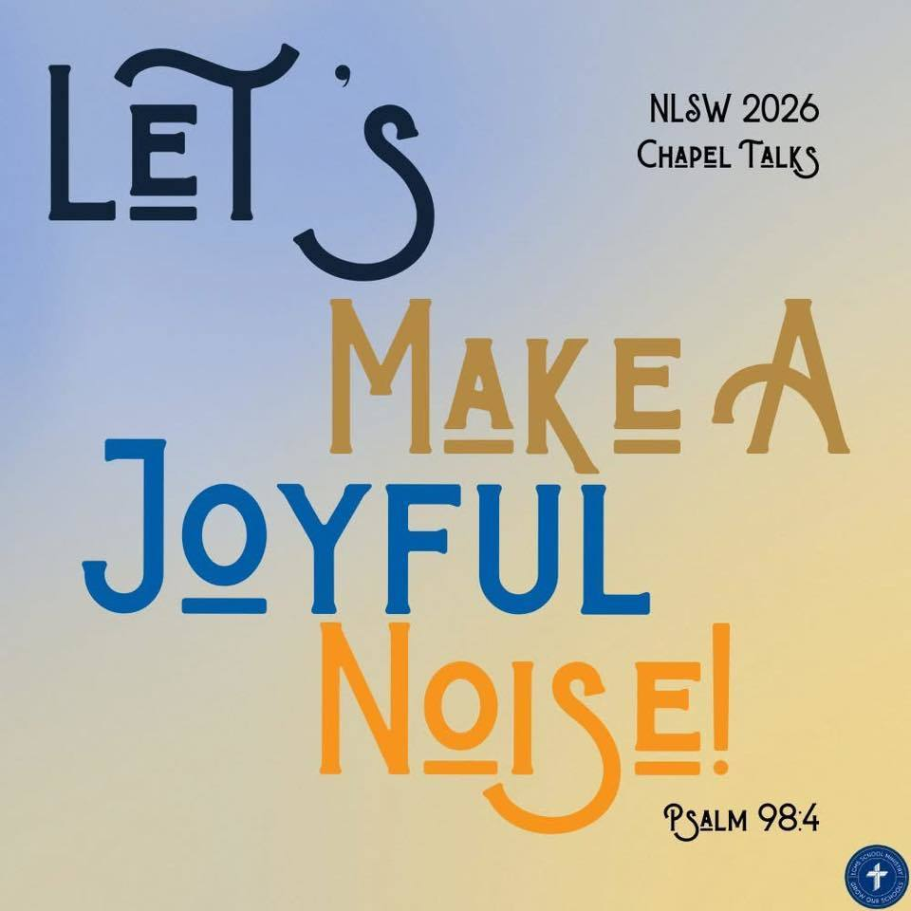
Trinity Lutheran School, Alma, Missouri April 22, 2026
Principal’s Pens will be electronically sent out unless you’ve requested a hard copy! Just reach out to the office if you’d like one sent home with your child. Upcoming Events can be found on the last page of this newsletter.

Mark your calendar now! May 1, 6:00 p.m.

Arrr matey! The spring musical be settin’ sail on May 1 at 6:00—ye best not be missin’ this grand and entertainin’ tale of baseball, pirates, and the treasures of the Good Lord!
From the littlest buccaneers in Kindergarten to the seasoned crew in 8th grade, all hands have been workin’ hard on their lines and sea shanties!
It's guaranteed to be a swashbucklin’ good time for the whole crew—so gather yer mates and come aboard!

All students grades kindergarten through 6th grade will be provided a shirt to wear the night of the program! We will send them home on April 30th (The day prior to the program) They can wear pants or shorts with their shirt.
If your 6th-8th grader is an actor, they will also be provided with a shirt, however, they will have a specific costume for the performance.


☀️ Sign-Up is NOW OPEN! ☀️https://forms.gle/MG37Cv6Gzppi53yBA

RE-Enrollment for next school year is open!
Trinity Lutheran's administration and staff are already looking ahead and making plans for next school year. In preparation for the start of the 2026-2027 school year, please take time now to complete your child’s reenrollment. Check your email or
To complete the enrollment process, please follow the steps below:
- Please go to FACTS Family Portal
- Type in your username and password
If you have forgotten your username or password, please click on the link provided
- Go to left-side Navigation Menu
- Click on Apply/Enroll
- Click on Enrollment/Reenrollment
Our Enrollment system will open with a link to the enrollment packet. The process should take approximately 15 minutes to complete. Your information will be saved if you need to quit and come back later. If you have any questions, please contact our office.
Early bird discount ends May 1! Get your registration fee paid TODAY!

$$ EVERY student enrolled here at Trinity is encouraged to apply for financial assistance! We have a generous fund to help pay your child’s tuition! Please take a few minutes to apply! Tuition Assistance Application The deadline is July 15, but don’t wait; get your application in NOW! $$
We want your pictures for the yearbook! Please email mschreiman@santafechiefs.k12.mo.us with any pictures you’d like to share!

27 8th graders' favorite lunches  Breakfast Bar  Applesauce  Fettuccine Alfredo  Peas  Pineapple  Bread stick  Cookie | 28  Egg Omelet  Bacon or Sausage  Cinni mini  Mixed fruit  Chicken Leg  Mashed Potatoes and gravy  Green Beans  Strawberries  Rice Krispie Treat | 29  Bacon and Egg Extravaganza  Cinnamon Roll  Peaches  Taco Crunch  Corn  Mixed Fruit  Ice Cream Sandwiches | 30  Waffles  Bacon or Sausage  Pears  Chicken Pot Pie  Broccoli  Peaches  Fruit Smoothie | 1  Biscuits and Gravy  Pineapple  Chicken Wings  French Fries  Baked Beans  Pears  Brownie
**Milk and fresh fruit offered daily** Salad option available
This institution is an equal opportunity provider.
Breakfast & Lunch Menus available on our app.

Upcoming Events

April
23 Carrollton Track 1:00 pm (Students 6th-8th LEAVE EARLY)
20-30 Spring Testing
25 Trinity Home Track Meet
27 AG Day @ Trinity
PTL Meeting 6:00 pm

May
1 Spring Musical 6:00 pm
4 Preschool to Blind Pony
5 AR Store
6 K & 1st to Hemme Dairy, Library, Bratchers
7 Day at the K
2nd & 6th to Zoo
8 Law Enforcement Day (5th grade)
6-8 Class Trip (7th/8th grade)
13 8th Grade Graduation 6:00
4th-8th Grade Choir Sings
14 Field Day at School
15 Last Day of School
9:30 am Pre-K Graduation
10:30 am Dismissal

