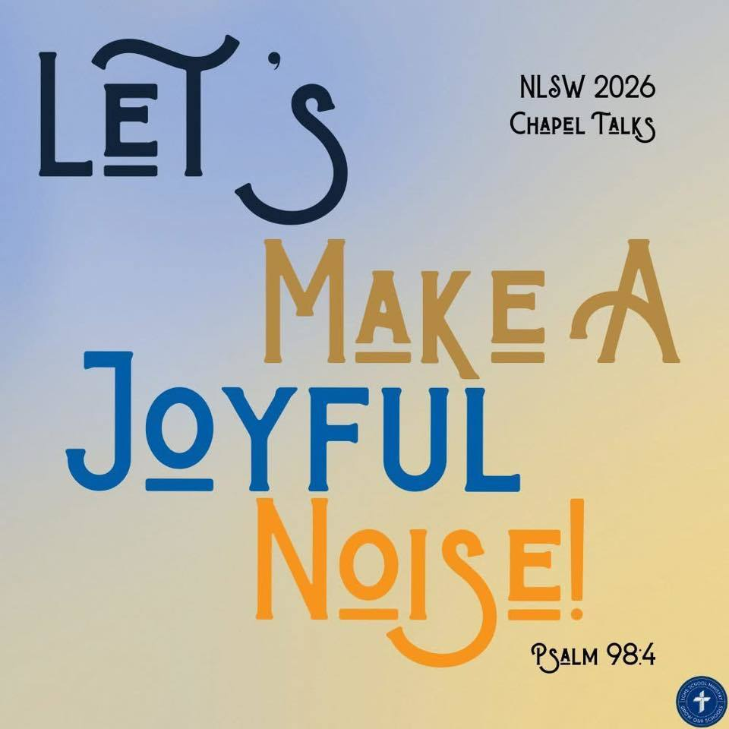
Trinity Lutheran School, Alma, Missouri April 15, 2026
Principal’s Pens will be electronically sent out unless you’ve requested a hard copy! Just reach out to the office if you’d like one sent home with your child. Upcoming Events can be found on the last page of this newsletter.

RE-Enrollment for next school year is open!
Trinity Lutheran's administration and staff are already looking ahead and making plans for next school year. In preparation for the start of the 2026-2027 school year, please take time now to complete your child’s reenrollment. Check your email or
To complete the enrollment process, please follow the steps below:
- Please go to FACTS Family Portal
- Type in your username and password
If you have forgotten your username or password, please click on the link provided
- Go to left-side Navigation Menu
- Click on Apply/Enroll
- Click on Enrollment/Reenrollment
Our Enrollment system will open with a link to the enrollment packet. The process should take approximately 15 minutes to complete. Your information will be saved if you need to quit and come back later. If you have any questions, please contact our office.
Early bird discount ends May 1! Get your registration fee paid TODAY!

$$ EVERY student enrolled here at Trinity is encouraged to apply for financial assistance! We have a generous fund to help pay your child’s tuition! Please take a few minutes to apply! Tuition Assistance Application The deadline is July 15, but don’t wait; get your application in NOW! $$

Mark your calendar now! May 1, 6:00 p.m.


Arrr matey! The spring musical be settin’ sail on May 1 at 6:00—ye best not be missin’ this grand and entertainin’ tale of baseball, pirates, and the treasures of the Good Lord!
From the littlest buccaneers in Kindergarten to the seasoned crew in 8th grade, all hands have been workin’ hard on their lines and sea shanties!
It's guaranteed to be a swashbucklin’ good time for the whole crew—so gather yer mates and come aboard!
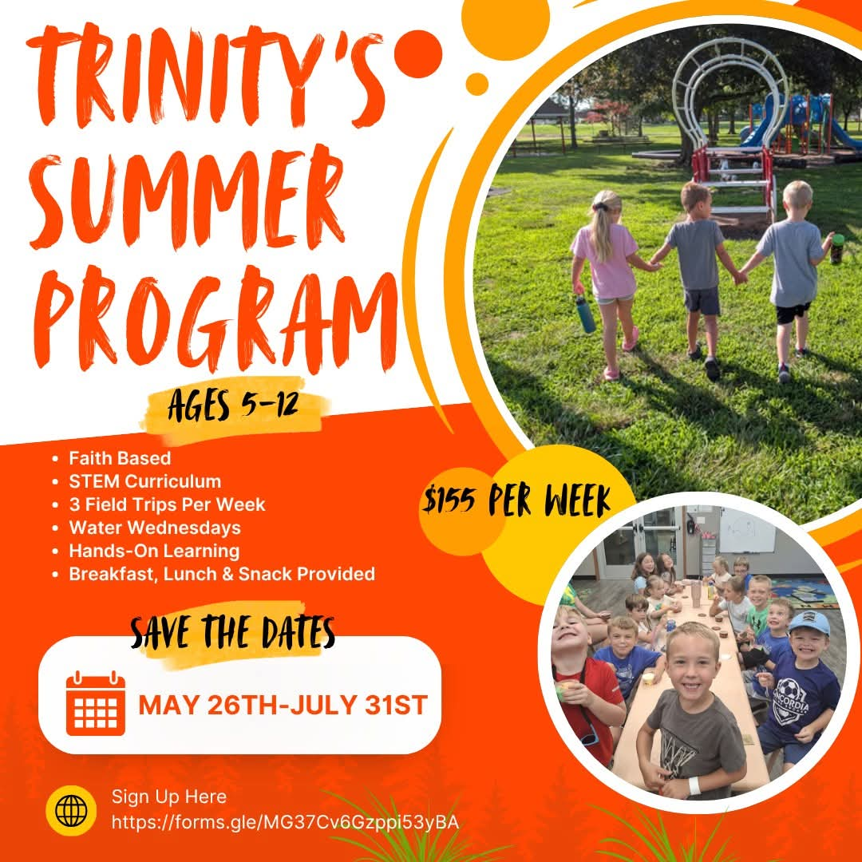

☀️ Sign-Up is NOW OPEN! ☀️https://forms.gle/MG37Cv6Gzppi53yBA

We want your pictures for the yearbook! Please email mschreiman@santafechiefs.k12.mo.us with any pictures you’d like to share!

20  Bacon, Egg and cheese Tornado  Applesauce  BBQ Chicken Sandwich  French Fries  Carrots  Peaches | 21  French Toast  Bacon or Sausage  Mixed fruit  Spaghetti  Green Beans  Strawberries  Bread Stick | 22 National Jelly Bean Day  Scrambled Eggs  Bacon or Sausage  Cinni mini  Peaches  Biscuits and Gravy  Sausage Patty  Tri Tater  Banana | 23  Pancakes  Bacon or Sausage  Pears  Meatball sub  Chips  Corn  Blueberries | 24  Bacon, Egg and cheese biscuit  Pineapple  Crispito  Corn  Peaches  Brownie
**Milk and fresh fruit offered daily** Salad option available
This institution is an equal opportunity provider.
Breakfast & Lunch Menus available on our app.

Upcoming Events

April
16 3rd to Senior Center
Hosting LAKC
17 6th Grade to Dairy Farm
Track Pictures
21 X Country Timothy
23 Carrollton Track 100 pm (Students 6th-8th LEAVE EARLY)
20-30 Spring Testing
25 Trinity Home Track Meet
27 AG Day @ Trinity
PTL Meeting 6:00 pm

May
1 Spring Musical 6:00 pm
4 Preschool to Blind Pony
8 Law Enforcement Day (5th grade)
5 AR Store
6 K & 1st to Hemme Dairy, Library, Bratchers
7 Day at the K
2nd & 6th to Zoo
6-8 Class Trip (7th/8th grade)
14 Field Day at School
13 8th Grade Graduation 6:00
4th-8th Grade Choir Sings
15 Last Day of School
9:30 am Pre-K Graduation
10:30 am Dismissal

