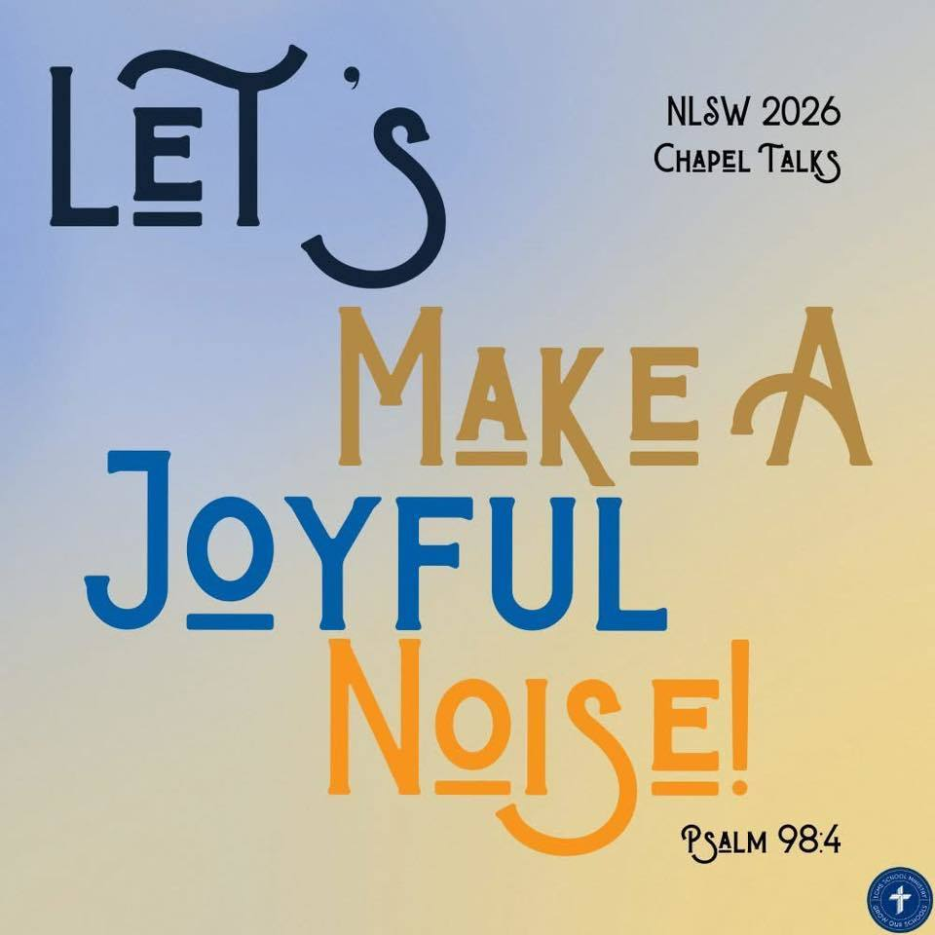
Trinity Lutheran School, Alma, Missouri November 19, 2025
Principal’s Pens will be electronically sent out unless you’ve requested a hard copy! Just reach out to the office if you’d like one sent home with your child. Upcoming Events can be found on the last page of this newsletter.

NO SCHOOL NEXT WEEK
November 23-28


We encourage all families to consider applying for the Free and Reduced Lunch Program. More information can be found here. If your family is experiencing food insecurity, please reach out to the front office. “And my God will supply every need of yours according to His riches in glory in Christ Jesus.” (Philippians 4:19). We have programs and caring members of our school community who are ready to assist.

Please return all volleyball & soccer jerseys before Thanksgiving break to Amber Ballenger or drop them off in the school office.


ONLY TWO MORE DAYS!!! Trinity Student Council is encouraging you to help us pack the pantry! We are collecting non-perishable food items to donate to the HCC Community Network in Waverly through next Friday, November 21st!

Thank you to Louis Bybee and Steve Bargfrede for visiting out 1st grade class!


Sucker Friday! $1 for a sucker or meat sticks!!

**PTL Class winners: TIE between Ms. Sarah’s class and Kindergarten! Congrats!
All students (regardless of class) with a parent in attendance will receive a free sucker.

1  Breakfast Bar  Hamburgers  French Fries  Baked Beans  Pineapple | 2  Tornado  (French Toast Sausage roll)  Chicken Patty  Mashed Potatoes and Gravy  Green Beans  Strawberries  Roll | 3  Waffles  Sausage or bacon  Spaghetti  Carrots  Peaches  Breadstick | 4 National Cookie Day  Egg omelet  Sausage or bacon  Taco Soup  Tortilla Chips  Grapes  Mixed Fruit  Cookies | 5  Sausage pancake on a stick  Hot Dogs  Tater Tots  Corn  Pears  Brownie
**Milk and fresh fruit offered daily** Salad option available
This institution is an equal opportunity provider. Breakfast & Lunch Menus available on our app.

We were thrilled to donate almost $500 to the Lafayette County Cancer Coalition from our Bake sale Donations! Thank you to everyone who made it happen!

We want your pictures for the yearbook! Please email mschreiman@santafechiefs.k12.mo.us with any pictures you’d like to share!

Family Devotion
Table Talk

Read: Mark 1:1-8 (ESV) 1 The beginning of the gospel of Jesus Christ, the Son of God. 2 As it is written in Isaiah the prophet, “Behold, I send my messenger before your face, who will prepare your way, 3 the voice of one crying in the wilderness: ‘Prepare the way of the Lord, make his paths straight,’ ” 4 John appeared, baptizing in the wilderness and proclaiming a baptism of repentance for the forgiveness of sins. 5 And all the country of Judea and all Jerusalem were going out to him and were being baptized by him in the river Jordan, confessing their sins. 6 Now John was clothed with camel’s hair and wore a leather belt around his waist and ate locusts and wild honey. 7 And he preached, saying, “After me comes he who is mightier than I, the strap of whose sandals I am not worthy to stoop down and untie. 8 I have baptized you with water, but he will baptize you with the Holy Spirit.”

Reflect: John attracted crowds and preached forgiveness yet pointed to someone even greater, Jesus. John’s role was to prepare the way for the coming of the Son of God. While we do not stand in the desert wearing camel’s hair and eating locusts, as Christians we play a similar role today, preparing the way for His return. Take a moment to talk about what this passage (Mark 1:1-8) means for you as a family. Now share with one another one thing you can do differently as a member of your family.

Pray: The head of the household prays: Father of all mercy, we thank you for sending a messenger to prepare the way for your Son, Jesus. Help us to live lives like John, pointing toward Jesus and preparing the way for His return. Amen.

Upcoming Events

November
21 7th & 8th Field Trip
24-28 Thanksgiving Break

December
6 Trinity Hosted BB Shootout
3 4th-8th Grade Choir Sings
6:30 Advent Service
12 6th-8th to Lyceum
14 All Choirs sing at Holy Cross
19 Christmas Break Begins
10:30 Dismissal
End of Q2
24 Christmas Eve Service
All Choirs Sing 5:30 pm
22-Jan 6 Christmas Break

