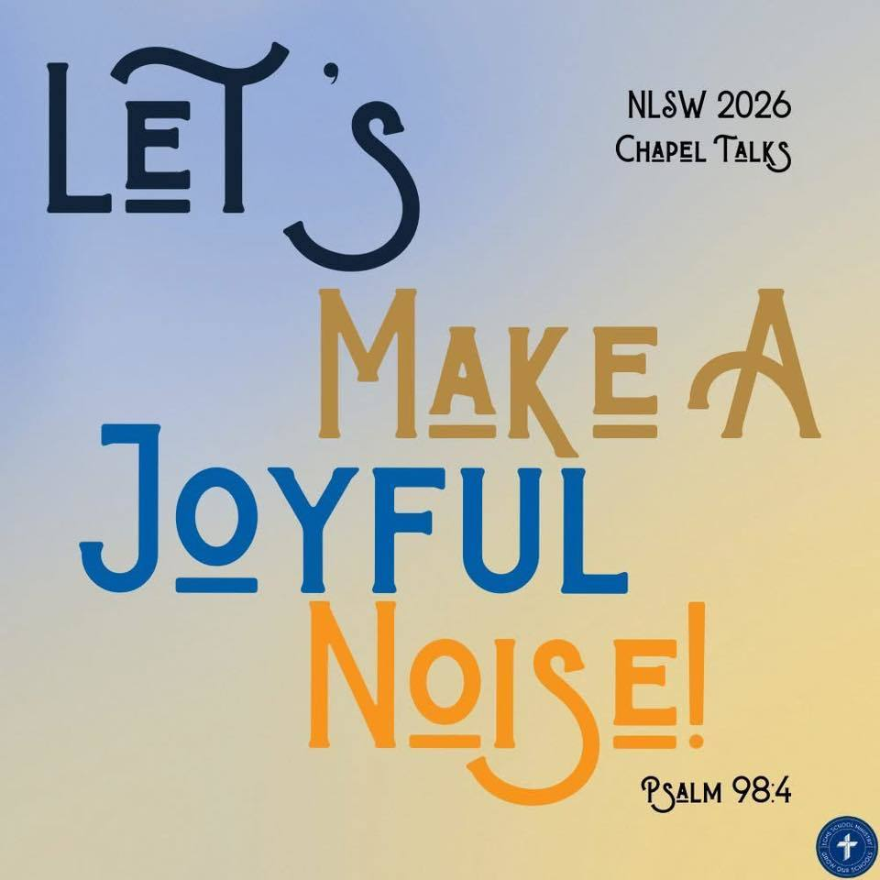
Trinity Lutheran School, Alma, Missouri April 8, 2026
Principal’s Pens will be electronically sent out unless you’ve requested a hard copy! Just reach out to the office if you’d like one sent home with your child. Upcoming Events can be found on the last page of this newsletter.

With warmer weather approaching, please be respectful of the school dress code! Suitable shorts and skirts must reach mid-thigh. Spandex shorts are NOT ALLOWED. Please note that any students not in accordance with this policy will be asked to change into appropriate clothing available here at school OR they will need to be picked up by their parents.
Any type of visible clothing bearing words and/or pictures associated with liquor, drugs, foul language, satanic groups, or any other non-Christian subject matter will not be tolerated. Clothing NOT to be worn includes spaghetti straps, halter-tops, off-the-shoulder, short shorts, cut-off Jean shorts, clothing with large holes, and undershirts. Midriffs and undergarments should not be showing.

☀️ Sign-Up is NOW OPEN! ☀️
https://forms.gle/MG37Cv6Gzppi53yBA


We want your pictures for the yearbook! Please email mschreiman@santafechiefs.k12.mo.us with any pictures you’d like to share!

13  French Toast tornado  Applesauce  Hot Dogs  Mac and Cheese  Baked Beans  Peaches | 14  Sausage, egg and cheese biscuit  Mixed fruit  Pizza  Peas  Oranges  Fruit Smoothie | 15  Breakfast Pizza  Peaches  Chicken Patty on bun  French Fries  Carrots  Banana | 16  Pancake on a stick  Pears  Lasagna  Green Beans  Pears  Breadstick  Fruit smoothie | 17  McGriddle Bites  Pineapple  Tater Tot Casserole  Pears  Roll  Brownie
**Milk and fresh fruit offered daily** Salad option available
This institution is an equal opportunity provider.
Breakfast & Lunch Menus available on our app.

RE-Enrollment for next school year is open!
Trinity Lutheran's administration and staff are already looking ahead and making plans for next school year. In preparation for the start of the 2026-2027 school year, please take time now to complete your child’s reenrollment. Check your email or
To complete the enrollment process, please follow the steps below:
- Please go to FACTS Family Portal
- Type in your username and password
If you have forgotten your username or password, please click on the link provided
- Go to left-side Navigation Menu
- Click on Apply/Enroll
- Click on Enrollment/Reenrollment
Our Enrollment system will open with a link to the enrollment packet. The process should take approximately 15 minutes to complete. Your information will be saved if you need to quit and come back later. If you have any questions, please contact our office.

Upcoming Events

April
9 Santa Fe Track Meet
10 5th Grade to Science City
6th Grade to Diary Farm
13 Sweet Springs Track Meet
School Board Meeting 6:00 pm
16 3rd to Senior Center
Hosting LAKC
17 6th Grade to Dairy Farm
Track Pictures
21 X Country Timothy
23 Carrollton Track 100 pm (Students 6th-8th LEAVE EARLY)
20-30 Spring Testing
25 Trinity Home Track Meet
27 AG Day @ Trinity
PTL Meeting 6:00 pm
May
1 Spring Musical 6:00 pm
4 Preschool to Blind Pony
5 Law Enforcement Day (5th grade)
AR Store
6 K & 1st to Hemme Dairy, Library, Bratchers
7 Day at the K
2nd & 6th to Zoo
7-9 Class Trip (7th/8th grade)
14 Field Day at School
13 8th Grade Graduation 6:00
4th-8th Grade Choir Sings
15 Last Day of School
9:30 am Pre-K Graduation
10:30 am Dismissal

