
Trinity Lutheran School, Alma, Missouri October 21, 2026
Principal’s Pens will be electronically sent out unless you’ve requested a hard copy! Just reach out to the office if you’d like one sent home with your child. Upcoming Events can be found on the last page of this newsletter.

NO SCHOOL TOMORROW or FRIDAY
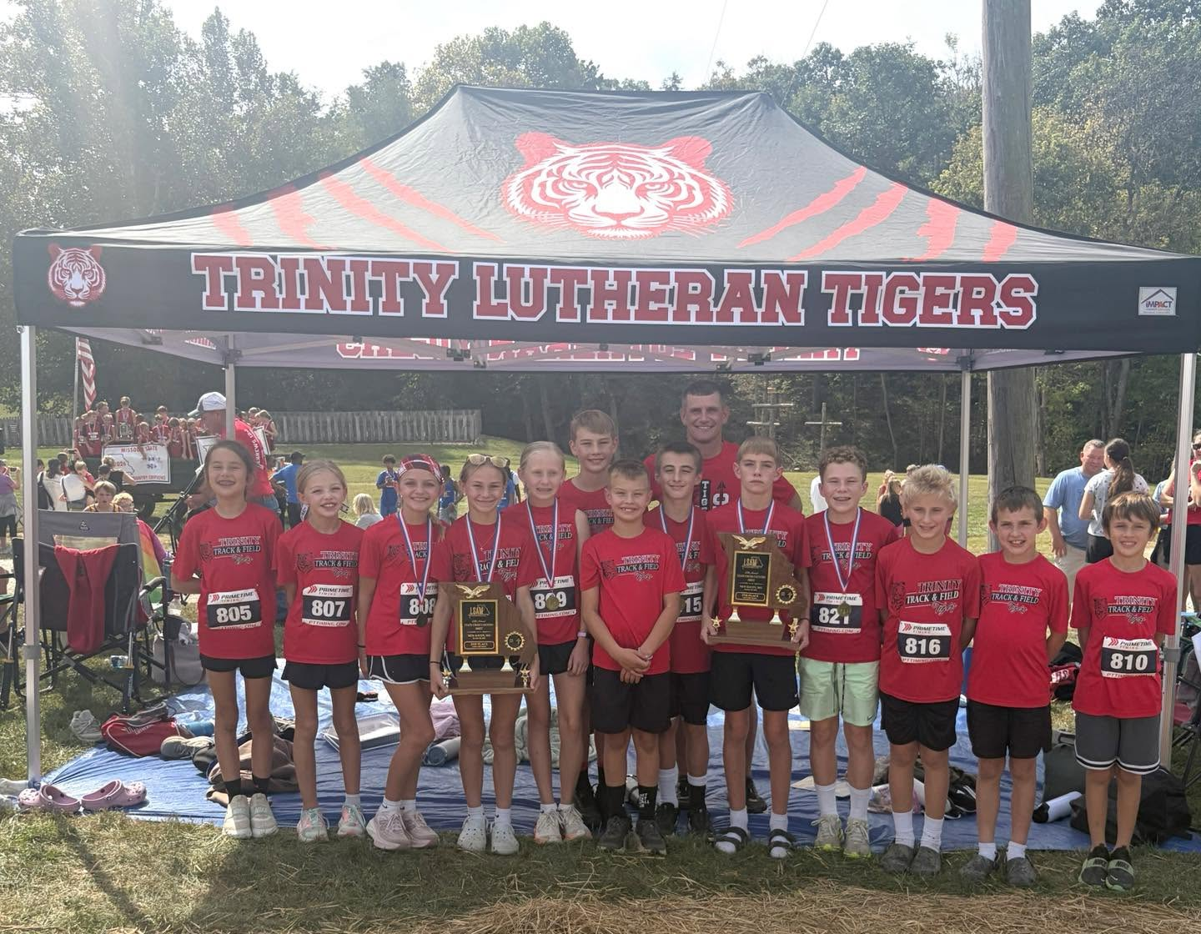

Prayers of encouragement and safe travels to Coach Nathan Hemme & the Trinity Cross Country Team as they travel to Nationals hosted in Mequon, WI, Saturday!

We will not be in session for the next two days, which allows our teachers to attend the Missouri District Professional Church Workers Conference.

The Missouri District Professional Church Workers Conference gathers pastors, educators, and other professional church workers for worship, learning, and fellowship, encouraging one another in our shared calling in Christ.

This year’s theme, Live as You Are Called, will focus on our shared vocation as professional church workers, rooted in God’s Word and centered in Christ and His cross. Grounded in our Lutheran identity and given joy in Christ, we are sent with confidence to teach, confess, and live out the Gospel in service to others.

Comfort Dog Lovers! Stop by Saint Paul Lutheran High School Campus this Saturday at 1:00 for a Comfort Dog Meet & Greet! 10 Comfort dogs from the region are expected to be there!

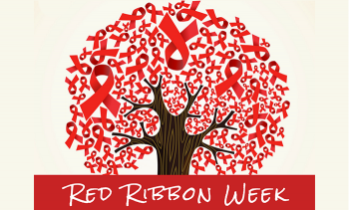
- What is Red Ribbon Week?
Red Ribbon Week is the nation’s oldest and largest drug prevention awareness campaign. Today, millions of people celebrate.
- Red Ribbon Week is October 25-31. During this week, alcohol, tobacco, and other drug and violence prevention awareness is emphasized. Dress-up days are just some of the fun planned for the week! Details on last page of the Pen.

Every spring, our PTL provides every child with a FREE school yearbook. We are able to offset that expense because we have amazing and generous sponsors. If you are interested in being a yearbook sponsor, please print the Yearbook Sponsor form and mail or bring it to the school office. Contact Martha Schreiman with any questions 660-229-3127.

26  Bagel w/Peanut Butter and Jelly  Fruit & Yogurt  Hamburger/Chz Burger  French Fries  Corn  Fruit | 27  French Toast  Sausage  Fruit & Yogurt  Hot Turkey & Cheese  On Bun  Ranch Pasta  Salad  Fruit | 28  Cereal  Bacon  Fruit & Yogurt  Meatloaf w/Sweet  Ketchup Sauce  Cheesy Mashed Potatoes  Green Beans  Fruit | 29  Cheesy Omelet  Blueberry Muffin  Fruit & Yogurt  BBQ Pulled Pork  Sandwich  Baked Beans  Coleslaw  Fruit | 30  Mini Waffles  Sausage  Fruit & Yogurt  Pepperoni Pizza  Salad  Fruit
**Milk and fresh fruit offered daily**
Salad OR PBJ option available--sandwiches only replace the main entree
This institution is an equal opportunity provider.

Breakfast & Lunch Menus available on our app. Available on googleplay or the apple store (Trinity Lutheran Alma)PICTURES WANTED! If you have any pictures (school events, parties, sports, field trips, etc) please share them with Martha Schreiman for the yearbook! mschreiman@santafechiefs.k12.mo.us or 660-229-3127
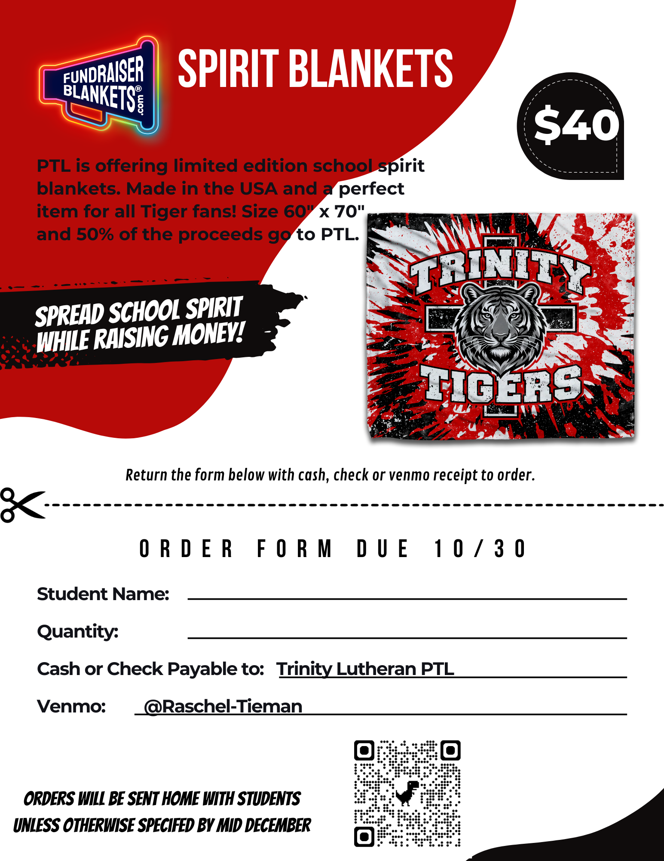

Upcoming Events
October
28 8:30 am Chapel with Kindergarten
Ms. Sarah PreK4 Field Trip
FLU Clinic @ School
230 JHVB Pep Rally
29 3rd Grade to Senior Center
5th/6th Volleyball Party
30 Fall Parties

November
8 Singing at Holy Cross
11 Veteran's Day Program
16 PTL Meeting 6:00 pm
23-27 NO SCHOOL Thanksgiving Break

December
2 4th-8th Grade Choir Sings
6:30 Advent Service
13 All Choirs sing at Holy Cross
22 Christmas Break Begins
10:30 Dismissal (End of Q2)
24 Christmas Eve Service
K -8 Choirs Sing
22-Jan 5 Christmas Break
