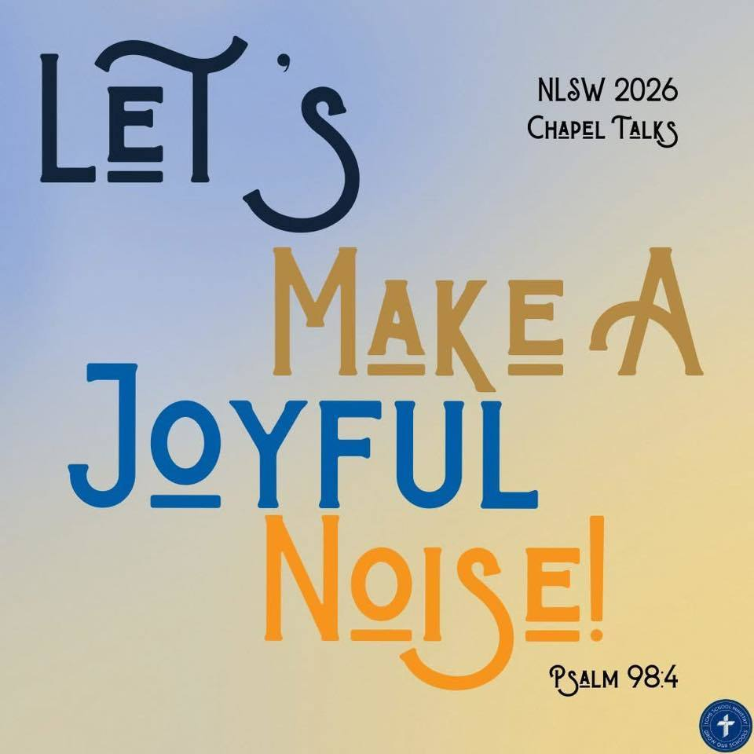
Trinity Lutheran School, Alma, Missouri May 6, 2026
Principal’s Pens will be electronically sent out unless you’ve requested a hard copy! Just reach out to the office if you’d like one sent home with your child. Upcoming Events can be found on the last page of this newsletter.

Next Thursday afternoon is FIELD DAY!! There will be water games during the day! NO SWIMSUITS are allowed, but you are welcome to send a change of clothes for your child to change into prior to dismissal!
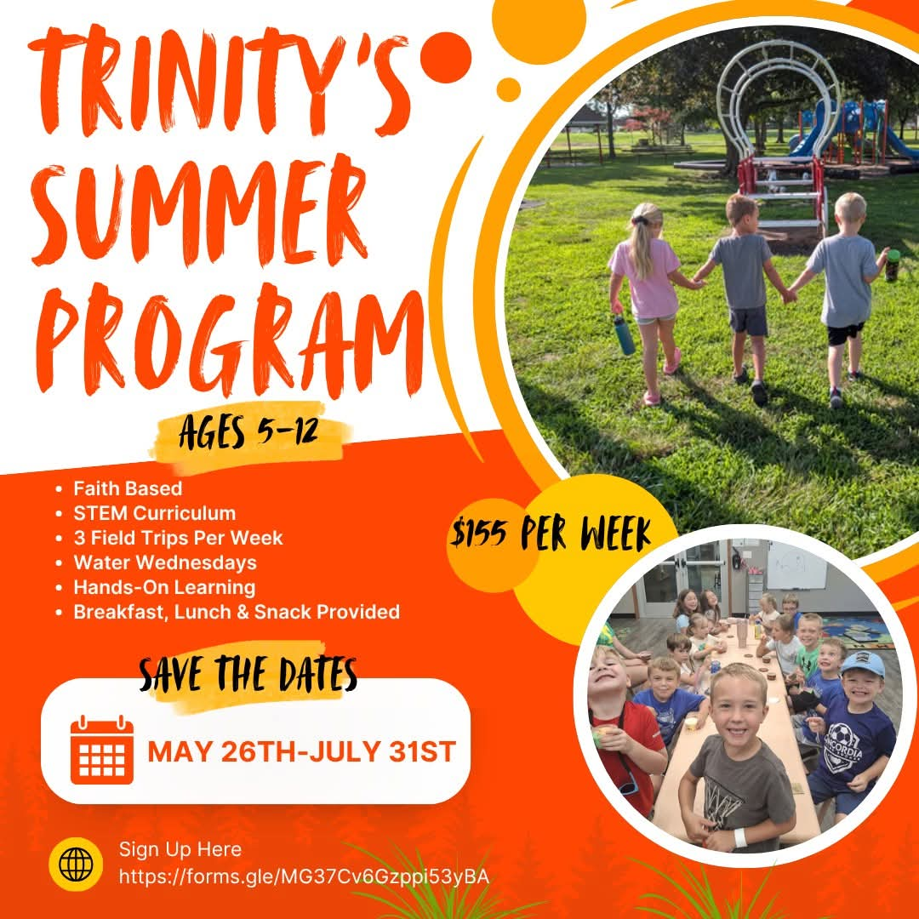

☀️ Sign-Up is NOW OPEN! ☀️https://forms.gle/MG37Cv6Gzppi53yBA

8th Grade Graduation next Wednesday, May 13 at 6:00 pm in the Gym. Grades 4th-7th will be singing at graduation, so please mark your calendars!


RE-Enrollment for next school year is open!
Trinity Lutheran's administration and staff are already looking ahead and making plans for next school year. In preparation for the start of the 2026-2027 school year, please take time now to complete your child’s reenrollment. Check your email or
To complete the enrollment process, please follow the steps below:
- Please go to FACTS Family Portal
- Type in your username and password
If you have forgotten your username or password, please click on the link provided
- Go to left-side Navigation Menu
- Click on Apply/Enroll
- Click on Enrollment/Reenrollment
Our Enrollment system will open with a link to the enrollment packet. The process should take approximately 15 minutes to complete. Your information will be saved if you need to quit and come back later. If you have any questions, please contact our office.

$$ EVERY student enrolled here at Trinity is encouraged to apply for financial assistance! We have a generous fund to help pay your child’s tuition! Please take a few minutes to apply! Tuition Assistance Application The deadline is July 15, but don’t wait; get your application in NOW! $$
We want your pictures for the yearbook! Please email mschreiman@santafechiefs.k12.mo.us with any pictures you’d like to share!

11  Bacon, Egg and cheese Tornado  Applesauce  Popcorn chicken  Tater Tots  Blueberries  Brownie | 12  French Toast  Bacon or Sausage  Mixed fruit  Burrito  Green Beans  Peaches  Fruit Smoothie | 13  Scrambled Eggs  Bacon or Sausage  Cinni mini  Peaches  Hot Dogs  Mac and Cheese  Corn  Pineapple | 14 Field Day  Pancakes  Bacon or Sausage  Pears  Sandwiches  Chips  Carrot sticks  Fruit  Cookie | 15  Have A Great SUMMER!
**Milk and fresh fruit offered daily** Salad option available
This institution is an equal opportunity provider.
Breakfast & Lunch Menus available on our app.

Upcoming Events

May
6-8 Class Trip (7th/8th grade)
7 Day at the K
2nd & 6th to Zoo
8 Law Enforcement Day (5th grade)
13 8th Grade Graduation 6:00
4th-8th Grade Choir Sings
14 Field Day at School
15 Last Day of School
9:30 am Pre-K Graduation
10:30 am Dismissal

