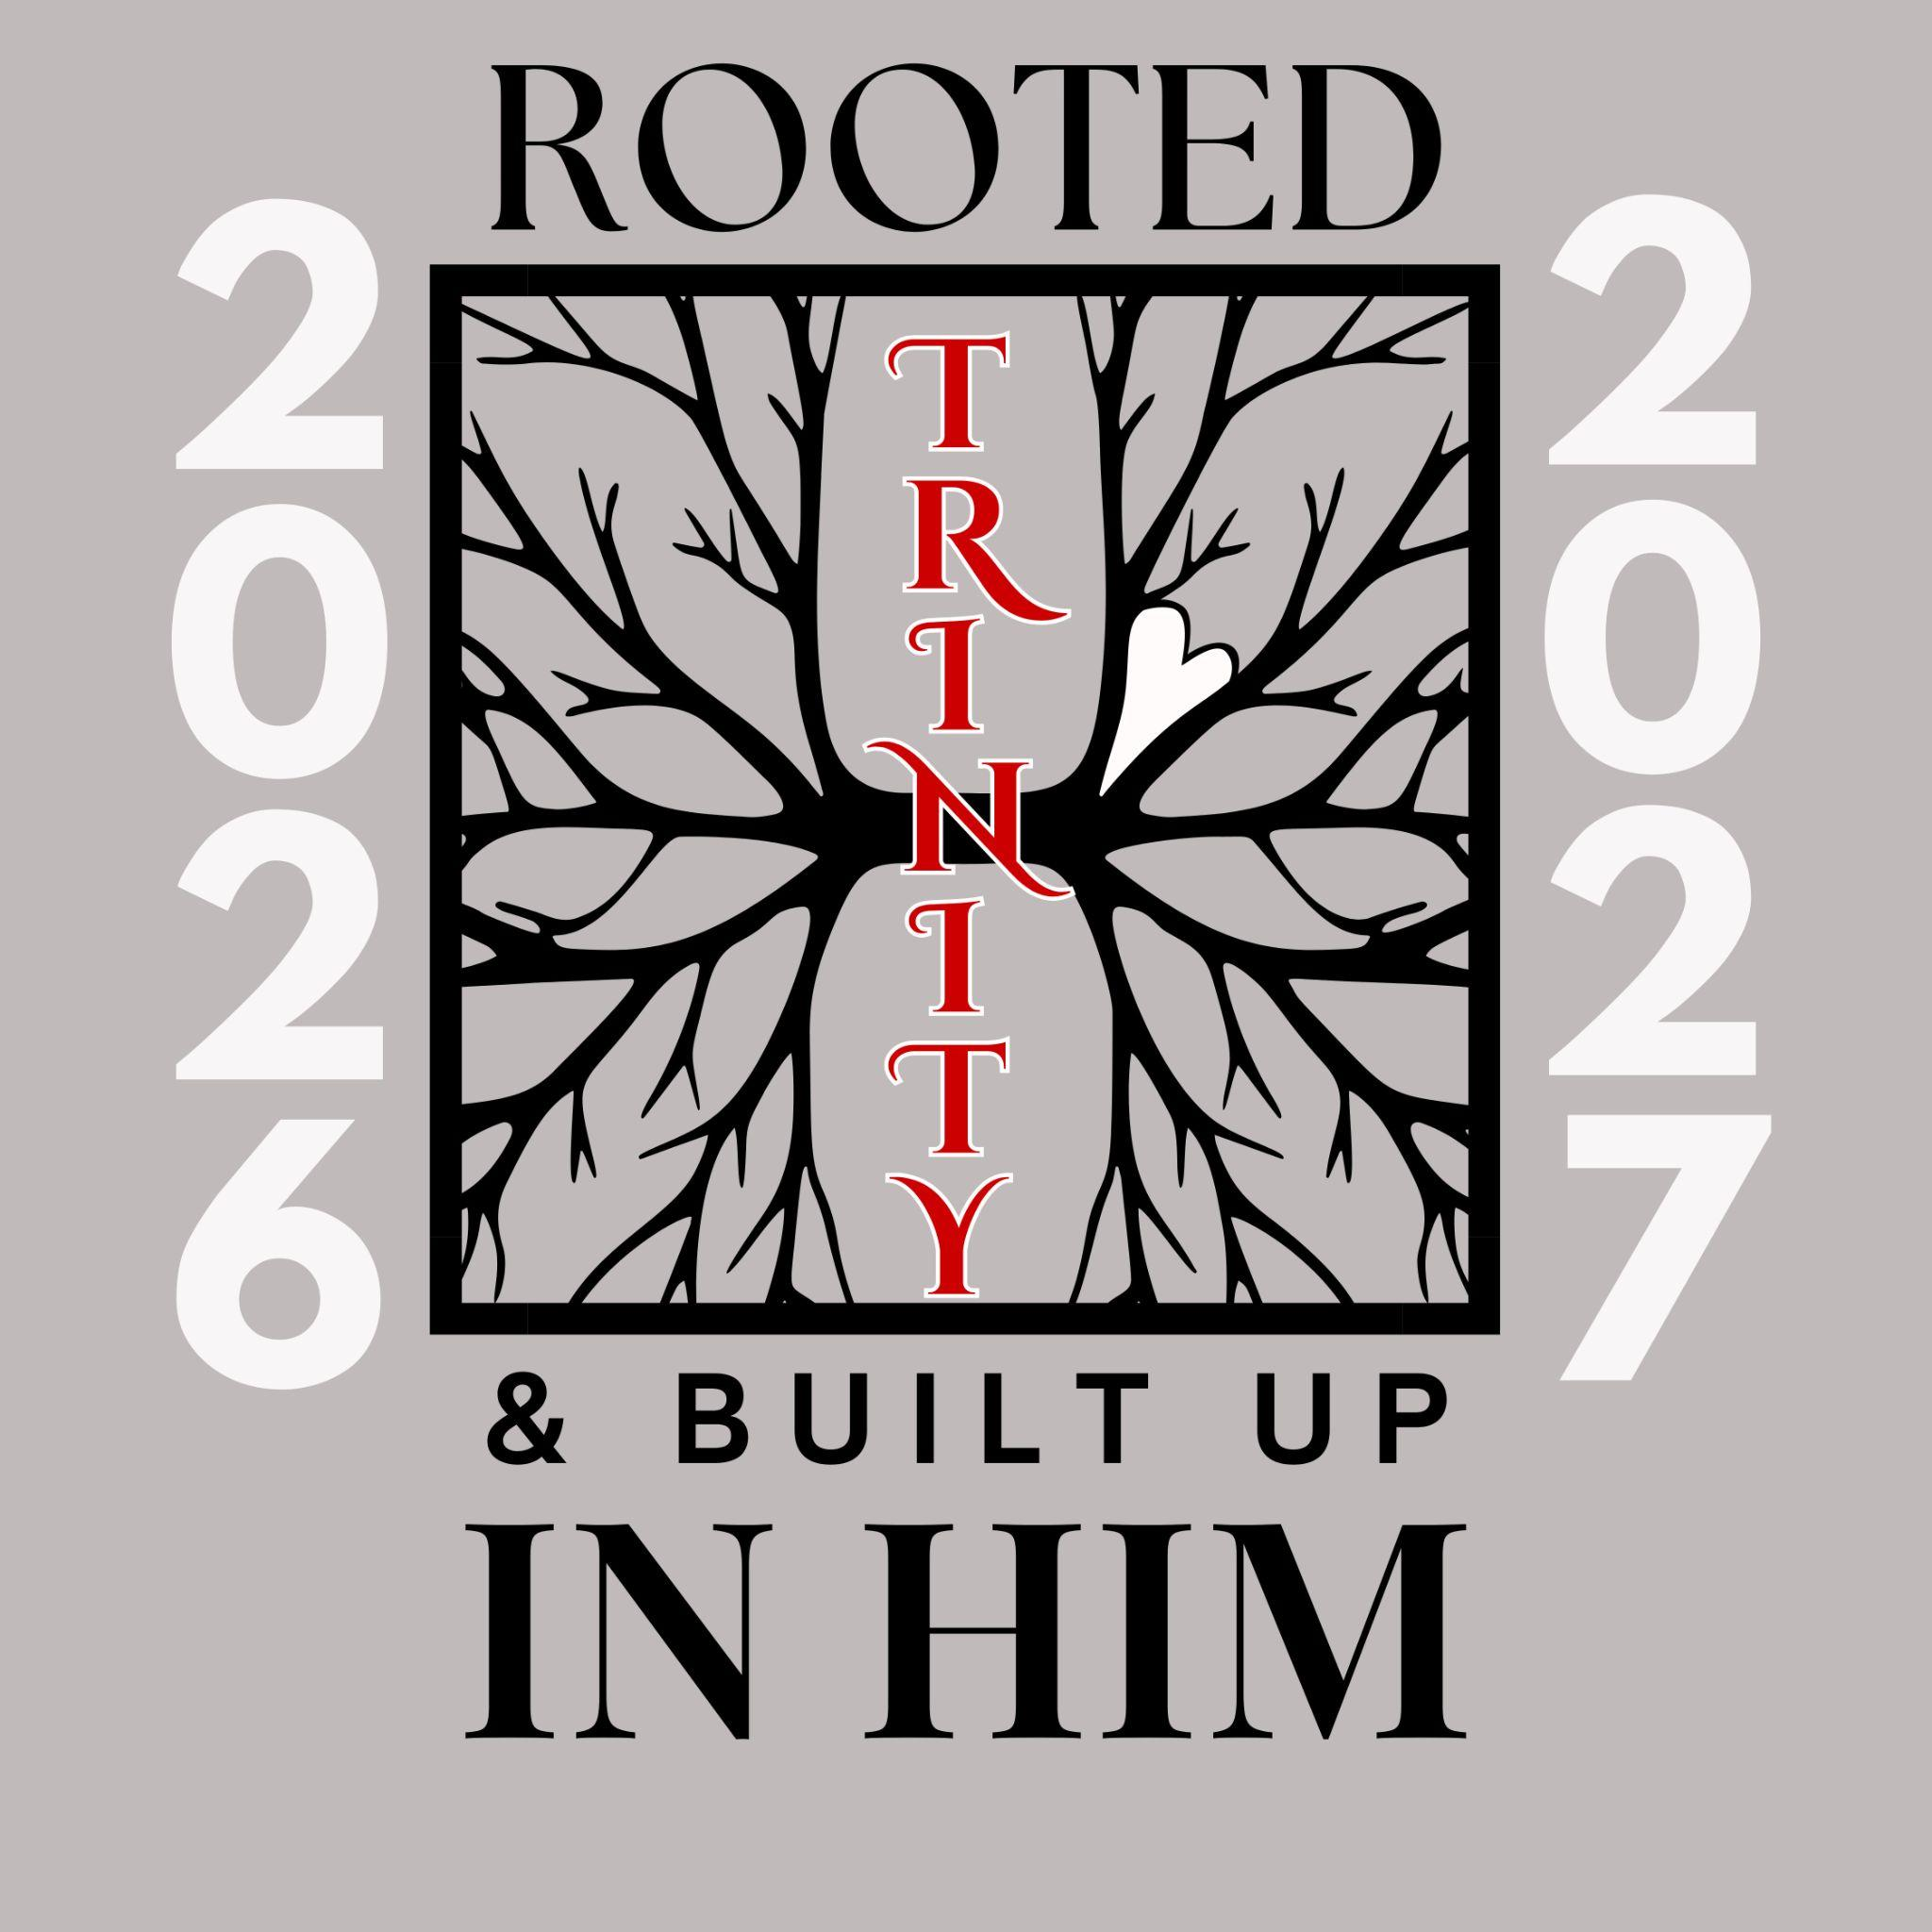
Trinity Lutheran School, Alma, Missouri September 2, 2026
Principal’s Pens will be electronically sent out unless you’ve requested a hard copy! Just reach out to the office if you’d like one sent home with your child. Upcoming Events can be found on the last page of this newsletter.


Mark your calendars!
Picture Day - Fri, Sept. 25

Cookie Dough & Shakespeare's Pizza fundraising forms will go home with your student today! You can also view them HERE > Shakespeare Pizza C' Cookie Creations
Forms are due back to the school on Wednesday, September 9th! This is a large fundraiser for our school, so we appreciate your help making it a success! If you have any questions, please contact Lauren Knipmeyer at 660-641-6675. Happy selling! 🍕🍪
Sucker Friday
$1 for a sucker Meat sticks will be available, but there has been a price increase. They are now $1.50!

Parent Teacher League September 28! Join us for our first PTL meeting of the year on Monday, September 28, at 6:00 p.m. in the school cafeteria. Families of all TLS students, preschool - 8th grade, are members of our PTL. There will be four regular meetings throughout the school year. In addition, the PTL will lead various special events for our students and families.


Baptismal Birthdays will be celebrated during chapel on the first Wednesday of the month (September 2), 8:30 am, except for the last day of school. Please come & celebrate with us. Congratulations to: Ella Frain, Paxton Hemme, Willow Hemme, Parker Lovercamp, Trevor Lovercamp, Charlotte Wagner, Scout Wagner, Kenadee Wagner

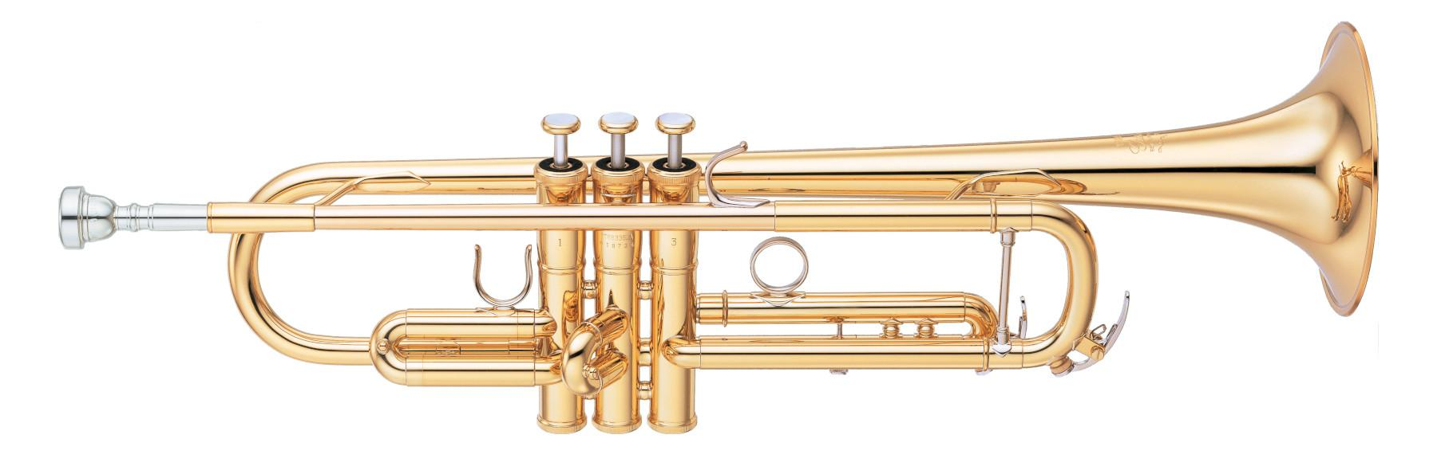

**We need instruments! Do you have a gently used instrument that you’d like to donate to the Trinity Band program? Please reach out and let us know! We will even pick it up!

*New Lunch Option! Starting Tuesday, September 8, we will be offering a ham and cheese OR PBJ as an alternate main entree choice. We will alternate weekly.

7  No School  No Daycare | 8  Sausage, egg and cheese biscuit  Mixed fruit  Fettuccine Alfredo  Green Beans  Apples  Breadstick | 9  Breakfast Pizza  Peaches  Baked Potato Bar  Broccoli  Pineapple  Roll  Cookie | 10  Pancake on a stick  Pears  Chicken Patty  Mashed potatoes and gravy  Carrots  Peaches  Fruit Smoothie | 11 Early out  Waffles  Bacon or Sausage  Pineapple  Corn Dog  Tater Tots  Corn  Applesauce  Cookie

**Milk and fresh fruit offered daily**
Salad OR HAM & CHEESE option available
This institution is an equal opportunity provider.

Breakfast & Lunch Menus available on our app. Available on googleplay or the apple store (Trinity Lutheran Alma)

We are excited to welcome back Mrs. Pottschmidt & Thomas! If you are interested in your child visiting with her, please sign the consent form (also sent home in backpacks) and return to school!

Church in the Park September 27
All students (prek-8th)sing at the 9:30 service at the City of Alma Park on September 27 so mark your calendars now! They will be practicing hard over the next month! You will also have the opportunity to meet the entire Trinity Lutheran School Faculty & Staff!

Upcoming Events

September
7 NO SCHOOL-Labor Day
8 Fall Testing Begins
11 12:30 Dismissal
Educator Development
18 12:30 Dismissal
19 Golf Tournament
25 Picture Day
27 Church in the Park
All Choirs Sing 9:30 am
28 PTL Meeting 6:00 pm

October
3 TLS Soccer/VB Tournament
9 12:30 Dismissal
Generations Together Day
End of Q 1
11 Chili & Soup Dinner
All Choirs Sing
15 12:30 Dismissal
1:00 PT Conferences Begin
16 NO SCHOOL
22-23 NO SCHOOL
LEA Educator’s Conference

