Just in time for basketball season!

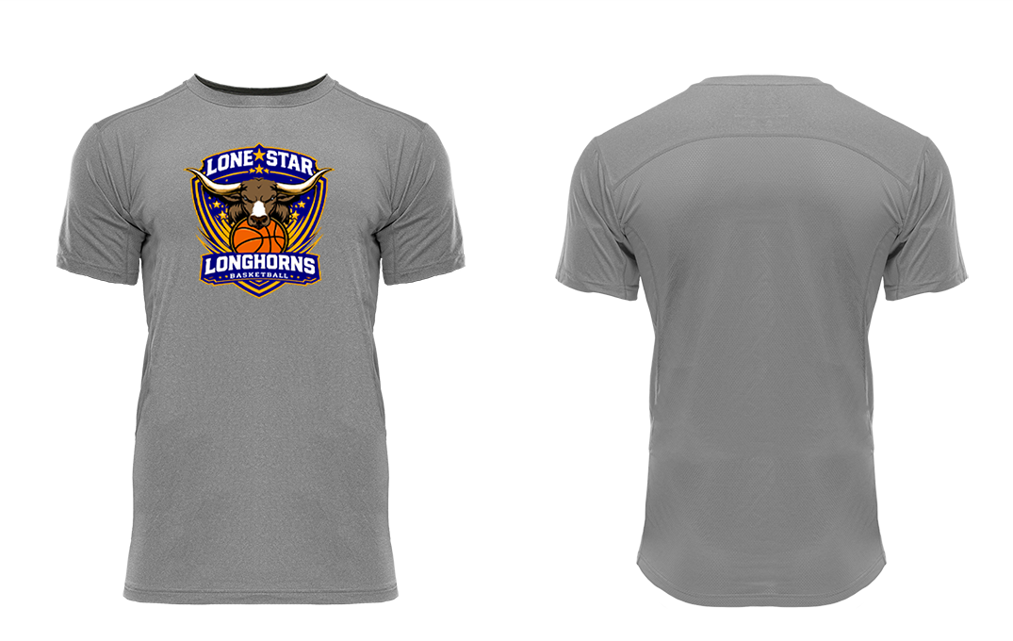

New design only $25!!
Pre-orders will be taken until November 12th.
To order contact any member of the class of 2032 or
Mrs. Ely elyd@lonestar.k12.co.us or
Mrs. Green greenj@lonestar.k12.co.us

