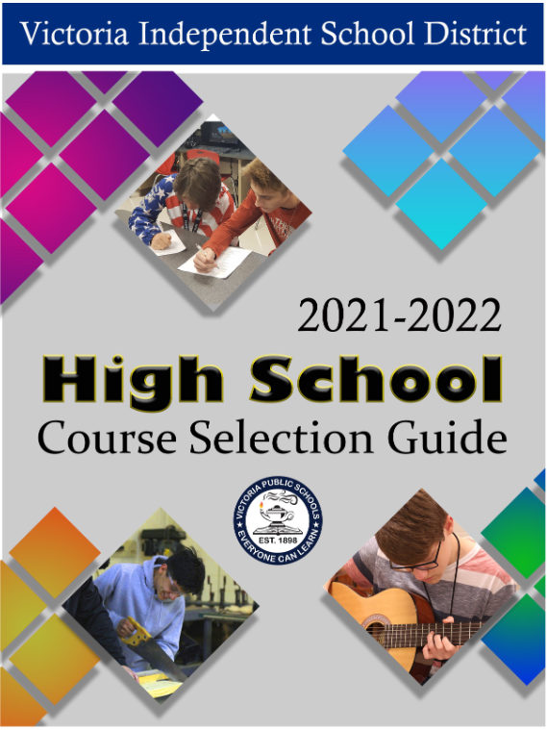

This page is intentionally left blank

VICTORIA

Independent School District





#### The Course Selection Guide is also available online: [www.visd.net/apps/pages/counseling/high-school-readiness](http://www.visd.net/apps/pages/counseling/high-school-readiness)

###### Information in the Course Selection Guide is subject to change pending decisions from the Texas Education Agency

The Victoria Independent School District does not discriminate against any person on the basis of race, color, national origin, gender, religion, sex, sexual orientation, disability, age, or any other basis prohibited by law for admission, treatment, or participation in its educational programs, services and activities, or employment.

El distrito escolar independiente de Victoria no discrimina contra ninguna persona por motivos de raza, color, origen nacional, género, religión, sexo, orientación sexual, discapacidad, edad o cualquier otra razón prohibida por la ley para la admisión, tratamiento, o la participación en los programas educativos, servicios y actividades, o empleo.

High Schools



Victoria East High School

4103 East Mockingbird

Victoria, TX 77904

(361) 788 - 2820

Victoria West High School 307 West Tropical Drive Victoria, TX 77904

(361) 788 - 2830

 

Liberty Academy 1110 Sam Houston Drive

Victoria, TX 77901

(361)788-9650

Career & Technology Institute 104 Profit Drive

Victoria, TX 77901

(361) 788 - 9288

Parent Gradebook



**Access your child’s grades through Parent Gradebook**

Go to [***www.visd.net***](http://www.visd.net/) and click on Parent Grade Book.

Select **Click Here to Register for HAC**.



Instructions are provided for parents/guardians/students who have not created a username and password in the prior year(s) for Home Access Center.

***Please contact your child’s school if your email address needs to be updated.***

All information must match ***exactly*** the parent/guardian information provided for your student on the Registration Verification form you approved and returned to the campus.

This will allow you to monitor your child’s grades, missing assignments, receive alerts and more.

Stay connected to your child’s education with the click of a button.

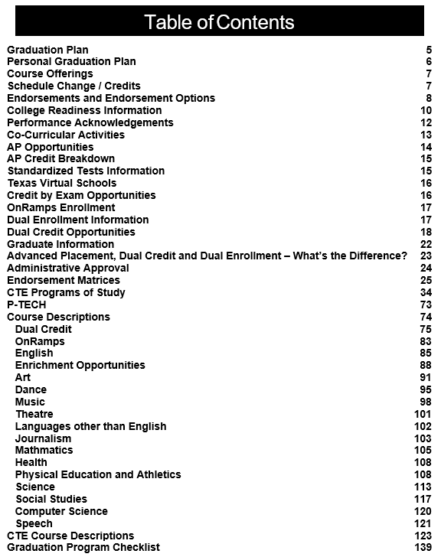

Graduation Plan 5

Personal Graduation Plan 6

Course Offerings 7

Schedule Change / Credits 7

Endorsements and Endorsement Options 8

College Readiness Information 10

Performance Acknowledgements 12

Co-Curricular Activities 13

AP Opportunities 14

AP Credit Breakdown 15

Standardized Tests Information 15

Texas Virtual Schools 16

Credit by Exam 16

OnRamps Enrollment 17

Dual Enrollment Information 17

Dual Credit Opportunities 18

Graduate Information 22

Advanced Placement, Dual Credit and Dual Enrollment – What’s the Difference? 23

Administrative Approval 24

Endorsement Matrices 25

CTE Programs of Study 34

P-TECH 73

Course Descriptions 74

Dual Credit 75

OnRamps 83

English 85

Enrichment Opportunities 88

Art 91

Dance 95

Music 98

Theatre 101

Languages other than English 102

Journalism 103

Mathmatics 105

Health 109

Physical Education and Athletics 109

Science 115

Social Studies 119

Computer Science 122

Speech 122

CTE Course Descriptions 124

Graduation Program Checklist 142

# Graduation Plan

Graduation Plan

**Victoria Independent School District**

**HB 5 Graduation Plan**

**Foundation + Endorsements-26 Credits**

**Distinguished Level of Achievement -26 Credits**

* **4 credits English** – English I, II, III , one credit in any authorized advanced English course
* **4 credits Mathematics** – Algebra I, Geometry, two credits in any authorized advanced math course
* **4 credits Science** – Biology, two credits in any advanced science course, one credit in IPC or in any additional authorized advanced science course
* **3 credits Social Studies** –US History, Government, Economics, World Geography or World History
* **2 credits LOTE or Computer Science**
* **1 credit Physical Education**
* **1 credit Fine Arts**
* **.5 credit Professional Communications**
* **.5 credit Health**
* **6 credits in electives**

**Credit requirements specific to at least one endorsement**

* **4 credits English** – English I, II, III , one credit in any authorized advanced English course
* **4 credits Mathematics** – Algebra I, Geometry, Algebra II, one credit in any authorized advanced math course
* **4 credits Science** – Biology, two credits in any advanced science course, one credit in IPC or in any additional authorized advanced science course
* **3 credits Social Studies** –US History, Government, Economics, World Geography or World History
* **2 credits LOTE or Computer Science**
* **1 credit Physical Education**
* **1 credit Fine Arts**
* **.5 credit Professional Communications**
* **.5 credit Health**
* **6 credits in electives**

**Credit requirements specific to at least one endorsement**

**Endorsements**

|  |  |  |  |  |  |  |
| --- | --- | --- | --- | --- | --- | --- |
| **\*STEM** | **Business/Industry** |  | **Public Services** | **Arts & Humanities** |  | **Multidisciplinary** |
| **Science; Computer Science; Engineering; Math;**  **\*algebra II, chemistry & physics are required** | **Agriculture, Food & Natural Resources;**  **Architecture & Construction;**  **Arts, A/V Tech & Comm; Business Management; Finance;**  **Hospitality & Tourism; Information Technology; Manufacturing; Marketing; Transportation; Advanced Journalism – Newspaper & Yearbook; Public Speaking; Debate:** | **Education & Training; Health Science; Human Services; JROTC** | **Language other than English (LOTE);**  **Fine Arts –Art, Theatre, Dance & Music; Social Studies;**  **English** | **4 Advanced courses in same or different endorsement area;**  **or**  **4 credits in each foundation subject areas to include English 4 and Chemistry and/or Physics; or**  **4 credits in advanced placement or dual credit selected from English, Math, Science, Social Studies, Economics, LOTE, or Fine Arts** |

# Personal Graduation Plan

Personal Graduation Plan

Name: ID #: School: Grade:

|  |  |
| --- | --- |
|  | **Foundation + Endorsement(s)** |
| **Subject** | **Credits** |
| English | 4 |
| Math | 4 |
| Science | 4 |
| Social Studies | 3 |
| Foreign Language | 2 |
| Fine Arts | 1 |
| Physical Education | 1 |
| Electives | 6 |
| Speech | ½ |
| Health | ½ |
| **Total Credits for**  **Graduation:** | **26** |

|  |  |  |
| --- | --- | --- |
| The Four Year Plan is intended to give you and your parent(s) a guide to use as you progress through high school. You will want to review the plan each year to make sure you are taking the required courses for graduation. You may use these as guides to help you select courses that support your career goals. Make sure that you are taking the academic courses that support your post-secondary plans. In VISD, all students enter high school under the Distinguished Level of Achievement Plan with an endorsement. Graduation plans may be changed by working through your campus counselor | | **Graduation Plan** |
| **Endorsement:** | **My post-secondary plan will take me to:**  (Check as many as apply):  Two Year College  Technical Training  Four Year College  Employment  Military Other |  |
| STEM |  |
| Business and Industry |  |
| Arts and Humanities |  |
| Public Services |  |
| Multidisciplinary Studies |  |
| Specialization Area: |  |
| In VISD, all students enter high school under the Distinguished Level of Achievement and Foundation High School Plan with an endorsement.  Graduation plans may be changed by working with your campus counselor. |  |

**Student’s Signature: Parent’s Signature:**

**Counselor's Signature: Date Initiated: Date(s) Amended**:

**Middle School Credits Earned:**

* Algebra I
* Health/Speech
* Spanish I
* Spanish II
* MAPS
* Other:
* I plan to take

Pre-AP/AP courses in high school.

|  |  |  |  |  |
| --- | --- | --- | --- | --- |
| **Pds**  **:** | **9th Grade** | **10th Grade** | **11th Grade** | **12th Grade** |
| **1** | English I | English II | English III | English IV |
| **2** | Algebra I | Geometry | MMA/Algebra II | Adv. Math: |
| **3** | IPC/Biology | Biology/Chemistry | Adv. Science: | Adv. Science: |
| **4** | W. Geography | W. History | US History | Government/ Economics |
| **5** |  |  |  |  |
| **6** |  |  |  |  |
| **7** |  |  |  |  |

# Course Offerings

Course Offerings

Schedule Change / Credits

# Schedule Change / Credits

**Course Offerings**

Every course is not offered on every campus, and every course is not offered each year. Courses must have a sustainable enrollment of a minimum of 15 students to be offered. Additionally, a teacher who meets the federal government’s Highly Qualified standard must be on staff to teach a course. Occasionally, the demand for a course exceeds the class capacity. In this case, campuses may limit the course to certain grade levels and/or close it to late enrollees. These requirements and restrictions impact elective and specialty courses more frequently than core courses and/or the required courses.

**Procedures for Schedule Change**

All students are given the opportunity to select their courses for the next school year during the course selection process. The master schedule is then designed to accommodate the students’ requests. Schedule changes can result in overcrowding of classes, which reduces teacher availability for addressing individual student needs. Please keep this in mind when choosing courses in the Spring for the upcoming year.

**Schedule changes will be made for the following reasons:**

* Course for graduation is not scheduled
* Already have credit for a course
* Extra-curricular
* Class balancing

Level Changes:

Before any level schedule changes (i.e. a Pre-AP/AP course to a regular course) are considered, the following interventions and/or strategies are required:

* Attend tutorials before and/or after school
* Attend class daily
* Complete eligible missing assignments
* Parent-teacher conference

The grades earned at the previous level of the course will transfer with the student to the new course.

11th ….. 12 - 171/2 12th ….. 18 - above

10th ….. 6 - 111/2

9th ….. 0 - 51/2

**Number of Credits Required for Each Grade Level**

# Endorsements and Endorsement Options

Endorsements

|  |  |  |  |
| --- | --- | --- | --- |
| **Business and Industry** | **Arts and Humanities** | **STEM** | **Public Service** |

**Agriculture Science**

|  |  |  |  |  |
| --- | --- | --- | --- | --- |
| ral | **Pre-Apprenticeships** Electrical Tech. I/II Plumbing Tech. I/II  **English**  *Adv. Broadcast Journ. I-III  *AP English Literature & Composition  *Debate III  *English IV  *College Prep English  **Fine Arts-Art**  Art I  Pre-AP Art I  Art II-IV Ceramics Art II-IV Drawing Art II-IV Painting Art II-IV Sculpture AP Art Drawing  AP Art 2-Dimension AP Art 3-Dimension  Digital Art and Animation Floral Design  **Fine Arts-Dance** Ballet Folklorico I-IV Color Guard I-IV Dance I-IV  Drill Team I-IV  **Fine Arts-Music** Applied Music Guitar I-IV Band I-IV  Choir I-IV Jazz Band I-IV Mariachi I-IV Orchestra I-IV  Vocal Ensemble I-IV  **Fine Arts-Theatre** Tech. Theatre I-II Theatre Arts I-IV Theatre Production I-IV  **Foreign Language (LOTE)** Pre-AP Spanish I-III Spanish I-II  AP Spanish V  American Sign Language I  **Social Studies**  AP Psychology  AP European History AP Human Geography Psychology  Sociology | **Science**  *Anatomy & Physiology  *Animal Science  *Engineering Design & Problem Solving  *Forensic Science  *AP Biology  *AP Chemistry  *AP Environmental Science  *AP Physics 1  *AP Physics 2  Aquatic Science Environmental Systems  **Technology- Computer Science**  *AP Computer Science Principles  *AP Computer Science A  **Engineering**  *Engineering Design & Problem Solving  Digital Fundamentals (Dual Credit)  Electricity Principles (Dual Credit)  Intro. to Process Technology  (Dual Credit) Practicum in STEM  Prin. of Applied Engineering Robotics I  Robotics II Rocketry (SRD)  Petrochemical Safety, Health & Environment (Dual Credit)  **Mathematics**  *AP Calculus AB  *AP Calculus BC  *AP Statistics  *Pre-Calculus  *College Prep Math | **Education and Training** Human Growth and Develop- ment  Instructional Practices Art of Teaching (DC)  **Health Science**  *Anatomy & Physiology Health Science Clinical Health Science Theory Medical Terminology Prin. of Health Science Pract. in Health Science Sports Medicine I-III  **Human Services**  Interpersonal Studies  Lifetime Nutrition and Wellness Cosmetology I/Cosmetology I Lab  Cosmetology II/Cosmetology II Lab  **Law, Public Safety, Corrections & Security**  Criminal Investigation & Law Enforcement II  *Forensic Science  Prin. of LPSCS &  Law Enforcement I Pract. in Law, Public Safety,  Corrections & Security | |
| al |
| tions Mgt. |
| nt I end |
| tend |
| y |
| I |
|  | **Multidisciplinary Studies** | |
|  | Allows a student to select courses from the curriculum of each endorsement area and earn credits in a variety of advanced courses for multiple content areas sufficient to complete the distinguished graduation plan. | |
| & | Methodology for Academic & Personal Success (MAPS) is an introductory courses that is allowable under any endorsement sequence. | |
| Above are the elective choices for each endorsement.  An asterisk (*) indicates advanced core course. | | | |  |

Ag. Equip. Design and Fabrication

Ag. Mech. & Metal

*Animal Science Floral Design Livestock Production

Pract. in Ag., Food & Natu Resources

Prin. of Ag., Food & Natur

Resources

Veterinary Medical Applica Wildlife, Fisheries, & Eco.

**Business Management &**

**Admin.**

Business Info. Manageme Career Preparation I & Ext CP

Career Preparation II & Ex CP

Keyboarding (TSDE) Personal Financial Literac Principles of Business

Marketing and Finance Pract. in Business

Management

**Construction** Construction Technology Construction Technology I Practicum in Construction Tech

Principles of Construction

**Arts, AV Tech & Comm.** Graphic Design & Illustr. I Graphic Design & Illustr. II Pract. in Graphic Design &

Illustration

**Finance**

Accounting I

**Information Technology**

Video Game Design

Adv. Video Game Design

Pract. Of Info. Tech

Prin. in Info. Technology

**Welding** Welding I Welding II

Pract. in Manufacturing

**Transportation**

Auto Tech I-Maintenance Light Repair

Auto Technology II-Auto Service

Pract. in Transportation & Systems

Endorsement Options

**Arts & Humanities**

An Arts & Humanities endorsement requires completion of the FHSP and *ONE* of the following:

Five (5) Social Studies credits

***OR***

Four (4) levels/credits of the same language in a Language other than English (LOTE)

***OR***

Two (2) levels/credits of one language other than English, *and* 2 levels/credits of a

*separate* language other than English

***OR***

A coherent sequence of 4 credits in Fine Arts from *ONE* or *TWO*

Fine Arts disciplines of Art, Dance, Music, and/or Theatre

***OR***

Four (4) English *elective* credits, selecting from English IV, Independent Study in Eng- lish, Literary Genres, Creative Writing, Research & Technical Writing, Communi- cation Applications, Humanities, and AP English Literature & Composition

*This endorsement cannot be earned through combining courses from separate Arts & Humanities pathways.*

**Multidisciplinary Studies**

A Multidisciplinary Studies endorsement requires completion of the FHSP and at least one of the following:

Four (4) additional/advanced courses, from within *one* endorsement area or from various endorsement areas, that prepare the student to either successfully enter postsecond- ary education without the need for mediation or successfully enter the workforce

***OR***

Four (4) credits in *each* of the four foundation subject areas of English Language Arts, Math, Science, and Social Studies, including a traditional English IV option (academic or Dual Credit) course, ***and*** Chemistry and/or Physics

***OR***

Four (4) AP, Dual Credit, or IB course credits *(IB for transfer students only as the Interna- tional Baccalaureate program is not offered in Victoria ISD)*, selected from English Language Arts, Math, Science, Social Studies, Languages other than

English, and/or Fine Arts

**Business & Industry**

A Business & Industry endorsement requires completion of the FHSP and one of the following: A coherent sequence of 4 CTE credits, including:

at least 2 courses in the same career cluster, ***and***

at least 1 advanced CTE course that is the 3rd course or

higher in a sequence in one of the following career clusters:

Agriculture, Food & Natural Resources Architecture & Construction

Arts, A/V Technology & Communications Business Management & Administration Finance

Hospitality & Tourism Information Technology

Manufacturing Marketing

Transportation, Distribution & Logistics

***OR***

Four (4) English Language Arts elective credits, in- cluding 3 levels in *ONE* of the following areas:

Journalism – Newspaper *or* Yearbook *or*

Speech – Debate *or* Oral Interpretation

***OR***

Four (4) Technology Applications credits selected from: Digital Design & Media Production

Digital Art & Animation

Digital Communication in the 21st Century Digital Video & Audio Design

***OR***

A combination of courses selected from various categories within the Business & Industry endorsement to form a coherent sequence

**Public Services**

A Public Service endorsement requires completion of the FHSP and *ONE*

of the following:

A coherent sequence of 4 CTE credits, including:

at least 2 courses in the same career cluster, ***and***

at least 1 advanced CTE course that is the 3rd course or higher in a sequence in *ONE* of the following career clus- ters:

Health Science Education & Training

Government & Public Administration Human Services

Law, Public Safety, Corrections & Security NJROTC (National Junior Reserve Officer Training

Corps)

*This endorsement cannot be earned through combining courses from sepa- rate Public Services pathways.*

**STEM**

**(Science * Technology * Engineering * Math)**

A STEM (Science, Technology, Engineering & Math) endorsement requires completion of the FHSP including Algebra II, Chemistry, Physics, and one of the following:

A coherent sequence of 4 CTE credits, including:

at least 2 courses in the same career cluster, ***and*** at least 1 advanced CTE course that is the 3rd course or higher in a sequence related to Science, Technology, Engineering, or Math

***OR***

A coherent sequence of four (4) credits in Computer Science or Computer Programming

***OR***

Successful completion of 2 additional Math courses for which Algebra II is a prerequisite

***OR***

Successful completion of 2 additional Science courses beyond Biology, Chemistry, and Physics

***OR***

A cross-disciplinary study of Science and Math, including 3 credits from a combination of courses chosen from

*up to TWO* of the following categories:

* STEM CTE career cluster courses
* Computer Science
* Math courses for which Algebra II is a prerequisite
* Science courses beyond Chemistry and Physics

# College Readiness Information

College Readiness

**Exploring Post-Secondary Options**

**CAREER AND COLLEGE CENTER**

Victoria Independent School District, in partnership with Victoria College, is committed to the individual success of all our students and their post-graduation plans. Victoria East and Victoria West both have a Career and College Center, formally known as CARS (College Access Resources and Success Center), located in the library to assist with these plans. These centers are eager to provide help with both academic and non-academic pathways which would include: information on colleges, universities, and trade schools, general admissions questions, career exploration, resume writing, financial aid pathways, including scholarship quests, and general college entrance exams. We are available throughout the year to meet with students and parents to engage in proactive conversations that lead to a fruitful plan after graduation.

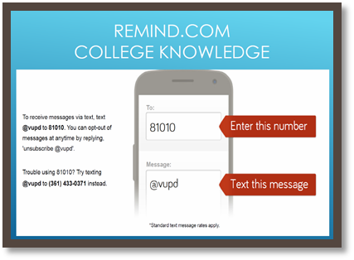**College Knowledge Text Reminders**

Students and parents text @vupd to 81010 to receive text

message reminders about upcoming deadlines and events.

**College is What’s Next**

When you plan for college, it is important to be aware of the requirements, deadlines and general process necessary to be admitted to the college of your choice. Begin by completing the ApplyTexas Application. This is the general form used for admission to any Texas public university, as well as to participating community and private colleges.

**Visit** [**www.applytexas.org**](http://www.applytexas.org/) **for details.**

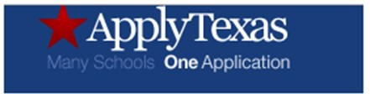

**FINANCIAL AID**

It is also necessary to apply for financial aid. Every student who meets certain eligibility requirements can get some type of federal student aid, regardless of age or family income. Completing and submitting the FAFSA is free and quick, and it gives you access to the largest sources of financial aid to pay for college or career school—federal, state, and school sources. Beginning with students enrolled in **12th grade**during the **2021-2022 school year**, each student must do one of the following in order to graduate. **www.fafsa.gov**

* Complete and submit a Free Application for Federal Student Aid (FAFSA)
* Complete and submit a Texas Application for State Financial Aid (TASFA)
* Submit a signed opt-out form

RaiseMe is a financial tool for high school students to earn micro-scholarships beginning their 9th grade year. This can be achieved by recording your high school activities, grades and test scores. Scholarships are awarded by participating colleges and universities. [**www.raise.me**](http://www.raise.me/)

**Career Exploration**

Below is a self-exploration and planning program that allows students to learn about themselves, their interests, as well as learn about career possibilities and educational pathways.

TEXAS GENUINE

Texas Genuine provides a free career assessment that takes less than 10 minutes to complete. Based on the responses, students can have their top three Career Clusters® of interest emailed to them. Students can then use the website to explore potential careers that fall within each of those categories, along with salary information – an important factor to consider when planning for the future. **Visit** [**www.texasgenuine.org/**](http://www.texasgenuine.org/) **for details.**

**College Readiness and the Foundation High School Program + Endorsement**

Because of the flexibility in course selections allowed on the Foundation High School Program + Endorsements, students on the FHSPE should check with the colleges to which they are interested in applying to determine any specific course requirements for admission.

Many major, Tier One universities recommend pursuing the rigor of the “4 x 4” requirements, which include:

* Four English credits, including a traditional English IV (English IV, AP English Literature and Composition, or Dual Credit English),
* Four Math credits, including Algebra II,
* Four Science credits, including Chemistry and Physics,
* Four Social Studies credits, and
* Two traditional Language Other Than English credits in the same (traditional) language. Computer Science may be excluded.

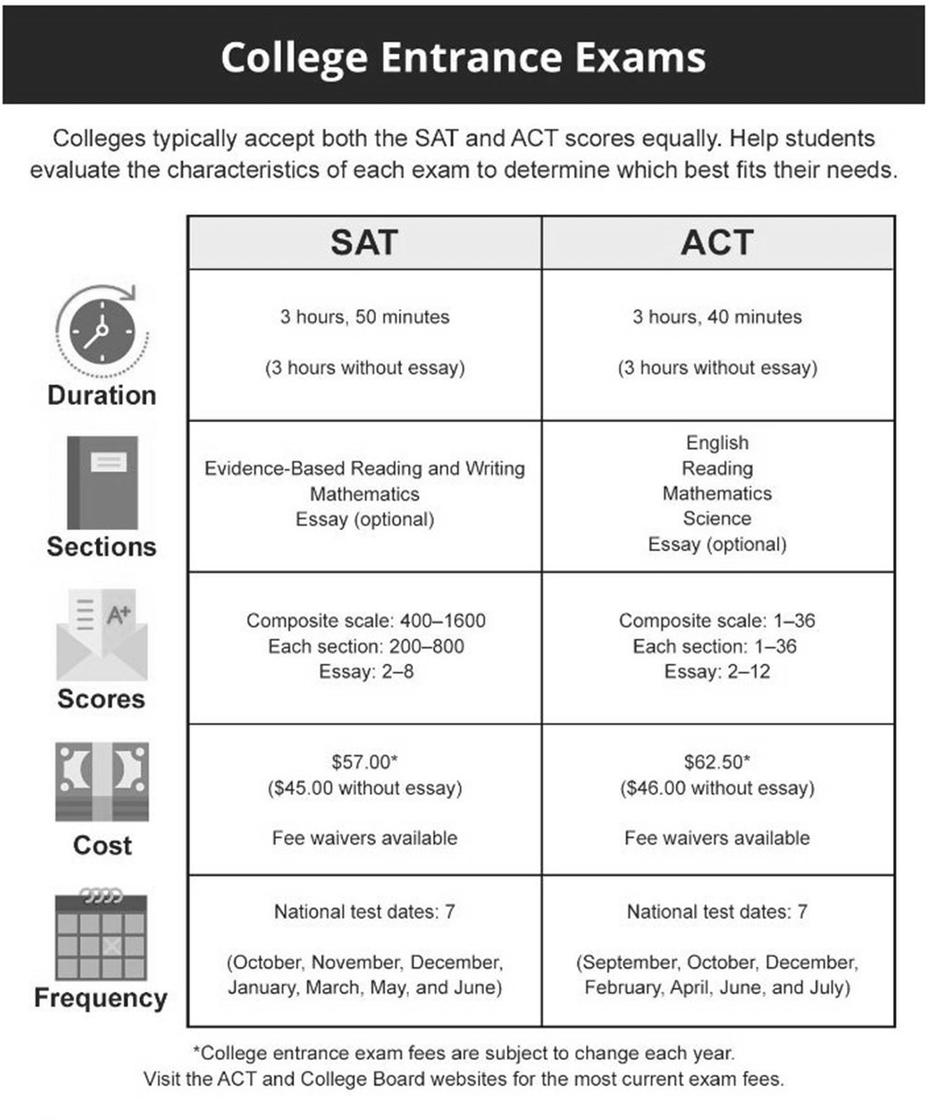

* Students requesting accommodations should apply through the College Board or ACT.

# Performance Acknowledgements

Performance Acknowledgements

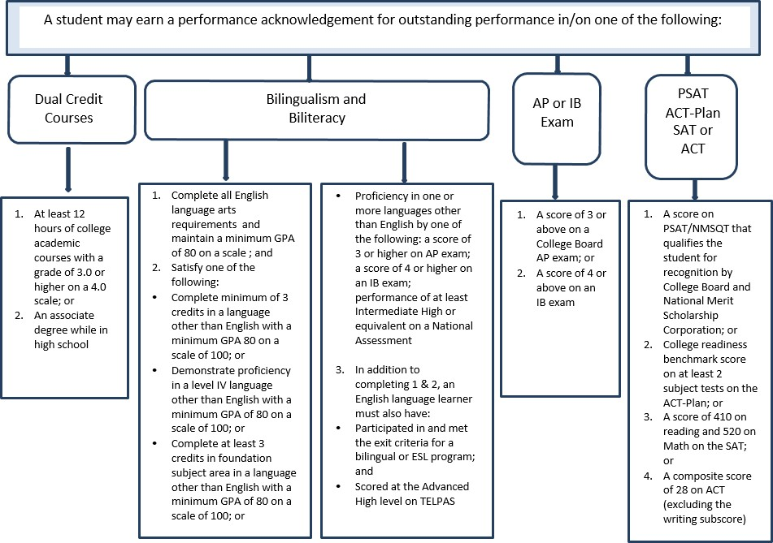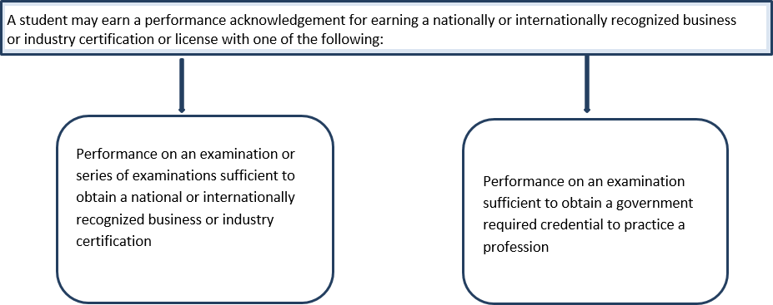

Co-Curricular Activities

# Co-Curricular Activities

Clubs and Organizations

Students are encouraged to participate in the following clubs and organizations. Check for offerings at your campus.

|  |  |  |
| --- | --- | --- |
| Anime Club | Golf - Boys | Soccer - Boys |
| Art Club | Golf - Girls | Soccer - Girls |
| Ballet Folklorico | Guitar Club | Softball |
| Band and Color Guard | Health Occupations Students of America | Spanish Club |
| Baseball | Interact Club | Speech, Theatre & Drama |
| Basketball - boys | Key Club | Student Council |
| Basketball - girls | Leo Club | Swimming - Boys |
| Business Professionals of America | Mariachi | Swimming - Girls |
| Cheerleaders - JV & Varsity | National Honor Society | TCEA Robotics |
| Choir | National Technical Honor Society | Texas Association of Future Educators |
| Class Officers | Newspaper | Texas Future Music Educators |
| Dance/Drill Team | PALS (Peer Assistance) | Tennis - Boys |
| DECA | Philosophy Club | Tennis - Girls |
| DIY Club | Photography Club | Track - Boys |
| Environmental Services Club | Powerlifting | Track - Girls |
| Fellowship of Christian Athletes | Quill and Scroll (Journalism) | UIL Academics |
| Future Farmers of America | Recycling Club | Volleyball |
| Football | Rho Kappa | Yearbook |
|  | Science Club | Wrestling |

|  |  |  |
| --- | --- | --- |
| UIL Academic Events | | |
| Students are encouraged to participate in the following University Interscholastic League academic contests: | | |
| * Accounting | * Exempt Persuasive | * Number Sense |
| * Calculator Applications | * Feature Writing | * One-Act Play |
| * Computer Applications | * Headline Writing | * Poetry Interpretation |
| * Computer Science | * Journalism | * Prose Interpretation |
| * Current Issues & Events | * Lincoln-Douglas Debate | * Ready Writing |
| * CX Debate | * Literary Criticism | * Science |
| * Editorial Writing | * Mathematics | * Social Studies |
| * Exempt Informative | * News Writing | * Spelling & Vocabulary |

# AP Opportunities

AP Opportunities

**GPA Exemption**

VISD encourages all students to experience a variety of opportunities and participate in the arts, athletics and competitive programs. Students should not be limited in their choices due to GPA constraints based on class weighting. A GPA exemption will allow a student to take a non-weighted course without calculating it into his/her GPA. This option is avail- able to juniors and seniors who wish to take a course that is not needed to meet graduation requirements. Students electing this option must return a completed form to the school counselor prior to the third week of the semester.

**College Board Advanced Placement® Courses**

Students in the Victoria Independent School District who are prepared to engage in college-level course content and rigorous academic challenge may choose to enroll in College Board Advanced Placement® (AP) courses. These courses are designed to provide students with coursework that is at the depth and complexity levels of comparable college courses. Enrollment in AP and Pre-AP courses is open to any student in the VISD who is committed to pursuing the in- creased academic rigor (including higher-level reading and independent learning opportunities) at an accelerated pace. Grades in AP and Pre-AP courses receive additional weighting as advanced courses. Students may earn college credit for their AP courses by taking the AP examination and achieving the required score. For more information about AP courses and the potential to earn college credit, please visit apstudent.collegeboard.org.

**Advanced Placement (AP) Examinations**

Each of the College Board AP courses includes an end-of-course examination. Based on the student’s AP exam score, many colleges and universities will award course credit for the student’s AP work. For more information about the AP exams, please contact your campus counselor or visit apstudent.collegeboard.org.

**Advanced Academic Skills Elective Course**

In the Advanced Academic Skills elective course, high-achieving students will enhance the skills needed to be successful in advanced high school and college courses. Course content will include the Texas Performance Standards Project (TPSP); college readiness assignments (CRA); preparation for PSAT-NMSQT, SAT, and ACT; leadership skills; and strategies for studying, managing time, researching, and organizing. The course is available to students in grades 9 -12, and course grades will receive additional weighting as an advanced course for consideration in student’s grade point average (GPA).

**Gifted and Talented Services**

All students who have been identified as gifted and talented (G/T) are required to complete a TPSP as a part of their G/T services. TPSP may be completed in Advanced Academic Skills or TPSP Independent Study courses. Other services to G/T students include the use of appropriate G/T strategies and models for instruction, including differentiation, acceleration, and curriculum compacting in Pre-AP and AP core courses. For more information about gifted and talented ser- vices, contact your campus counselor.

**UIL Waiver**

VISD believes that advanced courses provide the level of rigor that best prepares students for post-secondary success, and we also believe that students need opportunities to participate in extracurricular activities to prepare them socially and emotionally for life. Students participating in a UIL activity may be awarded one UIL Waiver per semester, if he/she earns a grade of a 65-69 in a Pre-AP (except Pre-AP Art I) or AP course. This will allow the student to meet eligibility requirements to participate in the UIL activity.

**AP Academy**

Beginning with the freshmen class of 2016-2017, students who choose to complete a rigorous sequence of AP and/or Dual Credit courses are eligible to be recognized as part of the AP Honors Academy or as an AP Academy Scholar at graduation. Students elect to be part of the AP Academy when they begin 9th grade and commit to a rigorous, college preparatory schedule that includes multiple AP or Dual Credit courses and requires students to maintain a predetermined GPA.

* If students take two AP level courses (or dual credit equivalent) in a single content area, one of these may count toward the “Other AP Credits” outside the specialization area.

# AP Credit Breakdown

AP Credit Breakdown

|  |  |  |
| --- | --- | --- |
|  | **AP Honors Academy** | **AP Academy Scholar** |
| **AP Specialization** | 4 years of Dual Credit/ Pre-AP/AP credits in one core subject (Science, Math, Social Studies, English) during high school; course sequence must culminate in an AP or Dual Credit course | 4 years of Dual Credit/ Pre-AP/AP credits in one core subject (Science, Math, Social Studies, English) during high school; course sequence must culminate in an AP or Dual Credit course |
| **Other AP Credits** | 3 additional AP level credits (or Dual Credit equivalent) outside of their specialization*  Example:  HIST 1301 & HIST 1302 =  1 AP level credit,  GOVT 2305 = ½ AP level credit (2 dual credit semesters = 1 AP level credit) | Complete 8 total AP level credits in high school (or the Dual Credit equivalent) with at least one Dual Credit or AP credit in each core content area |
| **TPSP** |  | Complete the Texas Performance Standards “Pursuit of Passion” project during 11th or 12th grade |
| **GPA** | Maintain a total weighted GPA of 90 for all courses | Maintain a total weighted GPA of 95 for all courses |

# Standardized Tests Information

Standardized Tests

STAAR

**STATE ASSESSMENT PERFORMANCE**

In addition to the course credit requirements, students who first entered 9th grade in 2011 and after must meet passing standards on English I, English II, Algebra I, Biology, and U.S. History EOC exams to meet high school graduation requirements.

PSAT/NMSQT

This preliminary SAT test measures students’ verbal and mathematical abilities. It is designed to give students experience with the types of questions they will face on the SAT. This test also gives junior students the opportunity to qualify for National Merit Scholarship competition. The PSAT is taken in the freshman, sophomore and junior years. Students may take the PSAT more than once.

# Texas Virtual Schools



The Texas Virtual School Network provides opportunities for students to receive credit for courses delivered via the Internet. Based on students’ academic needs, the TxVSN courses are to supplement the services the district currently offers. All high school courses are taught by an instructor that is Texas-certified in the course subject area and grade level and that have completed a TxVSN approved professional development on effective online instruction. These courses are rigorous and require self-discipline to complete. Students are eligible to enroll in TxVSN provided courses only if they:

* Are younger than 21
* Have not graduated from high school, and
* Are otherwise eligible to enroll in a public school

Deadlines for fall/spring registrations apply. The student will assume the cost of the course.

<http://www.txvsn.org/TxVSNFAQ.aspx>

Texas Virtual School Network and ITV

Personal Graduation Plan

|  |  |
| --- | --- |
| The VISD provides four testing windows that allow currently enrolled students (or pre-enrolled students) to earn Credit by Examination (CBE) in a variety of subjects. See your campus counselor for the list of subjects available. Additional information including test dates and registration deadlines can be found at https://[www.visd.net/apps/pages/](http://www.visd.net/apps/pages/) assessment-accountability/credit-by-examination.  Students must register with a counselor or other campus representative who has researched the student’s eligibility for CBE. High school students may register for one examination during each window. Exceptions will be considered for extenuating circumstances. If approved, secondary students may complete only two CBE’s per day. Students may take a specific exam only once during an administration window. A student may not attempt to earn credit by examination for a specific high school course more than two times. A counselor or other campus representative must submit all registration forms to the office of Assessment and Accountability. If a student is granted credit based on CBE scores, the campus representative must ensure that the grade(s) is/are recorded on the student’s official transcript.  There is no charge for parents or students to register for CBEs.  For students previously enrolled in applicable STAAR End-of-Course classes and earning course credit through examination, passing the STAAR End-of-Course test is still required. | |
| **WITH PRIOR INSTRUCTION** | **WITHOUT PRIOR INSTRUCTION** |
| Students must score a 70% or higher to earn credit. | Students must score an 80% or higher to earn credit. |

# Credit by Exam

Personal Graduation Plan

# OnRamps Enrollment

The University of Texas OnRamps

The Victoria ISD has added to its course offerings through the use of OnRamps, a dual enrollment course option designed by The University of Texas at Austin. OnRamps was established to help prepare high school students for the academic rigor and social expectations of college with added support and low risk.

**WHAT IS ONRAMPS DUAL ENROLLMENT?**

An OnRamps student is enrolled in two separate courses with two separate instructors—a high school teacher and a college instructor of record. The student receives a high school grade from the high school teacher and a college grade from the college instructor of record, as well as ongoing feedback and support throughout the course. Of the many benefits to this dual enrollment model, the student is empowered to take on the role of college student and is held to the same standards of leading universities. Students have the option of accepting the credit for their college transcript. If you are not satisfied with the college grade earned, you may choose NOT to accept the college credit. The grade and the credit will never show on your college transcript if you do not accept it. For more information, visit [www.onramps.utexas.edu](http://www.onramps.utexas.edu/) .

**Dual enrollment courses will be given AP weight and are included in class rank and GPA calculations.** However,

only the high school grade is weighted.

**The student is responsible for verifying transferability of course credit to the college/university of choice.**

Students interested in dual enrollment must meet with a counselor to obtain information necessary for enrollment.

**TUITION AND FEES**

* + For the 2021-2022 school year, VISD will pay the course fee ($149 or $99, the discounted rate for students who qualify)
  + There are no additional fees or textbooks required.

**WHO IS ELIGIBLE TO ENROLL IN A DUAL ENROLLMENT COURSE?**

* + Any student with the required prerequisite courses
  + Students ARE NOT required to be Texas Success Initiative (TSI) Complete

|  |  |
| --- | --- |
| UT OnRamps Dual Enrollment Opportunities | |
| HIGH SCHOOL COURSE | DUAL ENROLLMENT COURSE |
| English III OR IV (1st Semester) 1/2 Credit English III OR IV (2nd Semester) 1/2 Credit | UT RHE 306 Research and Writing  UT RHE 309K Rhetoric of American Identity |
| United States History (1st Semester) 1/2 Credit United States History (2nd Semester) 1/2 Credit | UT HIS 315K The US, 1492-1865  UT HIS 315L The US, Since 1865 |
| Chemistry (Two Semesters) 1 Credit | UT CH 301 Principles of Chemistry  UT CH 104M Introduction to Chemical Practices 1 |
| Principles of Audio/Video Technology, and Communication (Two Semesters) 1 Credit | UT AET 304 Foundations of Arts & Entertainment Technologies |
| Statistics (Two Semesters) 1 Credit | UT SDS 302 Statistics |

# Dual Credit Opportunities

Dual Credit Opportunities

**WHAT IS DUAL CREDIT?**

Dual credit is a process through which a student may earn high school credit for successfully completing a college course that provides advanced academic instruction beyond, or in greater depth than, the Texas Essential Knowledge and Skills (TEKS) for a corresponding high school course. The dual credit earned is a college credit and high school credit for one course.

**The student is responsible for verifying transferability of course credit to the college/university of choice. Dual credit courses will be given AP weight and are included in class rank and GPA calculations.**

**WHO IS ELIGIBLE TO ENROLL IN A DUAL CREDIT COURSE?**

* Students who are (TSI) Texas Success Initiative Complete and have completed the required checklist items.

**Students should contact their College and Career Coach to obtain assessment information. DUAL CREDIT SCHOLARSHIPS**

Scholarships are available. To be eligible, completion of the FAFSA (Free Application for Federal Student Aid) and a scholarship application are required. See your College and Career Coach for details.

**TUITION AND FEES**

Dual credit students must pay regular tuition and fees for college dual credit courses. Students are responsible for obtaining the college’s textbooks.

**REGISTRATION**

The student must provide the following when registering for dual credit courses:

* Completed application
* Permission letter from counselor
* Official high school transcript with STAAR scores and any SAT or ACT scores or assessment for TSI requirement
* Mandatory dual credit Information Session
* Dual credit contract

Dual credit courses are available through Victoria College, University of Houston-Victoria, and The University of Texas- Permian Basin. Please see your counselor for the approval process of courses listed on the next page through UHV and UTPB.

At registration, payment for tuition and fees can be made by cash, check, MasterCard, or Visa.



Websites for College Preparation

**College Searches** [www.ed.gov](http://www.ed.gov/) [www.collegeboard.org](http://www.collegeboard.org/) [www.thecb.state.tx.us](http://www.thecb.state.tx.us/) [www.collegenet.com](http://www.collegenet.com/) [www.collegeforalltexans.com](http://www.collegeforalltexans.com/) nces.ed.gov/collegenavigator

**Required Testing**

SAT: [www.collegeboard.org](http://www.collegeboard.org/)

ACT: [www.act.org](http://www.act.org/)

**Test Preparation** [www.number2.com](http://www.number2.com/) [www.khanacademy.org](http://www.khanacademy.org/)

**Scholarships and Financial**

**Aid**

[www.fastweb.com](http://www.fastweb.com/) [www.scholarship-page.com](http://www.scholarship-page.com/) [www.fafsa.ed.gov](http://www.fafsa.ed.gov/) [www.tgslc.org](http://www.tgslc.org/) [www.raise.me](http://www.raise.me/)

|  |  |
| --- | --- |
| Dual Credit Opportunities | |
| **High School Course Equivalent** | **College Course** |
| U. S. History (1st semester) 1/2 credit  U. S. History (2nd semester) 1/2 credit | **HIST 1301** - History of the U. S. through 1877  **HIST 1302** - History of the U. S. from 1877 |
| English III (1st semester) 1/2 credit English III (2nd semester) 1/2 credit | **ENGL 1301** - Composition I  **ENGL 1302** - Composition II  Students can place out of 1301 by an AP, CLEP, SAT or ACT score, stated in college catalog. *It is strongly recommended that ENGL 1302 be taken after successfully completing ENGL 1301* |
| English IV (1st semester) 1/2 credit English IV (2nd semester) 1/2 credit | **ENGL 1301** - Composition I **OR ENGL 2322** - British Literature I  **ENGL 1302** - Composition II **OR ENGL 2322** – British Literature I  Students can place out of 1301 by an AP, CLEP, SAT or ACT score, stated in college catalog.  **ENGL 2327** American Lit. I **ENGL 2328** American Lit. II |
| Earth and Space Science  (1st semester) ½ credit  (2nd semester) ½ credit | **GEOL 1403 Physical Geology**  **GEOL 1404 Historical Geology** |
| World Geography (2nd semester) 1/2 credit | **GEOG 1303 -** World Regional Geography |
| Government 1/2 credit | **GOVT 2305** - Federal Government |
| Social Studies Adv. Studies 1/2 credit | **GOVT 2306** - Texas Government |
| Economics 1/2 credit | **ECON 2301** - Principles of Macroeconomics |
| Independent Study in Math, 1 credit (Advanced Math Credit) | **MATH 1314** - College Algebra  Students can place out of 1314 by an AP, CLEP, SAT or ACT score, stated in the college catalog.   * **MATH 1316** - Plane Trigonometry   **MATH 1324** - Finite Math **OR**   * **MATH 1325** - Business Calculus **OR MATH 1332** - Contemporary Math **OR MATH 1342** - Statistical Methods **OR** * **MATH 2412** - Pre-Calculus **OR** * **MATH 2413** - Calculus I **OR** * **MATH 2414** - Calculus II |
| Biology (1st semester) 1/2 credit Biology (2nd semester) 1/2 credit Biology (1st semester) 1/2 credit Biology (2nd semester) 1/2 credit | **BIOL 1406** - General Biology I for Science Majors **AND**  **BIOL 1407** - General Biology II for Science Majors **OR BIOL 1408** - General Biology I for Non-Science Majors **AND BIOL 1409** - General Biology II for Non-Science Majors |
| Chemistry (1st semester) 1/2 credit Chemistry (2nd semester) 1/2 credit | **CHEM 1411** - General College Chemistry I for Science Majors **AND CHEM 1412** - General College Chemistry II for Science Majors |
| Chemistry (1st semester) 1/2 credit | **CHEM 1406** - Introductory Chemistry I for Non-Science Majors |
| Anatomy and Physiology (1st semester) 1/2 credit (2nd semester) 1/2 credit | **\* Prerequisite required**  **BIOL 2401** - Human Anatomy and Physiology  **BIOL 2402** - Human Anatomy and Physiology |
| Environmental System (2nd semester)  1/2 credit | **ENVR 1301** - Environmental Science |
| Fine Arts 1 credit | **ARTS 1301** - Art Appreciation **ARTS 1303** - History of Art **ARTS 1304** - History of Art  **MUSI 1304** - Foundation of Music  **MUSI 1306** - Music Appreciation  **MUSI 1310** - American Music/History of Rock  **MUSI 1311** - Music Theory & MUSI 1116 (.5 credit) **MUSI 1312** - Music Theory & MUSI 1117 (.5 credit) **DRAMA 1310** - Introduction to Theatre |
| Psychology 1/2 credit | **PSYC 2301** - General Psychology |
| Business Information Management 1/2 credit | **BCIS 1305** - Business Computer Applications |
| Business Law 1/2 credit | **BUSI 2301** - Business Law |

|  |  |
| --- | --- |
| Dual Credit Opportunities | |
| **High School Course Equivalent** | **College Course** |
| Human Growth & Development 1 credit | **\* PSY 2314** - Lifespan Growth and Development |
| Sociology 1/2 credit | **SOCI 1301** - Introduction to Sociology |
| Interpersonal Studies 1/2 credit | **EDUC 1300** - Learning Frameworks |
| Emergency Medical Technician Basic | **EMSP 1160** - Clinical, Emergency Medical Technology/Technician (0-0-5) **AND EMSP 1501** - Clinical, Emergency Medical Technology/Technician (EMT  Paramedic) 1 (0-0-10) (2 credits) |
| Spanish I, 1 credit | **SPAN 1411 -** Beginning Spanish |
| Communication Application 1/2 credit | **SPCH 1315** - Fundamentals of Public Speaking **OR**  **SPCH 1311** - Introduction to Speech (*Texas State Requirement) |
| Petrochemical Safety, Health & Environment (1st semester) 1 credit, 2 periods Introduction to Process Technology  (2nd semester) 1 credit, 2 periods | **PTAC 1308** - Safety, Health & Environment **AND PTAC 1302** - Introduction to Process Technology |
| Digital Fundamentals  (1st semester) 1 credit, 2 periods Electricity Principles  (2nd semester) 1 credit, 2 periods | **CETT 1325** - Digital Fundamentals **AND**  **CETT 1302** - Electronics |
| Accounting I, 1 credit | **ACCT 2301** - Principles of Financial Accounting I |
| Accounting II, 1 credit | **ACCT 2302** - Principles of Managerial Accounting II |
| Computer Science I, 1 credit | **COSC 1301** - Introduction to Computing |
| Computer Science II, 1 credit | **COSC 1315** - Fundamentals of Programming |
| Law Enforcement I, 1 credit | **CRIJ 1301** - Introduction to Criminal Justice |
| Court Systems & Practices, 1 credit | **CRIJ 1306** - Court Systems and Practices |
| Correctional Systems & Practices, 1 credit | **CRIJ 2313** - Correctional Systems and Practices |
| Adv. Broadcast Journalism, 1 credit | **COMM 1335** - Introduction to Radio and Television (UHV) |
| Instructional Practices, 2 credits  2nd Semester | **CUIN 1310** – The Art of Teaching (UHV) |
| Practicum in Education and Training, 2 credits  2nd Semester | **CUIN 1313** – The Well Child (UHV) |

**UIL Waiver**

VISD believes that advanced courses provide the level of rigor that best prepares students for post-secondary success, and we also believe that students need opportunities to participate in extracurricular activities to prepare them socially and emotionally for life. Students participating in a UIL activity may be awarded one UIL Waiver per semester, if he/she earns a grade of a 65-69 in a Pre-AP (except Pre-AP Art I), AP, or in the high school component of an OnRamps dual enrollment course. This will allow the student to meet eligibility requirements to participate in the UIL activity.

**Texas Success Initiative Assessment-TSIA**

If you are an incoming college student in Texas, you are required to take the TSI Assessment unless you are already exempt (see below), to determine your readiness for college-level work. Based on how you perform, you may either be enrolled in a college-level course that matches your skill level and/or be placed in the appropriate developmental course or intervention to improve your skills and prepare you for success in college-level courses.

|  |  |
| --- | --- |
| **Approved Testing for TSIA** | |
| *Description* | *College Ready Scores* |
| **ACT** | |
| English | 19 w/composite of 23 |
| Math | 19 w/composite of 23 |
| Composite | 23 |
| **SAT** | |
| Evidence Based Reading & Writing | 480 |
| Math | 530 |
| **TSIA 2** | |
| Method 1: |  |
| Math | College Readiness Classification of > 950 |
| English Language Arts and Reading | College Readiness Classification of > 945 |
|  |  |
| Method 2: |  |
| Math | College Readiness Classification of < 950 **AND** Diagnostic Level of 6 |
| English Language Arts and Reading | College Readiness Classification of < 945 **AND** Diagnostic Level of 5 or 6  **AND** Essay score of > 5 |
| **PSAT-NMSQT (VC Dual Credit Only)** | |
| Evidence Based Reading & Writing | 460 |
| Math | 510 |

# Graduate Information

Graduate Information







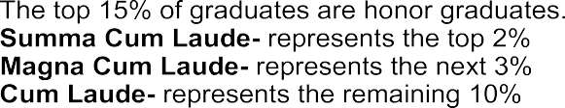





Pre-AP, AP, dual credit, and dual enrollment weighted points are not reflected on a student’s report card or transcript.

The weighted points are used for local ranking purposes only.

The Texas Education Code Section 25.092 provides that a student in any grade level from kindergarten through grade 12 may not be given credit or a final grade for a class unless the student is in attendance 90 percent of the days the class is offered. A student who is in attendance for at least 75 percent but less than 90 percent of the days a class is offered may be given credit or a final grade if the student completes a plan approved by the school’s principal that allows an Attendance Review Committee to give class credit or a final grade to a student whose attendance drops below the 75 percent because of extenuating circumstances. NOTE: The principal reviews all attendance cases between 75-90 percent, and the Attendance Review Committee considers cases below 75 percent.

Transcripts

In accordance with Texas Education Code (51.803) a student is eligible for automatic admission to a college or university as an undergraduate student if the applicant earned a grade point average in the top 10% of their graduating class. The University of Texas at Austin is no longer required to automatically admit applicants in excess of 75% of its enrollment capacity for first-time resident undergraduate students. Under the new foundation program with an endorsement, students must earn a distinguished level of achievement to be eligible for automatic college admission.



Transcript request forms are available at the registrar's office on campus. Official transcripts are signed and sealed.

Requests are handled in the order in which they are received. The normal processing time is 24-48 hours. Certain times of the year, however, will increase the processing time and should be taken into consideration. This includes the first month of the school year and the end of each grading cycle, as well as after graduation.

During the last month of the school year, graduation candidates should fill out a final transcript request form. Final transcripts need to be mailed directly to the college or university that the student is attending.

It is important that transcripts are requested in a timely manner in order for deadlines to be met. Students need to plan ahead so that they can be assured of receiving their transcripts when they need them.

The District shall include in the calculation of class rank grades earned in all high school credit courses taken in grades 9 - 12.

The calculation of class rank shall exclude grades earned in or by commercially provided PE; office aide; credit by exam; assigned remediation or tutoring course; course for which a pass/fail grade is assigned; summer school; and distance learning, unless the grade is earned in a course taken through the Texas Virtual School Network (TxVSN), Connections Learning, dual enrollment, or dual credit.

* See Victoria ISD Academic Achievement Class Ranking EIC (Local)

|  |  |  |  |
| --- | --- | --- | --- |
|  | **College Board Advanced Placement® (AP)** | **Dual Credit** | **UT OnRamps – Dual Enrollment** |
| **Description** | College-level coursework with the opportunity to earn college credit via the AP exam. | Students can earn college credit by taking Victoria College or University of Houston-Victoria college classes at their high school. | Using a hybrid delivery approach, students can earn UT Austin credit from a UT faculty member and high school credit from their high school teacher. |
| **College Credit** | A 3 or higher on an AP exam will award you college credit and any public college in Texas. | High school and college credit is awarded when the student passes the course. | Students who qualify for college credit choose at the end of the course whether or not to accept the credit. |
| **Instructor** | 1 person- taught by high school teachers trained by The College Board. | 1 person- taught by VC or UHV instructors or high school teachers who serve as adjunct professors. | 2 people- taught by a high school teacher and a UT professor. |
| **Transferability** | AP exam scores of 3-5 are accepted by most institutions, public and private. | Texas core curriculum courses transfer to all public, in-state colleges and universities. | Texas core curriculum courses transfer to all public, in-state colleges and universities. |
| **Eligibility** | Any high school student is eligible. | High school students who demonstrate college-readiness based on ACT, SAT, or TSI. | Any high school student is eligible. |
| **Cost** | No cost | Standard institution rate, however scholarships are available. | $149 or $99 (free/reduced lunch) per course. |
| **GPA** | Weighted | Weighted (high school course only) | Weighted (high school course only) |
| **Other Important Information** | College credit is based on a single test score.  AP coursework is one of the criteria colleges use for admissions consideration. | If a failing grade is earned, it is placed on college transcript impacting overall college GPA regardless of which institution the student chooses to attend. | If a failing grade is earned, the student can choose to not accept the college credit so it will never appear on a college transcript. |

# Advanced Placement, Dual Credit and Dual Enrollment – What’s the Difference?

# Administrative Approval

Administrative Approval

Seniors who meet the following criteria may be eligible for Administrative Approval, or the option to have up to two periods off in their schedule.

* Passed all STAAR End of Course (EOC) exams
* Earned the necessary credits to graduate on a Foundation Plan with an endorsement, and starting with class of 2024, must be a completer in a program of study*
* Must meet **one** of the following CCMR graduation expectations* :
  + Earn a qualifying score of 3 or higher on an AP exam
  + Meet TSI/SAT/ACT or College Prep English and Math criteria
  + Complete a dual credit course: either 3 or more credit hours in English or Math, OR 9 credit hours or more in any subject.
  + Earn an industry-based certification
  + Complete and pass both the high school and the college components of an OnRamps dual enrollment course

In addition, VISD will not provide transportation for late arrival or early release due to administrative approval.

Students will not be permitted to leave campus and return during the school day, so administrative approval will only be designated at the beginning or the end of the school day.

*\*as documented in the VISD Strategic Plan, Goals 3 and 4*

***What is Arts and Humanities?***

Regardless of whether it is history, literature, language or art, students who have an Arts and Humanities Endorsement will learn the best ways to figure out how to understand and relate to people. According to Georgetown Center on Education and the Workforce, being people-focused is the most high-demand, highly- compensated skill that students can possess.

Because the areas of study are broad, an Arts and Humanities Endorsement can prepare students for hundreds of different jobs. Careers in this area are varied, including audio recording, film and television technology, journalism, broadcasting, and telecommunications. Success in these fields is limited only by the talent and, more importantly, the drive of the students who have the flexibility to see the full range of directions their talents may lead them. Students have three options for completing Arts and Humanities Endorsement.

# Endorsement Matrices

|  |  |  |  |  |  |  |
| --- | --- | --- | --- | --- | --- | --- |
| Arts and Humanities Endorsement  Fine Arts | | | | | | |
| English | **Math** | **Science** | **Social Studies** | **Required** | **Electives** | **Total Credits** |
| English I  EOC | Algebra I  EOC | Biology I  EOC | World Geography | Foreign Language (2) |  |  |
| English II  EOC | Geometry | Chemistry |  | Physical Education (1) |  |
| English III | Additional Math  (Algebra II is recommended) | Additional Science | US History  EOC | Fine Arts (4)  In a coherent sequence from 1 or 2 disciplines |  |
| Additional  English | Additional Math | Additional Science | Government/ Economics |  |  |
| 4 credits | **4 credits** | **4 credits** | **3 credits** | **7 credits** | **4 credits** | **26 credits** |
| Distinguished Level of Achievement (DLA): Students completing the Arts and Humanities endorsement must take Algebra II as one of the four Math requirements in order to complete the DLA and be eligible for automatic admission/top 10%. | | | | | | |

**\*EOC** Indicates and **End of Course Exam** required for graduation.

|  |  |  |  |  |  |  |
| --- | --- | --- | --- | --- | --- | --- |
| Arts and Humanities Endorsement  Languages Other Than English (LOTE) | | | | | | |
| English | **Math** | **Science** | **Social Studies** | **Required** | **Electives** | **Total Credits** |
| English I  EOC | Algebra I  EOC | Biology I  EOC | World Geography | Foreign Language (4)  In one or two languages |  |  |
| English II  EOC | Geometry | Chemistry |  | Physical Education (1) |  |
| English III | Additional Math  (Algebra II is recommended) | Additional Science | US History  EOC | Fine Arts (1) |  |
| Additional  English | Additional Math | Additional Science | Government/ Economics |  |  |
| 4 credits | **4 credits** | **4 credits** | **3 credits** | **6 credits** | **5 credits** | **26 credits** |
| Distinguished Level of Achievement (DLA): Students completing the Arts and Humanities endorsement must take Algebra II as one of the four Math requirements in order to complete the DLA and be eligible for automatic admission/top 10%. | | | | | | |

**\*EOC** Indicates and **End of Course Exam** required for graduation.

What Fine Arts disciplines are offered?

Victoria ISD offers the following additional Fine Arts disciplines:

•

•

•

Visual Arts Choir Dance

•

•

•

Orchestra Ballet Folklorico Mariachi

•

•

•

Theater Band Guitar

* Some Fine Arts classes may be available as Dual Credit, AP, or Dual Enrollment. Check with your Fine Arts teacher or campus counselor to see what is available on your campus.

|  |  |  |  |  |  |  |
| --- | --- | --- | --- | --- | --- | --- |
| Arts and Humanities Endorsement  Social Studies | | | | | | |
| English | **Math** | **Science** | **Social Studies** | **Required** | **Electives** | **Total Credits** |
| English I  EOC | Algebra I  EOC | Biology I  EOC | World Geography | Foreign Language (2) |  |  |
| English II  EOC | Geometry | Chemistry | Additional Social Studies | Physical Education (1) |  |
| English III | Algebra II | Additional Science | US History  EOC | Fine Arts (1) |  |
| Additional  English | Additional Math  (Algebra II is recommended) | Additional Science | Government/ Economics |  |  |
| 4 credits | **4 credits** | **4 credits** | **3 credits** | **7 credits** | **4 credits** | **26 credits** |
| Distinguished Level of Achievement (DLA): Students completing the Arts and Humanities endorsement must take Algebra II as one of the four Math requirements in order to complete the DLA and be eligible for automatic admission/top 10%. | | | | | | |

**\*EOC** Indicates and **End of Course Exam** required for graduation.

What additional Social Studies courses are offered?

Victoria ISD offers the following additional Social Studies courses; however, not all courses may be offered on all campuses. Ask a social studies teacher or check with your campus counselor.

* + AP Human Geography
  + AP European History
  + AP Psychology
  + African American Studies
* Mexican American Studies
* Sociology
* Psychology
* Personal Financial Literacy

***What is Business and Industry?***

You can write your own ticket to success in the Business and Industry Endorsement! Business impacts everything in our world, and business is thriving in Texas. From small business owners to global corporate headquarters, there is a growing need for employees with strong financial, organizational, time-management, technical, and communication skills.

Because the Business and Industries Endorsement offers 11 different pathways for students, there is something here to interest almost everyone. An endorsement in Business and Industry offers students the opportunity to explore their interests. Students who want to plan, organize, direct, or evaluate a successful business should consider the Business and Industries Endorsement.

|  |  |  |  |  |  |  |
| --- | --- | --- | --- | --- | --- | --- |
| Business and Industry Endorsement | | | | | | |
| English | **Math** | **Science** | **Social Studies** | **Required** | **Electives** | **Total Credits** |
| English I  EOC | Algebra I  EOC | Biology I  EOC | World Geography | Foreign Language (2) |  |  |
| English II  EOC | Geometry | Chemistry | Additional Social Studies | Physical Education (1) |  |
| English III | Algebra II | Additional Science | US History  EOC | Fine Arts (1) |  |
| Additional  English | Additional Math | Additional Science | Government/ Economics | A coherent sequence of CTE courses for four or more credits chosen from one CTE-Business and Industry program of study |  |
| 4 credits | **4 credits** | **4 credits** | **3 credits** | **8 credits** | **3 credits** | **26 credits** |
| Distinguished Level of Achievement (DLA): Students completing the Business and Industry endorsement must take Algebra II as one of the four Math requirements in order to complete the DLA and be eligible for automatic admission/top 10%. | | | | | | |

**\*EOC** indicates an **End of Course exam** required for graduation

***What is Public Service?***

Students who desire to make a lasting contribution to society by serving their fellow man should consider the Public Service Endorsement. This endorsement offers some of the most in-demand careers in the areas of health Science, Education, Law, and Public Service.

VISD offers five different pathways for students interested in pursuing a Public Service Endorsement.

|  |  |  |  |  |  |  |
| --- | --- | --- | --- | --- | --- | --- |
| Public Service Endorsement | | | | | | |
| English | **Math** | **Science** | **Social Studies** | **Required** | **Electives** | **Total Credits** |
| English I  EOC | Algebra I  EOC | Biology I  EOC | World Geography | Foreign Language (2) |  |  |
| English II  EOC | Geometry | Chemistry | Additional Social Studies | Physical Education (1) |  |
| English III | Additional Math | Additional Science | US History  EOC | Fine Arts (1) |  |
| Additional  English | Additional Math | Additional Science | Government/ Economics | A coherent sequence of CTE courses for four or more credits chosen from:    * Education and Training  * Human Services  *Law, Public Safety, Corrections, Securities  * Health Science |  |
| 4 credits | **4 credits** | **4 credits** | **3 credits** | **8 credits** | **3 credits** | **26 credits** |
| Distinguished Level of Achievement (DLA): Students completing the Public Services endorsement must take Algebra II as one of the four Math requirements in order to complete the DLA and be eligible for automatic admission/top 10%. | | | | | | |

**\*EOC** indicates an **End of Course exam** required for graduation

***What is Science, Technology, Engineering & Math?***

Scientists, technologists, engineers, and mathematicians are men and women on the cutting edge. They investigate everything from supernovas to tiny subatomic particles. They invent the technologies that make our lives easier and healthier, and they find solutions for the problems that threaten our very existence.

If you are curious about the world around you, want to help the planet by finding solutions to our problems, or want to pursue a profession on the cutting edge of medicine or technology, then STEM may be the endorsement for you. Students have three options for completing a STEM endorsement.

|  |  |  |  |  |  |  |
| --- | --- | --- | --- | --- | --- | --- |
| Science, Technology, Engineering & Math Endorsement  Engineering | | | | | | |
| English | **Math** | **Science** | **Social Studies** | **Required** | **Electives** | **Total Credits** |
| English I  EOC | Algebra I  EOC | Biology I  EOC | World Geography | Foreign Language (2) |  |  |
| English II  EOC | Geometry | Chemistry | Additional Social Studies | Physical Education (1) |  |
| English III | Algebra II | Additional Science | US History  EOC | Fine Arts (1) |  |
| Additional  English | Additional Math  Recommended: Precalculus or Calculus | Additional Science | Government/ Economics | A coherent sequence of CTE courses for four or more credits chosen from STEM Programs of Study |  |
| 4 credits | **4 credits** | **4 credits** | **3 credits** | **8 credits** | **3 credits** | **26 credits** |
| Distinguished Level of Achievement (DLA): Students completing the STEM endorsement must take Algebra II as one of the four Math requirements in order to complete the DLA and be eligible for automatic admission/top 10%. | | | | | | |

**\*EOC** indicates an **End of Course exam** required for graduation

|  |  |  |  |  |  |  |
| --- | --- | --- | --- | --- | --- | --- |
| Science, Technology, Engineering & Math Endorsement  Math | | | | | | |
| English | **Math** | **Science** | **Social Studies** | **Required** | **Electives** | **Total Credits** |
| English I  EOC | Algebra I  EOC | Biology I  EOC | World Geography | Foreign Language (2) |  |  |
| English II  EOC | Geometry | Chemistry | Additional Social Studies | Physical Education (1) |  |
| English III | Algebra II | Additional Science | US History  EOC | Fine Arts (1) |  |
| Additional  English | Two additional Math courses for which Algebra II is a pre-requisite | Additional Science | Government/ Economics |  |  |
| 4 credits | **5 credits** | **4 credits** | **3 credits** | **4 credits** | **6 credits** | **26 credits** |
| Distinguished Level of Achievement (DLA): Students completing the STEM endorsement must take Algebra II as one of the four Math requirements in order to complete the DLA and be eligible for automatic admission/top 10%. | | | | | | |

**\*EOC** indicates an **End of Course exam** required for graduation

What are additional Math courses for which Algebra II is a prerequisite?

VISD offers the following advanced Math courses; however, not all courses may be offered on all campuses. Ask a math teacher or check with your campus counselor.

* + Pre-Calculus
  + AP Calculus AB
  + AP Statistics
* OnRamps Statistics
* Dual Credit Options
* AP Calculus BC

|  |  |  |  |  |  |  |
| --- | --- | --- | --- | --- | --- | --- |
| Science, Technology, Engineering & Math Endorsement  Science | | | | | | |
| English | **Math** | **Science** | **Social Studies** | **Required** | **Electives** | **Total Credits** |
| English I  EOC | Algebra I  EOC | Biology I  EOC | World Geography | Foreign Language (2) |  |  |
| English II  EOC | Geometry | Chemistry |  | Physical Education (1) |  |
| English III | Algebra II | Physics | US History  EOC | Fine Arts (1) |  |
| Additional  English | Additional Math | Two Additional Advanced Science courses | Government/ Economics |  |  |
| 4 credits | **4 credits** | **5 credits** | **3 credits** | **4 credits** | **6 credits** | **26 credits** |
| Distinguished Level of Achievement (DLA): Students completing the STEM endorsement must take Algebra II as one of the four Math requirements in order to complete the DLA and be eligible for automatic admission/top 10%. | | | | | | |

**\*EOC** indicates an **End of Course exam** required for graduation

What are additional Science courses?

VISD offers the following advanced science courses; however, not all courses may be

offered on all campuses. Ask a Science teacher or check with your campus counselor.

•

•

•

•

•

•

•

Advanced Animal Science Aquatic Science

Forensic Science Environmental Science Rocketry

Engineering Design and Problem Solving Dual Credit Options

•

•

•

•

•

AP Biology AP Chemistry AP Physics

AP Environmental Science Anatomy and Physiology

***What is Multi-Disciplinary?***

Students who choose a Multi-Disciplinary Endorsement will build a broad-based education. This endorsement is not geared toward any particular career, but will allow students to design their own program and explore more than one area of interest.

|  |  |  |  |  |  |  |
| --- | --- | --- | --- | --- | --- | --- |
| Multi-Disciplinary Endorsement | | | | | | |
| English | **Math** | **Science** | **Social Studies** | **Required** | **Electives** | **Total Credits** |
| English I  EOC | Algebra I  EOC | Biology I  EOC | World Geography | Foreign Language (2) |  |  |
| English II  EOC | Geometry | Chemistry or Physics | World History | Physical Education (1) |  |
| English III | Additional Math | Additional Science | US History  EOC | Fine Arts (1) |  |
| English IV | Additional Math | Additional Science | Government/ Economics |  |  |
| 4 credits | **4 credits** | **4 credits** | **4 credits** | **4 credits** | **6 credits** | **26 credits** |
| Distinguished Level of Achievement (DLA): Students completing the Multi-Disciplinary endorsement must take Algebra II as one of the four Math requirements in order to complete the DLA and be eligible for automatic admission/top 10%. | | | | | | |

**\*EOC** indicates an **End of Course exam** required for graduation

**What are additional English courses?**

VISD offers the following additional English courses; however, not all courses are offered on all campuses. Ask your English teacher or check with your campus counselor.

* English IV
* College Prep English
* AP English Literature and Composition
* Dual Credit Options
* OnRamps Rhetoric



CTE Programs of Study

|  |  |
| --- | --- |
| **Clusters** | **Programs of Study** |
| Agriculture, Food, and Natural Resources | Agricultural Veterinary Medicine, pp. 44 Animal Science, pp. 46  Applied Agricultural Engineering, pp. 48 Plant Science, pp.62 |
| Architecture and Construction | Carpentry, pp. 52  Electrical, pp. 56  Plumbing, pp. 64 |
| Arts, Audio Visual Technology, and Communications | Design and Multimedia Arts, pp. 58 |
| Business Marketing and Finance | Accounting and Financial Services, pp. 40 |
| Education and Training | Teaching and Training, pp. 74 |
| Energy | Refining and Chemical Processes, pp. 70 |
| Health Science | Healthcare Therapeutics, pp 60 |
| Human Services | Cosmetology, pp. 54 |
| Information Technology | Programming and Software Development, pp. 68 |
| Law and Public Service | Law Enforcement, pp.60 |
| Manufacturing | Welding, pp. 76  Advanced Manufacturing & Machinery Mechanics, pp 42 |
| Science, Technology, Engineering, and Mathematics | Engineering, pp. 72 |
| Transportation, Distribution, and Logistics | Automotive, pp. 50 |

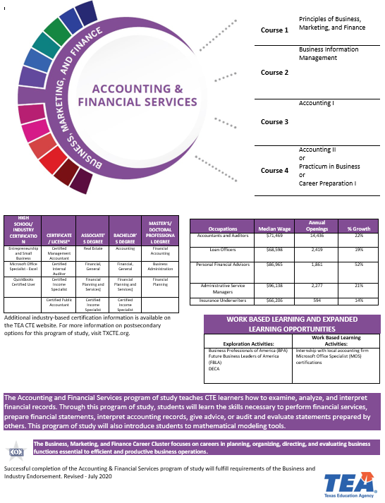

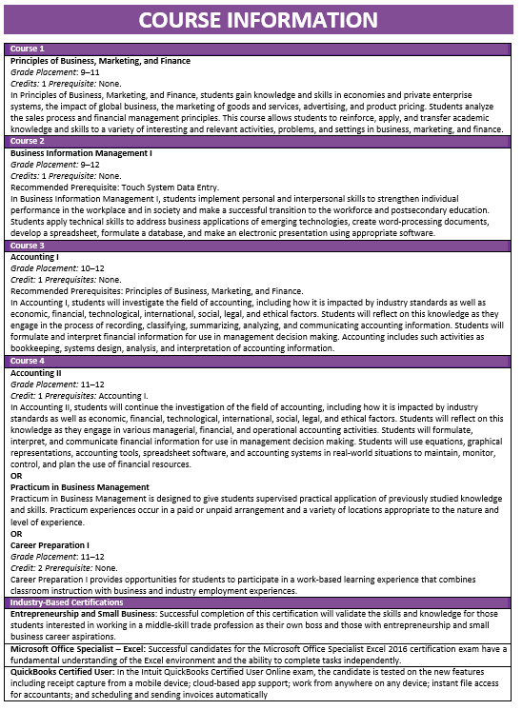

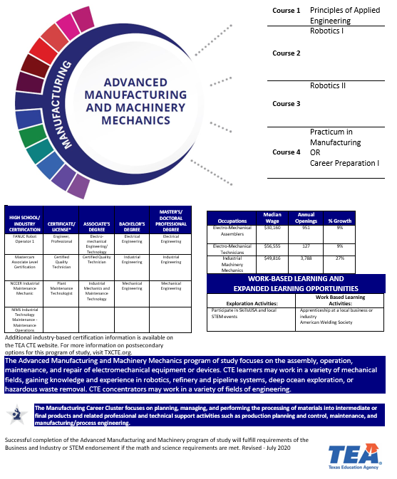

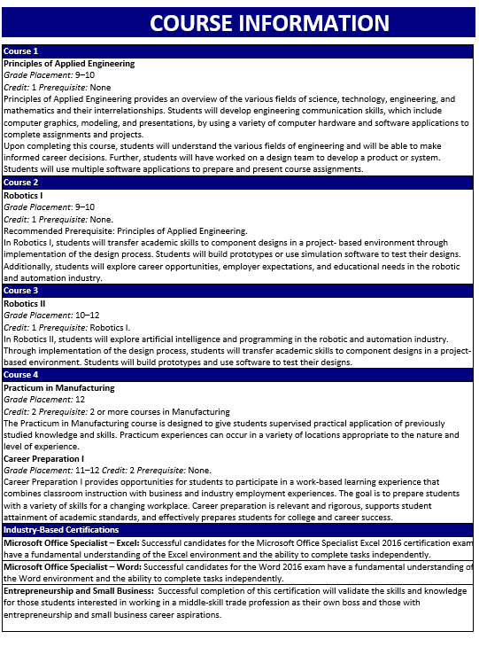

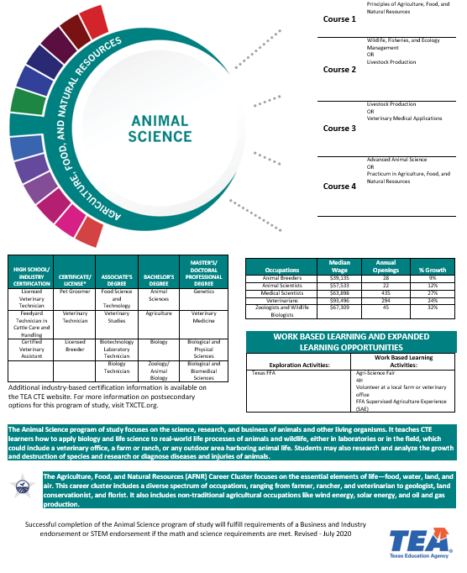

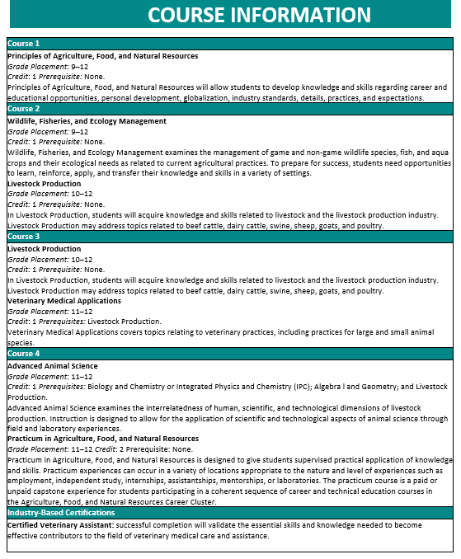

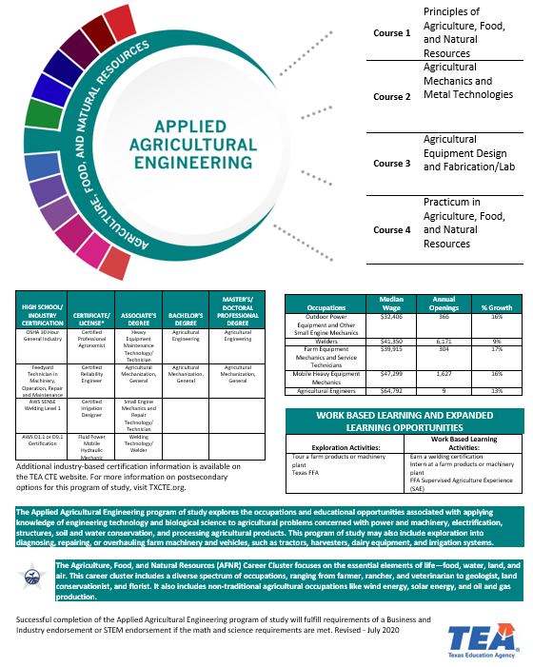

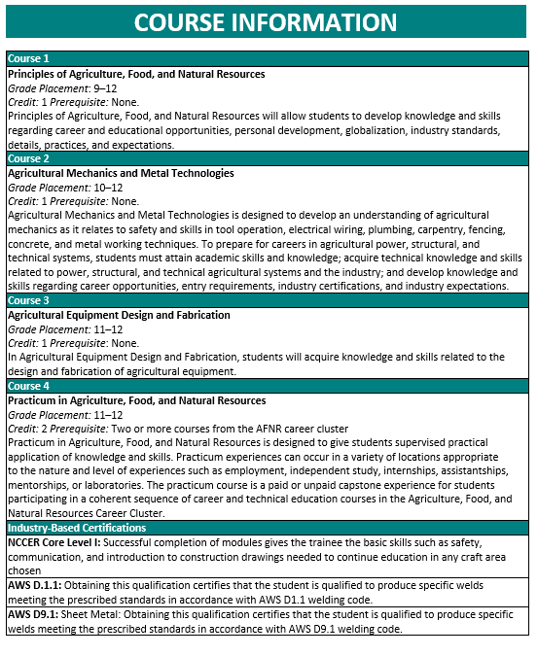

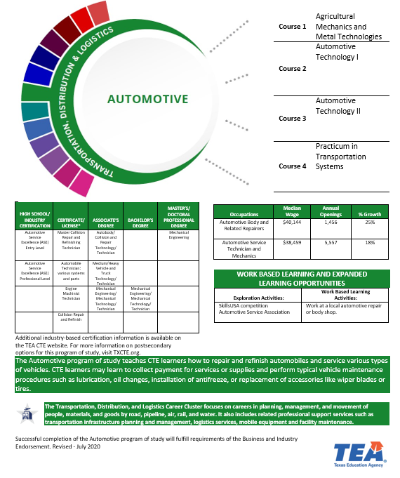

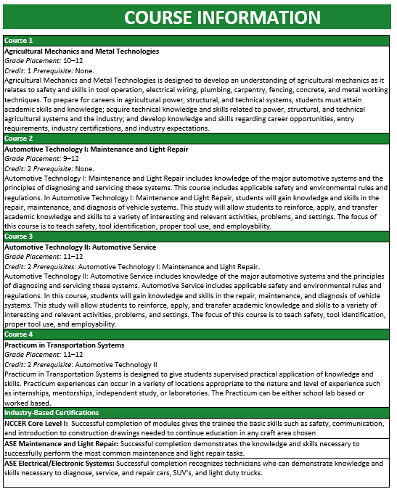

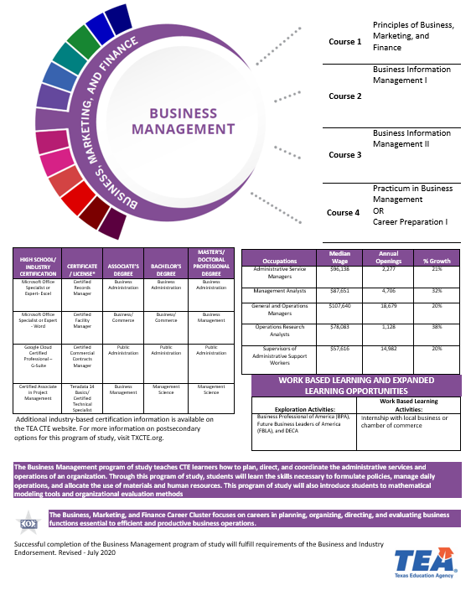

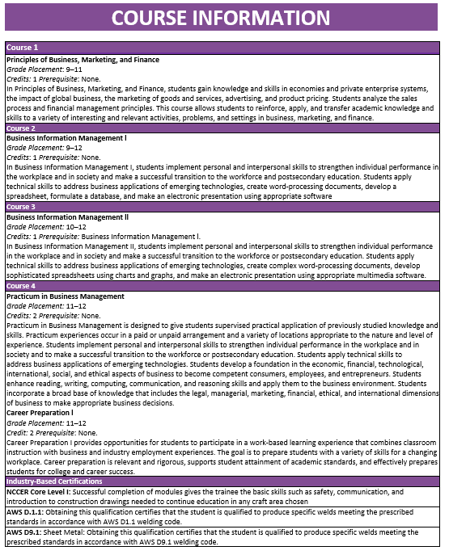

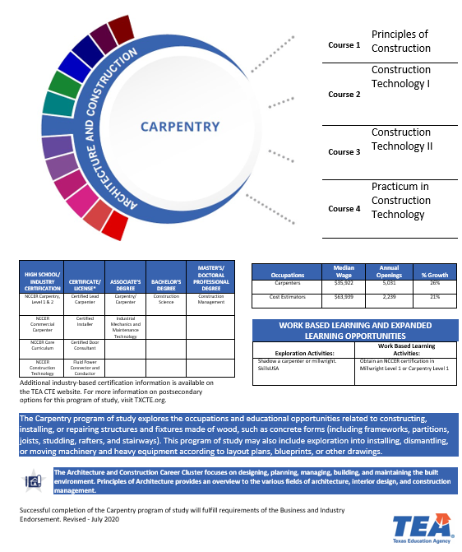

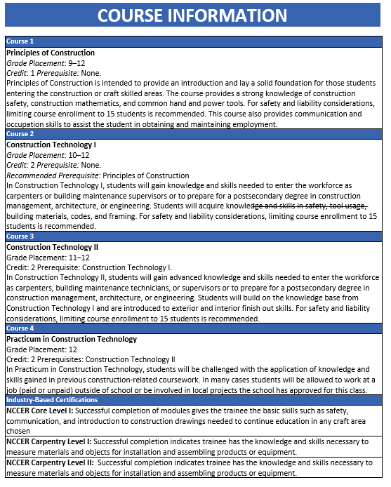

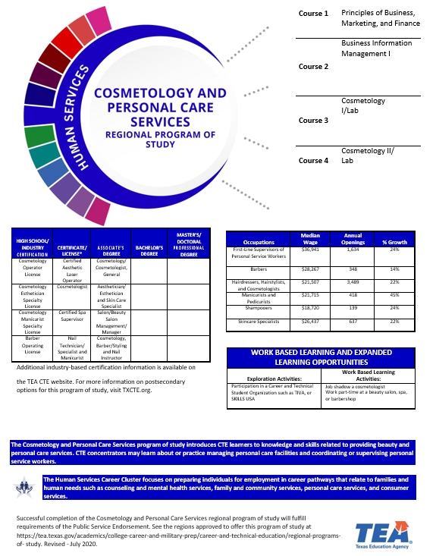

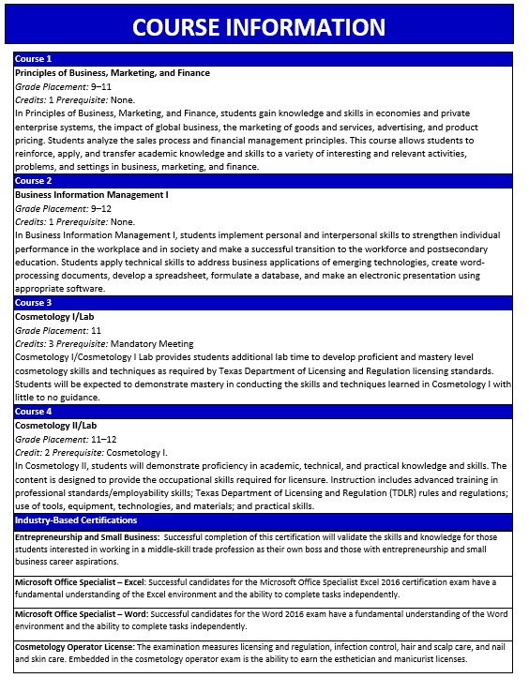

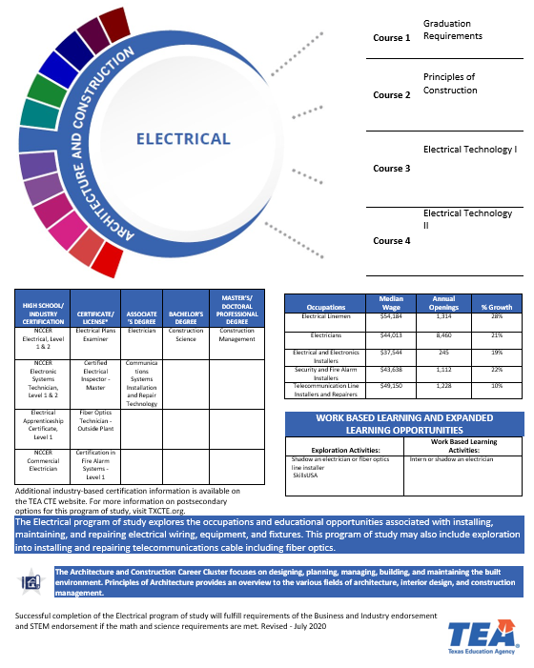

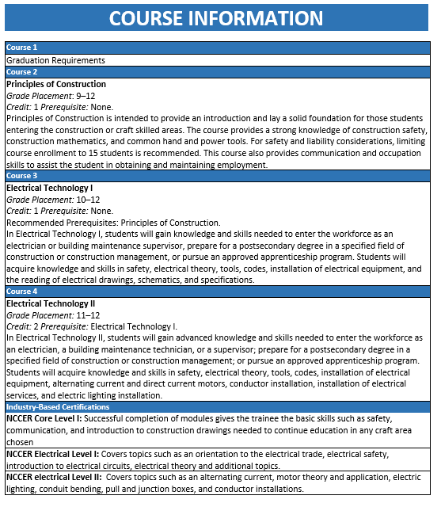

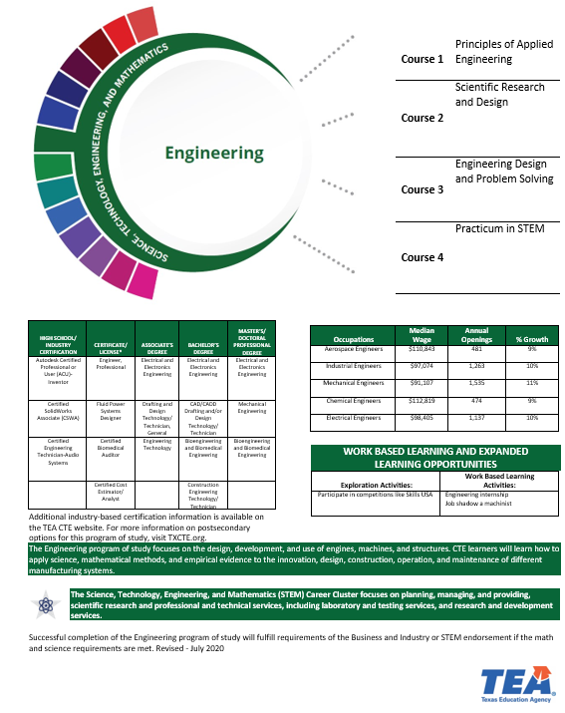

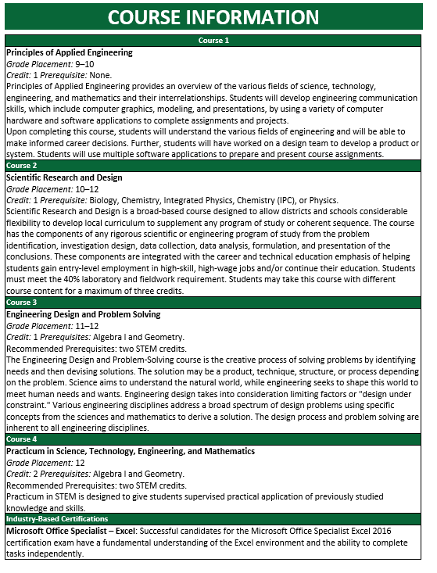

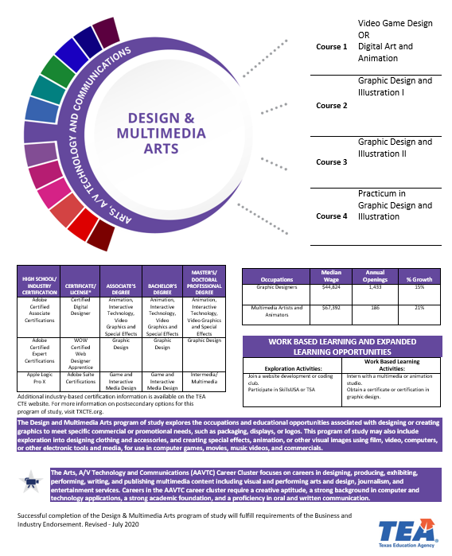

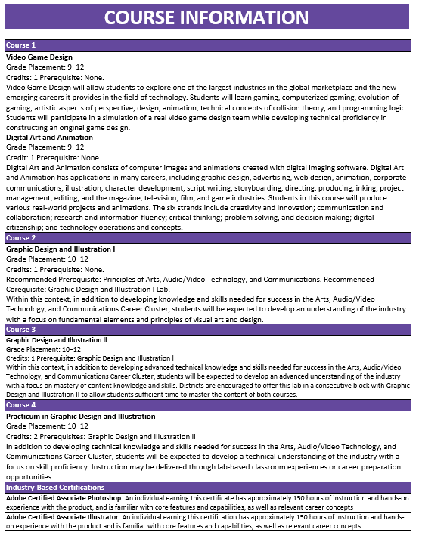

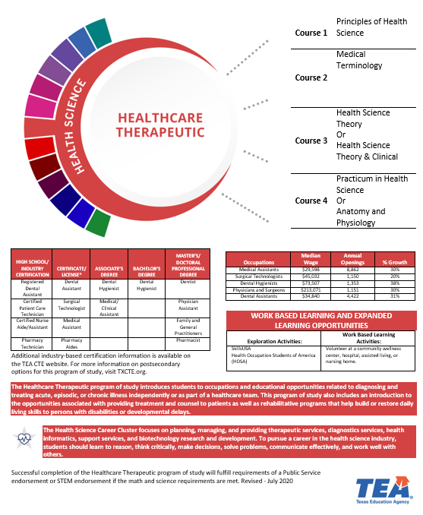

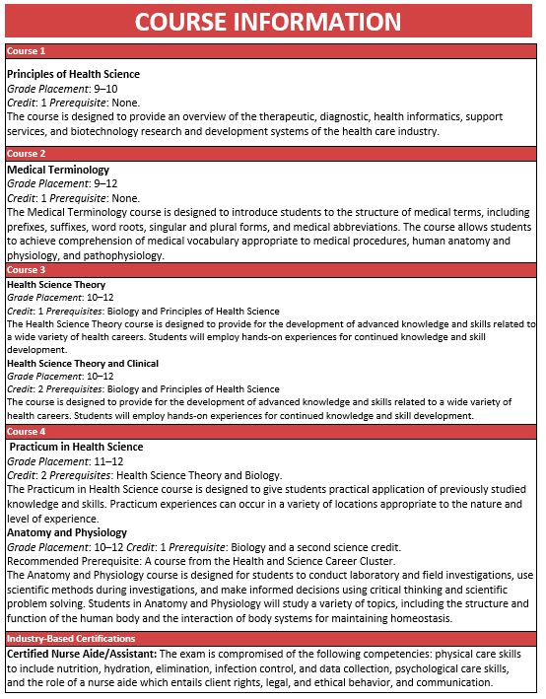

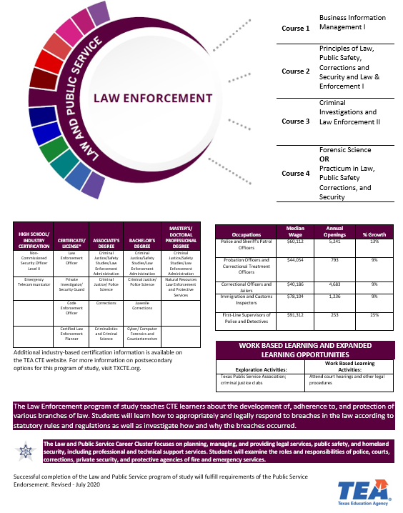

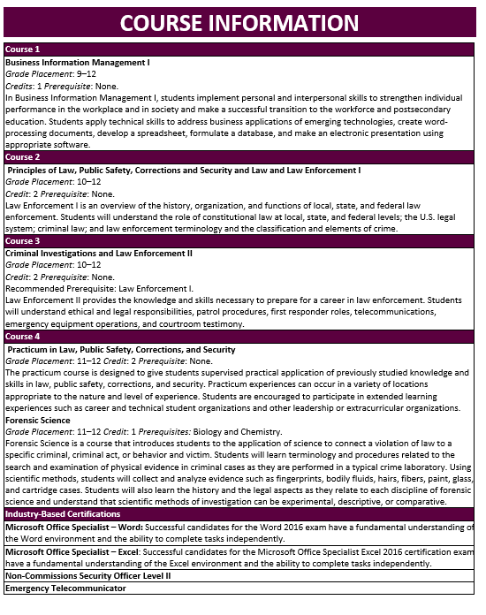

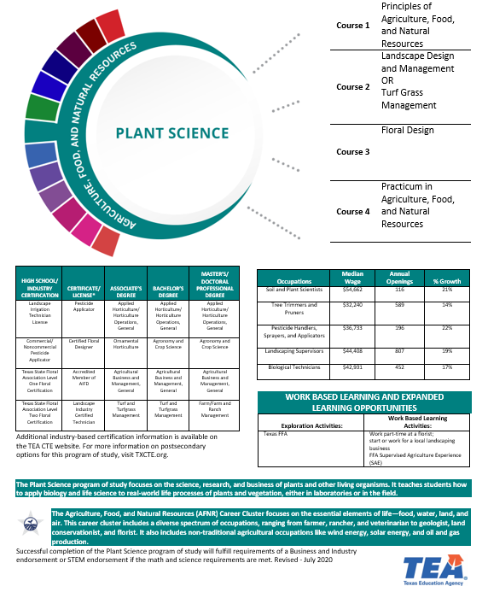

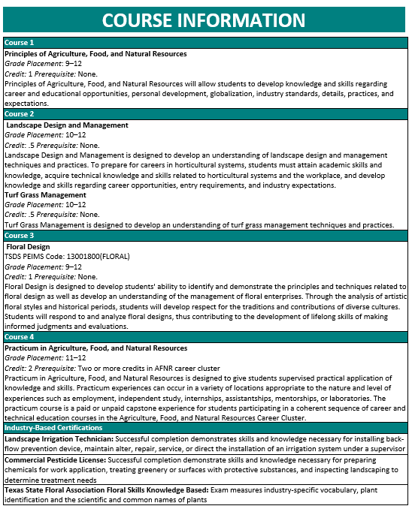

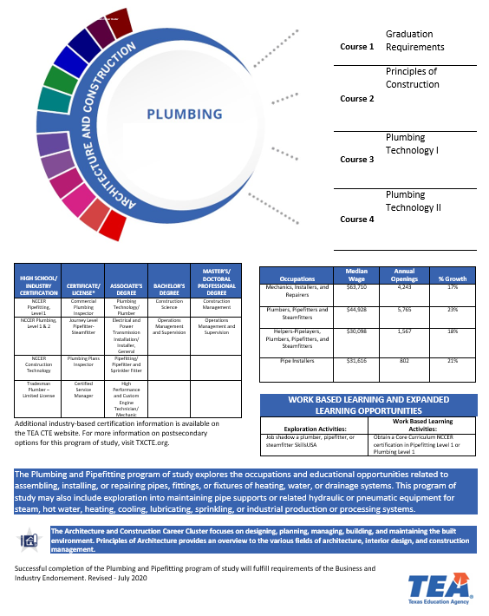

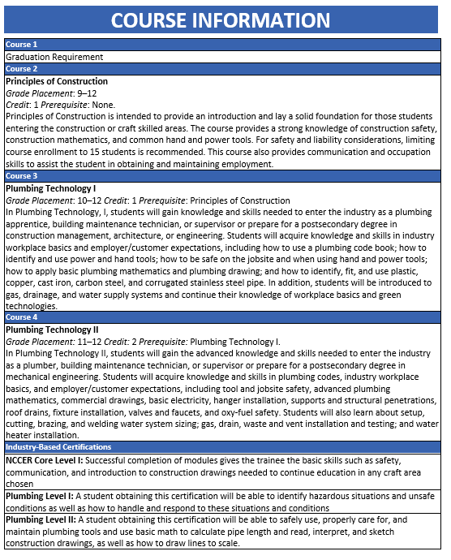

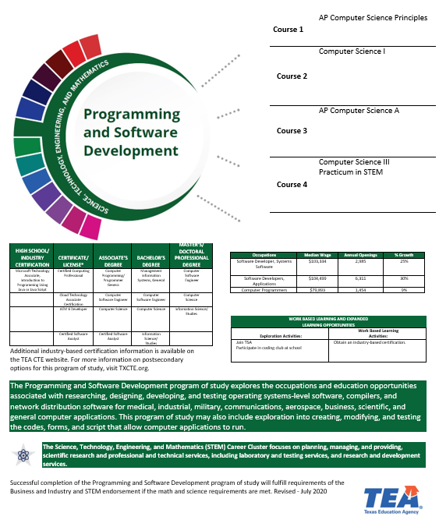

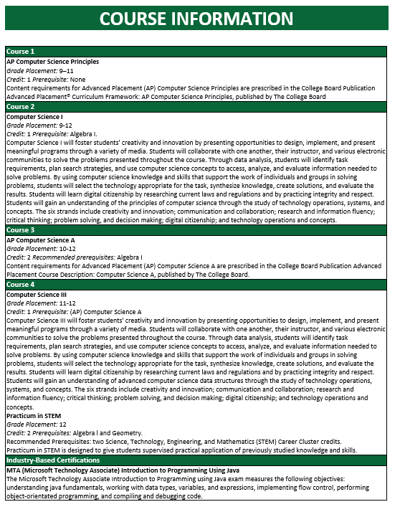

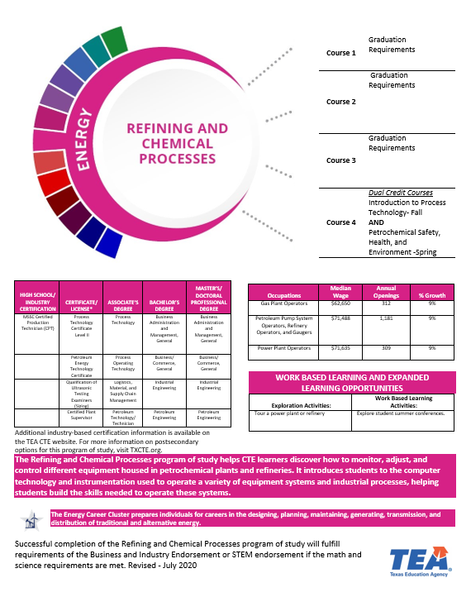

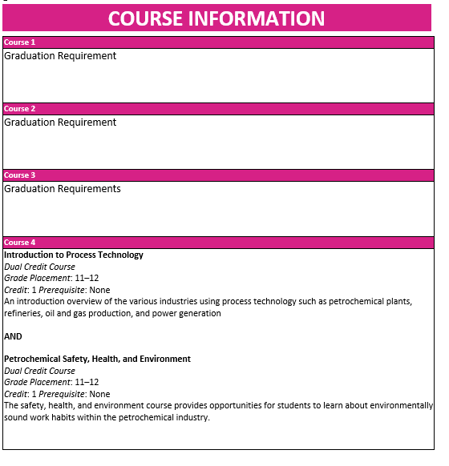

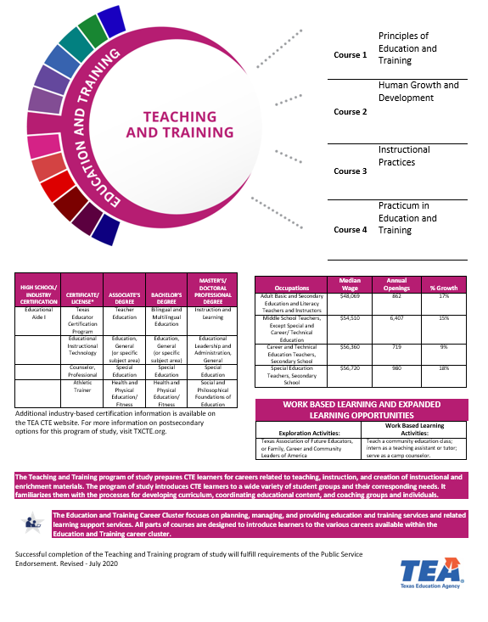

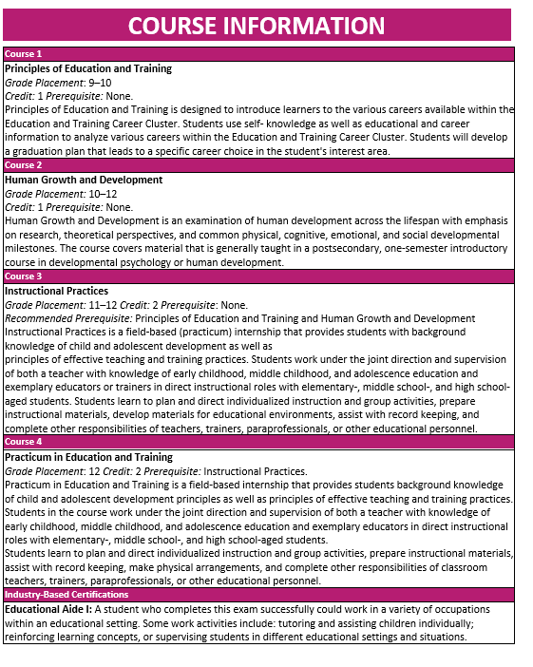

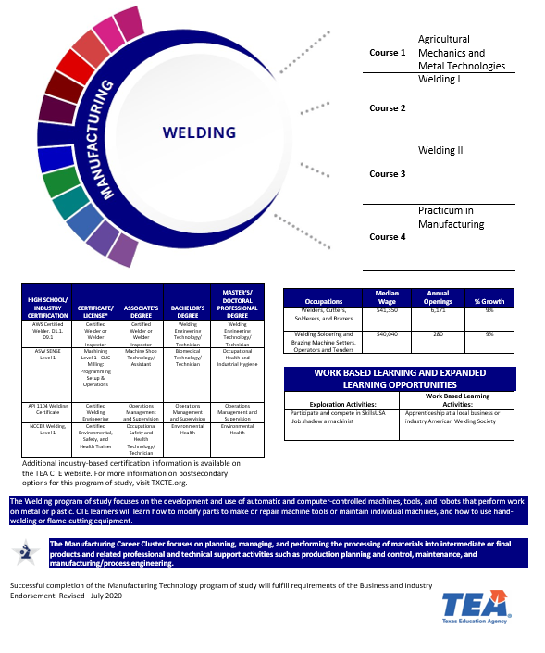

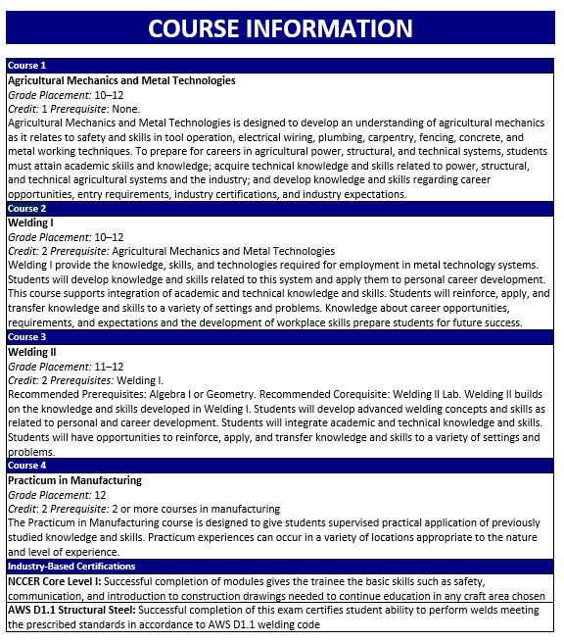

# P-TECH

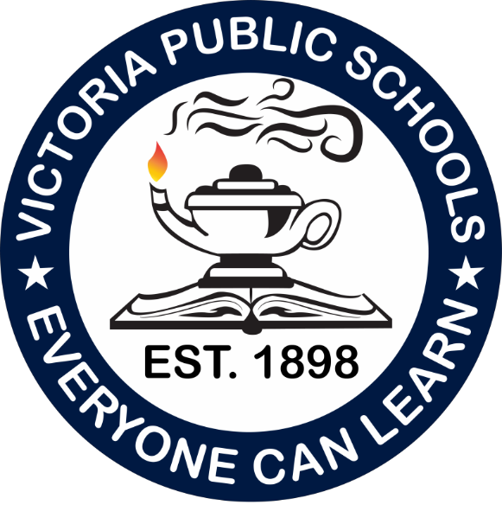

High School

# Course Descriptions



## Dual Credit

**ACCT 2301 PRINCIPLES OF FINANCIAL ACCOUNTING**

*Prerequisite: Meet Texas Success Initiative complete college-readiness standard for Mathematics; or equivalent Recommended corequisite: MATH 1324 Mathematics for Business & Social Science*

This course is an introduction to the fundamental concepts of financial accounting as prescribed by U.S. generally accepted accounting principles (GAAP) as applied to transactions and events that affect business organizations.

Students will examine the procedures and systems to

accumulate, analyze, measure, and record financial transactions. Students will use recorded financial information to prepare a balance sheet, income statement, statement of cash flows, and statement of shareholders’ equity to communicate the business entity’s results of operations and financial position to users of financial information who are external to the company. Students

will study the nature of assets, liabilities, and owners’ equity while learning to use reported financial information for purposes of making decisions about the company. Students will be exposed to International Financial Reporting Standards (IFRS).

ACCT 2302 PRINCIPLES OF MANAGERIAL ACCOUNTING

*Prerequisite: A grade of C or better in ACCT 2301*

This course is an introduction to the fundamental concepts of managerial accounting appropriate for all organizations. Students will study information from the entity’s accounting system relevant to decisions made by internal managers, as distinguished from information relevant to users who are

external to the company. The emphasis is on the identification and assignment of product costs, operational budgeting and planning, cost control, and management decision making. Topics include product costing methodologies, cost behavior, operational and capital budgeting, and performance evaluation.

ARTS 1301 ART APPRECIATION

*Prerequisite: Texas Success Initiative complete in Writing and Reading*

A general introduction to the visual arts designed to create an appreciation of the vocabulary, media, techniques, and purposes of the creative process. Students will critically interpret and evaluate works of art within formal, cultural, and historical contexts.

ARTS 1303 HISTORY OF ART I

*Prerequisite: Texas Success Initiative Complete in Writing and Reading*

Survey of world art from prehistoric times to the Renaissance.

ARTS 1304 HISTORY OF ART II

*Prerequisite: Texas Success Initiative Complete in Writing and Reading*

Survey of world art from the Renaissance through the 20th century.

BCIS 1305 BUSINESS COMPUTER APPLICATIONS

**(For Business Majors)**

Prerequisites: Texas Success Initiative complete or consent of instructor

Students will study computer terminology, hardware, and software related to the business environment. The focus of this course is on business productivity software applications and professional behavior in computing, including word processing, spreadsheets, databases, presentation graphics, and business-oriented use of the internet. NOTE: No Credit if COSC 1301 is taken.

BIOL 1406 GENERAL BIOLOGY FOR SCIENCE MAJORS I

*Prerequisite: Texas Success Initiative Complete in Reading, Writing, and Math*

General biology for science majors and pre-professionals in health sciences. Presentation of basic concepts in biology including chemical basis of life, cytology, metabolism, and genetics. Laboratory exercises complement and reinforce lecture material.

BIOL 1407 GENERAL BIOLOGY II FOR SCIENCE MAJORS

*Prerequisite: Texas Success Initiative Complete in Reading, Writing, and Math Recommended: BIOL 1406*

General biology for science majors and pre-professionals in health sciences. Presentation of basic concepts in biology including evolution; biodiversity; structure and function of plants, animals, and other organisms; and ecology. Laboratory exercises complement and reinforce lecture material.

BIOL 1408 GENERAL BIOLOGY I FOR NON-MAJORS

*Prerequisite: Texas Success Initiative complete in Reading, Writing and Math*

Fundamentals and principles of living organisms including properties of life, organization, functional evolutionary adaptation, classification, and ecology. Emphasis includes cells and tissues, plant studies, and use of speciation keys. Laboratory is required.

BIOL 1409 GENERAL BIOLOGY II FOR NON-MAJORS

*Prerequisite: Texas Success Initiative complete in Reading, Writing and Math*

Fundamentals and principles of living organisms including properties of life, organization, functional evolutionary adaptation, classification. Emphasis is placed on overviews of animal structure, and functional adaptation and genetics. Laboratory is required.

BIOL 2401 HUMAN ANATOMY AND PHYSIOLOGY I

*Prerequisite: A grade of “C” or better in one semester of college-level biology or chemistry, CHEM 1406 is recommended, plus Texas Success Initiative*

*complete in Reading and Writing*

*Recommended: One semester of college-level biology*

Structure and function study of the following: introduction of the human body, cells, tissues, integumentary system, skeletal system, muscle, and nervous system. Laboratory is coordinated with the lecture and includes the use of the microscope, fresh and preserved specimens, along with anatomical charts and models. Various electronic instruments are used to measure and record physiological data.

**BIOL 2402 HUMAN ANATOMY AND PHYSIOLOGY II**

*Prerequisite: BIOL 2401 with a grade of “C” or better*

Anatomy and Physiology II is the second part of a two-course sequence. It is a study of the structure and function of the human body including the following systems: endocrine, cardiovascular, immune, lymphatic, respiratory, digestive (including nutrition), urinary (including fluid and electrolyte balance), and reproductive (including human development and genetics). Emphasis is on interrelationships among systems and regulation of physiological functions involved in maintaining homeostasis. The lab provides a hands-on learning experience for exploration of human system components and basic physiology. Systems to be studied include endocrine, cardiovascular, immune, lymphatic, respiratory, digestive (including nutrition), urinary (including fluid and electrolyte balance), and reproductive (including human development and genetics).

**BIOL 2420 MICROBIOLOGY FOR NON-MAJORS**

*Prerequisite: Texas Success Initiative complete in Reading, Writing and Math.*

This course covers basic microbiology and immunology and is primarily directed at pre-nursing, pre-allied health, and non-science majors. It provides an introduction to historical concepts of the nature of microorganisms, microbial diversity, the importance of microorganisms and acellular agents in the biosphere, and their roles in human and animal diseases. Major topics include bacterial structure as well as growth, physiology, genetics, and biochemistry of microorganisms. Emphasis is on medical microbiology, infectious diseases, and public health.

**BUSI 2301 BUSINESS LAW**

*Prerequisite: High school coursework in U.S. history and government, or equivalent. Texas Success Initiative complete in Reading.* (Offered only in fall semester)

The course provides the student with foundational information about the U.S. legal system and dispute resolution, and their impact on business. The major content areas will include general principles of law, the relationship of business and the U.S. Constitution, state and federal legal systems, the relationship between law and ethics, contracts, sales, torts, agency law, intellectual property, and business law in the global context.

CHEM 1406 INTRODUCTORY CHEMISTRY FOR NON-SCIENCE MAJORS

*Prerequisite: Texas Success Initiative complete in Reading and Math*

A course in general, organic, and biological chemistry for non-science and allied health majors. Topics covered will include structure of the atom, stoichiometry, solutions, gas laws, equilibrium, acids, bases, salts and buffers, organic structures and nomenclature, functional groups, lipids, carbohydrates, proteins, and nucleic acids. Related laboratory exercises are performed during the semester.

CHEM 1411 GENERAL COLLEGE CHEMISTRY I FOR SCIENCE MAJORS

*Prerequisite: A grade of “C” or better in MATH 1314 or more advanced college mathematics course plus Texas Success Initiative Complete in Reading*

A course in general chemistry for science majors, pre-medical, pre-dental, engineering, and other students who plan to take subsequent courses in chemistry. The course emphasizes atomic and molecular structure, bonding, stoichiometry, properties of gases, chemical reactions, thermochemistry, the periodic table, liquids and solids, and solutions. Related laboratory exercises are performed during the semester.

CHEM 1412 GENERAL COLLEGE CHEMISTRY II FOR SCIENCE MAJORS

*Prerequisite: A grade of C or better in CHEM 1411*

A continuation of Chemistry 1411. The course emphasizes equilibrium, kinetics, acid-base concepts, thermodynamics, electrochemistry, descriptive chemistry of common elements and compounds, and a brief introduction to organic compounds. Related laboratory exercises are performed during the semester.

CETT 1325 DIGITAL FUNDAMENTALS

*(2nd semester)*

Digital Fundamentals is a course that will start to prepare high school students for the field of Instrumentation and Electronics. An entry level course in digital electronics covering number systems, including binary base 10, octal and hexadecimal, binary mathematics, digital codes, logic gates, Boolean algebra, and combinational logic.

CETT 1302 ELECTRICITY PRINCIPLES

*(1st semester)*

Electricity Principles is a course that will start to prepare high school students for the field of Instrumentation and Electronics. Electricity Principles will include the study of the fundamentals of alternating current/direct current (AC/DC) including Ohm’s law, Kirchoff’s laws, and circuit analysis techniques.

COMM 1335 INTRO TO RADIO AND TELEVISION

*Prerequisite: Texas Success Initiative Complete in Reading and Writing*

Survey course focusing on historical, technical, and governmental aspects of the broadcast industry. Topics such as

programming, sales, rating, and public broadcasting will be introduced.

COSC 1301 INTRODUCTION TO COMPUTING

*Prerequisites: Texas Success Initiative complete or consent of instructor.*

Overview of computer systems-hardware, operating systems, and microcomputer applications software, including the Internet, word processing, spreadsheets, presentations graphics, and databases. Current issues such as the effect of computers on society, and the history and use of computers in business, educational, and other modern settings are also studied. This course is not intended to count toward a student’s major field of study in business or computer science. No credit if BCIS 1305 has been taken.

COSC 1315 FUNDAMENTALS OF PROGRAMMING

*Prerequisite: Texas Success Initiative complete in Reading and Math or consent of instructor.*

(*Offered only in fall semester)*

Introduction to computer programming. Emphasis on the fundamentals of structured design, development, testing, implementation, and documentation. Includes coverage of language syntax, data and file structure, input/output

devices, and disks/files.

CRIJ 1301 INTRO TO CRIMINAL JUSTICE

*Prerequisite: Texas Success Initiative Complete in Reading and Writing*

History and philosophy of criminal justice, ethical considerations, definition of crime, its nature and impact, overview

of criminal justice system, law enforcement, court systems and corrections.

**CRIJ 1306 COURT SYSTEMS AND PRACTICES**

*Prerequisite: A grade of C or better in CRIJ 1301 or CRIJ 1307*

(Offered only in spring semester)

This course is a study of the court system as it applies to the structures, procedures, practices and sources of law in American courts, using federal and Texas statutes and case law.

**CRIJ 2313 CORRECTIONAL SYSTEMS AND PRACTICES**

*Prerequisite: Texas Success Initiative complete in Reading and Writing.*

*(Offered only in spring semester)*

This course is a survey of institutional and non-institutional corrections. Emphasis will be placed on the organization and operation of correctional systems; treatment and rehabilitation; populations served; Constitutional issues; and current and future issues.

CUIN 1310 THE ART OF TEACHING (UHV)

Provide insight into the teaching profession through field-based observations of P-12 classrooms with diverse populations in order to analyze schools and classrooms.

**CUIN 1313 THE WELL CHILD (UHV)**

A study of factors that impact the well-being of the children including healthy behavior, food, nutrition, fitness, and safety practices. There is a focus on local and national standards, as well as legal implications of relevant policies and regulations. Field Experience with children, infancy through age 12, is required.

DRAMA 1310 INTRODUCTION TO THEATRE

*Prerequisite: Texas Success Initiative Complete in Reading*

Introduction to the fundamentals of acting, technical production, design, directing, and theatre management. This course is designed to give students a better appreciation and understanding of dramatic art. Includes the opportunity to work with departmental productions. Student participation & presentations may be videotaped for educational purposes.

EMSP 1160 CLINICAL, EMERGENCY MEDICAL TECHNOLOGY/TECHNICIAN

*Credit: 1*

*Prerequisite: Admission into the EMT Program Corequisites: EMSP 1501*

A health-related, work-based learning experience that enables the student to apply specialized occupational theory,

skills, and concepts. Direct supervision is provided by the clinical professional.

EMSP 1501 CLINICAL, EMERGENCY MEDICAL TECHNOLOGY/TECHNICIAN (EMT PARAMEDIC)

*Credit: 2*

*Prerequisite: Admission into the Advanced EMT (AEMT)/Paramedic Program Corequisites: EMSP 1355, 1356, & 1438*

*(Offered only in summer session)*

A health-related, work-based learning experience that enables the student to apply specialized occupational theory, skills, and concepts. Direct supervision is provided by the clinical professional. At the completion of this course, the student will be able to perform a comprehensive history and physical exam, develop differential diagnoses, establish and/ or maintain a patent airway, oxygenate, and ventilate a patient, implement and evaluate a trauma care plan; perform venipuncture for phlebotomy and IV fluid infusion; safely prepare and administer medications, and communicate & document all

pertinent information.

ECON 2301 PRINCIPLES OF MACROECONOMICS

*Prerequisite: Texas Success Initiative Complete in Reading and Math*

An analysis of the economy as a whole, including measurement and determination of Aggregate Demand and Aggregate Supply, national income, inflation, and unemployment. Other topics include international trade, economic growth, business cycles, and fiscal policy and monetary policy.

EDUC 1300 LEARNING FRAMEWORKS

A study of the research and theory in the psychology of learning, cognition, and motivation; factors that impact learning; and application of learning strategies. Theoretical models of strategic learning, cognition, and motivation serve as the conceptual basis for the introduction of college-level student academic strategies. Students use assessment instruments (e.g., learning inventories) to help them identify their own strengths and weaknesses as strategic learners. Students are ultimately expected to integrate and apply the learning skills discussed across their own academic programs and become effective and efficient learners. Students developing these skills should be able to continually draw from the theoretical models they have learned. EDUC 1300 is equivalent to PSYC 1300; credit will not be given for both EDUC 1300 and PSYC 1300. EDUC 1300 may substitute for SDEV 0301.

ENGL 1301 COMPOSITION I

*Prerequisite: Texas Success Initiative Complete in Reading and Writing*

Intensive study of and practice in writing processes, from invention and researching to drafting, revising, and editing, both individually and collaboratively. Emphasis on effective rhetorical choices, including audience, purpose, arrangement, and style. Focus on writing the academic essay as a vehicle for learning, communicating, and critical analysis.

ENGL 1302 COMPOSITION II

*Prerequisite: A grade of C or better in ENGL 1301*

Intensive study of and practice in the strategies and techniques for developing research-based expository and persuasive texts. Emphasis on effective and ethical rhetorical inquiry, including primary and secondary research methods; critical reading of verbal, visual, and multimedia texts; systematic evaluation, synthesis, and documentation of information sources; and critical thinking about evidence and conclusions.

ENGL 2311 TECHNICAL AND BUSINESS WRITING

Intensive study of and practice in professional settings. Focus on the types of documents necessary to make decisions and take action on the job, such as proposals, reports, instructions, policies and procedures, e-mail messages, letters, and descriptions of products and services. Practice individual and collaborative processes involved in the creation of ethical and efficient documents. Best suited for students interested in technical, mechanical and STEM industries.

ENGL 2327 AMERICAN LITERATURE I

*Prerequisite: A grade of C or better in ENGL 1301*

A survey of American literature from the period of exploration and settlement through the Civil War. Students will study works of prose, poetry, drama, and fiction in relation to their historical and cultural contexts. Texts will be selected from among a diverse group of authors for what they reflect and reveal about the evolving American experience and character.

**ENGL 2328 AMERICAN LITERATURE II**

*Prerequisite:* *A grade of C or better in ENGL 1301*

A survey of American literature from the Civil War to the present. Students will study works of prose, poetry, drama, and fiction in relation to their historical and cultural contexts. Texts will be selected from among a diverse group of authors for what they reflect and reveal about the evolving American experience and character.

ENGL 2322 BRITISH LITERATURE I

*Prerequisite: A grade of C or better in ENGL 1301*

A survey of the development of British literature from the Anglo-Saxon period to the eighteenth century. Students will study works of prose, poetry, drama, and fiction in relation to their historical, linguistic, and cultural contexts. Texts will be selected from a diverse group of authors and traditions.

ENVR 1301 ENVIRONMENTAL SCIENCE I

*Prerequisite: Texas Success Initiative complete in Reading*

A survey of the forces, including humans, that shape our physical and biologic environment, and how they affect life on Earth. Introduction to the science and policy of global and regional environmental issues, including pollution, climate change, and sustainability of land, water, and energy resources.

GEOG 1303 WORLD REGIONAL GEOGRAPHY

*Prerequisite: Texas Success Initiative complete in Reading and Writing*

This course is an introduction to the world’s major regions seen through their defining physical, social, cultural, political, and economic features. These regions are examined in terms of their physical and human characteristics and their interactions. The course emphasizes relations among regions on issues such as trade, economic development, conflict, and the role of regions in the globalization process.

**GEOL 1403 PHYSICAL GEOLOGY**

*Prerequisite: Texas Success Initiative complete in Reading.*

Lecture: Introduction to the study of the materials and processes that have modified and shaped the surface and interior of Earth over time. These processes are described by theories based on experimental data and geologic data gathered from field observations. Lab: Laboratory activities will cover methods used to collect and analyze earth science data.

**GEOL 1404 HISTORICAL GEOLOGY**

*Prerequisite: GEOL 1303 or 1403 Physical Geology, and Texas Success Initiative complete in Reading.*

Lecture: A comprehensive survey of the history of life and major events in the physical development of Earth as interpreted from rocks and fossils. Lab: Laboratory activities will introduce methods used by scientists to interpret the history of life and major events in the physical development of Earth from rocks and fossils.

GOVT 2305 FEDERAL GOVERNMENT

**(Federal Constitution & Topics)**

*Prerequisite: Texas Success Initiative Complete in Reading and Writing*

Origin and development of the U.S. Constitution, structure and powers of the national government including the legislative, executive, and judicial branches, federalism, political participation, the national election process, public policy, civil liberties, and civil rights.

GOVT 2306 TEXAS GOVERNMENT

**(Texas Constitution & Topics)**

*Prerequisite: Texas Success Initiative Complete in Reading and Writing*

Origin and development of the Texas constitution, structure and powers of state and local government, federalism and inter-governmental relations, political participation, the election process, public policy, and the political culture of Texas.

**HIST 1301 UNITED STATED HISTORY I**

*Prerequisite: Texas Success Initiative Complete in Reading and Writing*

A survey of the social, political, economic, cultural, and intellectual history of the United States from the pre-Columbian era to the Civil War/Reconstruction period. United States History I includes the study of pre-Columbian, colonial, revolutionary, early national, slavery and sectionalism, and the Civil War/Reconstruction eras. Themes that may be addressed in United States History I

include: American settlement and diversity, American

culture, religion, civil and human rights, technological change, economic change, immigration and migration, and creation of the federal government.

HIST 1302 UNITED STATES HISTORY II

*Prerequisite: Texas Success Initiative Complete in Reading and Writing*

A survey of the social, political, economic, cultural, and intellectual history of the United States from the Civil War/ Reconstruction era to the present. United States History II examines industrialization, immigration, world wars, the Great Depression, Cold War and post-Cold War eras. Themes that may be addressed in United States History II include: American culture, religion, civil and human rights, technological change, economic change, immigration and migration, urbanization and suburbanization, the expansion of the federal government, and the study of U.S. foreign policy.

MATH 1314 COLLEGE ALGEBRA

*Prerequisite: Texas Success Initiative Complete in Mathematics*

In-depth study and applications of polynomial, rational, radical, exponential and logarithmic functions, and systems of equations using matrices. Additional topics such as sequences, series, probability, and conics may be included.

MATH 1316 PLANE TRIGONOMETRY

*Prerequisite: Meet TSI college-readiness standard for mathematics*

In-depth study and applications of trigonometry including definitions, identities, inverse functions, solutions of equations, graphing, and solving triangles. Additional topics such as vectors, polar coordinates and parametric equations may be included.

MATH 1324 FINITE MATH

*Prerequisite: Meet TSI college-readiness standard for mathematics*

Course will provide essentials of finite mathematics, including topics such as set theory, matric algebra, solving systems of equations using matric methods; counting method; probability theory; game theory.

MATH 1325 BUSINESS CALCULUS

*Prerequisite: Grade of C or higher in Math 1314 or Math 1324*

Course will provide essentials of business calculus, including study of functions and graphs from a calculus viewpoint as applied to problems in business.

**MATH 1342 STATISTICAL METHODS** *Prerequisite: Meet TSI college-readiness standards* for *Mathematics* Collection, analysis, presentation and interpretation of data, and probability. Analysis includes descriptive statistics, correlation and regression, confidence intervals and hypothesis testing. Use of appropriate technology is recommended.

**MATH 1332 CONTEMPORARY MATHEMATICS (QUANTITATIVE REASONING)**

*Prerequisite: Meet TSI college-readiness standard for mathematics*

Topics may include introductory treatments of sets, logic, number systems, number theory, relations, functions, probability and statistics. Appropriate applications are included.

MATH 2412 PRE-CALCULUS

*Prerequisite: Grade of C or higher in Math 1314 or the equivalent preparation*

Course will provide essentials of pre-calculus including linear and non-linear functions, graphs of functions, trigonometric functions; analytic trigonometry, analytic geometry, and solving system of linear equations and inequalities.

MATH 2413 CALCULUS I

*Prerequisite: Grade of C or higher in Math 2312, Math 2412 or the equivalent preparation*

Provide essentials of Calculus I. Discover the important topics such as mathematical models, continuity and limit, derivative and differentiation rules; optimization and approximation, and anti-derivatives.

MATH 2414 CALCULUS II

*Prerequisite: Grade of C or higher in Math 2413*

Course will provide essentials of Calculus II, including integration, rules for integration, sequences, finite and

infinite series, differential equations.

MUSI 1304 FOUNDATIONS OF MUSIC

*Prerequisite: Texas Success Initiative complete in Reading and Writing*

This course is designed for the non-music major who may wish to elect it, and for the music major or minor who may desire a review of music materials. It is a study of the basic fundamentals of music with an introduction to melody, rhythm and harmony through written work and playing the recorder. This course does not count toward a degree in music.

MUSI 1306 MUSIC APPRECIATION

*Prerequisite: Texas Success Initiative complete in Reading and Writing*

This course is a musical survey for non-music majors. Emphasis is placed upon the basic elements of music and learning to listen to large-scale works, stylistic differences between composers, and historical changes through the various genres of music from the Middle Ages to the present. This course does not count towards a degree in music.

**MUSI 1310 AMERICAN MUSIC/HISTORY OF ROCK**

*Prerequisite: Texas Success Initiative complete in Reading and Writing.*

This course is a musical survey for non-music majors to become familiar with the major developments in American popular music from the 1900s through the present. Students will be able to identify listening examples by form, period, and composer, as well as becoming familiar with the cultural environment in which the music was composed.

MUSI 1311 MUSIC THEORY

*Prerequisite: Texas Success Initiative complete in Reading AND the ability to read notes on the treble and bass staves; ability to read and count basic rhythms in 2/4, 3/4, and 4/4 using whole notes, dotted half notes, half notes, dotted quarter notes, quarter notes, eighth notes, dotted eighth notes, and sixteenth notes. A study guide is available from the department.*

*Corequisite: MUSI 1116 (Offered only in fall semester)*

Music Theory is a basic study of the material of counterpoint and harmony. The study is made through listening and observation of the literature. Lessons in application include activities in keyboard, composition, and analysis.

MUSI 1312 MUSIC THEORY

*Prerequisite: A grade of D or better in MUSI 1311*

*Corequisite: MUSI 1117 (Offered only in spring semester)*

The study of analysis and writing of tonal melody and diatonic harmony, including all diatonic chords and seventh chords in root position and inversions, non-chord tones, and functional harmony. Introduction to more complex topics, such as modulation, may occur. Optional correlated study at the keyboard.

**PSYC 2301 GENERAL PSYCHOLOGY**

*Prerequisite: Texas Success Initiative complete in Reading and Writing.*

General Psychology is a survey of the major psychological topics, theories and approaches to the scientific study of behavior and mental processes.

**PSYC 2314 LIFESPAN GROWTH AND DEVELOPMENT**

*Prerequisite: A grade of “C” or better in PSYC 2301.*

Life-Span Growth and Development is a study of social, emotional, cognitive and physical factors and influences of a developing human from conception to death.

**SOCI 1301 INTRODUCTION TO SOCIOLOGY**

*Prerequisite: Texas Success Initiative complete in Reading and Writing.*

The scientific study of human society, including ways in which groups, social institutions, and individuals affect each other. Causes of social stability and social change are explored through the application of various theoretical perspectives, key concepts, and related research methods of sociology. Analysis of social issues in their institutional context may include topics such as social stratification, gender, race/ethnicity, and deviance.

**SPAN 1411 BEGINNING SPANISH**

*Prerequisite: Texas Success Initiative complete in Reading.*

*(Offered only in fall semester)*

Basic Spanish language skills in listening, speaking, reading, and writing within a cultural framework. Students will acquire the vocabulary and grammatical structures necessary to communicate and comprehend at the beginner level.

**SPCH 1311 INTRODUCTION TO SPEECH COMMUNICATION**

*Prerequisite: Texas Success Initiative complete in Reading and Writing.*

Introduces basic human communication principles and theories embedded in a variety of contexts including interpersonal, small group, and public speaking.

**SPCH 1315 PUBLIC SPEAKING**

*Prerequisite: Texas Success Initiative complete in Reading and Writing.*

Application of communication theory and practice to the public speaking context, with emphasis on audience analysis, speaker delivery, ethics of communication, cultural diversity, and speech organizational techniques to develop students’ speaking abilities, as well as ability to effectively evaluate oral presentations. Student participation and presentations may be videotaped for educational purposes.



## OnRamps

**PRINCIPLES OF CHEMISTRY & INTRODUCTION TO CHEMICAL PRACTICES I**

*Grade: 10-12*

*Prerequisite: Algebra I*

*Course Duration: 36 weeks*

*Credit: 1 high school/ 4 college*

This course addresses the nature of matter, energy, chemical reactions, and chemical thermodynamics. The course be- gins with a review of descriptive chemistry of matter in the natural world as well as compositional and reaction stoichiometry of chemical compounds. Throughout the course, students learn to think like scientists by exploring the underlying theoretical foundations of chemistry, making intuitive arguments for how the world works, and supporting those arguments with quantitative measures. Built with an intention to engage students from a variety of backgrounds, students in the course will learn how to successfully study science by organizing their learning around mastery and ownership of materials. Introduction to Chemical Practices I, the course’s lab component, provides an introduction to the techniques of modern experimental chemistry, and is designed to instill basic laboratory and analytical skills.

*\*this course cannot be taken if credit has been earned for Chemistry.*

THE UNITED STATES 1492-1865 AND THE UNITED STATES SINCE 1865

*Grade: 11*

*Prerequisite: English 2*

*Course Duration: 36 weeks*

*Credit: 1 high school/ 6 college*

In this two-semester, six-credit course, students will study significant themes in US History to uncover the range and depth of the American story. Using lectures, primary and secondary readings, videos, maps, and other graphics, students work both independently and collaboratively to develop the critical thinking skills to evaluate the historical record. History 315K surveys from the colonial beginnings through the Civil War, and History 315L considers the post-Civil War era to the end of the 20th century. Exams include essay questions that require students to craft well-written narratives and arguments that set events in historical context, engage the complexity of cause and consequence, and make connections that reveal the dynamic of change over time.

READING, WRITING AND RESEARCH AND RHETORIC OF AMERICAN IDENTITY

*Grade: 11 or 12*

*Prerequisite: English 1 and English 2*

*Course Duration: 36 weeks*

*Credit: 1 high school/ 6 college*

This two-semester, six-credit writing intensive sequence features a fall RHE 306 “Research & Writing” course in argumentation that situates rhetoric as an art of civic discourse, followed by the spring semester RHE 309K “Rhetoric of American Identity” featuring an exciting series of case studies in race, gender, and ethnicity. Over the two courses, students analyze the various positions held in any public debate and learn to advocate their own positions effectively. In the fall, students explore the ethics of argumentation and what it means to “fairly” represent someone with whom they disagree. By the spring, students are ready to analyze and compose arguments about American identity and identity formation, both personal and cultural. The goal is to foster students’ abilities to analyze arguments presented by others and to write sound and effective arguments of their own — abilities that contribute meaningfully to their academic, professional, personal, and civic lives.

FOUNDATIONS OF ARTS AND ENTERTAINMENT TECHNOLOGIES

*Grade: 9-12*

*Recommended prerequisite: Introductory Computer Science and Fine Arts*

*Course Duration: 36 weeks*

*Credit: 1 high school/ 3 college*

This course presents a broad overview of digital media technologies, software, and applications along with the fundamental concepts of digital representations of images and signals. Students study an assortment of entertainment concepts and experiences, discover the underlying technology involved, and learn how this technology is delivered to the participant. Students also consider the cultural, philosophical, ethical, and practical aspects of entertainment technology.

**STATISTICS**

*Grade:*

*Prerequisite: Algebra I*

*Recommended Prerequisite: Geometry and Algebra II*

*Course Duration: 36 weeks*

*Credit: 1 high school/ 3 college*

This course is a dual-enrollment data analysis course for high school juniors and seniors seeking to develop the quantitative reasoning skills and habits of mind necessary to succeed in the higher education environment. This course will target conceptual understanding and hone highly relevant mathematical skills through scaffolded introduction to statistical methodologies, informal game play, and strategic lab exercises that engage students in hands-on analysis of real data. Valuable programming and coding skills are acquired as a means to conducting these analyses, giving students a solid foundation in data science. Team-based problem solving is highly valued, and assessments will guide students through self-reflective analyses of their own preparedness and depth of understanding. Students will experience high- quality curriculum designed by the faculty at The University of Texas at Austin. Students can earn three hours of UT credit with feedback and assessment provided by UT course staff.



## English

**GUIDELINES**

*Each of the following levels of English is designed to meet the needs of students.*

* ***English I, II, III, IV and Applied, Functional and Daily Living*** *classes are composed of concrete, skills-based literary units required by the district curriculum and the Texas Essential Knowledge and Skills, including communication skills necessary for post-high school education or employment training.*
* ***Pre-Advanced Placement*** *are challenging courses that emphasize the complex and abstract cognitive skills that are appropriate for college. Parents should be advised that the AP curriculum requires that it be college-level in maturity and substance and that the syllabi used in these classes are based on College Board recommendations. This course is weighted for class rank.*
* ***Advanced Placement*** *are challenging courses that emphasize the complex and abstract cognitive skills that are appropriate for college. Students enrolled in these courses will take the AP Language and/or Literature exams at the end of their junior and senior year. Parents should be advised that the AP curriculum requires that it be college level in maturity and substance and that the syllabi used in these classes were submitted and approved by College Board for rigor and relevance. Therefore, parents and students are advised to review the reading lists for AP classes before they register for them. This course is weighted for class rank.*

***\*\* Summer Reading***

*Students who sign up for a Pre-AP or AP English class should enjoy reading and will be expected to read novels simultaneously, one in class and another out of class most of the school year, as well as read over breaks and holidays. Students will be required to purchase novels during the year. Please contact your counselor if you need assistance in acquiring a novel. As this is an advanced course, there is a required summer reading project that must be completed and turned into the teacher within the first week of class. An assessment over the summer reading project can also be expected within the first week of school. Instructions for the summer reading project are available in hard copy or electronic format with each teacher. The summer reading project will be a major grade during the first nine weeks grading period.*

ENGLISH I

*Grade: 9 Prerequisite: None*

*Course Duration: 36 weeks Credit: 1*

English I consists of skills-based units of grammar, literature, composition and vocabulary development. Covered in the study of literature will be short stories, plays, novels, essays, and poetry. The study of composition includes multi- paragraph descriptive, narrative, and persuasive essays.

PRE-AP ENGLISH I

*Grade: 9 Prerequisite: None*

*Course Duration: 36 weeks Credit: 1*

*\*\*\* See Summer Reading under English Guidelines*

Pre-Advanced Placement English I will include all of the requirements for English I as well as pursue a course of study intended as an introductory college course. Students will develop analytical thinking skills, write in-depth teacher-guided papers, and read material of college-level depth and maturity. This course will begin to prepare students to take the AP Exam at the end of their junior and/or senior years.

ENGLISH II

*Grade: 10 Prerequisite: English I*

*Course Duration: 36 weeks Credit: 1*

English II consists of skills-based units of grammar, usage, composition, vocabulary development and a required research paper. The study of literature will focus on understanding literary themes reflected in stories, plays, novels, poetry and essays. The study of composition and literature will serve as preparation for the EOC reading and writing exams and PSAT.

PRE-AP ENGLISH II

*Grade: 10*

*Prerequisite: English l Course Duration: 36 weeks Credit: 1*

*\*\*\* See Summer Reading under English Guidelines*

Pre-Advanced Placement English II requires independent analytical writing and out-of-class reading at college levels of maturity and sophistication. The curriculum is aligned to College Board standards which require student dedication of time and effort. The course prepares students who will take the AP Exam at the end of their junior and/or senior years.

Students will be required to present a major research-based product**.**

ENGLISH III

*Grade: 11 Prerequisite: English II*

*Course Duration: 36 weeks Credit: 1*

English III consists of skills-based units that emphasize American literature, grammar, usage, composition, vocabulary development and a required non-literary research paper. Compositions will focus on the fully developed essay required by tests such as the SAT, ACT and the TSI.

AP ENGLISH LANGUAGE & COMPOSITION (AP ENG. III)

*Grade: 11 Prerequisite: English II*

*Course Duration: 36 weeks Credit: 1*

*\*\*\* See Summer Reading under English Guidelines*

This course is designed to prepare students to excel on the Language and Composition Advanced Placement Exam. Parents and students should be aware that students will read mature texts of literary merit used by College Board on previous tests or by authors listed in AP materials and write prose of sufficient richness and complexity to communicate effectively. Students are expected to work independently and be committed to the time requirements and scope of a college-level course.

ENGLISH IV

*Grade: 12 Prerequisite: English III*

*Course Duration: 36 weeks*

*Credit: 1*

English IV consists of skills-based units that emphasize British Literature and equip students with the communication and thinking skills essential for success in social, academic, and business situations. Students will complete a literary criticism research paper and will keep a portfolio with compositions including essays of persuasion, comparison/contrast, and cause/effect which echo the required Freshman College writing assignments and support success on the SAT, ACT and the TSI.

AP ENGLISH LITERATURE & COMPOSITION (AP ENG. IV)

*Grade: 12 Prerequisite: English III*

*Course Duration: 36 weeks Credit: 1*

*\*\*\* See Summer Reading under English Guidelines*

Advanced Placement English IV is designed to prepare students to excel on the Literature and Composition AP Exam. Students are expected to write and revise compositions in response to interpretive questions, to explicate poetry, and to explain prose narratives. Before selecting this course, parents and students should be aware that students will read mature texts of literary merit, many used by College Board on previous tests or by authors listed in AP materials. Students are expected to work independently and be committed to the time requirements and scope of a college-level course.

BUSINESS ENGLISH

*Grade: 12 (12th grade English credit or elective) Prerequisite: English III*

*Course Duration: 36 weeks Credit: 1*

This course will develop skills needed to compete in a working environment. Students will demonstrate skills in using higher level thinking to solve complex problems through the use of reading, writing, speaking, and listening. Emphasis is placed on producing professional business documents in a variety of formats using available technology. Students will apply technical skills to prepare a professional electronic multimedia portfolio to include samples of business documents, research writings, licenses or certificates, resume, community service participation, teacher evaluations, and presentations that will reflect the students’ acquired skills and knowledge.

COLLEGE PREP ENGLISH

*Grade: 12*

*Prerequisite: None*

*Course Duration: 36 weeks*

This is a performance-based course designed to advance students’ critical reading and academic writing skills. The focus of the course will be on applying critical reading skills for organizing, analyzing, and retaining material and developing written work appropriate to the audience, purpose, situation, and length of the assignment. The course uses intermediate academic reading and writing skills to compose a variety of academic texts. This course fulfills TSIa requirements for reading and writing.

PRACTICAL WRITING

*Grade: 9 Prerequisite: None*

*Course Duration: 36 weeks Credit: 1*

The study of writing allows high school students to earn one-half to one credit while developing skills necessary for practical writing. This course emphasizes skill in the use of conventions and mechanics of written English, the appropriate and effective application of English grammar, the reading comprehension of informational text, and the effective use of vocabulary. Students are expected to understand the recursive nature of reading and writing. Evaluation of students' own writing as well as the writing of others ensures that students completing this course are able to analyze and evaluate their writing.

READING 1 TECHNIQUES

*Grade: 9-12 (Elective Only) Prerequisite: None*

*Course Duration: 36 weeks Credit: 1*

Reading 1 Techniques offers students instruction in word recognition, comprehension strategies and vocabulary to ensure that students have an opportunity to read with competence and understanding. This course will also help prepare students for EOC as well as give them strategies to use in all test-taking situations across the curriculum.

ESOL I

*Grade: 9 Prerequisite: None*

*Course Duration: 36 weeks Credit: 1*

In order to be enrolled in ESOL, students must meet specific requirements, and students who are successful in ESOL I

will receive credit for English 1. Students enrolled in ESOL I increase and refine their communication skills. High

school students are expected to plan, draft, and complete written compositions on a regular basis. Students edit their papers for clarity, engaging language, and the correct use of the conventions and mechanics of written English and, with increasing accuracy, produce final, error-free drafts. ESOL I students read extensively in multiple genres from world literature such as reading selected stories, dramas, novels, and poetry.

ESOL II

*Grade: 10 Prerequisite: None*

*Course Duration: 36 weeks Credit: 1*

In order to be enrolled in ESOL, students must meet specific requirements, and students who are successful in ESOL II will receive credit for English 2. Students enrolled in ESOL II continue to increase and refine their communication skills. Students are expected to plan, draft, and complete written compositions on a regular basis. Students edit their papers for clarity, engaging language, and the correct use of the conventions and mechanics of written English and, with increasing accuracy, produce final, error-free drafts. An emphasis is placed on organizing logical arguments with clearly expressed related definitions, thesis, and evidence. Students learn literary forms and terms associated with selections being read. Students interpret the possible influences of the historical context on a literary work.

## Enrichment Opportunities

**ADVANCED ACADEMIC SKILLS**

*Grade: 9-12 Prerequisite: None*

*Course Duration: 18 weeks Credit: 1*

In the Advanced Academic Skills elective course, high-achieving students will enhance the skills needed to be successful in advanced high school and college courses. Course content will include the Texas Performance Standards Project (TPSP); college readiness assignments (CRA); preparation for PSAT-NMSQT, SAT, and ACT; leadership skills; and strategies for studying, managing time, researching, and organizing. The course is available to students in grades 9-12, and course grades will receive

additional weighting as an advanced course for consideration in student’s grade point average (GPA).

ADVANCEMENT VIA INDIVIDUAL

**DETERMINATION (AVID)**

*Grade: 9-12*

*Prerequisite: application and acceptance into the program, simultaneous enrollment in at least one Pre-AP, AP, or dual credit class.*

*Course Duration: 36 weeks Credit: 1*

The AVID class addresses key elements in college preparation: academic success skills, college entry skills, tutorials, motivational activities, and career and college

exploration. Additionally, students will improve their oral communication skills through presentation and Socratic Seminar, participate in writing to learn activities, including note-taking, learning logs, and essay-writing, prepare for college entrance examinations, including the SAT and ACT, and complete and present a multi-grade level portfolio of their work.

**TEXAS PERFORMANCE STANDARDS PROJECT (TPSP)**

*Grade: 9-12 Prerequisite: None*

*Course Duration: 18 Weeks*

Students who wish to complete a Texas Performance Standards Project, but do not have an open space in their daily schedules, may choose to complete the project as an independent study with the support of a TPSP project advisor. The TPSP Independent Study course is available to students in grades 9-12, and course grades will receive additional weighting as an advanced course for consideration in student’s GPA. For more information about the TPSP, contact your campus counselor or visit texaspsp.org.

PEER ASSISTANCE AND LEADERSHIP (PAL)

*Grade: 11-12*

*Prerequisite: Application and Interview Course Duration: 36 weeks*

*Credit: 1*

Students are given a classroom training period in which basic helping skills are taught. These skills include group dynamics, self-awareness, understanding behavior, communication and listening skills, decision making, and problem- solving. PAL students later use these skills by helping to improve the climate of the school and by helping other students have a more positive and productive school experience. The following leadership roles will be developed: (1) providing an empathic and supportive listening ear to other students, (2) welcoming new students, (3) providing support services to high-risk students,

(4) serving as tutoring resources, (5) participating in community service projects, and (6) serving as positive role models at middle school and elementary schools.

METHODOLOGY FOR ACADEMIC AND PERSONAL SUCCESS I (MAPS)

*Grade: 9-10 Prerequisite: None*

*Course Duration: 36 weeks*

*Credit: 1*

The *Methodology for Academic and Personal Success (MAPS)* courses focus on the skills and strategies necessary for students to make a successful transition into high school and an academic career. Students will explore the options available in high school, higher education, and the professional world in order to establish both immediate and long- range personal goals. After identifying their individual learning styles and abilities, students will build on these abilities by developing critical time management, organization, and study skills. The courses focus on self-understanding, decision- making, resiliency, attitude, character education, and leadership to help students maximize personal achievement. Students will develop the specific strategies necessary to achieve their personal and professional goals. The course emphasizes proactive problem solving, self-determination, and independent thinking and learning skills. In addition, students will explore and experience collaboration as a tool for creative problem solving. As part of the goal setting and leadership activities, students may complete an outside community service learning experience in addition to class

COLLEGE TRANSITION

*Grade: 10-12 Prerequisite: None*

*Course Duration: 18 weeks Credit: ½*

College Transition is designed to equip students with the knowledge, skills, and abilities necessary to be active and successful learners both in high school and in college. Students examine numerous research-based learning strategies that are proven to lead to academic success such as goal-setting, effective time management, handling stress, note-taking, active reading, test-taking strategies, and conducting research. The College Transition course provides the means and training for students to research financial scholarships and grant opportunities, complete applications, and explore technical schools, colleges and universities. With the increased emphasis on post-secondary education through HB 1, 4x4 curriculum requirements, and the development of the college readiness standards, students need a course that will pro- vide them the opportunities to meet these post-secondary educational opportunities in grades 10, 11 and 12, the traditional time for students to apply to various colleges, universities, and technical schools.

SPORTS MEDICINE I

*Grade: 9-12 Prerequisite: None*

*Course Duration: 36 weeks Credit: 1 elective*

This course provides an opportunity for the study and application of the components of sports medicine related careers, organizational and administrative considerations, prevention of athletic injuries, recognition, evaluation and immediate care of athletic injuries. The course also provides rehabilitation and management skills, tapping and wrapping techniques, first aid/CPR/AED training, emergency procedure, nutrition, sports psychology, human anatomy and physiology, therapeutic modalities and therapeutic exercise.

SPORTS MEDICINE II

*Grade: 10-12 Prerequisite: None*

*Course Duration: 36 weeks Credit: 1 elective*

This course is designed for athletic training students. It provides an in-depth study and application of the components of sports medicine including but not limited to: basic rehabilitation techniques; wound care: taping and bandaging techniques, prevention, recognition, and care of musculoskeletal injuries; injuries to the young athlete; drugs in sports; modern issues in sports medicine. Individualized and independent assignments will be included in this course. This course involves outside-of-class time homework and time required working with athletes and athletic teams.

SPORTS MEDICINE III

*Grade: 11-12 Prerequisite: None*

*Course Duration: 36 weeks*

*Credit: 1 elective*

This course will provide a logical progression for students that have advanced through the sports medicine courses and provide them with an opportunity to apply the knowledge and skills they have gained to athletic injury recognition, evaluation, management, treatment, and rehabilitation through research investigations and applications related to sports medicine. The course will provide opportunities for advanced students in the sports medicine program to research, investigate, prepare, and present article reviews, case studies, research projects, visual poster presentations, and multimedia presentations on instructor-approved topics. The athletic training students will continue to perform the assigned duties and responsibilities in the operation of the athletic training room under the supervision of a licensed athletic trainer. The required duties will be a portion of the grade earned in the course. Upon successful completion of this course, the student will be prepared for introductory athletic training courses at the college/university level.

*NOTE: Specific requirements dealing with eligibility, before and after school practice, fundraising and events will be listed in the program handbook for many of the following courses.*



## Art

**ART I**

*Grade: 9-12 Prerequisite: None*

*Course Duration: 36 weeks Credit: 1 Fine Arts*

*Purchase Art Kit or Pay Supply Fee*

This introductory course stresses the elements of art and principles of design. Refinement in skill development and problem-solving will be reinforced through studio projects in drawing, painting, sculpture, ceramics, graphic design and printmaking. Written units and major tests are part of this course.

PRE-AP ART I

*Grade: 9-12*

*Prerequisite: Extensive Art Experience Course Duration: 36 weeks*

*Credit: 1 Fine Arts*

*Purchase Art Kit or Pay Supply Fee*

This preparatory class is designed for students with an extensive art background. Refinement in skill development and creative problem-solving will be reinforced through more rigorous studio projects in drawing, painting, sculpture, ceramics, graphic design and printmaking. Students will view and discuss styles and types of art from

a variety of cultures and time periods. Written units and major tests are part of this course.

ART II – CERAMICS

*Grade: 10-12*

*Prerequisite: Art I, Teacher Approval Course Duration: 36 weeks*

*Credit: 1 Elective Supply Fee Required*

This survey course explores the specialized discipline of

3-D art in the specific medium of ceramics. Using the primary medium of clay, students will explore the various methods of construction, glazing and firing 3-D artwork and the creative process involved. Students will develop an understanding and appreciation of 3-D design through the creation of original art works involving critical thinking and problem-solving skills. Completion of this course prepares the student for: AP 3-D Design, Ceramics III, or Sculpture II.

ART II – DRAWING

*Grade: 10-12*

*Prerequisite: Art I, Teacher Approval Course Duration: 36 weeks*

*Credit: 1 Elective*

*Purchase Art Kit or Pay Supply Fee*

This survey course explores the specialized discipline of drawing with different media and the technical skills involved. Students will refine composition development and create original art works that involve critical thinking and problem- solving skills. Completion of this course prepares the student for: AP Drawing, Drawing III or Painting II.

ART II – PAINTING

*Grade: 10-12*

*Prerequisite: Art I, Drawing II, Teacher Approval*

*Course Duration: 36 weeks Credit: 1 Elective*

*Purchase Art Kit or Pay Supply Fee*

This survey course explores the specialized discipline of painting with various media and the technical skills involved. Students will refine composition development and create original art works involving critical thinking and problem-solving skills. Completion of this course prepares the student for: Painting III or AP Drawing.

**ART II – SCULPTURE**

*Grade: 10-12*

*Prerequisite: Art I, Teacher Approval Course Duration: 36 weeks*

*Credit: 1 Elective Supply Fee Required*

This survey course explores the discipline of 3-D art in a variety of media. Students will develop an understanding and appreciation of 3-D design through the development and creation of original art works involving critical thinking and problem-solving skills. Completion of this course prepares the student for: AP 3-D Design or Sculpture III.

ART III – CERAMICS

*Grade: 11-12*

*Prerequisite: Ceramics II, Teacher Approval Course Duration: 36 weeks*

*Credit: 1 Elective Supply Fee Required*

Students will continue to refine their technical in clay to creatively interpret their environment. Composition of original creative art works will be furthered developed. Students are required to participate in various art competitions. Completion of this course prepares the students for: AP 3-D or Art IV Ceramics.

ART III – DRAWING

*Grade: 11-12*

*Prerequisite: Art II and Teacher Approval Course Duration: 36 weeks*

*Credit: 1 Elective Supply Fee Required*

Students will continue to refine their technical skills while using various media and methods to creatively interpret their environment. Composition of original art works will be furthered developed. Students are required to participate in various art competitions. Completion of this course prepares the student for: AP Drawing or Drawing IV.

ART III – PAINTING

*Grade: 11-12*

*Prerequisite: Painting II, Teacher Approval Course Duration: 36 weeks*

*Credit: 1 Elective Supply Fee Required*

Students will continue to refine their technical skills while using various media and methods to creatively interpret their environment. Composition of original art works will be furthered developed. Students are required to participate in various art competitions. Completion of this course prepares the student for: AP Drawing or Painting IV.

ART III – SCULPTURE

*Grade: 11-12*

*Prerequisite: Sculpture II, Teacher Approval Course Duration: 36 weeks*

*Credit: 1 Elective*

*Supply Fee Required*

Students will continue to refine their technical skills while using various media and methods to creatively interpret their environment. Composition of original art works will be furthered developed. Students are required to participate in various art competitions. Completion of this course prepares the student for: AP 3-D or Art IV Sculpture.

ART IV – DRAWING

*Grade: 12*

*Prerequisite: Art III Drawing or Painting, Teacher Approval Course Duration: 36 weeks*

*Credit: 1 Elective Supply Fee Required*

In this independent study course, students will further develop their abilities to master advanced drawing skills and original compositions. Students are expected to participate in various art competitions and create a general portfolio to reflect and communicate their skill levels to a potential employer or undergraduate program.

ART IV – PAINTING

*Grade: 12*

*Prerequisite: Art III Painting or Drawing, Teacher Approval*

*Course Duration: 36 weeks Credit: 1 Elective*

*Supply Fee Required*

In this independent study course, students will further develop their abilities to master advanced painting skills and original compositions. Students are expected to participate in various art competitions and create a general portfolio to reflect and communicate their skill levels to a potential employer or undergraduate program.

ART IV – CERAMICS

*Grade: 12*

*Prerequisite: Art III Ceramics or Sculpture, Teacher Approval*

*Course Duration: 36 weeks Credit: 1 Elective*

*Supply Fee Required*

In this independent study course, students will further develop their abilities to master advanced skills and original compositions. Students are expected to participate in various art competitions and create a general portfolio to reflect and communicate their skill levels to a potential employer or undergraduate program.

ART IV – SCULPTURE

*Grade: 12*

*Prerequisite: Art III Sculpture or Ceramics, Teacher Approval*

*Course Duration: 36 weeks Credit: 1 Elective*

*Supply Fee Required*

In this independent study course, students will further develop their abilities to master advanced skills and original 3-D compositions. Students are expected to participate in various art competitions and create a general portfolio to reflect and communicate their skill levels to a potential employer or undergraduate program.

AP ART – DRAWING

*Grade: 11-12*

*Prerequisite: Art II Drawing or Painting, Teacher Approval Course Duration: 36 weeks*

*Credit: 1 Elective*

*Supply Fees Required*

In this independent study College Board course, students will master advanced drawing and painting skills. The final portfolio requirements developed by the College Board consists of approximately 24 completed original art works. The quality section reflects the quality of work; the breadth section reflects the variety of techniques and mediums; the con- centration section reflects the visual development of an original idea or theme.

AP ART - 2-DIMENSIONAL PORTFOLIO

*Grade: 11-12*

*Prerequisite: Art II Drawing or Painting, Teacher Approval Course Duration: 36 weeks*

*Credit: 1 Elective Supply Fees Required*

In this independent study College Board course, students will master advanced 2-D art and media skills. The final portfolio requirements developed by the College Board consists of approximately 24 completed original art works. The quality section reflects the quality of work; the breadth section reflects the variety of techniques and mediums; the concentration section reflects the visual development of an original idea or theme.

AP ART - 3-DIMENSIONAL DESIGN PORTFOLIO

*Grade: 11-12*

*Prerequisite: Art II Ceramics or Sculpture, Teacher Approval*

*Course Duration: 36 weeks Credit: 1 Elective*

*Supply Fees Required*

In this independent study College Board course, students will master advanced 3-D art skills. The final portfolio requirements developed by the College Board consists of approximately 24 completed original art works. The quality section reflects the quality of work; the breadth section reflects the variety of techniques and mediums; the concentration section reflects the visual development of an original idea or theme.

ART AND MEDIA COMMUNICATIONS I

*Grade: 9-12 Prerequisite: None*

*Course Duration: 36 weeks*

*Credit: 1 Fine Arts*

This course combines the powerful art principles with technology as a way to bridge traditional fine art education with contemporary digital media applications. One expected outcome is to equip students with 21st century skills that are highly sought-after by colleges and the workforce. The course combines rigorous and relevant experiential study of mod- ern, post-modern, and contemporary art and design with explorative student learning in various media platforms.

FLORAL DESIGN

*Grade: 9-12*

*Suggested Prerequisite: None Course Duration: 36 weeks Credit: 1 Fine Arts*

*This course is designed to develop students’ ability to identify and demonstrate the principles and techniques related to floral design as well as develop an understanding of the management of floral enterprises. Through the analysis of artistic floral styles and historical periods, students develop respect for the traditions and contributions of diverse cultures. Students respond to and analyze floral designs, thus contributing to the development of lifelong skills of making in- formed judgments and evaluations.*



## Dance

**PRINCIPALS OF DANCE I (Co-Ed Class)**

*Grade: 9-12 Prerequisite: None*

*Course Duration: 36 weeks Credit: 1 Fine Arts or PE*

The student will be given the opportunity to acquire and develop fundamental skills in dance technique and dance vocabulary. They should develop self-confidence while improving posture, coordination and flexibility. Students will receive a basic foundation in dance history. Course instruction will include, but is not limited to: Jazz, Ballet, Modern, Classical, Hip-Hop, Musical Theatre, Cultural Dance and Aerobic Fitness. The student will be required to purchase and wear required dance attire and dance shoes in class. Dance I is designed as a full year course.

PRINCIPALS OF DANCE II (Co-Ed Class)

*Grade: 10-12*

*Prerequisite: Principals of Dance I*

*Course Duration: 36 weeks Credit: 1 Elective or PE*

The student will further enhance their skills in various dance techniques, vocabulary, dance history and choreography. They will be required to purchase and wear proper dance attire and dance shoes in class. Dance II is designed as a full year course.

PRINCIPALS OF DANCE III (Co-Ed Class)

*Grade: 11-12*

*Prerequisite: Principals of Dance II*

*Course Duration: 36 weeks Credit: 1 Elective or PE*

Dance III provides an opportunity for the student to acquire advanced skills in dance as an art form and lifetime activity. Various dance techniques will be taught as well as dance history, the development of musicality and the analysis of movement ideas through the viewing of films and creating dance movement. The student will be required to purchase and wear proper dance attire and dance shoes in class. Dance III is designed as a full year course.

PRINCIPALS OF DANCE IV (Co-Ed Class)

*Grade: 12*

*Prerequisite: Principals of Dance III*

*Course Duration: 36 weeks Credit: 1 Elective or PE*

Dance IV provides an opportunity for the student to acquire advanced skills in dance as an art form and lifetime activity. Various dance techniques will be taught as well as dance history, the development of musicality and the analysis of movement ideas through the viewing of films and creating dance movement. The student’s creative expression will be demonstrated through choreography presented in class and in public performances. The student will be required to purchase and wear proper dance attire and dance shoes in class. Dance IV is designed as a full year course.

DRILL TEAM I, II

*Grade: 9-10 Prerequisite: Tryout*

*Course Duration: 36 weeks Credit: 1 Fine Arts and 1/2 PE*

Dance and Drill Team is a group that meets during an assigned period within the school day. Curriculum and TEKS from Dance will be covered in this course. Additional practice time outside the school day may be required throughout much of the school year. The student will be required to purchase and wear proper dance attire and shoes in class. This

group performs at various functions throughout the school year including, but not limited to: pep rallies, football games, parades, contests and dance recitals.

DRILL TEAM III, IV

*Grade: 11-12 Prerequisite: Tryout*

*Course Duration: 36 weeks Credit: 1 Elective*

Dance and Drill Team is a group that meets during an assigned period within the school day. Curriculum and TEKS from Dance I-IV will be covered in this course. Additional practice time outside the school day may be required throughout much of the school year. The student will be required to purchase and wear proper dance attire and shoes in class. This group performs at various functions throughout the school year including, but not limited to: pep rallies, football games, parades, contests and dance recitals.

**DANCE WELLNESS I**

*Grade: 9-12 Prerequisite: None*

*Course Duration: 36 weeks Credit: 1 Elective*

Dance Wellness is the integration of body, mind, emotions, and behaviors to help students make a conscious decision toward a lifetime of health and wellness through the use of dance. This course teaches that resilience, wellness, and self-care promote healthy minds and bodies. It provides students with essential knowledge and skills to improve attitudes, beliefs and behaviors for optimal physical and emotional health. This course allows students to explore how to be safe and secure with their own physical and emotional selves. Equally as important, it helps students understand the importance of having balanced nutrition and physical activity in a healthy lifestyle. This unique course takes a student-centered approach to developing comprehensive wellness skills in order to make healthier life choices. Teaching care for and positive regard of self allows the individual to take care of themselves first in order to be able to cultivate healthy relationships with others. This course addresses wellness from a multidisciplinary perspective. Concepts that will be addressed in this course are mission and purpose, identity development, belonging, competence, physical safety, emotional security, relationships, body image, physical activity, nutrition, wellness perspective, and self-care.

BAND COLOR GUARD I (Co-Ed Class)

*Grade: 9-12 Prerequisite: Tryout*

*Course Duration: 36 weeks*

*Credit: 1 Fine Arts and 1/2 PE equivalency for Marching Band*

Color Guard is a class that meets during an assigned period within the school day. Curriculum and TEKS from Dance will be covered in this course. Additional practice time outside the school day is also required throughout much of the school year. The student will be required to purchase and wear proper dance attire and dance shoes. This group performs at various functions throughout the school year including, but not limited to: pep rallies, football games, parades, contests, and dance recitals.

BAND COLOR GUARD II (Co-Ed Class)

*Grade: 10-12 Prerequisite: Tryout*

*Course Duration: 36 weeks*

*Credit: 1 Elective and 1/2 PE equivalency for Marching Band*

Color Guard is a class that meets during an assigned period within the school day. Curriculum and TEKS from Dance will be covered in this course. Additional practice time outside the school day is also required throughout much of the school year. The student will be required to purchase and wear proper dance attire and dance shoes. This group performs at various functions throughout the school year including, but not limited to: pep rallies, football games, parades, contests, and dance recitals.

BAND COLOR GUARD III, IV

**(Co-Ed Class)** *Grade: 11-12 Prerequisite: Tryout*

*Course Duration: 36 weeks Credit: 1 Elective*

Color Guard is a class that meets during an assigned period within the school day. Curriculum and TEKS from Dance will be covered in this course. Additional practice time outside the school day is also required throughout much of the school year. The student will be required to purchase and wear proper dance attire and dance shoes. This group performs at various functions throughout the school year including, but not limited to: pep rallies, football games, parades, contests, and dance recitals.

BALLET FOLKLORICO I

*Grade: 9-12 Prerequisite: Tryout*

*Course Duration: 36 weeks Credit: 1 Fine Arts or PE*

Ballet Folklorico is a class that provides opportunities for students to develop an appreciation for the Hispanic culture as well as to learn and perform traditional Mexican dances. The student will explore history, culture and geographic regions from which the various folk dances originate. The student will be introduced to proper warm-up and stretching techniques as well as learn rhythm and counting of music. Students will be afforded the opportunity to audition for competition level dances. Curriculum and TEKS from Dance will be covered in this course. After school practices and performances may be required.

BALLET FOLKLORICO II, III, IV

*Grade: 10-12 Prerequisite: Tryout*

*Course Duration: 36 weeks Credit: 1 Elective or PE*

Ballet Folklorico is a class that provides opportunities for students to develop an appreciation for the Hispanic culture as well as to learn and perform traditional Mexican dances. The student will explore history, culture and geographic regions from which the various folk dances originate. The student will be introduced to proper warm-up and stretching techniques as well as learn rhythm and counting of music. Students will be afforded the opportunity to audition for competition level dances. Curriculum and TEKS from Dance will be covered in this course. After school practices and performances may be required.

## Music

APPLIED MUSIC - GUITAR I

*Grade: 9-12 Prerequisite: None*

*Course Duration: 36 weeks*

*Credit: 1 Fine Arts*

Guitar I is open to students interested in learning basic music theory, rhythm, note reading and chords. Students will use classical guitars in class. Students are required to purchase their own textbook and pay a $10 maintenance fee.

**APPLIED MUSIC - GUITAR II, III, IV**

*Grade: 10-12*

*Prerequisite: Guitar I /Audition or teacher approval Course Duration: 36 weeks*

*Credit: 1 Elective*

Guitar II, II, IV is open to students interested in furthering their skills on the guitar. Students will use classical guitars in class. Students are required to purchase their own textbook and pay a $10 maintenance fee.

BAND I

*Grade: 9-12*

*Prerequisite: Successful completion of middle school band or Director Approval Course Duration: 36 weeks*

*Credit: 1 Fine Arts and 1/2 PE equivalency for Marching Band*

Band is a full year course consisting of two distinct semesters or “seasons.” During the fall semester students will engage in Marching Band performing at pep rallies, contests, football games, parades and various civic events. Following marching season, students will be placed in concert bands based upon their playing ability, attitude, participation, classification and ensemble instrumental needs. Students will be encouraged to participate in TMEA All- District, All-Region and All-State Band auditions, UIL Solo & Ensemble Contest, UIL Concert & Sight-reading Contest, and various music festivals and spring trips. Students may be required to attend before or after school rehearsals, concerts and events.

BAND II

*Grade: 10-12*

*Prerequisite: Successful completion of middle school band or Director Approval*

*Course Duration: 36 weeks*

*Credit: 1 Elective and 1/2 PE equivalency for Marching Band*

Band is a full year course consisting of two distinct semesters or “seasons.” During the fall semester students will engage in Marching Band performing at pep rallies, contests, football games, parades and various civic events. Following marching season, students will be placed in concert bands based upon their playing ability, attitude, participation, classification and ensemble instrumental needs. Students will be encouraged to participate in TMEA All- District, All-Region and All-State Band auditions, UIL Solo & Ensemble Contest, UIL Concert & Sight-reading Contest, and various music festivals and spring trips. Students may be required to attend before or after school

rehearsals, concerts and events.

BAND III, IV

*Grade: 11-12*

*Prerequisite: Successful completion of middle school band or Director Approval Course Duration: 36 weeks*

*Credit: 1 Elective*

Band is a full year course consisting of two distinct semesters or “seasons.” During the fall semester students will engage in Marching Band performing at pep rallies, contests, football games, parades and various civic events. Following marching season, students will be placed in concert bands based upon their playing ability, attitude, participation, classification and ensemble instrumental needs. Students are encouraged to participate in TMEA All- District, All-Region and All-State Band auditions, UIL Solo & Ensemble Contest, UIL Concert & Sight-reading Contest, and various music festivals and spring trips. Students may be required to attend before or after school rehearsals, concerts and events.

INSTRUMENTAL ENSEMBLE I, II, III, IV

*Grade: 9-12*

*Prerequisite: Successful completion of middle school band or Director Approval Course Duration: 36 weeks*

*Credit: 1 Elective*

Instrumental Ensemble is a full year course consisting of two distinct semesters or “seasons.” During the fall semester students will engage in Marching Band performing at pep rallies, contests, football games, parades and various civic events. Following marching season, students will be placed in concert bands based upon their playing ability, attitude, participation, classification and ensemble instrumental needs. Much of the focus of this course will be to prepare students for the technical demands involved in TMEA All-District, All-Region and All- State Band auditions, UIL Solo & Ensemble Contest, UIL Concert & Sight-reading Contest, and various music festivals. Students may be required to attend before or after school rehearsals, concerts and events.

ORCHESTRA I, II, III, IV

*Grade: 9-12*

*Prerequisite: Successful completion of middle school orchestra or Director Approval Course Duration: 36 weeks*

*Credit: 1 Fine Arts*

Orchestra is a full year course with group/ensemble instruction meeting State TEKS and National Standards of the stringed instruments of the orchestra: violin, viola, cello, and bass. Orchestra performs at various events as a string ensemble, in smaller ensembles, as soloists, and in full orchestra settings. Students are encouraged to participate in TMEA All-District, All-Region and All-State Orchestra auditions, UIL Solo & Ensemble Contest, UIL Concert & Sight-reading Contest, master classes, recitals, and various music festivals and spring trips. Students may be required to attend before or after school rehearsals, concerts, and events.

JAZZ BAND I, II, III, IV

*Grade: 9-12*

*Prerequisite: Audition and Director Approval Course Duration: 36 weeks*

*Credit: 1 Elective*

The Jazz Band performs literature based on a variety of modern styles including blues, rock, Latin, jazz and funk. Students in this ensemble will also have the opportunity to develop solo, ad-lib style playing. Membership in the Jazz Band is by audition and director approval. This organization performs at various civic and school functions throughout the year in addition to concerts and contests. This course may or may not be offered due to student interest. If not offered as a course during the school day, the director may choose to conduct an after-school group.

WOMEN’S CHOIR I, II, III, IV

*Grade: 9-12*

*Prerequisite: Successful completion of middle school choir and/or Director Approval Course Duration: 36 weeks*

*Credit: 1 Fine Arts*

Students will be encouraged to participate in TMEA All-District, All-Region and All-State Choir, UIL Solo & Ensemble Contest, UIL Concert & Sight-reading Contest, and various music festivals and spring trips. Students may be required to attend before or after school rehearsals, concerts and events.

JUNIOR VARSITY MIXED CHOIR I, II, III, IV

*Grade: 9-12*

*Prerequisite: Successful completion of middle school choir or Director Approval and successful completion of Beginning Level 1, and 2.*

*Course Duration: 36 weeks*

*Credit: 1 Elective*

Students will be encouraged to participate in TMEA Treble Region and Treble District Activities along with that of UIL Non-Varsity Treble Choir Activities and various festivals for Intermediate Level Choirs. Students may be required to attend before or after school rehearsals, concerts and events.

VARSITY MIXED CHOIR II, III, IV

*Grade 10-12*

*Prerequisite: Choir Experience, Audition and Director Approval Course Duration: 36 weeks*

*Credit: 1 Elective*

Students will participate in TMEA All-District, All-Region and All-State Choir auditions, UIL Regional and State Solo/Ensemble Contests, UIL Concert and Sight-Reading Contest, and various music festivals and spring trips. Students may be required to attend before or after school rehearsals, concerts and events.

**VOCAL ENSEMBLE I, II, III**

*Grade 10-12*

*Prerequisite: Choir Experience, Audition and Director Approval Course Duration: 36 weeks*

*Credit: 1 Elective*

A course for advanced vocal students that emphasizes the study of a variety of vocal styles, including madrigals, vocal jazz, and pop/show choir literature. Students develop and refine individual performance skills. All students enrolled in Vocal Ensemble must also be enrolled in a Varsity level choir.

MARIACHI I

*Grade: 9-12*

*Prerequisite: Successful completion of middle school choir or band and Director Approval Course Duration: 36 weeks*

*Credit: 1 Fine Arts*

Students will learn about the culture, various musical instruments, and history of mariachi music from Mexico. Opportunities for students to perform will include concerts, contests, trips and various civic functions. Before or after school rehearsals and events may be required.

MARIACHI II, III, IV

*Grade: 10-12*

*Prerequisite: Successful completion of middle school choir or band and Director Approval Course Duration: 36 weeks*

*Credit: 1 Elective*

Students will learn about the culture, various musical instruments, and history of mariachi music from Mexico. Opportunities for students to perform will include concerts, contests, trips and various civic functions. Before or after school rehearsals and events may be required.



## Theatre

**THEATRE ARTS I**

*Grade: 9-12 Prerequisite: None*

*Course Duration: 36 weeks Credit: 1 Fine Arts*

This course provides an introductory survey to all aspects of theatre. The student is introduced to technical theatre and stagecraft principles of acting and stage movement, and the fundamentals of play production. The course also includes training of the speaking voice, the study of stage diction and an exploration of theatrical history. Much time is spent in developing an appreciation of the art of design and acting as well as an understanding of dramatic structure.

THEATRE ARTS II, III, IV

*Grade: 10-12*

*Prerequisite: Theatre Arts I; incoming Freshmen must have taken both Theatre I & II in middle school and may need teacher approval—placement will be in Theatre Arts II*

*Course Duration: 36 weeks Credit: 1 Elective*

This course is a continuation of Theatre Arts I. It prepares the developing theatre student by strengthening their performance skills and readying them for increased theatrical responsibilities. The student will gain multi-level experiences while organizing and performing in a wide variety of productions. The student will gain a working knowledge of playwriting, directing, production and organization. Students may be required to attend rehearsals before or after school and participate in plays, trips or contests.

TECHNICAL THEATRE l

*Grade: 9-12*

*Prerequisite: Theatre I and teacher approval*

*Course Duration: 36 weeks*

*Credit: 1 Elective*

Technical Theatre is a lecture and laboratory course exploring all technical aspects of play production. Areas of study include history, concepts, theories and application of scenic design, construction, lighting, sound, costumes, make-up, properties, etc. Other units of study include the responsibilities of technical production staff and available careers. Theatre safety will also be taught in each unit. Students will be required to work as technical managers and/or assistants for all theatrical productions. Practice may be required each week after school and on many weekends.

TECHNICAL THEATRE II & III

*Grade: 10-12*

*Prerequisite: Technical Theatre I or II Course Duration: 36 weeks*

*Credit: 1*

Technical Theatre II extends and goes deeper into lecture and laboratory work exploring all technical aspects of play production. Areas of study include history, concepts, theories and application of scenic design, construction, lighting, sound, costumes, make-up, properties, etc. Other units of study include the responsibilities of technical production staff and careers available. Theatre safety will also be taught in each unit. Students will be required to work as technical managers and/or members for all theatrical productions. Practice may be required each week after school and on many weekends.

THEATRE PRODUCTIONS I, II, III, IV

*Grade: 10-12*

*Prerequisite: Theatre l & teacher approval Course Duration: 36 weeks*

*Credit: 1*

This course is designed to meet during (and outside) regular school hours. It provides practical hands on experience in acting and stage craft. Students develop production and acting skills for a specific public performance outside of school hours. In addition to the acting component, students will serve in technical roles and gain in depth understanding of sound / light / and design.



## Languages other than English

**SPANISH I**

*Grade: 9-12 Prerequisite: None*

*Course Duration: 36 weeks Credit: 1*

This is a course designed to teach the basic concepts of the Spanish language. The four language skills of: listening, speaking, reading and writing are developed through the study of basic grammar and linguistics and the study of culture, geography, and history of the Hispanic world.

PRE-AP SPANISH I

*Grade: 9 Prerequisite: None*

*Course Duration: 36 weeks Credit: 1*

This course is designed to teach the basic concepts of the Spanish language while developing the foundation for advanced coursework in Spanish. The four language skills of listening, speaking, reading and writing are developed through the study of grammar and linguistics and the study of culture, geography, and history of the Hispanic world. This course prepares students to take the AP Spanish Language exam.

SPANISH II

*Grade: 9-12 Prerequisite: Spanish I*

*Course Duration: 36 weeks Credit: 1*

This course is designed to expand the four language skills of listening, speaking, reading and writing through the study of

advanced grammar and linguistics and further studies of culture and history of the Hispanic world.

PRE-AP SPANISH II

*Grade: 9-10*

*Prerequisite: Pre-AP Spanish I Course Duration: 36 weeks Credit: 1*

This is course designed to teach expand the four language skills of listening, speaking, reading and writing through the study of advanced grammar and linguistics and further studies of culture, geography, and history of the Hispanic world. An emphasis on written and verbal skills continue to prepare students to take the AP Spanish Language exam.

PRE-AP SPANISH III

*Grade: 10-12*

*Prerequisite: Pre-AP Spanish II Course Duration: 36 weeks Credit: 1*

This course is designed to carry the student further in his/her development of the four language skills, while deepening his/her insights into Hispanic culture, including exposure to the works of writers of the Spanish-speaking world. This course continues to prepare students to take the AP Spanish Language exam.

AP SPANISH IV

*Grade: 11-12*

*Prerequisite: Pre-AP Spanish III Course Duration: 36 weeks Credit: 1*

Advanced Placement Spanish IV is designed to allow students an opportunity to further develop oral skills that satisfy routine social demands. This course will include intensive reading of important Spanish literary works. In addition, an in-depth study of Spanish culture will be explored. Students will be given ample opportunities to expand fundamental grammatical constructions. Culture is taught as an integral part of this course.

**AMERICAN SIGN LANGUAGE I**

*Grade: 9-12*

*Prerequisite: None*

*Course Duration: 36 weeks*

*Credit: 1*

In this course the student will learn to communicate in ASL using expressive and receptive communication skills without voice, gain knowledge and an understanding of the deaf culture, make connections with other subject areas and to acquire information, and develop insight into the nature of language and culture by comparing the student’s own language and culture to ASL and American Deaf culture. Additionally, students will participate in the Deaf/ASL community by using ASL to apply the language at a novice proficiency level and learn about methods of technology to communicate with the deaf community.

.

**CHINESE I**

*Grade: 9-12*

*Prerequisite: None*

*Course Duration: 36 weeks*

*Credit: 1*

This introductory course in Chinese language provides the basic communication skills in Modern Standard Chinese. This course is designed for the high school level students who have had no prior experience to Chinese language and are interested in learning basic Chinese language as well as culture. Throughout the course, students will develop their listening, speaking, reading, and writing skills. However, the emphasis in this course will be on building up students’ communicative competence in oral and aural skills. Reading and writing will be minimally introduced along with speaking and listening skills. Students will be able to communicate verbally in Chinese language within given situations.



## **JOURNALISM**

*Grade: 9-12 Prerequisite: None*

*Course Duration: 36 weeks Credit: 1*

This is an introductory course in the study and practice of writing styles required for newspaper and yearbook productions as well as journalistic writing styles, editing and the principles of layout and design. All areas of the mass media are covered including newspaper, magazine, radio, television, advertising, public relations, photography and media ethics.

NEWSPAPER I

*Grade: 10-12*

*Prerequisite: Journalism I Course Duration: 36 weeks Credit: 1*

Students apply fundamental journalism skills to interviewing and writing for the school newspaper. This course develops skills in advertising, photojournalism, caption writing, graphic design and layout. This is a performance level course and as such focuses on the production of the school newspaper. Students will be required to cover events after school hours and sell advertising. With a two-year commitment, students can earn letterman jackets and are eligible for membership into Quill and Scroll.

NEWSPAPER II

*Grade: 11-12 Prerequisite: Newspaper I*

*Course Duration: 36 weeks Credit: 1*

Skills developed in Journalism I and Newspaper I will be enhanced in this performance level course. Students will develop more in-depth reporting, advertising, and layout skills. Students will be required to cover events after school hours and sell advertising. Students can earn letterman jackets and are eligible for membership into Quill and Scroll.

NEWSPAPER III

*Grade: 12*

*Prerequisite: Newspaper II Course Duration: 36 weeks Credit: 1*

In this course, students have the opportunity to move into editorial management positions on the school newspaper. This is a performance level course. Students will be required to cover events after school hours and sell advertising. Students can earn letterman jackets and are eligible for membership into Quill and Scroll.

ADVANCED BROADCASTING JOURNALISM I, II, III

*Grade: 10-12*

*Prerequisite: Journalism I Course Duration: 36 weeks Credit: 1*

Students enrolled in this course will apply and use their journalistic skills for a variety of purposes. Students will learn the laws and ethical considerations that affect broadcast journalism; learn the role and function of broadcast journalism; critique and analyze the significance of visual representations; and learn to produce by creating a broadcast journalism product.

PHOTOJOURNALISM

*Grade: 10-12 Prerequisite: Journalism I*

*Course Duration: 36 weeks Credit: 1*

Students in this course study digital photography and Photoshop. Students are responsible for taking pictures for the newspaper and yearbook and the care and security of equipment. Students are expected to stay after school several days a week and some weekends to take photographs of athletic events. As staff photographers, students can earn letterman jackets and are eligible for membership into Quill and Scroll.

YEARBOOK I

*Grade: 10-12 Prerequisite: Journalism I*

*Course Duration: 36 weeks Credit: 1*

In this course, students apply the fundamentals established in beginning journalism to write, edit and produce the school’s yearbook. This course is a performance-based class and will require students to cover events outside of school hours and sell advertising. With a two-year commitment, students can earn letterman jackets and are eligible for membership into Quill and Scroll.

YEARBOOK II

*Grade: 11-12*

*Prerequisite: Yearbook I Course Duration: 36 weeks Credit: 1*

Students continue to work with more detailed emphasis on content, page design, advertising and layout. This is a performance level course whose primary function is to produce a yearbook. Students are expected to sell advertisements and participate in fund raisers. Students can earn letterman jackets and are eligible for membership into Quill and Scroll.

YEARBOOK III

*Grade: 12*

*Prerequisite: Yearbook II Course Duration: 36 weeks Credit: 1*

In this production course, students move into leadership areas of publication, including editing and managing the yearbook. Because this is a performance level course, students are expected to assume a leadership role so deadlines are met and the quality of the yearbook is maintained. Students are expected to sell advertisements and participate in fund raisers.

DESKTOP PUBLISHING

*Grade: 11-12*

*Prerequisite: Journalism I and Newspaper I or Yearbook I Course Duration: 36 weeks*

*Credit: 1*

This course emphasizes the use of computers in desktop publishing and includes the use of scanners and digital photography as it applies to newspaper publication. The primary computer programs used are InDesign, Illustrator, Microsoft Word and Photoshop. Students will use skills to assist in the publication of the student newspaper and function as part of the staff. As staff members, students are expected to sell advertisements and participate in fund raisers.



## Mathmatics

*Recommended four-year sequence for Mathematics: Algebra I; Geometry; Mathematical Models with Applications, Algebraic Reasoning or Algebra II; a 4th math*

ALGEBRA I

*Grade: 9-12 Prerequisite: None*

*Course Duration: 36 weeks Credit: 1*

First year Algebra is a study of the structure of algebra including sets, linear equations, inequalities and graphs.

Functions, variation and quadratic equations are introduced.

PRE-AP ALGEBRA I

*Grade: 9 Prerequisite: None*

*Course Duration: 36 weeks Credit: 1*

This course will include the topics in Algebra I along with an emphasis on concepts that require a high level of reasoning and analytical skills. This course begins to prepare students to take the Advanced Placement Calculus exam.

GEOMETRY

*Grade:9-12 Prerequisite: Algebra I*

*Course Duration: 36 weeks*

*Credit: 1*

Students will develop reasoning and problem-solving skills as they study topics such as congruency and similarity, and apply properties of lines, triangles, quadrilaterals, and circles. Students will also develop problem solving skills by using length, perimeter, circumference, area, surface area, and volume to solve real-world problems. Algebra I skills are used extensively throughout the course.

PRE-AP GEOMETRY

*Grade: 10*

*Prerequisite: Algebra I (Geometry-Pre AP and Algebra II Pre- AP may be taken concurrently) Course Duration: 36 weeks*

*Credit: 1*

This course will include the topics in regular Geometry along with geometric proofs and more in-depth inductive and deductive reasoning. Students will be required to do out-of-class projects. The course can be taken concurrently with Algebra II Pre-AP. It continues to prepare students to take the Advanced Placement Calculus exam.

**MATHEMATICAL MODELS WITH APPLICATIONS**

*Grade: 10-12*

*Prerequisite: Algebra I Course Duration: 36 weeks Credit: 1*

Students continue to build on the K-8 and Algebra I foundations. Students use mathematical models to solve real-life applied problems involving money, data, chance, patterns, music, design, and science. This course will also emphasize exit level math objectives.

**ALGABRAIC REASONING**

*Grades: 10-12 Prerequisite: Algebra I Course Duration: 36 weeks Credit: 1*

Students will build on the knowledge and skills for mathematics in Kindergarten-Grade 8 and Algebra I, continue with the development of mathematical reasoning related to algebraic understandings and processes, and deepen a foundation for studies in subsequent mathematics courses. Students will broaden their knowledge of functions and relationships, including linear, quadratic, square root, rational, cubic, cube root, exponential, absolute value, and logarithmic functions. Students will study these functions through analysis and application that includes explorations of patterns and structure, number and algebraic methods, and modeling from data using tools that build to workforce and college readiness such as probes, measurement tools, and software tools, including spreadsheets.

ALGEBRA II

*Grade: 10-12 Prerequisite: Algebra I*

*Course Duration: 36 weeks Credit: 1*

Second year algebra is a study of functions and their graphs—linear, quadratic, exponential, logarithmic, absolute value, radical and reciprocal. Students solve *a* variety of equations and inequalities with emphasis on *quadratic equations. Imaginary numbers and conic sections are introduced.*

PRE-AP ALGEBRA II

*Grade: 9-11 Prerequisite: Algebra I*

*Course Duration: 36 weeks Credit: 1*

This course will include the topics of Algebra II with greater emphasis on advanced topics such as exponential and logarithmic functions and conic sections. This course continues to prepare students to take the Advanced Placement Calculus exam. This course may be taken concurrently with Geometry Pre-AP.

COLLEGE PREP-MATH

*Grade: 12 Prerequisite: Algebra II*

*Course Duration: 36 weeks*

This course surveys a variety of mathematical topics needed to prepare students for college level statistics or quantitative reasoning or for algebra abased courses. Topics include: numeracy with an emphasis on estimation and fluency with large numbers; evaluating expressions *and formulas; rates, ratios, and proportions; percentages; solving equations; linear models; data interpretations including graphs and tables; verbal, algebraic and graphical representations of functions; exponential models. This course carries institutional credit but will not transfer and will not be used to meet degree requirements.*

PRE-CALCULUS

*Grade: 11-12*

*Prerequisite: Geometry, Algebra II Course Duration: 36 weeks*

*Credit: 1*

*This course is a combination of analysis and trigonometry. The analysis will build upon the skills learned in Algebra II with emphasis on solving equations and graphing functions. Trigonometry will include both triangular and sinusoidal*

*functions and will investigate how trigonometry is used to solve real-world problems. Students will be required to memorize the unit circle and trig identities.*

PRE-AP PRE-CALCULUS

*Grade: 11-12*

*Prerequisite: Geometry, Algebra II Course Duration: 36 weeks*

*Credit: 1*

This course includes the topics of Pre-Calculus with a greater emphasis on solving trigonometric equations. Sequences and series will be investigated. This course continues to prepare students to take the Advanced Placement Calculus Exam.

AP COMPUTER SCIENCE A

*Grade: 10-12 Prerequisite: None*

*Course Duration: 36 weeks*

*Credits: 1 Math, 1 Language Other Than English*

The AP Computer Science A course introduces students to computer science with fundamental topics that include problem solving, design strategies and methodologies, organization of data (data structures), approaches to processing data (algorithms), analysis of potential solutions, and the ethical and social implications of computing. The course emphasizes both problem solving and design.

AP STATISTICS

*Grade: 11 - 12*

*Prerequisite: Pre-AP Algebra II Course Duration: 36 weeks Credits: 1*

This course provides college-level work in statistics by introducing students to the major concepts and tools for collecting, analyzing, and drawing conclusions from data. The course will build around four essential themes: exploring data by observing patterns, planning a study by deciding what and how to measure, anticipating patterns in advance, producing models that use probability and statistics, and confirmation of models through statistical inference.

AP CALCULUS AB

*Grade: 11-12*

*Prerequisite: Pre-AP Calculus Course Duration: 18 weeks Credit: 1*

AP Calculus AB is the study of introductory differential and integral calculus. This course is a college-level class and students are expected to complete rigorous assignments and be committed to the time requirements and scope of a college-level class.

AP CALCULUS BC

*Grade: 11-12*

*Prerequisite: Advanced Placement Calculus AB Course Duration: 18 weeks*

*Credit: 1*

This course is an extension of Calculus AB with the addition of advanced topics in integral calculus and sequences and series. Students will continue the topics of a second course in college-level calculus. Students are expected to complete rigorous assignments and be committed to the time requirements and scope of a college level class.

.



## Health

**HEALTH EDUCATION**

*Grade: 9-12 Prerequisite: None*

*Course Duration: 18 weeks Credit: ½*

This course provides students with instruction and opportunity to acquire knowledge and skills of personal health. Topics include mental and emotional health; managing stress and coping with loss; violence prevention and abuse; nutrition; digestive and excretory systems; skeletal and muscular systems; circulatory and respiratory systems; parenthood and families; reproduction; STDs; and alcohol, tobacco, and drugs.

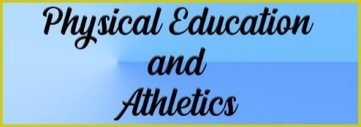

## Physical Education and Athletics

*Each student must complete a yearly fitness Assessment identified as FITNESSGRAM®. All information regarding this assessment is at* [*www.fitnessgram.net*](http://www.fitnessgram.net/) *.*

**PE - AEROBICS**

*Grade: 9-12 Prerequisite: None*

*Course Duration: 36 weeks Credit: 1*

This course incorporates the fundamental skills of “fitness center” quality aerobics such as floor aerobics, step aerobics, walk/jog aerobics, hand weight workouts and floor exercise workouts. Before and after assessments will be taken. Emphasis will be on improvement and maintenance of physical fitness.

PE - TEAM SPORTS

*Grade: 9-12 Prerequisite: None*

*Course Duration: 36 weeks Credit: 1*

This course includes the basic skills, rules, methods of training and conditioning and offers participation through practice and tournament play in various team sports. Students are expected to participate in various indoor and outdoor games and develop health-related fitness and an appreciation for team work and fair play. Activities taught will be determined by the instructor. Course assessment will be determined by skill, participation, and written exams.

CHEERLEADING

*Grade: 9-12 Prerequisite: Tryouts*

*Course Duration: 36 weeks Credit: 1*

This is a full-year course for all cheerleaders. Parents and students must attend a mandatory meeting prior to a mandatory two-week tryout workshop in the spring. Enrollment will be determined through a tryout process.

FOUNDATIONS OF PERSONAL FITNESS

*Grade: 9-12*

*Prerequisite: None*

*Course Duration: 36 weeks Credit: 1*

This course is designed to introduce students to the components of personal fitness. The class structure includes both classroom lecture and lab activities to assist students in the mastery of the course content. Topics covered shall include: nutrition in fitness, types of training techniques, the benefits of fitness, consumer issues related to fitness, and developing a personal fitness program.

PE - INDIVIDUAL SPORTS

*Grade: 9-12 Prerequisite: None*

*Course Duration: 36 weeks Credit: 1*

This course is designed to develop an interest in physical fitness, as well as an appreciation of the skills, knowledge, technique, and sportsmanship involved in lifetime fitness and well-being. Students are expected to participate in a wide range of individual sports and games that can be pursued for a lifetime. Activities taught will be determined by the instructor. Course assessment will be determined by skills, participation, and written exams.

Athletics

All Athletic courses require a physical examination and a parent permission form. BASEBALL 9-12

*Grade: 9-12*

*Prerequisite: Tryout and prior approval if not already in program Course Duration: 36 weeks*

*Credit: 1*

This is a course in the baseball athletic period. It is offered to 9th, 10th, 11th, and 12th grade students who have previously

been on a high school baseball team.

BASKETBALL 9-10

*Grade: 9-10 Prerequisite: None*

*Course Duration: 36 weeks Credit: 1*

This is a course that involves freshmen and sophomore basketball and off-season. Students should be prepared to start in-season practice in the fall. This course requires a physical examination and a parent permission form. Students must have passed to the 9th grade to be eligible. Students entering this high school for the first time need no prior approval from the coach if he or she enters before the second day of school. Students transferring or wishing to enter basketball after the second day of school must have the permission from the head boys’ basketball coach or the head girls’ basketball coach. Students must go through a tryout to remain in the class.

BASKETBALL 11-12

*Grade: 11-12*

*Prerequisite: Prior approval if not*

*already in program*

*Course Duration: 36 weeks (11th) and 27 weeks (12th) Credit: 1 (11th) and 1/2 (12th)*

This is a course that involves junior varsity and varsity basketball and off-season. Students should be prepared to start in

-season practice in the fall. This course requires a physical examination and a parent permission form. Students entering the basketball program for the first time need prior approval from the head boys’ basketball coach or the head girls’ basketball coach. Students must go through a tryout to remain in the class.

FOOTBALL 9-10

*Grade: 9-10 Prerequisite: None*

*Course Duration: 36 weeks Credit: 1*

This is a course that involves freshmen and sophomore football and off-season. Students should be prepared to start fall practice in August and go through spring practice. This course requires a physical examination and a parent permission form. Students must have passed to the 9th grade to be eligible. Students entering this high school for the first time need no prior approval from the coach if they enter before the second day of school. Students transferring or wishing to enter football after the second day of school must have the permission from the head football coach.

FOOTBALL 11-12

*Grade: 11-12*

*Prerequisite: Prior approval if not already in program Course Duration: 36 weeks (11) and18 weeks (12)*

*Credit: 1 (11) and 1/2 (12)*

This is a course that involves junior varsity and varsity football and off-season. Students should be prepared to start fall practice in August and go through spring practice in the spring. This course requires a physical examination and a parent permission form. Students entering the football program for the first time need prior approval from the head football coach.

GOLF 9-10

*Grade: 9-10*

*Prerequisite: Tryout and Coach’s Approval Course Duration: 36 weeks*

*Credit: 1*

This course is designed for those students who are not advanced enough to be on the varsity golf team. This course requires a physical examination and a parent permission form.

GOLF 11-12

*Grade: 11-12*

*Prerequisite: Prior approval if not already in program Course Duration: 36 weeks*

*Credit: 1*

This is a course that involves daily practice. Students should be prepared to start in-season junior varsity and varsity competition. This course requires a physical examination and a parent permission form. Students entering the golf program for the first time need prior approval from the girls’ head golf coach or the boys’ head golf coach.

SOCCER 9-10

*Grade: 9-10*

*Prerequisite: Tryout and head soccer coach’s approval Course Duration: 36 weeks*

*Credit: 1*

Students should be prepared to start in-season practice when announced by the coach. This course requires a physical examination and a parent permission form. Students entering this high school for the first time need no prior approval from the coach if he or she enters before the second day of school. Students transferring or wishing to enter soccer after the second day of school must have the permission of the girls’ head soccer coach or the boys’ head soccer coach.

SOCCER 11-12

*Grade: 11-12*

*Prerequisite: Prior approval if not already in the program*

*Course Duration: 36 weeks Credit: 1*

This is a course that involves varsity and junior varsity soccer and off-season training. Students should be prepared to start in-season practice when announced by the coach. Students entering the soccer program need prior approval from the girls’ head soccer coach or the boys’ head soccer coach.

SOFTBALL 9-12

*Grade: 9-12*

*Prerequisite: Prior approval if not already in the program Course Duration: 36 weeks*

*Credit: 1*

This is a course that involves junior varsity, varsity and off-season girls’ softball. Students should be prepared to start in- season practice in the fall. This course requires a physical examination and a parent permission form. Students, other than 9th grade girls entering the softball program for the first time, need prior approval from the head girls’ softball coach.

**SWIMMING: GIRLS AND BOYS 9-12**

*Grade: 9-12*

*Prerequisite: Tryout and prior approval if not already in program Course Duration: 36 weeks*

*Credit: 1*

This is a course that involves competitive swimming. Students should he prepared to start practice in the fall. This course requires a physical examination and a parent permission form. Students entering the swimming program for the first time need prior approval from the head swimming coach.

TENNIS: GIRLS AND BOYS 9-10

*Grade: 9-10*

*Prerequisite: Tryout and head tennis coach approval Course Duration: 36 weeks*

*Credit: 1*

This is a course that involves freshmen and sophomore tennis and off-season. Students should be prepared to start practice upon announcement by the head tennis coach. Students must have passed to the 9th grade to be eligible. This course requires a physical examination and a parent permission form. Students entering the tennis program for the first time need prior approval from the head tennis coach.

TENNIS: GIRLS AND BOYS 11-12

*Grade: 11-12*

*Prerequisite: Prior approval if not already in program Course Duration: 36 weeks*

*Credit: 1*

This course involves junior varsity and varsity tennis. Students should be prepared to start practice when announced by the head tennis coach. This course requires a physical examination and a parent permission form. Students entering the tennis program for the first time need prior approval from the head tennis coach.

TRACK 9-10

*Grade: 9-10*

*Prerequisite: None*

*Course Duration: 36 weeks Credit: 1*

This is a course that involves 9th and 10th grade track. Students should be prepared to start in-season practice immediately. Students need to be prepared to work out after school. This course requires a physical examination and a parent permission form. Students entering the track program for the first time need prior approval from the girls’ head track coach or the boys’ head track coach.

TRACK 11-12

*Grade: 11-12*

*Prerequisite: Prior approval if not already in program Course Duration: 36 weeks*

*Credit: 1*

This is a course that involves junior varsity and varsity track. Students should be prepared to start in-season practice immediately. Students need to be prepared to work out after school. This course requires a physical examination and a parent permission form. Students entering the track program for the first time need prior approval from the girls’ head track coach or the boys’ head track coach.

VOLLEYBALL 9-10

*Grade: 9-10*

*Prerequisite: Tryout and Head Coach’s approval Course Duration: 36 weeks*

*Credit: 1*

This is a course that involves freshmen and sophomore volleyball and off-season. Freshmen volleyball tryouts will be the first week of August before school starts. All girls need to attend these practices to be on the team. This course requires a physical examination and a parent permission form. Students must have passed to the 9th grade to be eligible. Students entering this high school for the first time need no prior approval from the coach. Students transferring or wishing to play volleyball after the 2nd day of school must have the permission of the head girls’ volleyball coach.

VOLLEYBALL 11-12

*Grade: 11-12*

*Prerequisite: Approval of Head Coach*

*Course Duration: 36 weeks (11) and 18 weeks (12)*

*Credit: 1 (11) and 1/2 (12)*

This is a course that involves junior varsity and varsity volleyball and off-season. Students should be prepared to start practice in August before school starts. Only transfers will be accepted based on the head coach’s approval after the 2nd day of school. This course requires a physical examination and a parent permission form.

WRESTLING 9-12

*Grade: 9-12*

*Prerequisite: Approval of Head Coach Course Duration: 36 weeks*

*Credit: 1*

The emphasis of the course is to improve physical and technical skills required to compete in the sport of wrestling. This course requires a physical examination and a parent permission form. Students should be prepared to start in- season practice when announced by the coach. Only students that have passed to the 9th grade will be eligible for participation in the class. Students entering the wrestling program for the first time need prior approval from the wrestling coach.



## Science

INTEGRATED PHYSICS AND CHEMISTRY (IPC)

*Grade: 9-10*

*Prerequisite: None*

*Course Duration: 36 weeks Credit: 1*

In IPC, students conduct field and laboratory investigations, use scientific methods during investigations, and make informed decisions using critical thinking and scientific problem solving. The course integrates the disciplines of physics and chemistry in the study of force and motion, properties of waves, transformation of energy, properties of matter, and physical and chemical changes of matter.

BIOLOGY

*Grade: 9-10*

*Prerequisite: None*

*Course Duration: 36 weeks*

*Credit: 1*

In Biology, students conduct field and laboratory investigations, use scientific methods during investigations, and make informed decisions using critical thinking and scientific problem solving. This course involves detailed investigations of all the major areas of modern biology including ecosystems, plants and their environment, genetics, taxonomy, biological evolution with a primary focus on the molecular and chemical basis of life. Students will be required to keep a biology notebook as part of their coursework.

PRE-AP BIOLOGY

*Grade: 9-10 Prerequisite: None*

*Course Duration: 36 weeks Credit: 1*

In Pre-Advanced Placement Biology, students conduct field and laboratory investigations, use scientific methods during investigations, and make informed decisions using critical thinking and scientific problem solving. This course is an in- depth study of the biological sciences. It involves detailed investigations of all the major areas of modern biology including ecosystems, plants and their environment, genetics, taxonomy, biological evolution with a primary focus on the molecular and chemical basis of life. Students will be required to keep a biology notebook as part of their coursework. This is a college preparatory course and requires work beyond what is expected of students at the academic level. Outside reading assignments are required. Prepares students for AP Biology.

CHEMISTRY

*Grade: 10-12*

*Prerequisite: One unit of high school science and Algebra I. Recommended - Biology and completion of or concurrent enrollment in second year of math*

*Course Duration: 36 weeks Credit: 1*

Chemistry is the study of the composition and behavior of matter and is intended for the college-bound student. In Chemistry, students conduct laboratory investigations, use scientific methods during investigations, and make informed decisions using critical thinking and scientific problem solving. Students study a variety of topics that include the characteristics of matter and energy transformations during chemical and physical changes, atomic structure, periodic table of elements, behavior of gases, bonding, nuclear fusion and nuclear fission, oxidation-reduction reactions, chemical equations, solutes, properties of solutions, acids and bases, and chemical reactions. Students will investigate how chemistry is an integral part of our daily lives. This course fulfills the prerequisite for Physics. A scientific calculator and a laboratory notebook are required.

PRE-AP CHEMISTRY

*Grade: 10-12*

*Prerequisite: One unit of high school science and Algebra I. Recommended - Biology and completion of or concurrent enrollment in Algebra II*

*Course Duration: 36 weeks Credit: 1*

Pre-Advanced Placement Chemistry is the study of the composition and behavior of matter and is intended for the college-bound student. In Pre-Advanced Placement Chemistry, students conduct more in-depth field and laboratory investigations, use scientific methods during investigations, and make informed decisions using critical thinking and scientific problem solving. Students study a variety of topics that include the characteristics of matter and energy transformations during chemical and physical changes, atomic structure, periodic table of elements,

behavior of gases, bonding, nuclear fusion and nuclear fission, oxidation-reduction reactions, chemical equations, solutes, properties of solutions, acids and bases, and chemical reactions. Students will investigate how chemistry is an integral part of our daily lives. A scientific calculator is required. Prepares students for AP Chemistry.

PHYSICS

*Grade: 11-12*

*Prerequisite: Recommended - Biology, Chemistry and Algebra II. (Algebra II can be taken concurrently) Course Duration: 36 weeks*

*Credit: 1*

This course provides an introduction to the main principles of physics and emphasizes the development of problem-solving skills. It provides a basic foundation in physics for students who plan to attend college. The topics covered

include kinematics, dynamics, heat, waves, and light. A scientific calculator is required.

AP PHYSICS 1

*Grade: 11-12*

*Prerequisite: Concurrent Enrollment in Algebra II, Biology, Chemistry Course Duration: 36 weeks*

*Credit: 1*

AP Physics 1 is an algebra-based, introductory college-level physics course. Students cultivate their understanding of Physics through inquiry-based investigations as they explore topics such as Newtonian mechanics (including rotational motion); work, energy, and power; mechanical waves and sound; and introductory, simple circuits.

AP PHYSICS 2

*Grade: 12*

*Prerequisite: AP Physics 1 Course Duration: 36 weeks Credit: 1*

AP Physics 2 is an algebra-based, introductory college-level physics course. Students cultivate their understanding of Physics through inquiry-based investigations as they explore topics such as fluid statics and dynamics; thermodynamics with kinetic theory; PV diagrams and probability; electrostatics; electrical circuits with capacitors; magnetic fields; electromagnetism; physical and geometric optics; and quantum, atomic, and nuclear physics.

AQUATIC SCIENCE

*Grade: 10-12 Prerequisite: Biology*

*Course Duration: 36 Weeks Credit: 1*

Students conduct field and laboratory investigations, use scientific methods during investigations, and make informed decisions using critical thinking and scientific problem solving. Students study a variety of topics that include components of an aquatic ecosystem, relationships among aquatic habitats and ecosystems, roles and cycles within an aquatic environment, adaptations of aquatic organisms, changes within aquatic environments, geological phenomena and fluid dynamics effects, and origin and use of water in a watershed.

ENVIRONMENTAL SYSTEMS

*Grade: 11-12*

*Prerequisite: Recommended - Biology and one physical science (IPC, Chemistry or Physics) Course Duration: 36 Weeks*

*Credit: 1*

In Environmental Systems, students conduct field and laboratory investigations, use scientific methods during investigations, and make informed decisions using critical thinking and scientific problem solving. Students study a variety of topics that include biotic and abiotic factors in habitats, ecosystems and biomes, interrelationships among resources and an environmental system, sources and flow of energy through an environmental system, relationship between carrying capacity and changes in the populations and ecosystems, and changes in environment.

AP ENVIRONMENTAL SCIENCE

*Grade: 11-12*

*Prerequisite: Biology, Chemistry Course Duration: 36 Weeks Credit: 1*

The Advanced Placement Environmental Science Course is designed to be the equivalent of a one-semester, introductory college course. The goal of the course is to provide students with the scientific principles, concepts, and methodologies required to understand the interrelationships of the natural world, to identify and analyze environmental problems both natural and human made, to evaluate the relative risks associated with these problems, and to examine alternative solutions for resolving and/or preventing them. The course is interdisciplinary. It embraces a wide variety of topics from different areas of social and scientific study.

ANATOMY AND PHYSIOLOGY

*Grade: 11-12*

*This CTE course satisfies a high school science graduation requirement; this course receives Pre-AP weight.*

*Prerequisite: Biology and a second Science credit*

*Course Duration: 36 Weeks Credit: 1*

The Anatomy and Physiology course is designed for students to conduct laboratory and field investigations, uses scientific methods during investigations, and make informed decisions using critical thinking and scientific problem solving. Students in Anatomy and Physiology will study a variety of topics, including the structure and function of the human body and the interaction of body systems for maintaining homeostasis.

ADVANCED ANIMAL SCIENCE

*Grade: 11-12*

*This CTE course satisfies a high school science graduation requirement; this course receives Pre-AP weight*

*Prerequisite: Biology and Chemistry * *Course Duration: 36 Weeks*

*Credit: 1 science credit*

This course examines the interrelatedness of human, scientific, and technological dimensions of livestock production. Instruction is designed to allow for the application of scientific and technological aspects of animal science through field and at least 40% laboratory experiences. Students will use critical thinking, scientific reasoning and problem-solving methods. Students will learn how to examine and compare animal anatomy & physiology in livestock species. Aspects of the course will include nutritional requirements of ruminant and non-ruminant animals, as well as the study of policies and issues in animal science. Students will learn to evaluate animal diseases & parasites, in addition to livestock harvesting and marketing.

ENGINEERING DESIGN AND PROBLEM SOLVING

*Grade: 11-12*

*This CTE course satisfies a high school science graduation requirement; this course receives Pre-AP weight. Prerequisite: Algebra I and Geometry*

*Suggested Prerequisite: Two STEM credits Course Duration: 36 Weeks*

*Credit: 1*

Engineering Design and Problem Solving reinforces and integrates skills learned in previous mathematics and science courses. This course emphasizes solving problems, moving from well-defined toward more open ended, with real-world application. Students apply critical- thinking skills to justify a solution from multiple design options. This course is intended to stimulate students’ ingenuity, intellectual talents, and practical skills in devising solutions to engineering design problems. Students use the engineering design process cycle to investigate, design, plan, create, and evaluate solutions. At the same time, this course fosters awareness of the social and ethical implications of technological development. Fees may apply.

**FORENSIC SCIENCE**

*Grade: 11- 12*

*This CTE course satisfies a high school science graduation requirement; this course receives Pre-AP weight.*

*Prerequisite: Biology and Chemistry*

*Course Duration: 36 Weeks Credit: 1*

Forensic Science is a course that introduces students to the application of science to connect a violation of law to a specific criminal, criminal act, or behavior and victim. Students will learn terminology and procedures related to the search and examination of physical evidence in criminal cases as they are performed in a typical crime laboratory. Using scientific methods, students will collect and analyze evidence such as fingerprints, bodily fluids, hairs, fibers, paint, glass, and cartridge cases. Students will also learn the history and the legal aspects as they relate to each discipline of forensic science.

AP BIOLOGY

*Grade: 10-12*

*Prerequisite: Biology, Chemistry (Chemistry may be taken concurrently.) Course Duration: 36 weeks*

*Credit: 1*

Advanced Placement Biology is equivalent to a freshman level college biology course. Topics include three (3) categories: molecules and cells, genetics and evolution, and organisms and populations. Advanced Placement laboratory assignments must be completed throughout the year.

AP CHEMISTRY

*Grade: 11-12*

*Prerequisite: Chemistry, and Algebra II. (Algebra II may be taken concurrently.) Course Duration: 36 weeks*

*Credit: 1*

This course is an in-depth survey of the structure and properties of matter intended for the science-oriented students, especially those planning to study in fields of chemistry, biology, medicine, or engineering. This course is equivalent to a first-year college chemistry course. Strong academic students desiring to reinforce their high school curriculum may also select it. A scientific calculator is required. This course requires work beyond what is expected of students at the academic level.

ROCKETRY (SRD)

*Grade: 11-12*

*This CTE course satisfies a high school science graduation requirement. Prerequisite: Biology, Chemistry, Integrated Physics and Chemistry, or Physics*

*Course Duration: 36 Weeks*

*Credit: 1*

Students will design and build a series of rockets culminating in a trip to launch a Tsiolkovsky level rocket

one mile high. This project-based curriculum built on the framework of Engineering Design, promotes student knowledge and skills applicable to the field of engineering. Students who want to take Advanced Placement classes should be willing to pursue a rigorous course of study intended for those in an introductory college course entailing the following requirements:

* + - Utilize analytical thinking, reading, and writing skills
    - Read college-level material
    - Write in-depth,

teacher-guided papers

* + - Engage in analytic research

## Social Studies

**WORLD GEOGRAPHY STUDIES**

*Grade: 9 -10 Prerequisite: None*

*Course Duration: 36 weeks Credit: 1*

This course covers the study of the Earth and the way people live and work on it. Concepts studied include location,

place, human/environmental interaction, movement, and region.

PRE-AP WORLD GEOGRAPHY STUDIES

*Grade: 9 Prerequisite: None*

*Course Duration: 36 weeks Credit: I*

World Geography Pre-AP examines people, places, and environments at local, regional, national and international levels. Concepts include location, place, human/environmental interaction, movement, and region with an emphasis on the interrelationships between the physical environments, political, economic and social processes. A major portion of the course centers on the physical

processes that shape patterns in the physical environment, and the characteristics of major land forms, climates, and ecosystems. The course is designed to develop the student’s analytical, collaborative, problem solving, decision-making processes, and other necessary skills from the normal standard to the higher level required in Advanced Placement (AP) courses.

WORLD HISTORY STUDIES

*Grade: 10 Prerequisite: None*

*Course Duration: 36 weeks Credit: 1*

World History is the study of humanity’s past and present with emphasis on the political, economic and social development of mankind.

AP WORLD HISTORY STUDIES

*Grade: 10*

*Prerequisite: Recommended - Pre-AP World Geography*

*Course Duration: 36 weeks Credit: 1*

The Advanced Placement World History course content is structured around the investigations of course themes and key concepts in six chronological periods. The six historical periods, from approximately 8000 B.C.E. to the present, provide a temporal framework for the course.

UNITED STATES HISTORY

*Grade: 11 Prerequisite: None*

*Course Duration: 36 weeks Credit: 1*

United States History is a study of the history of the United States from the period of reconstruction to the present time.

AP UNITED STATES HISTORY

*Grade: 11*

*Prerequisite: Recommended - AP World History or AP European History*

*Course Duration: 36 weeks*

*Credit: 1*

Advanced Placement US History is a survey of the history of the United States from colonial times to the present organized around seven themes. The course develops AP writing and reasoning skills and utilizes college level materials.

UNITED STATES GOVERNMENT

*Grade: 12 Prerequisite: None*

*Course Duration: 18 weeks Credit: 1/2*

United States Government is a study of governmental processes at the national, state and local levels. The course includes a study of the United States Constitution. Emphasis is placed on a citizen’s duties, responsibilities and roles.

AP UNITED STATES GOVERNMENT AND POLITICS

*Grade: 12 Prerequisite: None*

*Course Duration: 18 weeks Credit: 1/2*

Advanced Placement United States Government & Politics course provides an analytical perspective on government and politics in the United States. This course involves both the study of general concepts used to interpret U.S. politics and the analysis of specific case studies. Students engage in college level preparation.

ECONOMICS (Free Enterprise)

*Grade: 12 Prerequisite: None*

*Course Duration: 18 weeks Credit: 1/2*

Economics is the study of free enterprise/capitalism with emphasis on business organization, demand and supply, and the role of government in taxation and the budgetary process. Students will also study personal finance, including the role of savings, investment and credit.

AP MICROECONOMICS (AP Economics)

*Grade: 12 Prerequisite: None*

*Course Duration: 18 weeks*

*Credit: ½*

*This course emphasizes the economic principles that apply to the functions of individual decision makers, both consumers and producers, within the larger economic system. The completion of group and individual projects, presentations, and outside readings are expected of students in this course.*

AP EUROPEAN HISTORY

*Grade: 10-12 Prerequisite: None*

*Course Duration: 36 weeks Credit: 1*

Beginning with the Renaissance, the course traces the major political, social, economic and cultural trends of Europe through the World War II era and beyond. In addition to objective examinations, emphasis is placed on developing writing skills through research and the use of primary and secondary sources.

AP HUMAN GEOGRAPHY

*Grade: 9-12 Prerequisite: None*

*Course Duration: 36 weeks Credit: 1 credit elective*

The AP Human Geography course engages in college level preparation that focuses on cultural patterns, spatial organizations and the connections between people and places that have shaped human understanding, use, and alteration of Earth’s surface.

PSYCHOLOGY

*Grade: 10-12*

*Prerequisite: None*

*Course Duration: 18 weeks Credit: 1/2*

This course provides students with basic knowledge of psychology: concepts, theories, practices, history, and important persons in the field. It is intended to give students understanding of themselves and others.

AP PSYCHOLOGY

*Grade: 10-12 Prerequisite: None*

*Course Duration: 36 weeks Credit: 1*

Advanced Placement Psychology is a college-level introduction to Psychology. It includes the study of Biology- Psychology, history of psychology, research methodology and statistics, senses and perception, abnormal psychology and developmental psychology.

SOCIOLOGY

*Grade: 11-12*

*Prerequisite: None*

*Course Duration: 18 weeks Credit: 1/2*

Broad areas of content include the study of socialization through adolescence, cultural areas and cultural diversity, propaganda, group interaction and social control, and the role and status of American society. The impact of values, attitudes, and traditions relating to cultural norms is stressed. Research observations and speakers address contemporary social problems.

PERSONAL FINANCIAL LITERACY

*Grade: 10-12 Prerequisite: None*

*Course Duration: 18 weeks Credit: 1/2*

This course is designed to be an interactive and research-based course. The course will teach students to apply critical- thinking and problem-solving skills to analyze decisions involving earning and spending, saving and investing, credit and borrowing, insuring and protecting, and college and postsecondary education and training. It will develop students who have the knowledge and skills to make sound, informed financial decisions that will allow them to lead financially secure lifestyles and understand personal financial responsibility.

## er Science



## Speech

**DEBATE I**

*Grade: 9-12*

*Prerequisite: Communication Applications Course Duration: 36 weeks*

*Credit: 1*

This course introduces argumentation and debate to students interested in competitive academic debate. Students will develop skills in analysis, research, and the writing of briefs as well as logic and reasoning. The national debate topic serves as a foundation for the course research and study. After school practice is required and students will compete at a regional and/or national level at tournaments.

DEBATE II

*Grade: 10-12 Prerequisite: Debate I*

*Course Duration: 36 weeks Credit: 1*

This is an advanced study in argumentation and debate for the experienced student. The course offers in-depth study in evaluating evidence, research, refutation and public address. Students are encouraged to attend summer workshops on the national debate topic before taking the course. The course requires tournament participation.

DEBATE III

*Grade: 11-12 Prerequisite: Debate II*

*Course Duration: 36 weeks Credit: 1*

This course provides students with skills in argumentation, persuasion, research, and audience analysis. The course requires students to participate in tournament competitions. Students are also encouraged to attend summer workshops on the national debate topic before taking the course.

PROFESSIONAL COMMUNICATIONS

*Grade: 9-12 Prerequisite: None*

*Course Duration: 18 weeks Credit: 1/2*

Students enrolled in Communication Applications will be expected to identify, analyze, develop, and evaluate communication skills needed for professional and social success in interpersonal situations, group interactions, and personal and professional presentations.

HIGH-DEMAND CTE COURSE SELECTION PROCESS

When the number of students pre-registered for a course exceeds the number of seats available, a selection process

may be implemented to determine student placement in the course. Students will be selected based on:

* + Attendance
  + Discipline
  + Number of courses the student has completed in the Program of Study
  + Certifications earned in prior years in selected Program of Study

**HELPFUL WEBSITES**

Victoria Independent School District CTE [www.visd.net](http://www.visd.com/)/apps/pages/cte

VISD Career and Technology Institute cti.visd.net

Texas Wages [www.texaswages.com/](http://www.texaswages.com/)

Top Industries in the Victoria Area [www.texasindustryprofiles.com/](http://www.texasindustryprofiles.com/)

Career and College Exploration [www.Texasgenuine.com](http://www.Texasgenuine.com/)

Texas Reality Check – [www.texasrealitycheck.com/](http://www.texasrealitycheck.com/) The Right Career for Your Spending Needs

Apply for Admission to Any College or University [www.applytexas.org](http://www.applytexas.org/)

Fastweb – Scholarships, Internships. Colleges and More [www.fastweb.com/](http://www.fastweb.com/)

Labor Market and Career Information Data [www.lmci.state.tx.us](http://www.lmci.state.tx.us/)

America’s Career Infonet – Pathways to Career Success [www.acinet.org/](http://www.acinet.org/)

Occupational Outlook Handbook [www.bls.gov/ooh/](http://www.bls.gov/ooh/)

|  |
| --- |
| CTE Course Descriptions |

AGRICULTURE, FOOD AND NATURAL RESOURCES

ADVANCED ANIMAL SCIENCE

*Grade: 11-12*

*Satisfies a high school science graduation requirement; this course receives Pre-AP weight.*

*Prerequisite: Biology and Chemistry or IPC, Algebra 1 and Geometry, Small Animal Management and Equine Science, or Livestock Production*

*Course Duration: 36 Weeks Credit: 1 Science credit*

This course examines the interrelatedness of human, scientific, and technological dimensions of livestock production. Instruction is designed to allow for the application of scientific and technological aspects of animal science through field and at least 40% laboratory experiences. Students will use critical thinking, scientific reasoning and problem-solving methods. Students will learn how to examine and compare animal anatomy and physiology in livestock species. Aspects of the course will include nutritional requirements of ruminant and non-ruminant animals, as well as the study of policies and issues in animal science. Students will learn to evaluate animal diseases and parasites, in addition to livestock harvesting and marketing.

AGRICULTURE EQUIPMENT DESIGN AND FABRICATION

*Grade: 11-12*

*Prerequisite: Agriculture Mechanics and Metal Technologies*

*Duration: 36 Weeks*

*Credit: 1 Science credit Certification: AWS D.1.1.*

In Agriculture Equipment Design and Fabrication, students will acquire knowledge and skills related to the design and fabrication of agricultural equipment. To prepare for careers in mechanized agriculture and technical systems, students must attain knowledge and skills related to agricultural equipment design and fabrication. To prepare for success, students reinforce, apply and transfer their academic knowledge and technical skills in a variety of settings.

AGRICULTURAL MECHANICS AND METAL TECHNOLOGIES

*Grades: 9-12*

*Suggested Prerequisite: Principals of Agriculture, Food, and Natural Resources Course Duration: 36 Weeks*

*Credit: 1*

*Certification: NCCER Core; AWS D.1.1*

Agricultural Mechanics and Metal Technologies is designed to develop an understanding of agricultural mechanics as it relates to safety and skills in tool operation, electrical wiring, plumbing, carpentry, fencing, concrete, and metal working techniques. To prepare for careers in agricultural power, structural and technical systems, students much attain academic skills and knowledge; acquire technical knowledge and skills related to power, structural, and technical agricultural systems and the industry; and develop knowledge and skills regarding career opportunities, entry requirements, industry certifications, and industry expectations. To prepare for success, students need opportunities to learn, reinforce, apply, and transfer knowledge and skills and technologies in a variety of settings.

FLORAL DESIGN

*Grades: 9-12*

*This course satisfies the fine arts graduation requirement.*

*Suggested Prerequisite: None Course Duration: 36 Weeks Credit: 1 Fine Arts*

*Certification: Texas State Floral Association Knowledge Based Certification*

This course is designed to develop ability to identify and demonstrate the principles and techniques related to floral design as well as develop an understanding of the management of floral enterprises. Through the analysis of artistic floral styles and historical periods, students develop respect for the traditions and contributions of diverse cultures. Students respond to and analyze floral designs, thus contributing to the development of lifelong skills of making informed judgments and evaluations.

LANDSCAPE DESIGN AND MANAGEMENT

*Grade: 10-12 Credit: ½ Prerequisite: None*

*Certification: Landscape Irrigation Technician*

Landscape Design and Management is designed to develop an understanding of landscape design and management techniques and practices. To prepare for careers in horticultural systems, students must attain academic skills and knowledge, acquire technical knowledge and skills related to horticultural systems and the workplace, and develop knowledge and skills regarding career opportunities, entry requirements, and industry expectations. To prepare for success, students need opportunities to learn, reinforce, apply, and transfer their knowledge and skills and technologies in a variety of settings.

LIVESTOCK PRODUCTION

*Grade: 10-12 Prerequisite: None Course Duration: 36 Weeks Credit: 1*

In this course, students will learn the principles of livestock production, including the anatomy and physiology related to nutrition, reproduction, health and management of domesticated animals. Animal species to be addressed in this course may include, but are not limited to, beef cattle, dairy cattle, swine, sheep, goats, and poultry. Fees may apply.

PRACTICUM IN AGRICULTURE, FOOD, AND NATURAL RESOURCES

*Grade: 12*

*Prerequisite: Two or more courses from the Agriculture, Food, and Natural Resources Career Cluster. Course Duration: 36 Weeks*

*Credit: 2*

Practicum in Agriculture, Food, and Natural Resources is designed to give students supervised practical application of knowledge and skills. Practicum experiences can occur in a variety of locations appropriate to the nature and level of experiences such as employment, independent study, internships, assistantships, mentorships, or laboratories. To prepare for careers in agriculture, food and natural resources, students must attain academic skills and knowledge, acquire technical knowledge and skills related to the workplace, and develop knowledge and skills regarding career opportunities, entry requirements, and industry expectations. To prepare for success, students need opportunities to learn, reinforce, apply, and transfer their knowledge and skills and technologies in a variety of settings.

PRINCIPLES OF AGRICULTURE, FOOD, AND NATURAL RESOURCES

*Grade: 9-12 Prerequisite: None*

*Course Duration: 36 Weeks*

*Credit: 1*

This course will provide students with a broad understanding of the skills and knowledge necessary for a career in Agriculture, Food, and Natural Resources. Environmental and natural resource systems, plant and animal systems, agribusiness systems, and agriculture mechanical systems will be introduced. Students will be engaged in lab based hands-on activities.

TURF GRASS MANAGEMENT

*Grade: 10-12 Credit: 1/2 Prerequisite: None*

*Certification: Non- Commercial Pesticide Applicator*

To be prepared for careers in horticultural systems, students need to attain academic skills and knowledge, acquire technical knowledge and skills related to horticultural systems and the workplace, and develop knowledge and skills regarding career opportunities, entry requirements, and industry expectations. To prepare for success, students need opportunities to learn, reinforce, apply, and transfer their knowledge and skills and technologies in a variety of settings. This course is designed to develop an understanding of landscape and turf grass management techniques and practices.

**VETERINARY MEDICAL APPLICATIONS**

*Grade: 11-12*

*Prerequisite: Livestock Production Course Duration: 36 Weeks Credit: 1*

*Certification: Certified Veterinary Assistant*

Veterinary Medical Applications covers topics relating to veterinary practices, including practices for large and small animal species. To prepare for careers in the field of animal science, students will attain academic skills and knowledge, acquire technical knowledge and skills related to animal systems and the workplace, and develop knowledge and skills regarding career opportunities, entry requirements, and industry expectations.

WILDLIFE, FISHERIES, AND ECOLOGY MANAGEMENT

*Grade: 9-12 Prerequisite: None*

*Course Duration: 36 weeks Credit: 1*

This course examines the management of game and non- game wildlife species, fish, and aqua crops and their ecological needs as related to current agricultural practices. Students will identify the interrelationships between the various aspects of wildlife and outdoor public use management with the ability to acquire Hunter Education Certification.

ARTS, AV TECHNOLOGY AND COMMUNICATIONS

**DIGITAL ART AND ANIMATION**

*Grade: 9 – 12*

*Pre-requisite: None*

*Course Duration: 36 weeks*

*Credit: 1 Fine Art or Elective*

Digital Art and Animation Consists of computer images and animations created with digital imaging software. Digital Art and Animation has applications in many careers, including graphic design, advertising, wed design, animation, illustration, character development, storyboarding, directing, producing, project management, television, film, and game industries. Students in this course will produce various real-world projects and animations.

GRAPHIC DESIGN AND ILLUSTRATION I

*Suggested Prerequisite: Principles of Information Technology, Business Information Management 1 or Art 1 Course Duration: 36 weeks*

*Credit: 1*

*Certification: Adobe Certified Associate Photo Shop*

Careers in graphic design and illustration span all aspects of the advertising and visual communications industries. Within this context, in addition to developing knowledge and skills needed for success in the Arts, Audio/Video Technology, and Communications Career Cluster, students will be expected to develop an understanding of the industry with a focus on fundamental elements and principles of visual art and design.

GRAPHIC DESIGN AND ILLUSTRATION II

*Grade: 10-12*

*Suggested Prerequisite: Graphic Design and Illustration I Course Duration: 36 weeks*

*Credit: 1*

*Certification: Adobe Certified User Illustrator*

Careers in graphic design and illustration span all aspects of the advertising and visual communications industries. Within this context, in addition to developing advanced technical knowledge and skills needed for success in the Arts, Audio/Video Technology, and Communications Career Cluster, students will be expected to develop an advanced understanding of the industry with a focus on mastery of content knowledge and skills.

VIDEO GAME DESIGN

Grade: 9-12

Credit: 1 Prerequisite: None

Certification: Microsoft Technology Associate Introduction to Python

Video Game Design will allow students to explore one of the largest industries in the global marketplace and the new emerging careers it provides in the field of technology. Students will learn gaming, computerized gaming, evolution of gaming, artistic aspects of perspective, design, animation, technical concepts of collision theory, and programming logic. Students will participate in a simulation of a real video game design team while developing technical proficiency in constructing an original game design.

PRACTICUM IN GRAPHIC DESIGN AND ILLUSTRATION

*Grade: 11-12*

*Prerequisite: Graphic Design and Illustration II Course Duration: 36 Weeks*

*Credit: 2*

Careers in graphic design and illustration span all aspects of the advertising and visual communications industry. Within this context, in addition to developing technical knowledge and skills needed for success in the Arts, Audio/ Video Technology, and Communications Career Cluster, students will be expected to develop a technical understanding of the industry with a focus on skill proficiency. Instruction may be delivered through lab-based classroom experiences or career preparation opportunities

BUSINESS MANAGEMENT AND ADMINISTRATION

ACCOUNTING 1

*Grade: 10-12*

*Suggested Prerequisite: Principles of Business, Marketing and Finance*

*Course Duration: 36 Weeks Credit: 1*

*Certification: Quickbooks Certified User*

Students will investigate the field of accounting, including how it is impacted by industry standards as well as economic, financial, technological, international, social, legal, and ethical factors. Students will reflect on this knowledge as they engage in the process of recording, classifying, summarizing, analyzing, and communicating accounting information. Students will formulate and interpret financial information for use in management decision making.

BUSINESS INFORMATION MANAGEMENT I

*Grade: 9-12*

*Course Duration: 36 Weeks Credit: 1*

*Certification: Microsoft Office Specialist Excel and Microsoft Office Specialist Word*

In Business Information Management I, students implement personal and interpersonal skills to strengthen individual performance in the workplace and in society and make a successful transition to the workforce and postsecondary education. Students apply technical skills to address business applications of emerging technologies, create word- processing documents, develop a spreadsheet, formulate a database, and make an electronic presentation using appropriate software.

BUSINESS INFORMATION MANAGEMENT II

*Grade: 10-12*

*Pre-requisite: Business Information Management I*

*Course Duration: 36 Weeks Credit: 1*

*Certification:*

TOUCH SYSTEM DATA ENTRY

*Grade: 9-12 Prerequisite: none*

*Course Duration: 18 weeks Credit: ½*

Students apply technical skills to address business applications of emerging technologies. Students enhance reading, writing, computing, communication, and reasoning skills and apply them to the business environment. Students will need to apply touch system data entry for the production of business documents.

PRACTICUM IN BUSINESS MANAGEMENT

*Grade: 12*

*Suggested Prerequisite: Touch System Data Entry or Business Information Management II Course Duration: 36 Weeks*

*Credit: 2*

Practicum in Business Management is a 12th grade course in which students will develop essential knowledge and skills through classroom technical instruction and on-the- job training through the school store. Students will develop skills for lifelong learning, employability, leadership, management, work ethics, safety, and communication as a group; however, each student will have an individual training plan that will address job-specific knowledge and skills.

PRINCIPLES OF BUSINESS, MARKETING, AND FINANCE

*Grade: 9-12*

*Credit: 1 Prerequisite: None*

*Certification: Microsoft Technology Associate Windows Operating System Fundamentals*

In Principles of Business, Marketing, and Finance, students gain knowledge and skills in economics and private enterprise systems, the impact of global business, marketing of goods and services, advertising, and product pricing. Students analyze the sales process and financial management principles. This course allows students to reinforce, apply, and transfer academic knowledge and skills to a variety of interesting and relevant activities, problems and settings in business, marketing, and finance.

**CAREER DEVELOPMENT**

**CAREER PREPARATION I/EXTENDED CAREER PREPARATION**

*Grade: 11- 12*

*Prerequisite: Student and a parent must attend a mandatory meeting. Course Duration: 36 Weeks*

*Credit: 3*

*Certification: Microsoft Office Specialist Excel and Microsoft Office Specialist Word*

Career Preparation I provides opportunities for students to participate in a work-based learning experience that combines classroom instruction with business and industry employment experiences. The goal is to prepare students with a variety of skills for a changing workplace. Career preparation is relevant and rigorous, supports student attainment of academic standards, and effectively prepares students for college and career success. $25 OSHA certification fee.

Eligibility requirements: student must be at least 16 years old and have current employment or must secure employment by the 10th day of school from the first day of school. Students must provide their own transportation.

CAREER PREPARATION II/EXTENDED CAREER PREPARATION*

*Grade: 12*

*Prerequisite: Career preparation I and a student/parent must mandatory meeting. Course Duration: 36 Weeks*

*Credit: 3*

Career Preparation II develops essential knowledge and skills through advanced classroom instruction with business and industry employment experiences. Career Preparation II maintains relevance and rigor, supports student attainment of academic standards, and effectively prepares students for college and career success. Eligibility requirements: student must be at least 16 years old and have current employment or must secure employment by the 10th day of school from the first day of school. Students must provide their own transportation.

* **A student may repeat this course once for credit provided that the student is experiencing different aspects of the industry and demonstrating proficiency in additional and more advanced knowledge and skills.**

**CONSTRUCTION TECHNOLOGY**

**CONSTRUCTION TECHNOLOGY I**

*Grade: 9-12*

*Suggested Prerequisite: Principles of Construction Course Duration: 36 weeks*

*Credit: 2*

*Certification: NCCER Core-Carpentry Level 1*

In Construction Technology I, students will gain knowledge and skills needed to enter the workforce as carpenters or building maintenance supervisors or to prepare for a postsecondary degree in construction management, architecture, or engineering. Students will acquire knowledge and skills in safety, tool usage, building materials, codes, and framing.

CONSTRUCTION TECHNOLOGY II

*Grade: 10-12*

*Prerequisite: Construction Technology I*

*Course Duration: 36 weeks*

*Credit: 2*

*Certification: NCCER-Carpentry Level II,*

In Construction Technology II, students will gain advanced knowledge and skills needed to enter the workforce as carpenters, building maintenance technicians, or supervisors or to prepare for a postsecondary degree in construction management, architecture, or engineering. Students will build on the knowledge base from Construction Technology I and are introduced to exterior and interior finish out skills.

PRACTICUM IN CONSTRUCTION TECHNOLOGY

*Grade: 11-12*

*Prerequisite: Construction Technology II Course Duration: 36 weeks*

*Credit: 2*

In Practicum in Construction Technology, students will be challenged with the application of gained knowledge and skills from Construction Technology I and II. In many cases students will be allowed to work at a job (paid or unpaid) outside of school or be involved in local projects the school has approved for this class.

PRINCIPLES OF CONSTRUCTION

*Grade: 9-12 Prerequisite: None Course Duration: 36 weeks Credit: 1*

*Certification: NCCER Core*

Principles of Construction is intended to provide an introduction and lay a solid foundation for those students entering the construction or craft skilled areas. The course provides a strong knowledge of construction safety, construction mathematics, and common hand and power tools. For safety and liability considerations, limiting course enrollment to 15 students is recommended. This course also provides communication and occupation skills to assist the student in obtaining and maintaining employment.

EDUCATION AND TRAINING

HUMAN GROWTH AND DEVELOPMENT

*Grade 10-12*

*Suggested Prerequisite: Principles of Education and Training Course Duration: 36 Weeks Credit: 1*

Human Growth and Development is an examination of human development across the lifespan with emphasis on research, theoretical perspectives, and common physical, cognitive, emotional, and social developmental milestones. The course covers material that is generally taught in a postsecondary, one-semester introductory course in developmental psychology or human development.

PRINICPLES OF EDUCATION AND TRAINING

*Grade: 9-12*

*Credit: 1 Prerequisite: None Certification: None*

Principles of Education and Training is designed to introduce learners to the various careers available within the education and training career cluster. Students use self-knowledge and educational and career information to analyze various careers within the education and training career cluster. Students will also gain an understanding of the basic knowledge and skills essential to careers within the education and training career cluster. Students will develop a graduation plan that leads to a specific career choice in the student’s interest area.

INSTRUCTIONAL PRACTICES

*Grade: 11-12*

*Credit: 2 Prerequisite: None Certification: None*

Instructional Practices in Education and Training is a field-based internship that provides students with background knowledge of child and adolescent development as well as principles of effective teaching and training practices. Students in the course work under the joint direction and supervision of both a teacher with knowledge of early childhood education and exemplary Humble ISD educators in direct instructional roles with elementary and middle school-aged students. Students learn to plan and direct individualized instruction and group activities, prepare instructional materials, develop materials for educational environments, assist with record keeping, and complete other responsibilities of teachers, trainers, paraprofessionals, or other educational personnel. Practicum courses are reserved for students who have completed a sequence of courses leading up to the practicum and who have the skills and foundation to be successful in a professional setting. This course could lead to an industry certification.

PRACTICUM IN EDUCATION AND TRAINING

*Grade: 12*

*Credit: 2*

*Prerequisite: Instructional Practices Certification: Educational Aid 1*

Practicum in Education and Training is a field-based internship that provides students background knowledge of child and adolescent development principles as well as principles of effective teaching and training practices. Students in the course work under the joint direction and supervision of both a teacher with knowledge of early childhood education and exemplary Victoria ISD educators in direct instructional roles with elementary and middle school-aged students. Students learn to plan and direct individualized instruction and group activities, prepare instructional materials, assist with record keeping, make physical arrangements, and complete other responsibilities of teachers, trainers, paraprofessionals, or other educational personnel. This is a non-paid practicum. Practicum EDUCATION AND TRAINING 133 courses are reserved for students who have completed a sequence of courses leading up to the practicum and who have the skills and foundation to be successful in a professional setting. This course could lead to an industry certification.

HEALTH SCIENCE

**ANATOMY AND PHYSIOLOGY**

*Grade: 11-12*

*Satisfies a high school science graduation requirement; this course receives Pre-AP weight. Prerequisite: Biology and a second Science credit*

*Course Duration:*

*36 Weeks*

*Credit: 1*

The Anatomy and Physiology course is designed for students to conduct laboratory and field investigations, uses scientific methods during investigations, and make informed decisions using critical thinking and scientific problem solving. Students in Anatomy and Physiology will study a variety of topics, including the structure and function of the human body and the interaction of body systems for maintaining homeostasis.

HEALTH SCIENCE THEORY & HEALTH SCIENCE CLINICAL

*Grade: 11-12*

*Prerequisite: Principles of Health Science and Biology Course Duration: 36 weeks*

*Credit: May be taken for 1 (HST) or 2 credits*

*Certification: American Heart Association Basic Life Support*

The Health Science Theory and Health Science Clinical courses are designed to provide for the development of advanced knowledge and skills related to a wide variety of health careers. Students will have hands-on experiences for continued knowledge and skill development. Fees may apply.

MEDICAL TERMINOLOGY

*Grade: 9-12 Prerequisite: None*

*Course Duration: 36 Weeks Credit: 1*

The Medical Terminology course is designed to introduce students to the structure of medical terms, including prefixes, suffixes, word roots, singular and plural forms, and medical abbreviations. The course allows students to achieve comprehension of medical vocabulary appropriate to medical procedures, human anatomy and physiology, and pathophysiology.

PRACTICUM IN HEALTH SCIENCE

*Grade: 11-12*

*Prerequisite: Principles of Health Science, Health Science Theory, and Biology and student and a parent are required to attend a mandatory informational meeting.*

*Course Duration: 36 Weeks Credit: 2 Certification: Certified Nurse Aide*

The practicum course is a paid or unpaid capstone experience for students participating in a coherent sequence of courses in Health Science. The course is designed to give students supervised practical application and skills. Certification opportunities may be available such as Certified Nurse Aide. Students may be required to have their own transportation.

PRINCIPLES OF HEALTH SCIENCE

*Grade: 9-10 Prerequisite: None Course Duration: 36 Weeks Credit: 1*

The Principles of Health Science provides an overview of the therapeutic, diagnostic, health informatics, support services, and biotechnology research and development systems of the health care industry. Students will learn to apply reasoning, critical thinking, decision making, problem solving, and communication skills effectively. Students will recognize that quality health care depends on the ability to work well with others.

HUMAN SERVICES

**COSMETOLOGY I/COSMETOLOGY I LAB**

*Grade: 11*

*Prerequisite: Student and a parent must attend a mandatory meeting. Course Duration: 36 Weeks*

*Credit: 3*

In Cosmetology I, students explore careers in the cosmetology industry. To prepare for success, students must have academic and technical knowledge and skills relative to the industry. Students may begin to earn hours toward state licensing requirements. In Cosmetology I, students coordinate integration of academic, career, and technical knowledge and skills in this laboratory instructional sequence course designed to provide job- specific training for employment in cosmetology careers. Instruction includes sterilization and sanitation procedures, hair care, nail care, and skin care and meets the Texas Department of Licensing and Regulation (TDLR) requirements for licensure upon passing the state examination. Analysis of career opportunities, license requirements, knowledge and skills expectations, and development of workplace skills are included. A one-time student TDLR Student Permit, $25. Other fees may apply.

COSMETOLOGY II/COSMETOLOGY II LAB

*Grade: 12*

*Prerequisite: Cosmetology I and student and a parent must attend a mandatory meeting. Course Duration: 36 Weeks*

*Credit: 3*

*Certification: Cosmetology Operator License*

In Cosmetology II, students coordinate integration of academic, career, and technical knowledge and skills in this laboratory instructional sequence course designed to provide job-specific training for employment in cosmetology

careers. Students will attain academic skills and knowledge as well as technical knowledge and skills related to cosmetology design and color theory. Students will develop knowledge and skills regarding various cosmetology design elements such as form, lines, texture, structure and illusion or depth as they relate to the art of cosmetology. Instruction includes sterilization and sanitation procedures, hair care, nail care, and skin care and meets the TDLR requirements for licensure upon passing the state examination.

Analysis of career opportunities, license requirements, knowledge and skills expectations, and development of workplace skills are included. A one-time student TDLR Student Permit, $25. Other fees may apply

INTERPERSONAL STUDIES

*Grade 9-12 Prerequisite: None Course Duration: 18 Weeks Credit: ½*

This course examines how the relationships between individuals and among family members significantly affect the quality of life. Students use knowledge and skills in family studies and human development to enhance personal development, foster quality relationships, promote wellness of family members, manage multiple adult roles, and pursue careers related to counseling and mental health services.

LIFETIME NUTRITION AND WELLNESS

*Grade 9-12 Prerequisite: None Course Duration: 18 Weeks Credit: ½*

In this course, students will use principles of lifetime wellness and nutrition to help them make informed choices that promote wellness pursue careers related to hospitality and tourism, education and training, human services, and health sciences.

**Science, Technology, Engineering and Mathematics**

**AP COMPUTER SCIENCE PRINCIPLES**

*Grade: 9-12*

*Prerequisite: Algebra I*

*Course Duration: 36 weeks*

*Credit: 1*

AP Computer Science Principles introduces you to the essential ideas of computer science with a focus on how computing can impact the world. Along with the fundamentals of computing, you will learn to analyze data, information, or knowledge represented for computational use; create technology that has a practical impact; and gain a broader understanding of how computer science impacts people and society. You will creatively address real-world issues and concerns while using the same processes and tools as artists, writers, computer scientists, and engineers to bring ideas to life.

**AP COMPUTER SCIENCE A**

*Grade: 10-12*

*Prerequisite: Algebra I*

*Course Duration: 36 weeks*

*Credits: 2 (1 Math and 1 Language Other Than English) This is a one-period course*

The AP Computer Science A course introduces students to computer science with fundamental topics that include problem solving, design strategies and methodologies, organization of data (data structures), approaches to processing data (algorithms), analysis of potential solutions, and the ethical and social implications of computing. The course emphasizes both problem-solving and design.

**COMPUTER SCIENCE I**

*Grades: 9-12*

*Prerequisite: Algebra I*

*Course Duration: 36 weeks*

*Credit: 1*

Computer Science I will foster students' creativity and innovation by presenting opportunities to design, implement,

and present meaningful programs through a variety of media. Students will collaborate with one another, their instructor, and various electronic communities to solve the problems presented throughout the course. Through data analysis, students will identify task requirements, plan search strategies, and use computer science concepts to access, analyze, and evaluate information needed to solve problems. By using computer science knowledge and skills that support the work of individuals and groups in solving problems, students will select the technology appropriate for the task, synthesize knowledge, create solutions, and evaluate the results. Students will learn digital citizenship by researching current laws and regulations and by practicing integrity and respect. Students will gain an understanding of the principles of computer science through the study of technology operations, systems, and concepts. The six strands include creativity and innovation; communication and collaboration; research and information fluency; critical thinking; problem solving, and decision making; digital citizenship; and technology operations and concepts.

COMPUTER SCIENCE III

*Grade: 11-12*

*Prerequisite: AP Computer Science A*

*Course Duration: 36 weeks Credits: 1*

Computer Science III is a course intended for students who have taken two previous years of structured programming. Students will design and implement computer-based solutions to problems in several application areas expanding the use of object-oriented programming. Students will learn how to develop and use data abstractions that include stacks, queues, linked lists, and binary trees. There will be a continued emphasis on selecting the appropriate algorithms and data structures for the most efficient coding of a solution.

PRINCIPLES OF INFORMATION TECHNOLOGY

*Grade: 9-12*

*Prerequisite: None Course Duration: 36 Weeks Credit: 1*

*Certification: Microsoft Technology Associate; Windows Operating System Fundamentals*

In Principles of Information Technology, students will develop computer literacy skills to adapt to emerging technologies used in the global marketplace. Students will implement personal and interpersonal skills to prepare for a rapidly evolving workplace environment. Students will enhance reading, writing, computing, communication, and reasoning skills and apply them to the information technology environment. Students have the opportunity to earn an IC3 (Internal & Computing Core Certification).

PRINCIPLES OF APPLIED ENGINEERING

*Grade: 9-10 Prerequisite: None*

*Course Duration: 36 weeks Credit: 1*

Principles of Applied Engineering provides an overview of the various fields of science, technology, engineering, and mathematics and their interrelationships. Students will develop engineering communication skills, which include computer graphics, modeling, and presentations, by using a variety of computer hardware and software applications to complete assignments and projects. Upon completing this course, students will have an understanding of the various fields of engineering and will be able to make informed career decisions. Further, students will have worked on a design team to develop a product or system. Students will use multiple software applications to prepare and present course assignments.

**ENGINEERING DESIGN AND PROBLEM SOLVING**

*Grade: 11-12*

*Satisfies a high school science graduation requirement; this course receives pre-ap weight. Prerequisite: Algebra I and Geometry Suggested Prerequisite: Two STEM credits*

*Course Duration: 36 Weeks*

*Credit: 1*

Engineering Design and Problem Solving reinforces and integrates skills learned in previous mathematics and science courses. This course emphasizes solving problems, moving from well-defined toward more open ended, with real-world application. Students apply critical- thinking skills to justify a solution from multiple design options. This course is intended to stimulate students’ ingenuity, intellectual talents, and practical skills in devising solutions to engineering design problems. Students use the engineering design process cycle to investigate, design, plan, create, and evaluate solutions. At the same time, this course fosters awareness of the social and ethical implications of technological development. Fees may apply.

PRACTICUM IN SCIENCE, TECHNOLOGY, ENGINEERING, AND MATHEMATICS

*Grade: 12*

*Prerequisite: Algebra I and Geometry*

*Suggested Prerequisites: Two science, Technology, Engineering, and Mathematics Career Cluster Credits. Course Duration: 36 Weeks*

*Credit: 2*

Practicum in STEM is designed to give students supervised practical application of previously studied knowledge and skills. Practicum experiences can occur in a variety of locations appropriate to the nature and level of experience.

ROBOTICS I

*Grade: 9-10*

*Suggested Prerequisite: None Duration: 36 Weeks*

*Credit: 1*

In Robotics I, students will transfer academic skills to component designs in a project-based environment through implementation of the design process. Students will build prototypes or use simulation software to test their designs. Additionally, students will explore career opportunities, employer expectations, and educational needs in the robotic and automation industry.

ROBOTICS II

*Grade: 10-12*

*Suggested Prerequisite: Robotics I Course*

*Duration: 36 Weeks*

*Credit: 1*

In Robotics II, students will explore artificial intelligence and programming in the robotic and automation industry. Through implementation of the design process, students will transfer academic skills to component designs in a project- based environment. Students will build prototypes and use software to test their designs.

INDEPENDENT STUDY IN TECHNOLOGY APPLICATIONS

*Grade: 12*

*Prerequisite: Completion of a Technology Application course Course Duration: 36 weeks*

*Credit: 1*

Independent Study in Technology Applications will include activities individually designed for high-achieving students. The student will be provided opportunities to do one or more of the following activities:

1. conduct research,
2. produce original project in technology area,
3. extensively develop an advanced technology skill, or
4. study in a specific technology application area of interest.

Students in this course must be self-motivated and able to work independently.

ROCKETRY (SRD)

*Grade: 10-12*

*This course satisfies a high school science graduation requirement. Prerequisite: Biology, Chemistry, Integrated Physics and Chemistry, or Physics Course Duration: 36 Weeks*

*Credit: 1*

*Certification: Microsoft Office Specialist*

Students will design and build a series of rockets culminating in a trip to launch a Tsiolkovsky level rocket one mile high. This project-based curriculum built on the framework of Engineering Design, promotes student knowledge and skills applicable to the field of engineering.

LAW, PUBLIC SAFETY, CORRECTIONS, AND SECURITY

**FORENSIC SCIENCE**

*Grade: 11- 12*

*Satisfies a high school science graduation requirement; this course receives Pre-AP weight. Prerequisite: Biology and Chemistry Course Duration: 36 Weeks*

*Credit: 1*

Forensic Science is a course that introduces students to the application of science to connect a violation of law to a specific criminal, criminal act, or behavior and victim. Students will learn terminology and procedures related to the search and examination of physical evidence in criminal cases as they are performed in a typical crime laboratory. Using scientific methods, students will collect and analyze evidence such as fingerprints, bodily fluids, hairs, fibers, paint, glass, and cartridge cases. Students will also learn the history and the legal aspects as they relate to each discipline of forensic science.

PRINCIPLES OF LAW, PUBLIC SAFETY, CORRECTIONS, AND SECURITY & LAW ENFORCEMENT I

*Grade: 10-12*

*Suggested Prerequisite: Touch System Data Entry & Interpersonal Studies Course Duration: 36 Weeks*

*Credit: 2*

*Certification: Emergency Telecommunication*

Principles of Law, Public Safety, Corrections, and Security introduces students to professions in law enforcement, protective services, corrections, firefighting, and emergency management services. Students will examine the roles and responsibilities of police, courts, corrections, private security, and protective agencies of fire and emergency services. Law Enforcement I is an overview of the history, organization, and functions of local, state, and federal law enforcement. Students will understand the role of constitutional law at local, state, and federal levels; the U.S. legal system; criminal law; and law enforcement terminology and the classification and elements of crime.

CRIMINAL INVESTIGATION & LAW ENFORCEMENT II

*Grade: 11-12*

*Prerequisite: Law Enforcement I Course Duration: 36 Weeks Credit 2 Certification: NECC 911, Level II Security Certification*

Criminal Investigation is a course that introduces students to the profession of criminal investigations. Students will understand basic functions of criminal investigations and procedures and will learn how to investigate or follow up during investigations. Students will learn terminology and investigative procedures related to criminal investigation, crime scene processing, evidence collection, fingerprinting, and courtroom presentation. Through case studies and simulated crime scenes, students will collect and analyze evidence such as fingerprint analysis, bodily fluids, hairs, fibers, shoe and tire impressions, bite marks, drugs, tool marks, firearms and ammunition, blood spatter, digital evidence, and other types of evidence. Law Enforcement II provides the knowledge and skills necessary to prepare for a career in law enforcement. Students will understand ethical and legal responsibilities, patrol procedures, first responder roles, telecommunications, emergency equipment operations, and courtroom testimony.

**PRACTICUM IN LAW ENFORCEMENT**

*Grade: 12*

*Prerequisite: Law Enforcement II Course Duration: 36 Weeks Credit 2*

The practicum course is designed to give students supervised practical application of previously studied knowledge and skills in law, public safety, corrections, and security. Practicum experiences can occur in a variety of locations appropriate to the nature and level of experience

MANUFACTURING

**WELDING I**

*Grade: 10-12*

*Prerequisite: Agricultural Mechanics and Metal Technologies Course Duration: 36 Weeks Credit: 2*

*Certification: AWS D.1.1*

Welding I provides the knowledge, skills, and technologies required for employment in metal technology systems. Students will develop knowledge and skills related to this system and apply them to personal career development. This course supports integration of academic and technical knowledge and skills. Students will reinforce, apply, and transfer knowledge and skills to a variety of settings and problems. Knowledge about career opportunities, requirements, and expectations and the development of workplace skills prepare students for future success. Fees may apply and students are responsible for providing steel-toe boots, leather gloves, two pairs of safety glasses, long-sleeve cuffed shirt, and denim pants.

WELDING II

*Grade: 11-12 Prerequisite: Welding I Course Duration: 36 Weeks*

*Credit: 2*

*Certification: AWS D1.1, Carbon Steel 3G, Carbon Steel Pipe 4G 5G*

Welding II builds on the knowledge and skills developed in Welding I. Students will develop advanced welding concepts and skills as related to personal and career development. Students will integrate academic and technical knowledge and skills. Students will have opportunities to reinforce, apply, and transfer knowledge and skills to a variety of settings and problems. Students will have the opportunity to earn an American Welding Society (AWS), 3G or higher (D1:1). Fees may apply and students are responsible for providing steel-toe boots, leather gloves, and two pairs of safety glasses, long-sleeve cuffed shirt, and denim pants.

**PRACTICUM IN MANUFACTURING**

*Grade: 12*

*Prerequisite: Two or more courses in the Manufacturing Career Cluster. Course Duration: 36 Weeks*

*Credit: 2*

The Practicum in Manufacturing course is designed to give students supervised practical application of previously studied knowledge and skills. Practicum experiences can occur in a variety of locations appropriate to the nature and level of experience.

TRANSPORTATION, DISTRIBUTION AND LOGISTICS

**AUTOMOTIVE TECHNOLOGY I – MAINTENANCE AND LIGHT REPAIR**

*Grade: 10-12 Prerequisite: None Course Duration: 36 Weeks Credit: 2*

*Certification: ASE Maintenance and Light Repair*

Automotive Technology I - Maintenance and Light Repair includes knowledge of the major automotive systems and the principles of diagnosing and servicing these systems. This course includes applicable safety and environmental rules and regulations. Students will gain knowledge and skills in the repair, maintenance, and diagnosis of vehicle systems. This study will allow students to reinforce, apply, and transfer academic knowledge and skills to a variety of interesting and relevant activities, problems, and settings. The focus of this course is to teach safety, tool identification, proper tool use, and employability. Students may earn an ASE Maintenance and Light Repair. Fees may apply.

AUTOMOTIVE TECHNOLOGY II – AUTOMOTIVE SERVICE

*Grade: 11-12*

*Prerequisite: Automotive Technology I – Maintenance and Light Repair Course Duration: 36 Weeks*

*Credit: 2*

*Certification: ASE Electronics/Electrical Systems (A6)*

Automotive Technology II: Automotive Service includes applicable safety and environmental rules and regulations. In this course, students will gain knowledge and skills in the repair, maintenance, and diagnosis of vehicle systems. This study will allow students to reinforce, apply, and transfer academic knowledge and skills to a variety of interesting and relevant activities, problems, and settings. The focus of this course is to teach safety, tool identification, proper tool use, and employability. Fees may apply.

PRACTICUM IN TRANSPORTATION SYSTEMS

*Grade: 12*

*Prerequisite: Automotive Tech II-Auto Service or Paint & Refinishing Course Duration: 36 weeks*

*Credit: 2*

The practicum course is a paid or unpaid capstone experience for students participating in a coherent sequence of career and technical education courses in the distribution and logistics industry. Practicum in Transportation System is designed to give students supervised practical application of knowledge and skills. Practicum experiences can occur in a variety of locations appropriate to the nature and level of experience such as internships, mentorships, independent study, or laboratories. The Practicum can be either school lab based or work based.

DUAL CREDITS

**CETT 1325 DIGITAL FUNDAMENTALS**

*Grade: 11-12*

*Suggested Prerequisite: Algebra I and Physics. This is a dual credit course with Victoria College. Students must pay regular tuition and fees for dual credit college courses.*

*Students are responsible for obtaining the college’s textbooks. This course may not be offered every semester.*

*Credit: 1*

Digital Fundamentals is a course that will start to prepare high school students for the field of Instrumentation and Electronics. An entry level course in digital electronics covering number systems, including binary base 10, octal and hexadecimal, binary mathematics, digital codes, logic gates, Boolean algebra, and combinational logic.

CETT 1302 ELECTRICITY PRINCIPLES

*Suggested Prerequisite: Algebra I and Physics. This is a dual credit course with Victoria College. Students must pay regular tuition and fees for dual credit college courses.*

*Students are responsible for obtaining the college’s textbooks.*

Principles of electricity including proper use of test equipment, A/C and D/C circuits, and component theory and operations.

PTAC 1302 INTRO TO PROCESS TECHNOLOGY

*Grade: 11-12*

*Suggested Prerequisite: Algebra I. This is a dual credit course with Victoria College. Students must pay regular tuition and fees for dual credit college courses. Students are responsible for obtaining the college’s textbooks. This course may not be offered every semester.*

*Credit: 1*

An Introduction overview of the various industries using process technology such as petrochemical plants, refineries, oil and gas production, and power generation. In addition to applied chemistry, physics, and math, topics include the responsibilities and work environment required in process technology fields: basic processes, equipment and systems; and safety, environmental, and quality concepts associated with the work environment of the process technician.

**PTAC 1308 SAFETY, HEALTH AND ENVIRONMENT I**

*Grade: 11-12*

*This is a dual credit course with Victoria College. Students must pay regular tuition and fees for dual credit college courses. Students are responsible for obtaining the college’s textbooks. This course may not be offered every semester.*

*Credit: 1*

The Safety, Health, and Environment course provides opportunities for students to learn about environmentally sound work habits within the petrochemical industry. Settings include, but are not limited to, petrochemical plants, refineries, oil and gas production plants and power generation plants. Emphasis will be on safety, health, and environmental considerations and the performance of all job tasks and regulatory compliance matters. Topics include components of a typical plant safety, environmental programs, and the role of a process and production technician in relation to safety, health, and environmental equipment usages.

This page intentionally left blank.

VICTORIA

# INDEPENDENT SCHOOL DISTRICT



The mission of the Victoria Independent School District’s Career and Technical Education is to empower all students to be

successful citizens, workers and leaders in a global economy.

# Graduation Program Checklist

If you plan to pursue technical training or enter the workforce after grad visit *Texas it*

VICTORIA

# INDEPENDENT SCHOOL DISTRICT

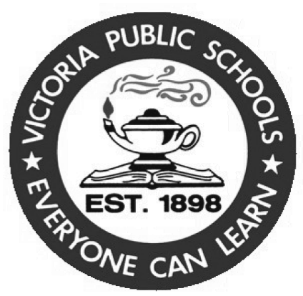

##### 102 Profit Drive

*Victoria TX 77901*

*(361) 576-3131*

The Victoria Independent School District does not discriminate against any person on the basis of race, color, national origin, gender, religion, sex, sexual orientation, disability, age, or any other basis prohibited by law for admission, treatment, or participation in its educational programs, services and activities, or employment.

El distrito escolar independiente de Victoria no discrimina contra ninguna persona por motivos de raza, color, origen nacional, género, religión, sexo, orientación sexual, discapacidad, edad o cualquier otra razón prohibida por la ley para la admisión, tratamiento, o la participación en los programas educativos, servicios y actividades, o empleo.