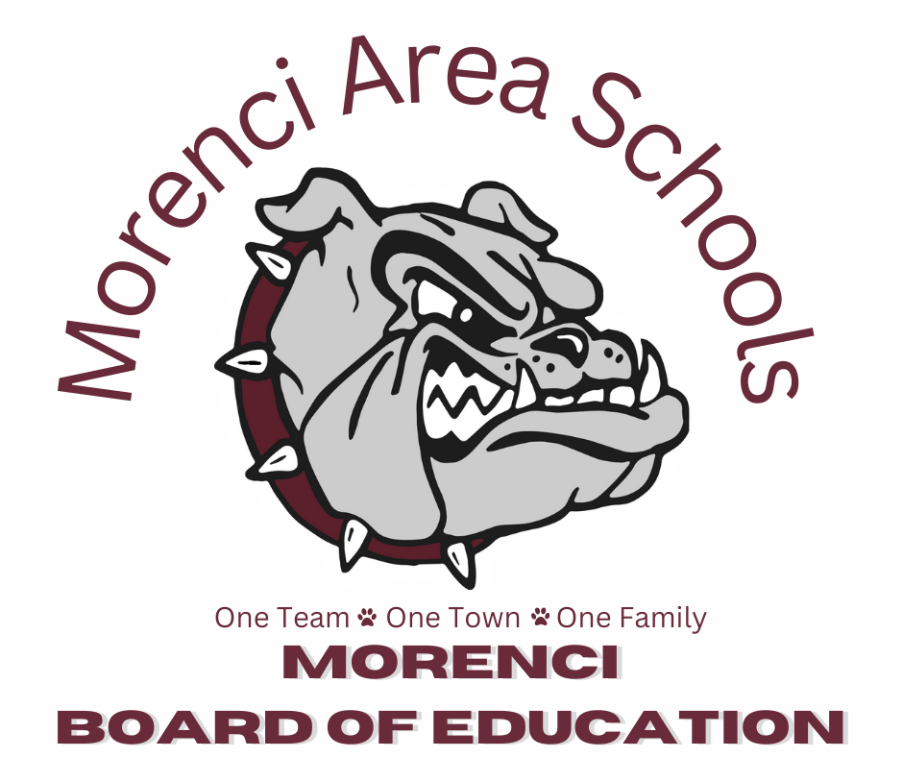
REGULAR MEETING AGENDA
October 26, 2026
MIDDLE SCHOOL LIBRARY
6:00 P.M.

- Call To Order
- Roll Call
- Pledge of Allegiance
- Moment of Silence
- Set Agenda (Action Required)
- Public Comment - Agenda Item
- 2025-2026 Audit Report - Willis & Jurasek
- Administrative Reports and District Highlights
- Educational Topic: Financial Literacy Field Trip
- Staff of the Month:
- Consent Agenda (Action Required)
- Minutes from the September 28, 2026 Regular Meeting
- Approval of Financial Reports
- Approval of Athletic Director’s Resignation
- Old Business
- Bond Update
- Enrollment Update
- Student Outcomes
- New Business (Action Required)
  - Approve HS Math Teacher - Irene Brown
  - Approve Weightroom Supervisor - Sophie Corkle
  - Approve Jr Varsity Boys Basketball - Keontae Townsend
  - Approve 7th Grade Girls Basketball - Emilio Aranda
  - Approve Stair Library Board Appointment
  - Approve Updated 2026-2027 Transportation Staff Handbook
  - Approve Kingscott Invoices
  - Approve E-Rate Bid
  - Approve Superintendent’s Contract
- New Business (Discussion Only)
- Board Education: Sinking funds and Long-Term Financial Planning
- Public Comment - Non-Agenda Item
- Adjournment (Action Required)

