Baker School
6th-8th Grade
Curriculum Guide
2026-2027



Academic Excellence with a Personal Touch
1369 14th Street Baker, FL 32531 | 850-689-7279 | www.okaloosaschools.com/baker

2026-2027 REGISTRATION INSTRUCTIONS
As a student enrolled in Baker School, you are given the opportunity to select coursework each spring for the following year. It is important that you involve your parents in course selection, that you make certain you meet the prerequisites, and that you keep interests and educational goals in mind.
This guide is designed to aid you in making appropriate choices by providing brief program and course descriptions, prerequisites, and other information related to this process. In order to complete registration successfully, you are urged to follow the steps below:

- READ the curriculum guide carefully.
- REVIEW middle school requirements and determine which requirements have been met and which courses need to be taken next year. Consider courses which need to be repeated because of lost credit.
- TALK to your parents and teachers about course selections and appropriate academic levels (general, honors, advanced studies, or vocational) as determined by your classroom teacher.
- General – These courses are designed for in-depth instruction that challenges students. These classes are suitable for all students.
- Honors – These courses are designed for self-motivated students who wish to pursue a more challenging curriculum while in middle school.
- Vocational – These courses are designed to prepare students for employment and/or post-secondary education in a career of their choice.
- SELECT courses that will correspond to or complement your goals for the future.

Course selection represents a commitment on the part of the student and parent to complete the schedule of classes chosen. Choose your courses carefully as requests for schedule changes will only be considered for the following reasons:
- Scheduling error (example – request Algebra I and receive Algebra II)
- Failure to complete a prerequisite course or requirement
- Credit recovered for course and/or course completed during the summer
- Duplicate course
- Blank period on schedule

Be sure that you meet the prerequisites for all selected courses. If a registration form is not returned with all of the necessary requirements completed, a counselor will make course selections for you based on class availability. Students should take a combination of seven or more courses.

Special Note: Additionally, the administration reserves the right to make necessary changes based on class size and teacher load as determined by the state of Florida class size requirements. The number of course requests and teacher availability will determine whether or not some courses will be offered. As a reminder, Baker School does not accept teacher requests in regard to student scheduling.

GENERAL INFORMATION 5
ADMINISTRATION 5
SCHOOL COUNSELORS 5
GUIDANCE STAFF 5
SCHOOL WEBSITE 5
SOCIAL MEDIA SITES 5
PARENT/TEACHER COMMUNICATION 6
GRADES AND ATTENDANCE ONLINE 6
GRADING SCALE AND GRADE POINT VALUE FOR ACADEMIC SUBJECTS 6
GRADE FORGIVENESS 6
COURSE SELECTION VERIFICATION 6
SCHEDULE CHANGE POLICY 7
REMINDERS: 7
GUIDANCE AND COUNSELING SERVICES 7
MIDDLE SCHOOL PROGRESSION 8
Required Courses 8
SPECIAL SERVICES 8
EXCEPTIONAL STUDENT EDUCATION 9
INTENSIVE READING AND INTENSIVE MATH: 9
HIGH SCHOOL COURSES: 9
MTSS (Multi-Tiered System of Supports) 9
Course Descriptions 10
ENGLISH LANGUAGE ARTS 11
MATHEMATICS 12
SCIENCE 14
SOCIAL STUDIES 15
ELECTIVES 17
ART 17
BAND 17
FLAG 18
CHORUS 18
DRAMA 18
CREATIVE WRITING 18
JROTC 19
LEADERSHIP 19
LEARNING STRATEGIES 19
FOREIGN LANGUAGE 20
CAREER AND TECHNICAL EDUCATION (CTE) 20
BUILDING TRADES/CONSTRUCTION 20
ARTIFICIAL INTELLIGENCE 21
CRIMINAL JUSTICE 23
PHYSICAL EDUCATION 23

GENERAL INFORMATION
OUR VISION
We strive to inspire a lifelong passion for learning.

OUR MISSION
We strive to prepare all students to achieve excellence by providing the highest quality education while empowering each individual to positively impact their families, communities, and the world.

ADMINISTRATION
Michael Martello Principal Ext. 17107
Victoria Hurley Asst. Principal Ext. 17908
Gary Taylor Asst. Principal Ext. 17102
Elizabeth Richards Asst. Principal Ext. 17103
TBA Dean of Students, Discipline Ext. 17115

SCHOOL COUNSELORS
A counselor is assigned to each student to help guide him or her throughout the high school years. A student or parent may set up an appointment or a conference with a counselor through the guidance office.

Polly Brunson 6th-12th Grade: Last Names A-J Ext. 17111
Angila Walker 6th-12th Grade: Last Names L-Z Ext. 17314
Shannon Brunson K-5 Grade Ext. 17315

GUIDANCE STAFF
Tanya Brunson Secretary, Registration, Transcripts Ext. 17313
Kayla Ashburn Teacher on Special Assignment Ext. 17217

SCHOOL WEBSITE
The Baker School website is https://www.okaloosaschools.com/baker/


SOCIAL MEDIA SITES
Instagram
Like us on Facebook
Baker School

PARENT/TEACHER COMMUNICATION
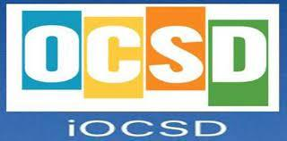
If a student is experiencing a problem in a course, the best solutions result from direct communication between the parent, student, and teacher. Please call or email the instructor with your concerns and allow at least 24 hours for a response. Email addresses can be found on the school website at https://www.okaloosaschools.com/baker/ under “Faculty.” You may also arrange for a conference with a guidance counselor and your student’s teachers by contacting your child’s guidance counselor to schedule an appointment.

GRADES AND ATTENDANCE ONLINE
Paper report cards are not distributed to the students. Parents can sign up for a FOCUS Parent Portal account to access grades and attendance online, 24-7 at www.okaloosaschools.com/page/focus-parents.

GRADING SCALE AND GRADE POINT VALUE FOR ACADEMIC SUBJECTS
This table reflects the statewide, uniform grading system used on report cards for grades 1-12, the grade definitions, and the grade point values. The table also lists the weighted grade point values that apply to Okaloosa County. F.S.1003.437

Grade | Percent | Definition | Grade Point  Value  Non-Weighted | Grade Point Value Weighted:  0.5 | Grade Point Value Weighted: 1.0
A | 90-100 | Outstanding Progress | 4 | 4.5 | 5
B | 80-89 | About Average Progress | 3 | 3.5 | 4
C | 70-79 | Average Progress | 2 | 2.5 | 3
D | 60-69 | In Danger of Failing | 1 | 1.5 | 2
F | 0-59 | Failure | 0 | 0 | 0

GRADE FORGIVENESS
Students who earn a grade of “D” or “F” may retake the course and replace the “D” or “F” grade with a grade of “C” or higher. Credit toward graduation can only be awarded once. For those students who received high school credit in middle school, courses for forgiveness may be taken if a student earned less than a “B” average in the original course.

COURSE SELECTION VERIFICATION
Course request verification will be available before the end of the year on your FOCUS account so you can verify your selections. There will be no changes to course selections after the end of this school year. The master schedule will be built to accommodate these requests and course changes will not be permitted. Due to class size amendment, these policies will be strictly enforced.

SCHEDULE CHANGE POLICY
Baker School will adhere to the schedule change policy below for the beginning of each semester.

First 3 Days of the Semester: The only adjustments allowed are for students who fit one or more of the following situations; no routine requests to change classes can be accepted.
- Students who have no schedule at all should report to Guidance.
- Students who have no course during a particular period should report to Guidance during that period.
- Students who are scheduled for a class previously completed successfully should check in with the teacher and report to Guidance that period.

After the First 3 Days of the Semester:
- Students must request an appointment with their counselor to change a schedule.
- Level changes (such as dropping an honors course for a regular course) must be requested by the teacher after a parent-teacher conference via phone, email, or in person.

After the End of the 4th Week until the End of the Semester:
- Students must request an appointment with their counselor to change a schedule.
- Students will receive a grade of “F” for the semester in the dropped class and the course will be placed on the transcript.

REMINDERS:
- Any request for a teacher change must be made by the parent.
- Any parent concern will require a conference that includes the teacher, parent, student, and administrator.
- Baker School does not accept specific teacher requests.
- The administration reserves the right to make necessary changes based on class size and teacher load as determined by the state of Florida class size requirements.
- All schedule change requests are due by the last day of school.

GUIDANCE AND COUNSELING SERVICES
In an effort to provide a successful and rewarding school experience, a number of services have been made available to assist you and your parents through the Guidance Department. They include the following:
- Short-term individual counseling
- Registration of new students
- Course selection and scheduling
- Maintenance and transfer of student records
- Conference scheduling
- Group presentations involving financial aid, college admissions procedures, and scholarships
- Academic credit checks
You are encouraged to meet with your counselor on an individual basis and take advantage of her expertise when planning for your future.

MIDDLE SCHOOL PROGRESSION

Required Courses

SUBJECT AREA | REQUIREMENTS
English  Language Arts (ELA) | 3 Credits
English  Language Arts (ELA) | - ELA 6th, 7th, and 8th  - ELA honors courses may satisfy this requirement
Mathematics | 3 Credits
Mathematics | - 6th, 7th, and 8th  - Baker offers at least one high school level math course and students will receive high school credit if successfully completed
Science | 3 Credits
Science | - 6th Grade: Earth/Space Regular or Advanced  - 7th Grade: Life Science Regular or Advanced  - 8th Grade: Physical Science Regular or Advanced
Social Studies | 3 Credits
Social Studies | - 6th Grade: World History Regular or Advanced  - 7th/8th Grade: United States History or Advanced  - 7th/8th Grade: Civics or Civics Advanced  - Civics EOC required which constitutes 30% of the course final grade
Physical Education | 3 Credits – State Required
Physical Education | 6th Grade: PE  7th Grade: PE  8th Grade: PE
Electives | 2 Credits per School Year
Electives | - Art  - Band/Flags  - Building Trades/ Construction  - Chorus  - Computers  - Creative Writing  - Exploring Technology  - Criminal Justice OPS 1  - Drama  - JROTC  - Leadership  - Spanish I  - STEMM/ Artificial Intelligence

SPECIAL SERVICES

EXCEPTIONAL STUDENT EDUCATION
SPECIAL PROGRAMS
Students selecting these courses must have an active Individualized Education Plan (IEP). Baker offers a variety of courses for ESE students:
- Communication
- Curriculum and Learning Environment
- Health Care
- Independent Functioning
- Social/Emotional Behavior

INTENSIVE READING AND INTENSIVE MATH:
Students who score a Level 1 on FSA are required to be enrolled in Intensive Reading or Intensive Math. These classes are electives and cannot be used to replace the regular English and mathematics courses used for progression. Students work on specific skills identified through screening and as specified in their Progress Monitoring Plan (PMP).

HIGH SCHOOL COURSES:
Baker School offers accelerated progression for students who are significantly advanced. The following courses are offered at Baker School and are 4.5 credit Courses:
- Algebra I Honors
- Geometry Honors
- Artificial Intelligence (Foundations, Data Analytics)
- Building Trades (1,2)
- Criminal Justice OPS 1
- JROTC
- Spanish I
Once enrolled, students will be held to all the high school course requirements to receive high school credit. All high school courses taken in middle school will count toward meeting graduation requirements, will be part of the student’s overall GPA, and are eligible to be included in calculating honors graduation designation.

MTSS (Multi-Tiered System of Supports)
MTSS has been implemented as a general education process to address the needs of struggling learners early in their educational experience. MTSS interventions are systematically applied and derived from research-based practices. The model is highly dependent on progress monitoring and data collection. A multi-disciplinary team of professionals will design, implement, and monitor MTSS intervention plans.

Baker School

Course Descriptions



This section of the catalog outlines the course options and recommended progression by discipline of the courses offered at Baker School. Prerequisites are incorporated at certain levels to foster academic success.

ENGLISH LANGUAGE ARTS

Florida requires a minimum of 3 English Language Arts in middle school. The following table is the recommended progression:
6th Grade | 7th Grade | 8th Grade
Language Arts I | Language Arts II | Language Arts III
Language Arts I Advanced | Language Arts II Advanced | Language Arts III Advanced

M/J LANGUAGE ARTS 1 1001010
Grade Level: 6 1 English Credit/Year Long
Prerequisite: *FSA ELA Level 1 or 2
This course defines what students should understand and be able to do by the end of 6th grade. Knowledge acquisition should be the primary purpose of any reading approach as the systematic building of a wide range of knowledge across domains is a prerequisite to higher literacy. At this grade level, students are building their facility with rhetoric, the craft of using language in writing and speaking, using classic literature, essays, and speeches as mentor texts.

M/J LANGUAGE ARTS 1 ADVANCED 1001020
Grade Level: 6 1 English Credit/Year Long
Prerequisite(s): *FSA ELA 3 or higher
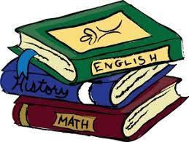
*Current English teacher recommendation
The purpose of this course is to provide grade 6 students, using texts of high complexity, advanced integrated language arts study in reading, writing, speaking, listening, and language for college and career preparation and readiness. Through the application, analysis, evaluation, and creation of complex ideas that are often abstract and multi-faceted, students in the advanced course are challenged to think and collaborate critically on the content.

M/J LANGUAGE ARTS II 1001040
Grade Level: 7 1 English Credit/Year Long
Prerequisite: *M/J Language Arts I
*FSA ELA Level 1 or 2
This course defines what students should understand and be able to do by the end of 7th grade. Knowledge acquisition should be the primary purpose of any reading approach as the systematic building of a wide range of knowledge across domains is a prerequisite to higher literacy. At this grade level, students are building their facility with rhetoric, the craft of using language in writing and speaking, using classic literature, essays, and speeches as mentor texts.

M/J LANGUAGE ARTS II ADVANCED 1001050
Grade Level: 7 1 English Credit/Year Long
Prerequisite(s): *FSA ELA 3 or higher
*Current English teacher recommendation
The purpose of this course is to provide grade 7 students, using texts of high complexity, advanced integrated language arts study in reading, writing, speaking, listening, and language for college and career preparation and readiness. Through the application, analysis, evaluation, and creation of complex ideas that are often abstract and multi-faceted, students in the advanced course are challenged to think and collaborate critically on the content.

M/J LANGUAGE ARTS III 1001070
Grade Level: 8 1 English Credit/Year Long
Prerequisite: *M/J Language Arts II
*FSA ELA Level 1 or 2
This course defines what students should understand and be able to do by the end of 8th grade. Knowledge acquisition should be the primary purpose of any reading approach as the systematic building of a wide range of knowledge across domains is a prerequisite to higher literacy. At this grade level, students are building their facility with rhetoric, the craft of using language in writing and speaking, using classic literature, essays, and speeches as mentor texts.

M/J LANGUAGE ARTS III ADVANCED 1001080
Grade Level: 8 1 English Credit/Year Long
Prerequisite(s): *FSA ELA 3 or higher
*Current English teacher recommendation
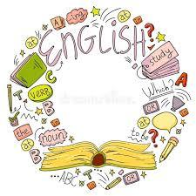
The purpose of this course is to provide grade 8 students advanced integrated language arts study in reading, writing, speaking, listening, and language for high school, college, and career preparation and readiness. Students will be exposed to texts of high complexity. Through the application, analysis, evaluation, and creation of complex ideas that are often abstract and multi-faceted, students in the advanced course are challenged to think and collaborate critically on the content.

MATHEMATICS
Florida requires a minimum of 3 mathematics credits in middle school. The following table is the recommended progression:
6th Grade | 7th Grade | 8th Grade
Mathematics Grade 6 Regular | Mathematics Grade 7 Regular | Mathematics Grade 8 Regular
Mathematics Grade 6 Advanced | Mathematics Grade 7 Advanced | Algebra 1 Honors*
Mathematics Grade 7 Advanced | Algebra 1 Honors* | Geometry Honors*
*High school credit

MATHEMATICS REGULAR 1205010/1205040/1205070
Grade Level: 6, 7, 8 1 Math Credit/Year Long
Prerequisite(s): None
The objective of this course is to provide additional practice and to establish grade level proficiency with the standards established for 6th, 7th, or 8th grade by the Florida Department of Education. The content may include, but not be limited to multiplication and division of decimals and fractions, data analysis, ratios, rates, fraction, decimal and percent equivalents and their applications, algebraic expressions and equations, functions and inequalities and using formulas in geometry. Many of these concepts will be taught through word problems.

MATHEMATICS ADVANCED 1205020/1205050/1205080
Grade Level: 6, 7 1 Math Credit/Year Long
Prerequisite(s): *FAST Math 3 or higher

*Current Math teacher recommendation
The objective of this course is to provide additional practice and to establish proficiency with the standards established for 6th & 7th grade by the Florida Department of Education. The content may include, but not be limited to multiplication and division of decimals and fractions, data analysis, ratios, rates, fractions, decimals, and percent equivalents and their applications, algebraic expressions and equations, functions and inequalities and using formulas in geometry. Many of these concepts will be taught through word problems. Additionally, students will explore integers, operations with rational numbers and measurement specifically volume and surface area. This course involves independent work, follows chapter sequence of the text which builds on previously taught concepts and requires students to apply the skills that they have learned. The pace is accelerated and requires at least 15 minutes of homework daily.
ALGEBRA I HONORS 1200320
Grade Level: 7, 8 HS Credit 1 Math Credit/Year Long
Prerequisite(s): *FAST/FSA Math Level 3 or higher
*A or B in Grade 6 or 7 Advanced Math
*Current math teacher recommendation
This course gives a rigorous in-depth study of algebra and algebraic concepts and processes that can be used to solve a variety of real world mathematical problems. Topics will include the language of algebra, solving equations with one and two variables, polynomials, quadratics, exponents, statistics, factoring functions, and graphing. (Students who took Algebra I Honors in 8th grade and did not receive credit or made a “C” average or below should retake this course.) At the completion of this course, all students will take the state mandated EOC exam which counts 30% of the student’s final grade. Passing the Algebra I EOC is required for graduation.

GEOMETRY HONORS 1206320
Grade Level: 8 HS Credit 1 Math Credit/Year Long
Prerequisite(s): *FSA Math Level 3 or higher
*A or B in Algebra 1 Honors
*Current math teacher recommendation
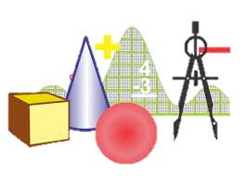
This course gives a rigorous in-depth study of geometry with emphasis on methods of proof and the formal language of mathematics. Instruction is rapidly paced for the most advanced math student. At the completion of this course, all students will take the state mandated FSA exam which counts 30% of the student’s final grade.

SCIENCE

EARTH /SPACE SCIENCE ____________________________2001010
Grade Level: 6 1 Science Credit/Year Long
Prerequisite(s): None
This course covers an overview of the structure of the Earth, our solar system, galaxy and universe. A basic overview of scientific inquiry and how scientific investigations are also conducted. This course will give an overview of basic cycles on Earth and how the Earth has changed over time, the layers of the Earth, how forces inside impact the surface, and how the Earth fits into our solar system and beyond.

EARTH /SPACE SCIENCE ADVANCED 2001020
Grade Level: 6 1 Science Credit/Year Long
Prerequisite(s): *A/B 5th grade Science
*5th grade teacher signature
The Earth Science curriculum builds on the natural curiosity of students. By connecting them to the beauty of geological history, the amazing landforms around the globe, the nature of the sea and air, and the newest discoveries about our universe, the curriculum gives students an opportunity to relate to their everyday world. Students will explore topics such as the fundamentals of geology, oceanography, meteorology, and astronomy; Earth’s minerals and rocks; Earth’s interior; plate tectonics, earthquakes, volcanoes, and the movements of continents; geology and the fossil record; the oceans and the atmosphere; and the solar system and the universe. Lesson assignments help students discover how scientists investigate the science of our planet.

LIFE SCIENCE 2000010
Grade Level: 7 1 Science Credit/Year Long
Prerequisite(s): None
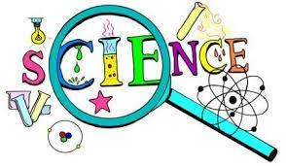
This course covers an overview of the structure of the Earth, our solar system, galaxy and universe. A basic overview of scientific inquiry and how scientific investigations are also conducted. This course will give an overview of basic cycles on Earth and how the Earth has changed over time, the layers of the Earth, how forces inside impact the surface, and how the Earth fits into our solar system and beyond.

LIFE SCIENCE ADVANCED 2000020
Grade Level: 7 1 Science Credit/Year Long
Prerequisite(s): *A/B 6th grade Science
*Teacher signature
The Life Science program invites students to investigate the world of living things—at levels both large and small—by reading, observing, and experimenting with aspects of life on Earth. Students explore an amazing variety of organisms, the complex workings of the cell and cell biology, the relationship between living things and their environments, and discoveries in the world of modern genetics. Students tackle such topics as ecology, microorganisms, animals, plants, cells, animals, species, adaptation, heredity, genetics, and the history of life on Earth. Lesson activities and assignments help students discover how scientists investigate the living world. At the advanced and gifted level in each grade, critical thinking and application skills are emphasized.

PHYSICAL SCIENCE 2003010
Grade Level: 8 1 Science Credit/Year Long
Prerequisite(s): None
The Physical Science program introduces students to many aspects of the physical world, focusing first on chemistry and then on physics. The course provides an overview of the physical world and gives students tools and concepts to think clearly about matter, atoms, molecules, chemical reactions, motion, force, momentum, work and machines, energy, waves, electricity, light, and other aspects of chemistry and physics. Among other subjects, students study the structure of atoms; the elements and the Periodic Table; chemical reactions; forces, including gravitational, motion, acceleration, and mass; and energy, including light, thermal, electricity, and magnetism.

PHYSICAL SCIENCE ADVANCED 2003320
Grade Level: 8 1 Science Credit/Year Long
Prerequisite(s): *A/B 7th grade Science
*Teacher signature
Physical Science will provide opportunities for students to investigate the introductory concepts of physics and chemistry. Topics will include but not be limited to: dynamics, classification, interaction of matter, the periodic table, forms of energy, electricity and magnetism, chemical interactions, nuclear reactions, and career opportunities. Laboratory activities that include the use of the scientific method, measurement, laboratory apparatus, and safety are an integral part of this course. This course also awards High School credit.

SOCIAL STUDIES

WORLD HISTORY 2109010
Grade Level: 6 1 Social Studies Credit/Year Long
Prerequisite(s): None

The primary content for this course pertains to the world's earliest civilizations to the ancient and classical civilizations of Africa, Asia, and Europe. Students will be exposed to the multiple dynamics of world history including economics, geography, politics, and religion/philosophy. Students will study methods of historical inquiry and primary and secondary historical documents.

WORLD HISTORY ADVANCED 2109020
Grade Level: 6 1 Social Studies Credit/Year Long
Prerequisite(s): *A/B 5th grade Social Studies
*Teacher signature
The objective of this course is to understand that the world is comprised of many diverse cultural groups who have made significant contributions to both the past and present. Students will explore the development of civilizations in historical and geographical settings, as well as the individuals and events that have significantly influenced culture and history. They will examine the major political, economic, social, and religious beliefs and institutions of selected Eastern and Western cultures. The content will include, but not be limited to, the study of ancient societies such as Egypt, Greece, and Rome. At the advanced level, critical thinking and application skills are emphasized when comparing/contrasting historical and contemporary issues. Students will develop collaborative skills, as well as public speaking skills, through individual and group projects.

UNITED STATES HISTORY 2100015
Grade Level: 7/8 1 Social Studies Credit/Year Long
Prerequisite(s): None
Primary content emphasis for this course pertains to the study of American history from the Exploration and Colonization period to the Reconstruction Period following the Civil War. Students will be exposed to the historical, geographic, political, economic, and sociological events which influenced the development of the United States and the resulting impact on world history. So that students can clearly see the relationship between cause and effect in historical events, students should have the opportunity to explore those fundamental ideas and events which occurred after Reconstruction.

UNITED HISTORY ADVANCED 2100025
Grade Level: 7/8 1 Social Studies Credit/Year Long
Prerequisite(s): *A/B 6th grade Advanced Civics
*Teacher signature
Primary content emphasis for this course pertains to the study of American history from the Exploration and Colonization Period to the Reconstruction Period following the Civil War. Students will be exposed to the historical, geographic, political, economic, and sociological events, which influenced the development of the United States and the resulting impact on world history. This course offers scaffolded learning opportunities for students to develop the critical skills of analysis, synthesis, and evaluation in a more rigorous and reflective academic setting.

CIVICS 2106010
All students will be required to take the Florida State End of Course Exam (EOC). The test score will account for 30% of their overall Civics grade. Pacing to prepare for this exam will be adjusted accordingly, depending on whether the class is working at the regular or advanced level.
Grade Level: 7/8 1 Social Studies Credit/Year Long
Prerequisite(s): None
The primary content for the course pertains to the principles, functions, and organization of government; the origins of the American political system; the roles, rights, responsibilities of United States citizens; and methods of active participation in our political system. The course is embedded with strong geographic and economic components to support civic education instruction.

CIVICS ADVANCED 2106020
Grade Level: 7/8 1 Social Studies Credit/Year Long
Prerequisite(s): *A/B 7th grade Social Studies
*Teacher signature
This course provides students with the critical skills to analyze and study the duties and rights of citizens. Students will learn the importance of knowing the rights and responsibilities that are guaranteed under the Constitution of the United States. Students will examine the different forms and functions of government. Students will use research and higher thinking skills to create collaborative projects to extend their knowledge of the Constitution and its principles. An in-depth study of the Bill of Rights will reinforce an understanding of the purpose and goals of the Legislative, Executive and Judicial Branches of government. Units on voting, political parties and public opinion about national, state and local governments will enable students to better understand society and the challenges people face.

ELECTIVES
6th Grade Offerings | 7th Grade Offerings | 8th Grade Offerings
Art | Art | Art
Beginning Band | Beginning Band or Band 2 | Beginning Band/Band 2/Band 3/Flags
Chorus 6 | Chorus 7 | Chorus 8
Creative Writing | Creative Writing | Creative Writing
Drama 6 | Drama 7 | Drama 8
Exploring Technology | Artificial Intelligence: Foundations* | Artificial Intelligence:  Foundations*/Data Analytics*
Learning Strategies | Learning Strategies | Learning Strategies
 | Leadership | Leadership
 | Fundamentals of Architecture and Construction | Construction: Building Trades 1*
 |  | JROTC*
 |  | Criminal Justice OPS 1*
 |  | Spanish 1*
*High school credit

ART
ART 1700000
Grade Level: 6,7,8 1 Elective Credit/Year Long
Prerequisite(s): None
Students investigate a wide range of media and techniques as they engage in the art-making processes of creating two-dimensional works, which may include drawing, painting, printmaking, and/or collage. Student artists reflect on their own artwork and that of others through critical analysis to achieve artistic goals related to craftsmanship, technique, and application of 21st-century skills. Opportunities are provided for creative decision-making in the context of the structural elements of art and the organizational principles of design. This course incorporates hands-on activities and consumption of art materials.

BAND
BAND 1– 1st year 1302000
BAND 2 – 2nd year 1302010
BAND 3 – 3rd year 1302020
Grade Level: 6, 7, 8 1 Fine Arts Credit/Year Long
Prerequisite(s): Placement will be determined by band director
Students with little or no instrumental experience develop foundational instrumental technique and foundational music literacy through rehearsal, performance, and study of high-quality band literature. Students may be required to attend and/or participate in rehearsals and performances outside the school day. This course may also require students to obtain a musical instrument (e.g., borrow, rent, purchase) from an outside source.

FLAG

Flag Corp in the March Band (BAND 3) 1302020
Grade Level: 8 1 Fine Arts Credit/Year Long
The Baker School Color Guard performs alongside the Baker School Sound of the Swamp Marching Band at all Football games, festivals, competitions, and parades.
This group is part of the “Sound of the Swamp” Marching Band and performs at football games, festivals, competitions, and parades.

CHORUS

GRADE 6 - Chorus 1303000
GRADE 7 - Chorus 1303010
GRADE 8 – Chorus 1303020
Grade Level: 6,7,8 1 Fine Arts Credit/Year Long
Prerequisite(s): None
Students with little or no choral experience develop beginning vocal technique and skills, critical and creative thinking skills, and an appreciation of music from around the world and through time. Public performances may serve as a culmination of specific instructional goals. Students may be required to attend and/or participate in rehearsals and performances outside the school day to support, extend, and assess learning in the classroom.

DRAMA
DRAMA _____ 0400000/0400010/0400020
Grade Level: 6, 7, 8 Elective Credit/Year Long

Prerequisite(s): None
Students explore theatre history, study the great American playwrights, examine the cultural and historical contributions to theatre, and begin to use the information to inform and improve their theatre knowledge and skills. Students begin to use the basic elements of theatre design through practical application and projects. Public performances may serve as a culmination of specific instructional goals. Students may be required to attend and/or participate in rehearsals and performances outside the school day to support, extend, and assess learning in the classroom.

CREATIVE WRITING
Creative Writing 1009000
Grade Level: 6, 7, 8 Elective Credit/Year Long
Prerequisite(s): None
Students will develop and use writing and language skills for creative expression in a variety of literary forms. Whether you are new to creative writing or you have authored your own fabulous piece (or pieces), this course is designed to help you unlock your creativity as well as give you the tools to develop your storytelling abilities.

JROTC

JROTC 801300
Grade Level: 8 HS Credit 1 Elective Credit/Year Long
Prerequisite(s): None

JROTC encourages students to become involved, informed, and responsible members of the community. Course requirements include wearing the Army uniform weekly, learning Army customs and courtesies, and participating in drills and ceremonies. Students will also be required to actively participate weekly in Health, Wellness, and Fitness classes. There is no military commitment associated with being a member of the Army JROTC program.

Students successfully completing two years of JROTC, will have the 0.5 credit PE activity elective requirement and the full 1.0 credit performing arts requirement waived. Students must still take the 0.5 credit Personal Fitness class to complete the PE requirement.


The purpose of this course is to enable students to develop knowledge of the history, customs, traditions, and purpose of the Army Junior Reserve Officer Training Corps (JROTC). The course includes the development of basic leadership skills including leadership principles, values, and attributes. Students should master appreciation for diversity. Active learning strategies are integrated throughout the course with an emphasis on writing skills and oral communication techniques. Financial planning as well as physical fitness, diet, nutrition, healthy lifestyles, awareness of substance abuse and prevention, and basic first aid measures are included. An overview of the globe and geography and basic map reading skills are incorporated. A study of the United States Constitution, Bill of Rights, responsibilities of United States citizens, and the federal justice system is also provided.

LEADERSHIP

LEADERSHIP _______ 1400000/10
Grade Level: 7, 8 1 Elective Credit/Year Long
Prerequisite(s): None
The objective of this course is to provide knowledge and opportunities for students to assist their peers. This is accomplished through enhancing interpersonal skills; role- playing, team building and skill building activities are used. The content will include, but not be limited to, peers as tutors, counselors, mentors, mediators and helpers.

LEARNING STRATEGIES

LEARNING STRATEGIES __ 7863090
Grade Level: 6, 7, 8 1 Elective Credit/Year Long
Prerequisite(s): IEP
The purpose of this course is to enable students with disabilities to acquire and generalize strategies and skills across academic and community settings to achieve annual goals based on assessed needs and the student’s individual educational plan (IEP). The course may address academic skill deficits enabling students to learn strategies to access the general curriculum and close educational gaps. A student may repeat this course.

FOREIGN LANGUAGE

SPANISH I* 0708340
Grade Level: 8 1 Elective HS Credit/Year Long

Prerequisite(s): A or B in 7th grade ELA
Spanish I introduces students to the target language and its culture. The student will develop communicative skills in all three modes of communication and cross-cultural understanding. Emphasis is placed on proficient communication in the language. An introduction to reading and writing is also included as well as culture, connections, comparisons, and communities.

CAREER AND TECHNICAL EDUCATION (CTE)


CTE programs offer students the opportunity to explore and prepare for their future and ensure relevant learning experiences that engage students while providing a real-world, career-oriented curriculum. Acquiring skills and knowledge relevant to future careers prepares students no matter the path they take after graduation. Students will have the opportunity to earn in-demand, national industry certifications in many of the CTE programs. Career and Technical Education programs set students up on the path of future success!

CTE Benefits
- Learn from industry-certified experienced professionals in state-of-the-art classrooms
- Earn national industry certifications that lead to high skill/high wage positions

BUILDING TRADES/CONSTRUCTION

SKILLS TO BUILD 1/ INTRODUCTION TO ARCHITECTURE AND CONSTRUCTION ___ 8109350/8109360
Grade Level: 7 1 Elective Credit/Year Long
Prerequisite(s): None
Do you enjoy working with your hands--learning by doing? If so, this course is for you. In Skills to Build 1, students will have the opportunity to work with their hands as they learn the art of the construction industry. Equipment safety and the construction process provides students with foundational knowledge of the industry. Students will have the opportunity to work with their hands as they work on tangible projects while gaining industry skills.

BUILDING TRADES 1 8722010
Grade Level: 8 1 Elective/HS Fine Arts 4.5 Weighted H.S. Credit
Skills to Build 3 is a foundational high school course that prepares students for any career in the field of construction. It prepares the student for the basic knowledge to function safely on or around a construction site and in the industry in general. Safety obligations of workers, supervisors, and managers to ensure a safe workplace is included in the basic OSHA 10-hour safety standards certification portion of the course. Participating in full-sized carpentry projects will provide students with real-world carpentry skills. Students will gain the knowledge and skills to succeed in this rapidly changing workforce. Students have the opportunity to earn industry certification.

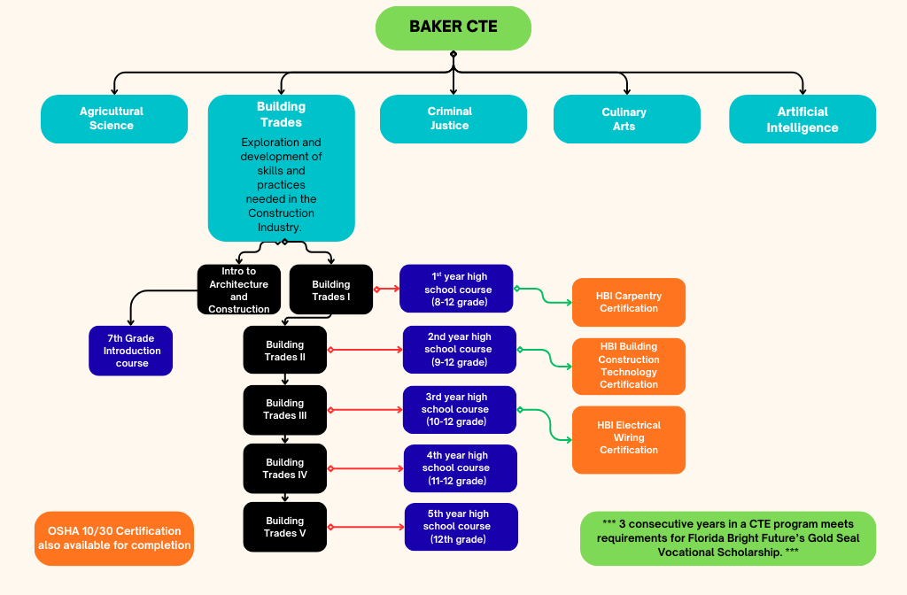

ARTIFICIAL INTELLIGENCE

Exploring Technology 8600020
Grade Level: 6 1 Elective
(Prerequisite: Introduction to Technology)
This course takes a deeper look into the world of computer programming and the logic behind it all. Hone your skills, increase your content knowledge, and learn through the applications of computer-aided design. Students will learn the basics of 3-D printing and rapid prototyping. You will use the design process to test, evaluate, and refine your solutions to open-ended problems in the world of technology, and robotics. Students will have the opportunity to earn a Digital Tools Certificate.

Foundations of Programming for Data Science _______ 9007710
Grade Level: 7,8 1 Elective/HS Fine Arts 5.0 Weighted High School Credit
“Your Ticket to the Big Leagues of Tech!" Hey future tech gurus! Ready to crack the code to an exciting and rewarding digital world? Jump into our Python Programming course, where we make coding cool, fun, and totally approachable. Think Python is just a snake? Think again! It's one of the most popular programming languages out there, used by pros from game developers to AI wizards. And guess what? It's also perfect for beginners like you!
In this hands-on, project-based course, you'll go from zero to hero in the world of programming. We're talking about building your own games, solving real-life problems, and maybe even programming the next big app – all using Python. You'll learn how to speak to computers (and make them listen to you!) in a language that’s as easy to learn as it is powerful. Whether you dream of being a game developer, a data scientist, or just want to try something new and exciting, our Python course is your first step into a world where you can literally write your own future. So, are you ready to join the league of extraordinary programmers? Let's make some coding magic happen!

Data Analytics & Database Design _______ 9007720
Grade Level: 7,8 1 Elective/HS Fine Arts 5.0 Weighted High School Credit
Data analytics is the science of analyzing large amounts of data to help organizations make sense of the data. Analysis of data allows the analyst to gain insight on trends such as what is the most popular car, fashion, and technology usage. Businesses are embracing data science so they can stay competitive and not miss any opportunities. Organizations can use data analytics to deliver personalized experiences and spur action and engagement by targeting consumers and customizing their experiences to their needs. Students will have the opportunity to earn industry certifications.

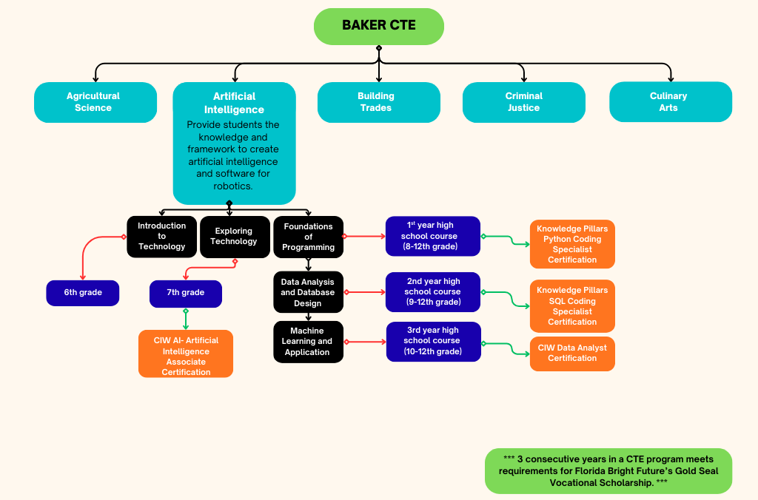

CRIMINAL JUSTICE

CRIMINAL JUSTICE OPERATIONS 1 8918010 Grade Level: 8 1 Elective HS Credit/Year Long Prerequisite(s): None
This course is designed to introduce students to the fields of law enforcement. This class will include introductory studies in the history of law enforcement, corrections, the United States courts systems, hate crimes, the United States Constitution as it applies to law enforcement, and report writing for law enforcement. This course is a prerequisite and introductory course to all other Criminal Justice courses.
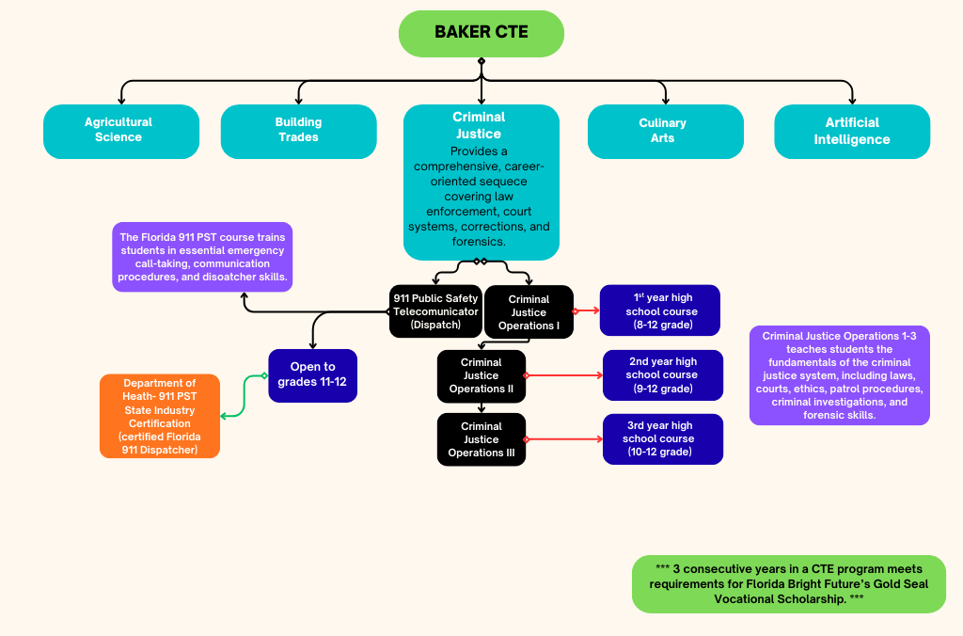

PHYSICAL EDUCATION

Grade 6/7/8 PE 1508000/1508060/1508070
Grade Level: 6/7/8 Elective Credit/Year Long
Required every year of Middle School
This course is designed to provide a developmentally appropriate and comprehensive experience through exposure to a wide variety of activities. The goal of the course is to promote the acquisition of skills and beliefs needed to pursue a lifetime of involvement in physical activity and healthful decision making. Students will have the opportunity to learn basic skills and fundamentals for core sports and activities. Students will be required to dress out in proper P.E. attire.

