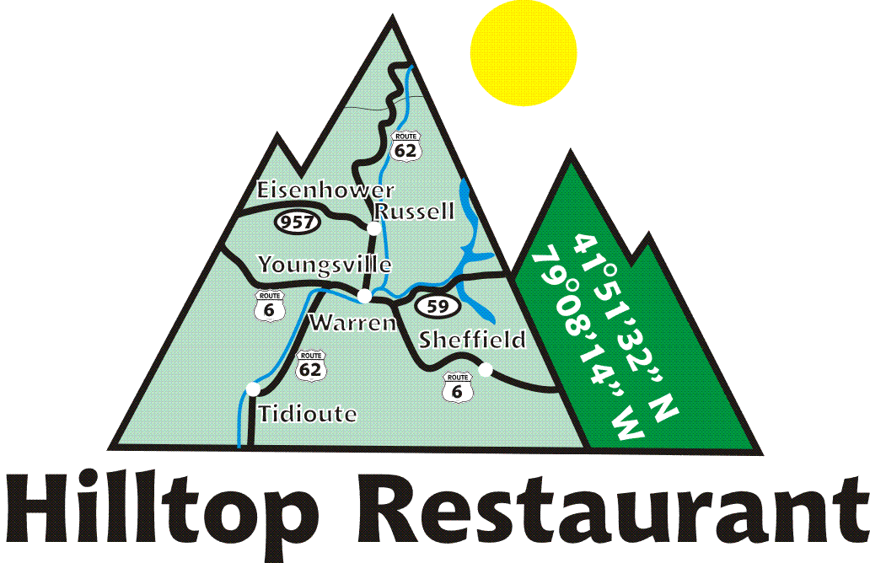
__________________________Starters________________________
Bacon Dippers
Crispy bacon covered with pancake batter and served with maple syrup for dipping.
$5
_______________________Main Course________________________

Chicken & Waffles
Southern style crispy chicken served with waffles, whip cream, and strawberries drizzled with local maple syrup
$10

Honey Butter Chicken Croissant
Crispy chicken filet with hickory smoked bacon and honey butter on a toasted croissant, served with a side of home fries
$10

Stuffed Flap Jack Stack
Fluffy pancakes stuffed with sage sausage stacked and served with local maple syrup
$10

Breakfast Burrito
Roasted potatoes, bell peppers, onions, sage sausage, cheddar cheese, eggs and chipotle sauce in a flour tortilla, served with a side of fruit salad
$12

HashBurger
Fresh ground beef combined with corned beef hash seared and served on a toasted brioche roll with cooper cheese, bacon, over easy egg, on a toasted brioche bun and served with homefries
Single $12
________________________Dessert__________________________
Cinnamin Rolls
House made cinnamon roll topped with vanilla icing.
$3
*Accepting Cash Only*
Tips are collected for student account.
Reservations must be made one day in advance by 3 PM per email to salapekca@wcsdpa.org
We are a dine in establishment only to facilitate student learning.
*Consuming raw or undercooked meats, poultry, seafood, shellfish or eggs may increase your risk of foodborne illness. Menu for the week of 5/12/26 - 5/14/26

Sauces: Hot, Buffalo, Hot Honey, Jambo, BBQ, Sweet Chili, Nashville, Kickin Boubron, Spicy Peach, General Tso, Carolina Gold, Butte& Garlic

