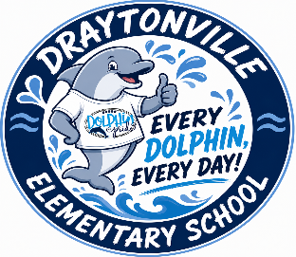
Assessment | Window/Date
iReady Diagnostic - K-5  (Achievement assessment administered in Reading and Math. Last 2 days are makeup days) | Fall: Aug 17 - 26  Winter: Jan 6 - 15  Spring: Mar 24 - April 2
Predictive Assessment - K-8  (ELA, Math, Science administered to students in selected K-5 schools and all middle school’s students. A TDW will be included w/ each ELA) | Fall: Oct 23 – Oct 30  Winter (No K): Jan. 6 – Jan 15  Spring: March 24-April 2
Iowa and CogAT  (Grade 2-Achievement and Aptitude assessment, used for GT identification and Performance Task Assessment participation) | Oct 5 - 27
Performance Task Assessment  (2-3 grade students w/ qualifying aptitude score, who have met GT criteria, and 4-5 grade students who met GT criteria w/ an aptitude/achievement score.) | Feb 16 - Feb 26  Make ups Mar 1 - 3
KRA: 5K Readiness  (Literacy assessment for 5K) | Aug 10 - Oct 13  First 45 days of school
myIGDIs & GOLD  (Measure for Literacy & Numeracy for 4K) | Fall: Aug 10 - Oct 13  Spring: Mar 19 - May 27  1st & last 45 days of school
SC Ready-Grades 3-5  (Summative achievement assessment grades 3-5 in ELA-Reading, ELA-Writing, and Math. Grade 4 will take Science) | ELA-Writing: May 4  Science: May 18  ELA-Reading A: May 10  ELA-Reading B: May 11  Math : May 13
ACCESS  (English proficiency assessment administered to designated MultiLingual students in grades K-12) | Jan 20 - Mar 5
National Assessment of Educational Progress-(NAEP) (Random sampling for each student group: Reading-4 & 8, Math-4 & 8, Civics-8, US History-8) | Jan 25 - Mar 13
Draytonville Elementary School
2026-2027 Test Dates - Grades 4K-5th

