Parent Involvement Policy
Limestone-Central Elementary
2026-2027
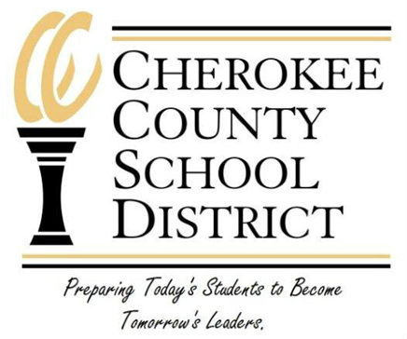
Limestone-Central Elementary School encourages, supports, and values the participation and involvement of parents and families in the educational experiences of their children. Limestone-Central Elementary School is committed to developing family-friendly schools to welcome and serve parents and families in positive and supportive environments. To provide effective parent involvement and to comply with Title 1 requirements, Limestone-Central Elementary School will:

1. Involve parents in the joint development of Limestone-Central Elementary School’s plan and the process of school review and improvement by:
a. Including parents on the School Improvement Council to review the policy.
b. Convening an annual meeting to inform parents of the school’s participation under the Title I,
requirements, programs, and their right to be involved.
c. Recording observations and comments in the minutes of annual meetings.
d. Providing opportunity for parents to review the federal regulations by making them available at the
annual meeting and at the school.

2. Provide coordination, technical assistance, and support to schools for effective parent involvement by:
a. Providing a Parent/Family Literacy program which strongly supports the Title I program through
collaboration with district office staff, school PTO’s, and school improvement councils.
b. Providing on-going in-service for all faculty on programs and means of effectively involving parents.

3. Build the school’s parents’ capacity for strong parental involvement by:
a. Working directly with families, teachers, administrators, and support staff in helping students reach the
goals as established by the district.
b. Encouraging volunteering, PTO attendance, workshop attendance, and participation in surveys.
c. Providing opportunities for program planning from teachers and principals through meetings and/or
questionnaires.
d. Conducting surveys (needs assessment) to determine services needed by parents to facilitate involvement.
e. Using findings from surveys to assist schools in planning for parent involvement.

4. Coordinate and integrate parent involvement under this program with parent involvement under other programs
such as Child Early Reading Development and Education Program (CERDEP) and other district/state programs by:
a. Using school guidance counselors and/or the district social worker to help families who need services
provided by the district and/or other agencies.

5. Involve parents in the activities of the school served under Title I by:
a. Conducting Family nights.
b. Conducting Parent/Teacher conferences that address test results, the district annual report and the school
report card.
c. Keeping records, such as minutes of SIC Meetings and responses from parents on surveys.
d. Providing feedback to parents on findings at the annual meeting and/or by newsletter.

6. Consult annually with parents through the district public meeting and school Title I meetings to:
a. Assess the effectiveness of parent involvement activities.
b. Modify the activities to increase participation.
c. Modify and be involved in how parent involvement funds are allotted.

7. Conduct, with the involvement of parents, an annual evaluation of the content and effectiveness of the parent
involvement policy in improving the academic quality of the schools by:
a. Identifying barriers to greater participation of parents as noted in section 1118 of the law in parent
involvement activities.
b. Using the findings of the evaluation to design strategies for effective parent involvement.
c. Revising the policy if necessary.

8. Use findings from evaluations to design strategies for school improvement and revise, if necessary, the LEA and
school parental involvement policies by:
a. Meeting with schools to share information and make revisions as necessary.
b. Providing feedback to parents on findings at the annual meeting and/or newsletter.
c. Analyzing information, suggestions, etc. from parents to determine if revisions are necessary.

If you have any further questions, please feel free to contact the following:

- Mr. Brandon Coggins, Limestone-Central Elementary School
864-206-6620

- Dr. Sharon Jefferies, Coordinator of State/Federal Programs
864-206-2306

