LAURENS COUNTY SCHOOL DISTRICT #55
BOARD OF TRUSTEES MONTHLY MEETING MINUTES
LCSD 55 ADMINISTRATIVE OFFICE- CALL IN
February 2, 2026

Present: Trustees Cathy Little (Chair), Mike Hughes, Tabitha Keitt (Vice-Chair), Heather Elders, Chip Jenkins (Secretary), Peggy Nance, Superintendent Dr. Jody Penland

OPENING BUSINESS

- Call to Order - Mrs. Cathy Little called the meeting to order at 6:30 p.m. per call-in.

- Confirmation of Notice to Media - Mrs. Little confirmed that she had spoken to Mrs. Candice Branim, who had confirmed that the media were notified of the date, time, agenda, and location.

- Declaration of a Quorum - Mrs. Cathy Little confirmed a quorum of 6 board members in attendance via phone call in. Mr. Anthony Carpenter did not attend.

- Approval of Agenda— Mrs. Cathy Little stated she would need a motion to approve the agenda. Mr. Chip Jenkins motioned, and Mr. Mike Hughes seconded. All were in favor.

- Welcome - Mrs. Little welcomed everyone to the meeting and asked the board members to “Tell Me Something Good.”

- Pledge of Allegiance - Mrs. Cathy Little led the board in the Pledge of Allegiance.

- Prayer - Mr. Chip Jenkins led the meeting in prayer.

- Approval of Minutes for the November 17, 2025, Board Meeting and January 9, 2026, Special Called Board Meeting- Mrs. Little asked if there was a motion to approve the minutes of the board meetings from the November 17, 2025, Board Meeting and January 9, 2026, Special Called Board Meeting. Mr. Chip Jenkins made a motion, and Mr. Mike Hughes seconded. All were in favor.

SUPERINTENDENT’S REPORT

- District Updates - Dr. Penland presented the District Update Report. He discussed the new water tower design on Dean Drive, revision of the Vision/Mission Statement, Sanders Middle School grade configurations, and the Facility Needs Town Hall Meetings. He also gave athletic updates, discussed E-Learning, and shared the 2026-2027 calendar updates that will be voted on during the February 23rd board meeting.
- Department of Student Nutrition Services Report - Ms. Wanda Knight presented the Department of Student Nutrition Services Report. She discussed how the SND served 496,097 meals during the 2024-2025 school year. Ms. Knight discussed summer and winter break meals and mentioned that the SND sent 3976 breakfasts and 3976 lunches home with students for the January 26, 2026, E-Learning Day, and then again on Friday, January 30th, where 4040 breakfasts and 4040 lunches were sent home with students. Ms. Knight discussed some of the challenges that the department face, such as increased food prices, equipment repairs and replacements.

- Comprehensive School Improvement Plan (CIP) for Underperforming Schools - Mrs. Amanda Lecaroz presented the Comprehensive School Improvement Plan (CIP) for Underperforming Schools. She discussed the Education Accountability Act that requires schools with “below average” or “unsatisfactory” ratings on the SC School Report Card to engage in a Continuous School Improvement Process (CIP). Ford Elementary, Gray Court Owings Elementary, Laurens Elementary, and Laurens High School fall under this plan. Mrs. Lecaroz discussed the plans and goals for each school, noting that Ford Elementary students comprise close to 40% Multi-Language (ML) students and that ML students can count five (5) times on a school report card and are counted in federal programs as well. Mr. Jenkins requested further clarification on how ML students are counted, and both discussed how this could impact a school’s report card ratings. Mrs. Lecaroz stated that the state is looking into the statewide impact that ML students are having on report card scoring and is in talks to reevaluate how scoring is done because it is not a valid measure for schools. Mrs. Lecaroz explained that the board would need to vote on the new strategic plan before she could send the plan to the state. Mr. Mike Hughes made a motion to approve the plan as-is, with Mrs. Tabitha Keitt seconding. All were in favor of the plan.

FINANCE AND OPERATIONS

- Monthly Financial Report - Dr. Jody Penland discussed the district's monthly financial report for December 2025 and January 2026. He introduced the new Chief Financial Official, Leann London.

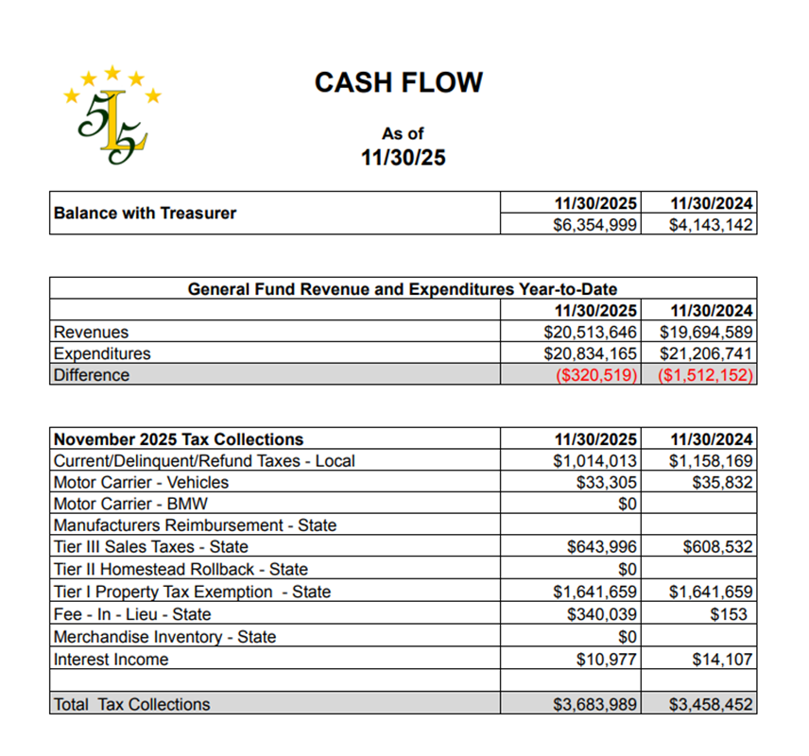

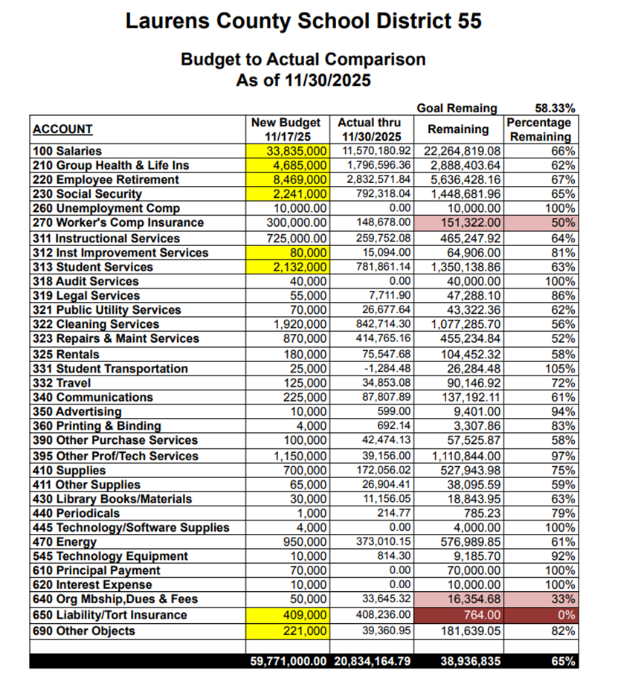

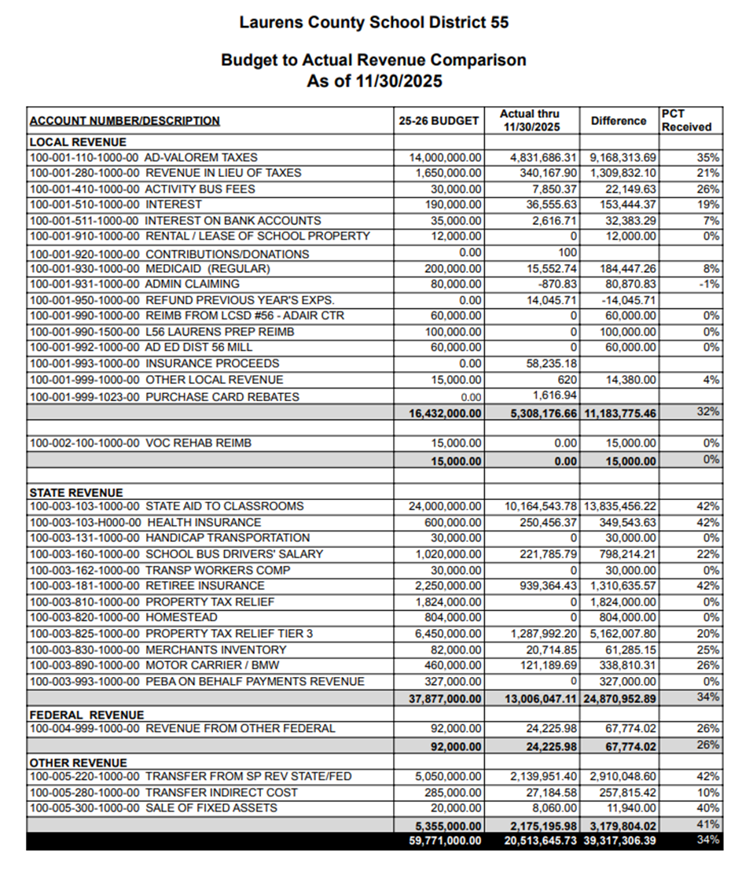

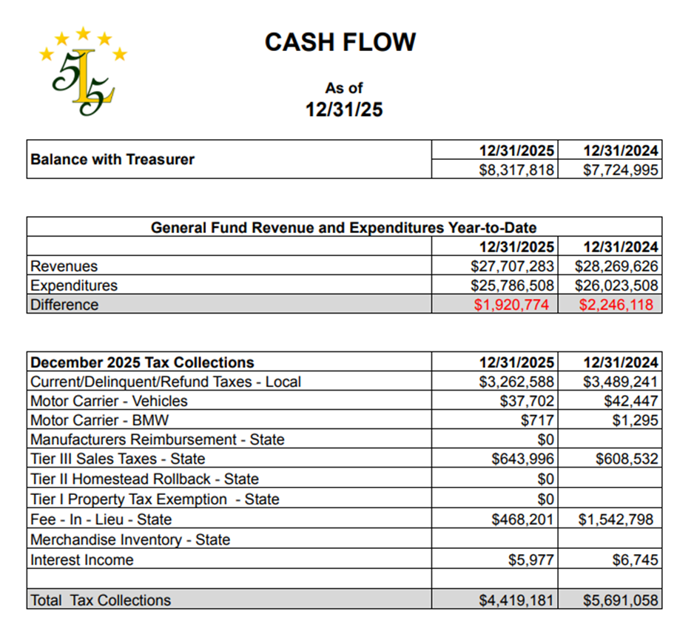

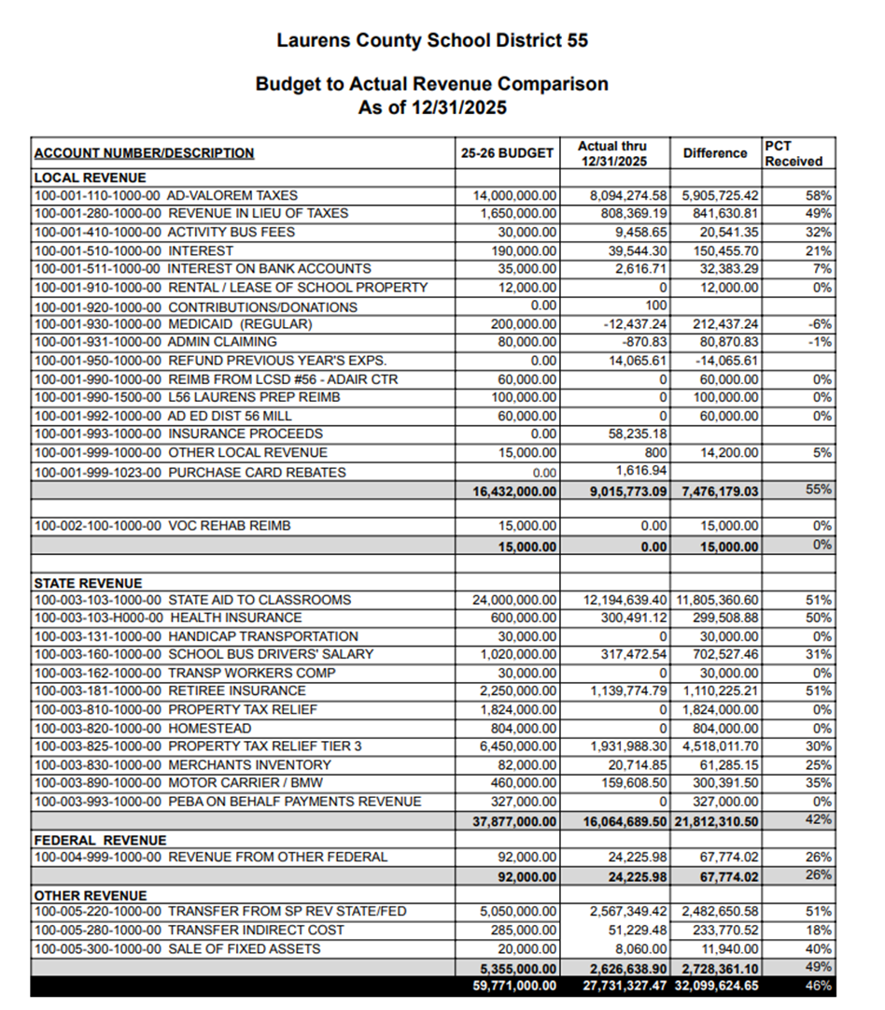

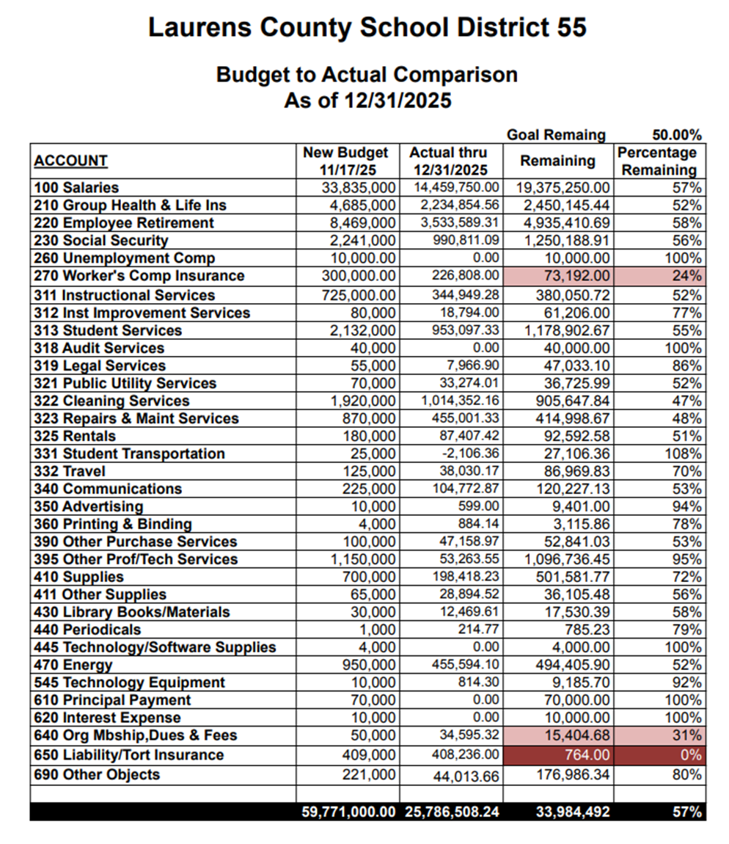

- Capital Projects Budget Amendment - Dr. Penland presented the board with a Capital Projects Budget Amendment request. Along with $4 million from ESSR Funds, the district budgeted $1.6 million for the addition at Sanders Middle School, but only needed $500,000. Dr. Penland requested that the board allow the $1.1 remaining in the Sanders addition fund to be allocated to other items that need Capital upgrades, such as athletic upgrades, bathroom upgrades, and security measures. Mr. Chip Jenkins made a motion to allow this transfer of the Capital Projects Budget, and Mr. Mike Hughes seconded. The board voted unanimously in favor.

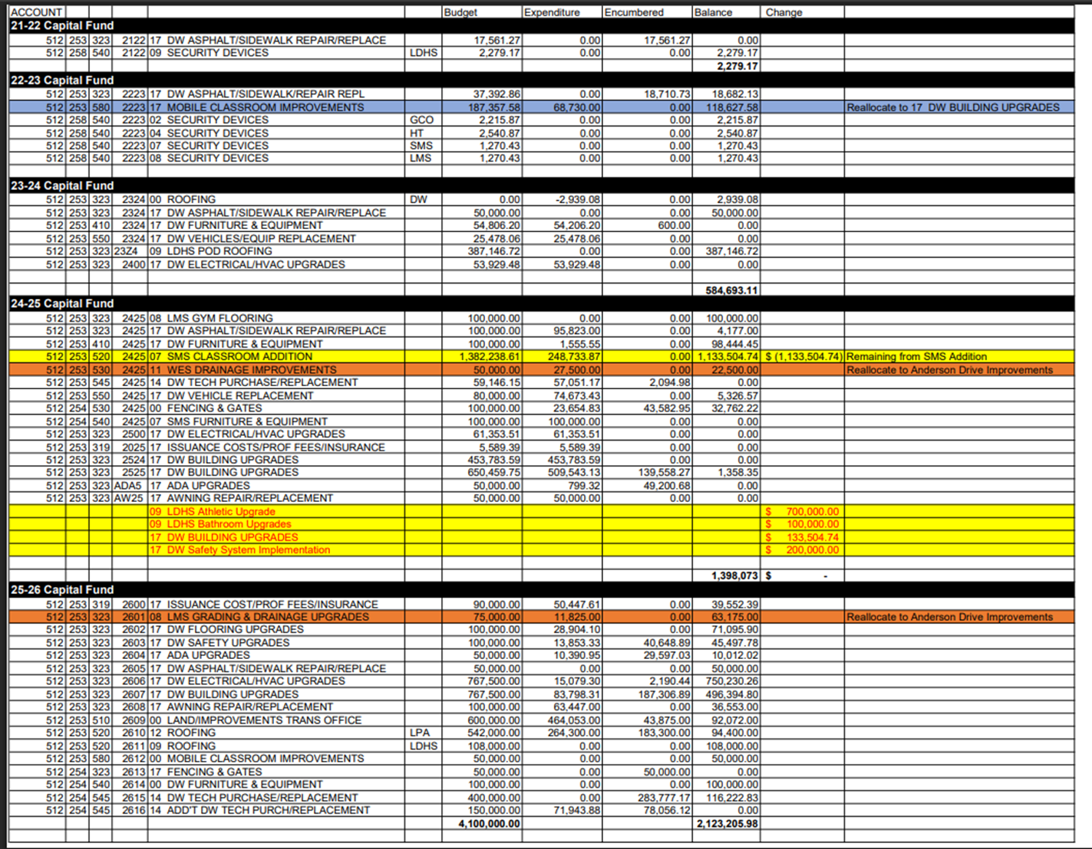

MOTION TO ENTER EXECUTIVE SESSION - Mr. Mike Hughes made a motion to enter into Executive Session, and Mrs. Tabitha Keitt seconded. All were in favor.

EXECUTIVE SESSION - The board entered into Executive Session at 7:30 p.m. to discuss:

- Updates for Certified Employee Contracts and Retiree Employment Lists for the 2025-2026 School Year
- Legal Updates

RECONVENE IN OPEN SESSION - Mrs. Cathy Little called the meeting back to order in open session at 7:43 p.m.

ACTION ON EXECUTIVE SESSION - Mrs. Little stated there was action needed from the Executive Session to approve a list of employee contracts and resignations. Mrs. Little stated that they would need a motion to approve the list of certified resignations. Mr. Mike Hughes made a motion, and Mrs. Heather Elders seconded. All were in favor.

ADJOURNMENT - Mrs. Little stated the meeting was adjourned at 7:44 p.m.

Candice Branim Chip Jenkins
Recorder Board Secretary
cbd 2/6/2026

