South Glens Falls Central School District Official Proceedings of the Board of Education
Special Called Meeting - March 16, 2026

The South Glens Falls Central School District Board of Education, Saratoga County, New York, met in a Special Called Session on Monday, March 16, 2026, in the High School Library, 42 Merritt Road, South Glens Falls, Saratoga County, New York.

Call to Order:
President Farrell called the meeting to order at 6:00 PM and led the Pledge of Allegiance.

Members Present:
Haley Brashears, Heidi Brennan, Amanda Cedrone, William Elder, John Farrell, Roger Fedele, Nicholas Healy, Dr. John Leary, Kevin Ostrander

Members Absent:
None

District Administrators Present:
None

Others Present:
Dr. Turina Parker, WSWHE BOCES District Superintendent

ACTION ITEMS:
APPOINTMENT OF CLERK PRO TEM
Motion: Mr. Healy
Second: Mr. Elder
Motion unanimously carried 9 to O appointing Mr. Farrell as Clerk Pro Tern.

AGENDA
Motion: Ms. Cedrone
Second: Mr. Healy
Motion unanimously carried 9 to O approved Consent Item A.

A. Agenda

ADJOURNMENT TO EXECUTIVE SESSION
Mr. Farrell asked for a motion to go into executive session to review the applications for the Superintendent's position.
Motion: Mr. Elder Time: 6:03 PM
Second: Mr. Ostrander
Motion unanimously carried 9 to O approved to enter into executive session.

RETURN TO OPEN SESSION
Motion: Mr. Elder Time: 7:11 PM
Second: Mr. Healy
Motion unanimously carried 9 to O approved to return to open session.

ADJOURNMENT

Motion: Ms. Cedrone Time: 7:12 PM Second: Mrs. Brennan
Motion unanimously carried 9 to O approved to adjourn the meeting.

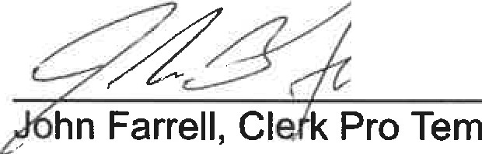
CJ

