We are thrilled to recognize Mrs. Jeannie Baumann as Mountain View Elementary School’s Teacher of the Year for the 2025-2026 school year!
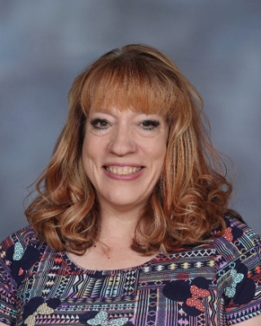
Jeannie has been a teacher with Elko County School District since 2006 and has been part of the MVE family for the last 16 years in kindergarten, first grade, and most recently, as our beloved PE teacher.

Jeannie is an exemplary educational professional at MVE whose unwavering commitment and initiative have profoundly impacted both students and staff. Through her long-standing dedication, she has spearheaded vital initiatives like the Kids Heart Challenge, organized the school carnival, been an active PTA member, sponsored a daily student Running Club, and secured major enhancements such as a climbing wall and professional football camps.

Known for her reliability, positive attitude, and exceptional organizational skills, Jeannie consistently goes above and beyond her role to foster a healthy community. Her colleagues and students view her as a cornerstone of the school, making her the definitive choice for Teacher of the Year as she perfectly embodies the values and standards of educational excellence.

Congratulations, Mrs. Jeannie Baumann!
We are so lucky to have had you as part of the MVE team!

