3K | 4K | 5K | 1st | 2nd | 3rd | 4th | 5th
Book bag large enough to hold a folder  Blanket  Complete change of clothes | 1 small blanket or towel for rest time  Book bag large enough to hold a 3-prong folder | Book bag or backpack  1 box of 8 count “Fine Tip” Black Expo Dry Erase Markers  (2) boxes of Crayola crayons (24 count)  24 count of pencils  8 glue sticks | (2) Primary Journals (blank area at the top of each page)  8 glue sticks  (2) boxes of Crayola crayons (24 count)  Blunt tip scissors  Black dry erase markers | 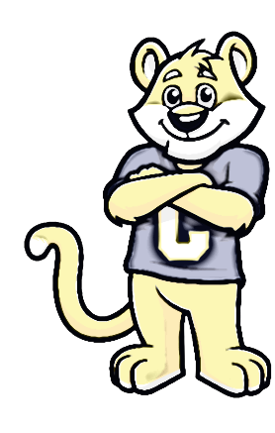  3 Marble composition books (not spirals)  2 boxes of crayons (24 count)  6 glue sticks  Expo markers  1 pack of blunt tip scissors | 3 Marble composition books (not spirals)  2 pocket folders (no holes or brads)  Colored pencils  1 box of Crayola crayons  6 glue sticks  1 Pack of yellow highlighters  Headphones  1 pk of “Fine Tip” black expo markers | 3 Marble composition books (not spirals)  Colored pencils  3 glue sticks  1 highlighter  1 Roll of tape  Expo markers  Earbuds or Headphones  Please do not purchase wireless headphones. | (2) Marble composition book (not spirals)  (2)-3 subject spiral notebooks  (3)-pocket folders (no holes or brads)  Colored pencils  1 Roll of tape  1 Highlighter  Earbuds or Headphones
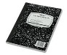
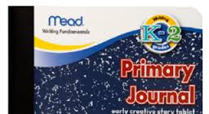
Optional Items:
Kleenex
Hand sanitizer
Baby wipes
Example of a marble composition notebook
Example of a primary journal
Zip lock freezer bags
Pencils


COWPENS ELEMENTARY SCHOOL – SUPPLY LIST FOR 2026-2027

