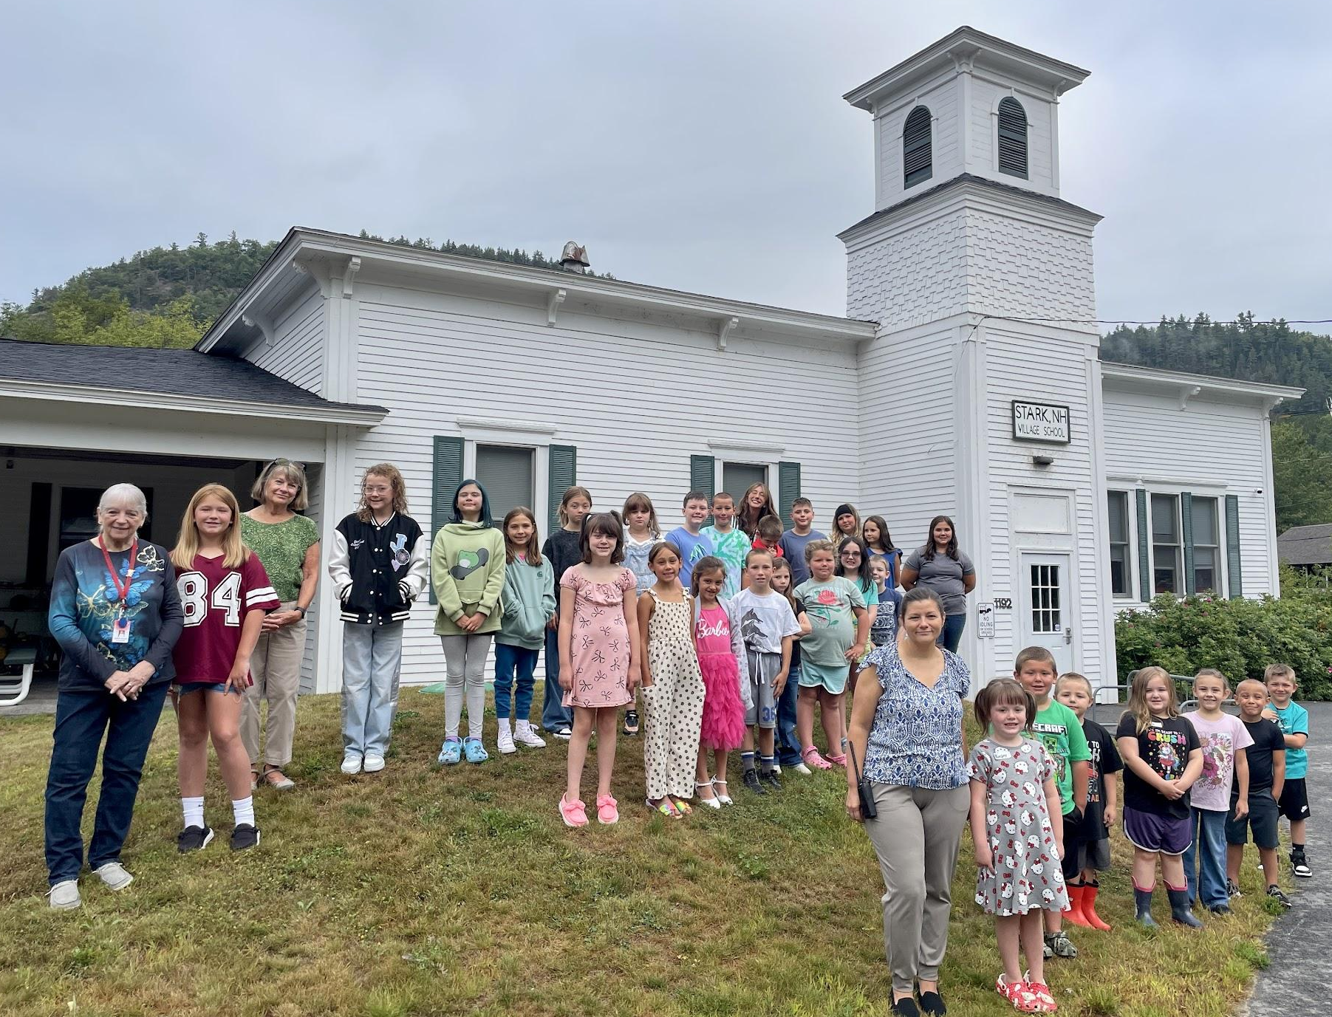

Stark Village School
1192 Stark Highway, Stark, NH 03582
Phone: (603) 636-1092

Katherine A. Landry, Principal

Dear Stark Village School Family and Friends,
While it’s been a lovely summer, we are so excited to get back to what we do best, helping your kiddos succeed! Staff have spent the summer recharging, have redesigned their classrooms, and organized their bookshelves. I’m thankful I got to see so many of you over the summer at drop off for summer school, for ice cream, and at the family fun night.
Classrooms
Mrs. Ann Auger- K/1 Mrs. Kelly Jewell-2/3 Mrs. Helen Martin 4/ 5/6
a_auger@sau58.org k_jewell@sau58.org h_martin@sau58.org
At Stark Village School, priority is creating a safe, engaging space where your child can truly thrive. Great school years are built on strong partnerships, and we deeply value the connection between home and classroom. Please never hesitate to contact your child’s teacher, open communication is key to giving them the support they deserve, and we are thrilled to work alongside you this year.
Morning Arrival & Drop-Off
- 7:30 AM | Arrival Window: Bus pulls up and student drop-off begins. (Note: Buses depart promptly at 7:35 AM for the high school route).
- 7:30 – 7:45 AM | Morning Routine: Once inside, students have time to grab breakfast, order lunch, get organized, and socialize.
- 7:45 AM | Morning Meeting: Our daily school-wide kickoff begins. Please ensure your child arrives with enough time to settle in before 7:45.
Afternoon Dismissal & Pick-Up Routine
- 2:15 PM | Standard Schedule: To keep traffic moving safely, bus riders are released first, followed by walkers and car pick-ups.
- 11:15 AM | Half-Day Schedule: On early release days, students are dismissed at 11:15 AM.

Important Safety & Transportation Notes
- Routine Changes: If your child’s end-of-day plan changes, please send a signed and dated note with them that morning.
- Authorized Pick-Ups: For student safety, we only release children to parents, legal guardians, or individuals listed on your student's Emergency Form. We can’t make exceptions for other family members or past pick-ups without your explicit permission.
- Last-Minute Emergencies: We know unexpected situations arise! If plans change unexpectedly during the school day, call the main office right away to notify our secretary, Mrs. Wentworth.
- Emergency Forms: Please double-check that your emergency contacts and their phone numbers are completely up to date in our system heading into the new school year.
Free and Reduced Lunch Forms
In an effort to reduce paper and to speed up the turnaround time, we will be sharing Free and Reduced lunch forms online through Whitson’s Group or this link, https://linqconnect.com/public/meal-application/new. We encourage all families to complete a Free and Reduced Lunch application, even if you think you may not qualify. Eligibility can change depending on income guidelines, family circumstances, or work status. If your family qualifies, it will not only give students free or reduced meals costs (breakfast and lunch), it could also potentially provide our school with extra funding. In the past we have missed this funding by one student. If you are unable to complete a copy online please reach out to us and we will provide you with a paper copy.
Family Vacation/Educational Opportunity
As a reminder families may request up to 5 days of vacation or educational opportunity to be counted as excused absences. To make this possible, we ask that you contact Ms. Landry and complete the required form at least two weeks in advance. This allows teachers to prepare curriculum materials to help your child stay on track. For the absences to be excused, all assigned work must be completed and turned in on the day your child returns to school, and permission must have been granted beforehand.
Our classrooms are organized, our shelves are stocked, and our doors are ready to swing wide open. A brand-new school year is waiting, and we couldn't be more excited to share it with your kiddos!

Sincerely,

Ms. Landry

