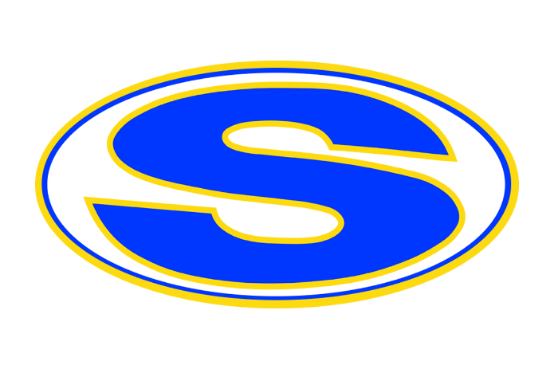
sunnyvale health

adisory committee

Minutes
Date: September 24, 2024
Time: 4pm
Facilitator: Amy Tutle

Board members
Robin Platt | Sarah Mitchell | Melissa James | Danielle Hawkins | Juany Gaytan | Vlasta Pinto | Justin Mathew | Sinu George | Jennifer Rountree | Alex George | Travis Hammond | Amy Haberman | Ruth Thomas | Heather Morris | Anju Mathew |Jency Jacob
Time | Item | Owner
4pm | Welcome | Amy Tutle
4:10pm | Introductions of New Members | Amy Tutle
4:20pm | Duties of SHAC | Amy Tutle
4:25pm | Officer Nominations  - Co-Chair: Amy Haberman  - Co-Chair: Ruth Thomas  - Secretary: Sinu George | Amy Tutle
4:30pm | Discussion of Fentanyl Poisoning Awareness Week | Amy Tutle
4:40pm | Ideas  - Red Ribbon Week, October 2024  - Drug Awareness Week, Oct 28-Nov 1  - Possible Educational Topics to Add: AED use, CPR, Narcan use, Epi Pen use, Seizures, Suicide, Child Abuse, Human Trafficking, Vaping, Bullying, Social Media  - Education Distribution: Live vs virtual meetings, piggyback off of already planned school events, emailing YouTube videos  - Create a SHAC email to send out information out to parents
5pm | Adjournment | Amy Tutle

