

Search for the student associated with the parent account.

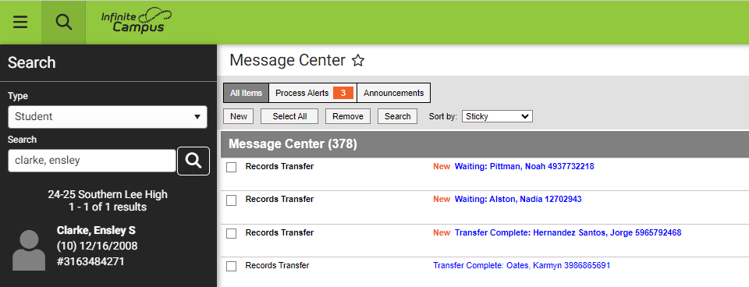



Go to Census > People > Relationships.
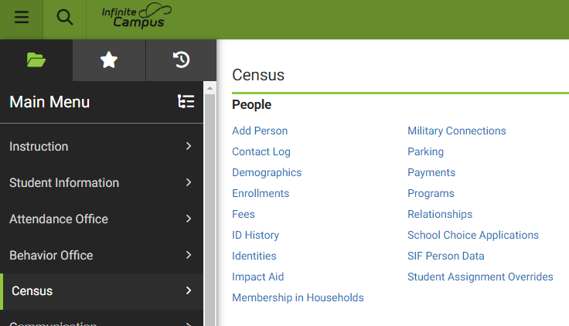


Ensure that the student’s guardians are marked with guardian (if applicable), mailing, portal and messenger.
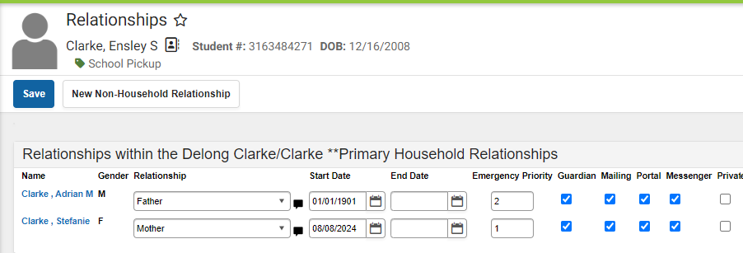


Then click on the name of the guardian seeking a Campus Parent account. IMPORTANT: You should be on the guardian page, not the student. Notice that from the guardian view, you can still see all students connected to that guardian (see red arrow for an additional student connected to the guardian). All connected students will appear in Campus Parent. Make sure the connected students do not have an end date.

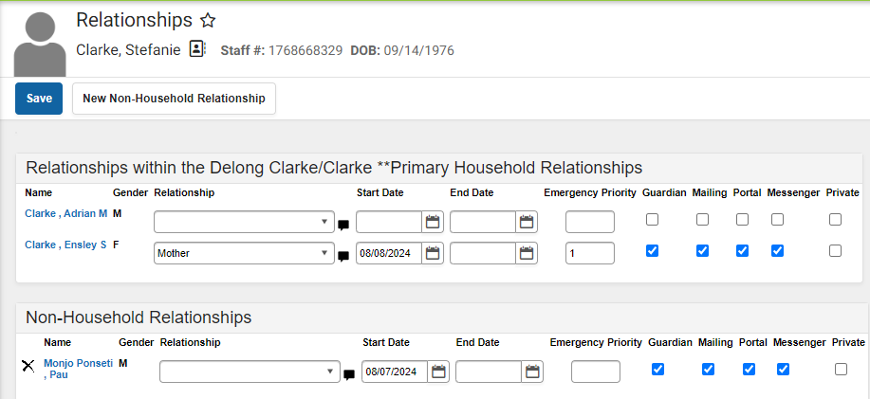


Click on the demographics within the guardian account.
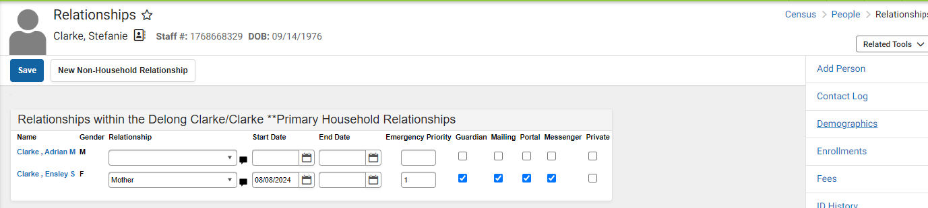



Go to the Person Identifiers in Census > People > Demographics.

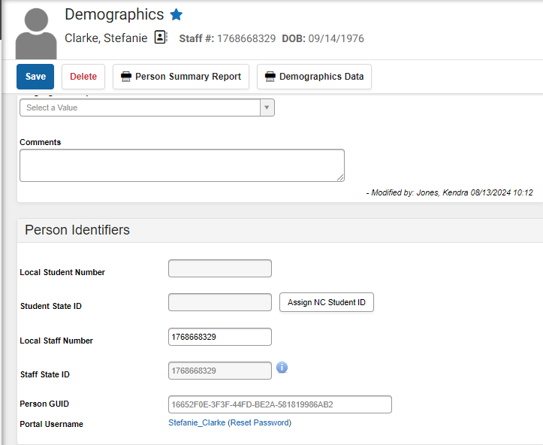


Cut and paste the GUID to the user, following the instructions. A fillable PDF will be distributed soon.

Welcome to the new Campus Student and Campus Parent portals!
Campus Student and Campus Parent put school information at your fingertips with real-time access to announcements, assignments, attendance, grades, schedules, and more! To get started, follow the steps below.
- Download the Campus Parent app from the App Store or Google Play.
- Open the app and search for your District Name and State. Skip to Step 6.
- If using a web browser, visit infinitecampus.com and click Login at the top right.
- Search for your District Name and State. Select your district from the list.
- Click Parent/Student and then click Campus Parent.
- Click New User?
- Enter your Activation Key in the space provided and then Submit. The activation key was sent to the guardian email address at your child's school.
- Enter a Username and Password and click Submit.

