July 17, 2023

Memorandum

To: Leadership Team

From: Mike Alba, Director, Professional Learning and Development
Lynnette Thorstensen, PD Specialist, Professional Learning and Development

Re: Frontline Training for Professional Learning Management System

Training for the new Frontline Professional Learning Management tool will be provided to all users. For those with specific roles for course creation and management of in-service credit, there will be live sessions that will be recorded and made available to all School Site Inservice Representatives and all ESF Course Creators. Both of these roles will now require users to submit a course proposal that will be approved by the Office of Professional Learning and Development. This will ensure consistency as we launch this new software. Evaluation training will be completed by anyone responsible for evaluating employees. Below you will find training information to assist your staff in connecting to the training that is right for them. We ask principals, directors, and managers to make sure this information is provided to the correct individuals.

Mandatory Pre-planning User Training: Principals, please use the YouTube link below to show this 15 minute video to all staff. You can choose the date and time, but it must be shown during pre-planning. This should include all staff.

https://youtu.be/-N33hiUyWXs

Defining Roles and Training Plan

User Type | Description | Training
General Frontline User  (Inservice Only) | Instructional and Non-Instructional Staff NOT responsible for the creation of courses or management of in-service credit | Users will access Frontline through Launchpad. Once signed into the platform, users will have access to training videos. All staff will watch the video (linked above) during pre-planning. Additional training videos are located on the Insights Landing Page in Frontline.
ESF Course Creators | Instructional and Non Instructional Staff working at the district office and responsible for the planning, implementing, and executing of professional learning | Live Virtual Session on July 24, 2023 from 9am-12pm  OR  Live Virtual Session on July 31, 2023 from 9am-12pm  ENROLL HERE  (These are identical sessions, choose to attend only 1 of them)
School Site In-service Representative | Instructional and Non instructional staff working at a school site and responsible for the planning, implementing, and executing of professional learning OR have the responsibility to create PD activities in the catalog and then award attendance and credit to participants | Live Virtual Session on July 24, 2023 from 9am-12pm  OR  Live Virtual Session on July 31, 2023 from 9am-12pm  ENROLL HERE  (These are identical sessions, choose to attend only 1 of them)
School Administrators, Directors, District Coordinators  /Managers/Supervisors | Anyone responsible for completing evaluations for instructional and non-instruction personnel | Live Virtual Session on July 24, 2023 from 1-3pm  OR  Live Virtual Session on July 31, 2024 from 1-3 pm  ENROLL HERE  (These are identical sessions, choose to attend only 1 of them)

If someone is unable to attend the Live Virtual Sessions, they will be recorded and links will be provided for individuals in need of training.

Virtual Office Hours for ESF Course Creators and School Site Inservice Reps will also be available to provide additional support. This would be a designated time to for system users to ask questions about building courses and managing those courses within the system. The office hours would NOT cover any training topics related to evaluation. The sessions will be as follows:
Date | Zoom Link
August 4, 2023 8:00am-12:00pm | https://brevardschools-org.zoom.us/j/82575130891
August 15, 2023 1:00pm-4:00pm | https://brevardschools-org.zoom.us/j/87357129990

Training will be ongoing and multilayered throughout the school year. Additional training will be provided specific to understanding our BPS Inservice Records, information on that training will be forthcoming.

Please be aware, inservice records may NOT be available until after the start of the school year. School Principals will be notified when the historical records become available, and in turn would then notify teachers.

Finding Additional Training Information on Frontline:
The Frontline icon will be made available to Staff within the BPS Launchpad on July 24

Step 1 – Sign in through Launchpad
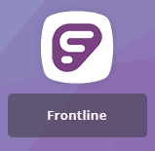

Step 2- Once signed in click on Insights in the left side navigation
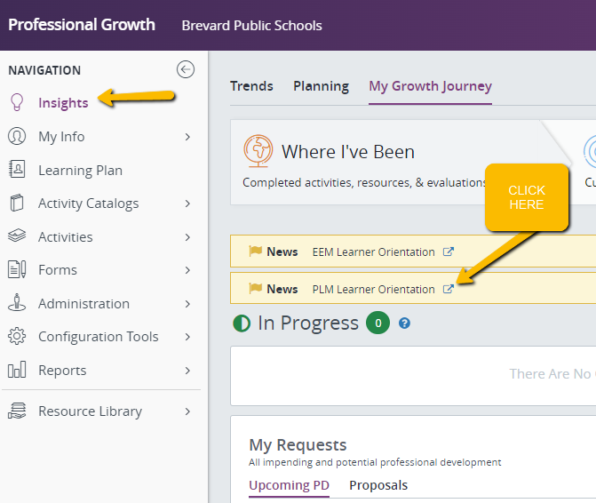

Step 3-Click on hyperlink to find additional training
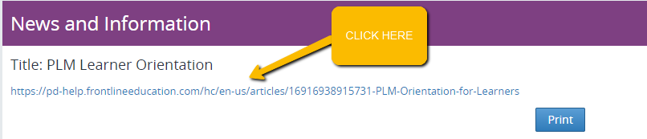

If you have any questions or need further clarification regarding training, please reach out to Lynnette Thorstensen by email at thorstensen.lynnette@brevardschools.org or by phone at 321-633-1000 ext. 11175.

Approved by:__________________________________
Ryan Dufrain, Assistant Superintendent
Human Resources Services

