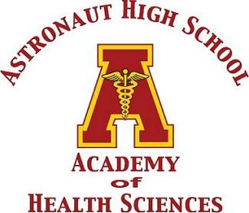

The 2023 Astronaut High School
Health Sciences Scholarship
Information Packet
This scholarship is available for Astronaut High School Seniors who participated in the AHS Health Sciences program and are pursuing a career in the Health Sciences.

The DEADLINE for applications to be submitted to Mrs. Duncan is Tuesday, May 2, 2023. No late applications will be accepted!

In order to be considered, the student must submit the following items together:
_________ Completed Application Form
_________ Letter of Recommendation
_________ Resume of High School Accomplishments/Activities
_________ Copy of College Acceptance Letter*
_________ Essay (Typed – One Page, double spaced)

*The scholarship payment will be made directly to your university/college. You must be Full-Time in Fall 2023.

2023 Astronaut High School
Health Sciences Scholarship
Application Form

Full Name: ________________________________________________________

Address: _________________________________________________________

__________________________________________________________

Phone: ___________________________________________________________

Email Address: ____________________________________________________

Parent/Guardian’s Name: ____________________________________________

Parent/Guardian’s Phone: ___________________________________________

College You Will Attend: _____________________________________________

High School GPA: Weighted ___________ Unweighted ___________

_______ Yes, I will be attending college Full-Time in Fall 2023.
*Required – 12 credits minimum (4 classes)

Please attach the following:
- One Letter of Recommendation from a teacher or a counselor
- A resume with your high school accomplishments/activities
- A copy of your University/College Acceptance Letter
- Type a one-page essay (double spaced) explaining your plans for a career in Health Sciences. How do you plan to achieve that goal? How did your experiences in the AHS Health Sciences program affect your future plans?

