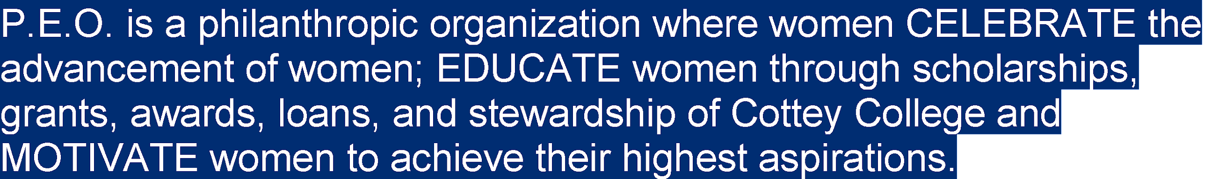

Florida P.E.O. Scholarship (FPEOS)

Eligibility – Need based scholarship
- Florida resident (female) who is a citizen or permanent legal resident of the U.S. or Canada
- Accepted for admission for first year of full-time post-secondary (collegiate) study at an accredited Florida college or university (private or public)
- Dual enrolled high school students are eligible
- Pursuing a course of study leading to associate’s or bachelor’s degree
- Sponsored by a Florida chapter of the P.E.O. Sisterhood
- Meets requirements of scholarship, character, and financial need
- Has high scholastic standing as measured by GPA of 3.0 or greater, class rank and standardized test scores
Scholarship Amounts
- Awards up to $2,500 for tuition and fees.
- Renewable for second year of full time study (24 hours in an academic year) pending submission of a completed renewal application, minimum 3.0 cumulative collegiate GPA, and sponsoring chapter recommendation
Deadline for Application
- Application due to sponsoring chapter no later than January 15 with chapter sponsorship documents to Florida State Chapter no later than February 1.

Connect with a local chapter for more information by filling out the form at this link: Interest form for Florida P.E.O. Scholarship

