**Parent Resource Links for Read-At-Home Plan**

**The Thrive by Five website will host a variety of resources and helpful information at the click of a button for families in Brevard County. Together, education, healthcare and businesses are partnering together to ensure that every child in our community can Thrive by Five. To learn more about the Thrive by Five program, please visit** [**www.brevardschools.org/ThrivebyFive**](http://www.brevardschools.org/ThrivebyFive)**. To watch an introductory video, please visit:** [**Thrive By Five 2021 - YouTube**](https://www.youtube.com/watch?v=VcoTWotaXSc)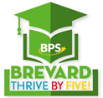

**Supporting Your Child’s Reading at Home (K-3)**

<https://ies.ed.gov/ncee/edlabs/regions/southeast/foundations/index.asp>

**Tips for Supporting Reading Skills at Home**

<https://ies.ed.gov/ncee/wwc/Docs/practiceguide/wwc_fr_tips_022118.pdf>

**Evidence on Tips for Supporting Reading Skills at Home**

<https://ies.ed.gov/ncee/wwc/Docs/practiceguide/wwc_fr_tips_summary_022118.pdf>

**Reading Rockets Monthly Parent Letters**

<https://www.readingrockets.org/newsletters/extras>

**Reading Tips for Parents (Multiple Languages)**

<https://www.readingrockets.org/article/reading-tips-parents-multiple-languages> -

**FCRR for Families** - <https://www.fcrr.org/families>

**At Home with FCRR - Student Centered Activities introduction for use at home** <https://www.youtube.com/watch?v=GaM7oQQn-iY>

**FCRR’s You Tube Channel – FCRR Student Centered Activities Videos** <https://www.youtube.com/user/FCRRFSU/videos>

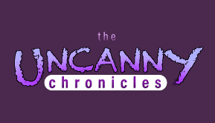 <https://improvingliteracy.org/kid-zone/uncanny-chronicles>

***Uncanny Chronicles, takes you on journey with Kayla as she confronts reading challenges in this adventure series. Each episode presents Kayla with a new obstacle from struggling with dyslexia to coping with social and emotional issues.***

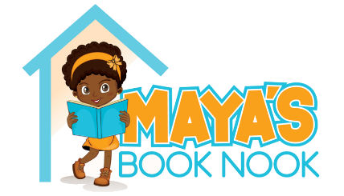<https://mayasbooknook.com/>

**Maya’s Book Nook promotes language and literacy skills through diverse children’s literature.**

**Take 20 for Families** – <https://www.fldoe.org/academics/standards/just-read-fl/just-take-20/families/>

**Just Read, Families!** - <https://www.fldoe.org/academics/standards/just-read-fl/families/>

**BPS – Summer Reads – Provides book title by grade level bands and other resources to motivate readers** - <https://sites.google.com/a/share.brevardschools.org/librarymedia/summer-reading?authuser=0>

**Snap and Read – eLearning Toolkit that can be used at home and at school** - <https://sites.google.com/view/bpssnapandread/home>

**Learning Ally** – Audio library available for students identified with a reading deficiency.

[**https://improvingliteracy.org/kit**](https://improvingliteracy.org/kit)

[**https://qmi-fcrr.shinyapps.io/CBMatHome/?fbclid=IwAR32SXB2Ko6PbzDpkwbZj3MBEXL2D32CrHGlPUg5v1EUe5yIqf9MKgB0rjI**](https://qmi-fcrr.shinyapps.io/CBMatHome/?fbclid=IwAR32SXB2Ko6PbzDpkwbZj3MBEXL2D32CrHGlPUg5v1EUe5yIqf9MKgB0rjI)