How to Create a Course in Frontline
Prep Step – Make sure you have visited the Brevard Professional Learning Catalog and chosen the correct component to align with your professional learning. Find the catalog here
Step 1- Log into Frontline using Launchpad (charter school course creators will need to bookmark the site after creating their log in)
Step 2-Once logged in, go to FORMS in the left side navigation and click on BPS District/Site Catalog Proposal
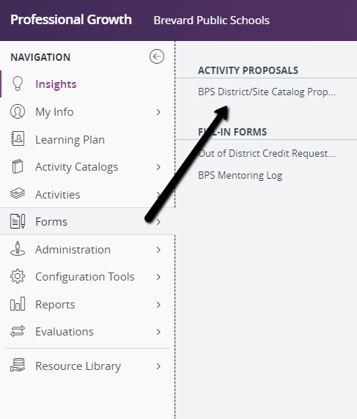
Step 3-When the form comes up, you will need to complete the following:
Start by selecting a template, if you cannot find the component you chose from the catalog within the template listing, then go directly to the next step and choose the component # from the drop down. The component description will NOT auto-populate so you will need to copy the course description from the component in the catalog.
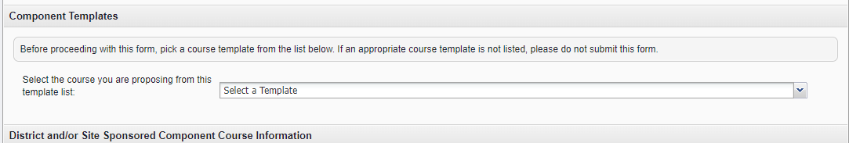
OR
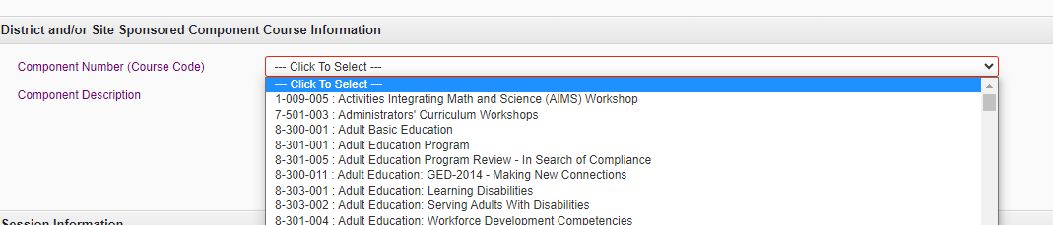
Step 4-Session Information
In this section you will choose the Title. This will be the actual description of the course (ex. Reading-Exploring Structured Literacy). If it is a school based course, place the name of the school in the Session Title (ex. Atlantis Elementary-Cooperative Learning Strategies)
In Session Description thoroughly describe what teachers will be learning at the training and include the connection to student outcomes (Why are they learning it?)
Step 5-DOE Collection and Reporting
PD Learning Method- What type of course is it and how is it instructed. How are you delivering the content?
PD Evaluation Method Staff-At the conclusion of the training, what is the expected outcome for the participant. What do you expect them to be able to do once they have this information?
PD Evaluation Method Student-What type of assessment will be evaluated to determine the impact of the training? What measure will be used to know if the participants made an impact on students? If you are using G, then this is a training individuals would only be able to receive points for ONE TIME within their validity period. Multiple credits can only be issued when student impact is being shown. Rule 6A-5.071 Professional Learning Catalogs
PD Implementation Method-What type of product or activity are participants creating to show their learning?
Step 6- Primary Purpose
This selection is made based off of the final alpha in the component. Most of our components end with C, however there are a few exceptions. This would be noted when you choose your component from the PLC (Professional Learning Catalog). If you are acting on behalf of your principal and assistant principal, it is important for the person planning the training to choose the component.
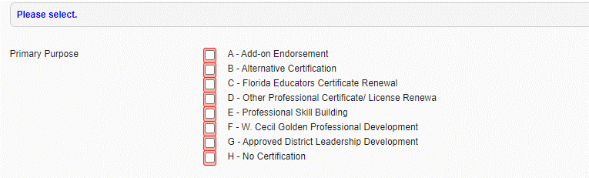
Step 7-Credit Type – This field will be determined by our office, you can leave this BLANK
Step 8- Primary Target Audience-This field is optional. Course creators may choose a specific target audience for their training. Teachers and support can search using this flag.
Step 9- Dates/Times/ Locations- You would need a different meeting date for each meeting if it is a multi-day training.
Step 10-Start and Stop Showing in BPS Professional Learning Catalog- Start date when you want people to be able to see the training in the catalog. Stop it ONE DAY AFTER the date of the training.
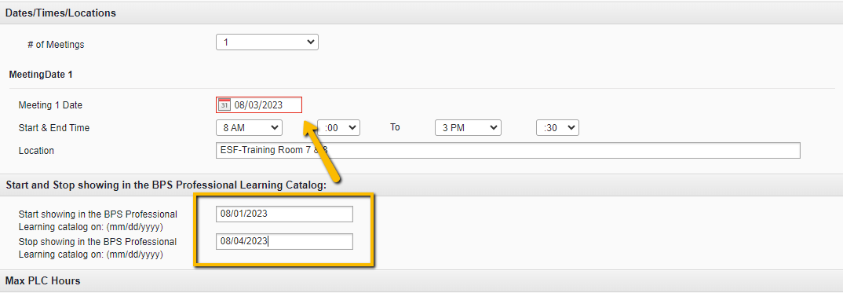
Step 11-Max PLC Hours- The first one is the number of hours allowed by the component. It is usually 60. If you are using a template when you create the course, it will be automatically populated. The Total Hours box should match the number of hours for the course. If it is a full day course, then you should subtract the lunch time (8:00 a.m.-3:30 p.m. = 6.5)

Step 12-Follow up Assignment- Every PL activity MUST have a follow up implementation, but you are not required to add it to the course. However, it is a best practice to add it to the course so it will be in one spot for the participant. No one should be receiving credit for professional learning if there is no evaluation/implementation.
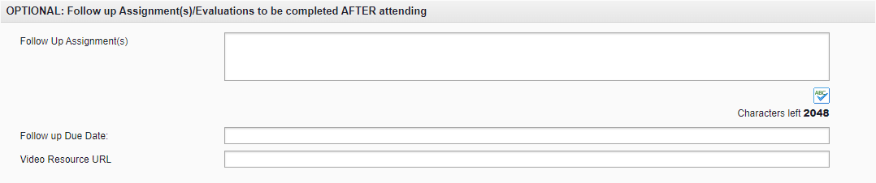

Step 13-Provider Information- Provider Information-If it is being delivered by ESF staff, then the course should be Brevard Public Schools. If it is being delivered at a school, it should be Brevard-School Based Training.
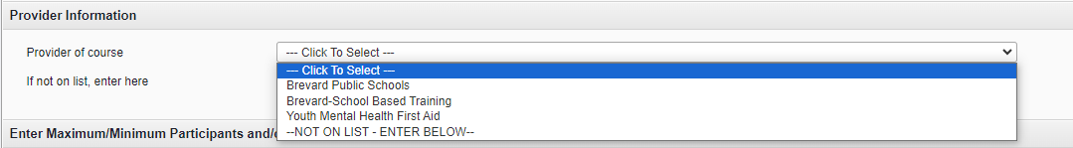

Step 14-Enter Maximum/Minimum Participants and/or Waitlist- Max participants should match your seat availability in the course. Minimum is only required if you will not hold a training with less than a certain amount of people. You can choose if you want to allow for a waitlist.

Step 15-Site In-service Rep and/or ESF Course Creator & PLM or Other Instructor(s)/Presenter(s)- You will use the blue button to select the person who will be issuing the FINAL CREDIT in the course. They are the course creator/or site in-service rep. Then you will select the course instructors, it may be the same person. If there is an outside agency or someone not on the list, you can add them to the Presenters not on the list entry.
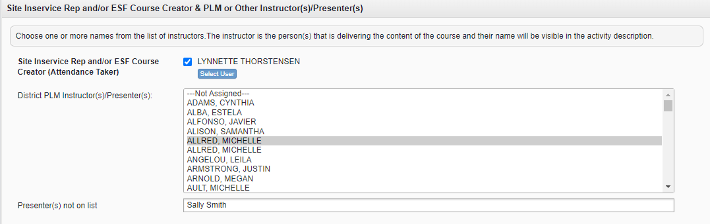
Step 16-Dimensions/Elements- These are the rubrics. It is important to connect your training objectives to the rubric of the group you will be presenting to. All of the rubrics are represented in this section. Rubrics with the word DIMENSION in the title are specific to teachers.
Step 17- FL Educator Standards- This section is directly connected to the first number of the component. Follow this guide:
If the first number in your component is a:
1=Subject Content
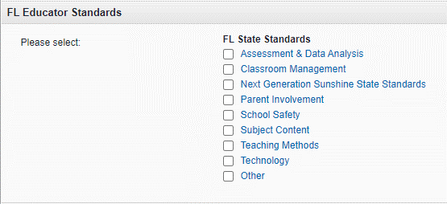
2=Teaching Methods
3=Technology
4=Assessment
5=Classroom Management
6=School Safety
7/8/9=Other

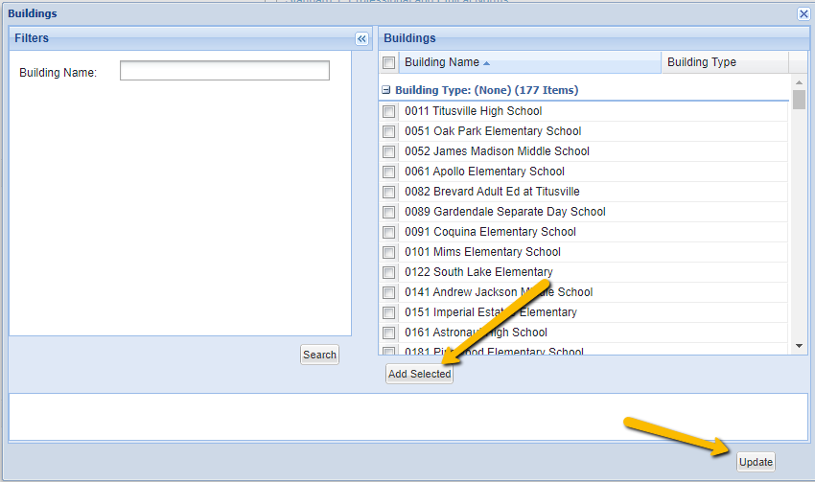
Step 18(optional) Building Restrictions-If you are at a school and would like to restrict the course to only show for people in your building, you can click the blue button, then select your school. You can type the building name to the left. Then you will click ADD SELECTED and UPDATE. This will add the building as a restriction for enrollment.

Step 18 –SUBMIT- Once you have submitted your course you will find it on your learning plan. Once it is approved, you will find it listed in the approved section of your learning plan.

You will go back to manage the activity by going to ACTIVITIES, then ENROLLMENT TOOLS. Then you will search for your course and click the blue hyper link. This will bring you into the different functions of your course.
