How to Register for a Course in Frontline
Step 1- Go to www.brevardschools.org and click on the BPS Launchpad (Charter schools will not use Launchpad, they will create their accounts and bookmark the site)
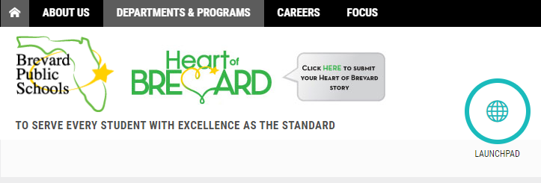
Step 2- Use your Microsoft log in credentials to get into the Launchpad, then find the Frontline App
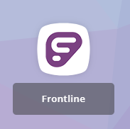
Step 3- On the left side navigation, go to Activity Catalogs then BPS Professional Learning Catalog
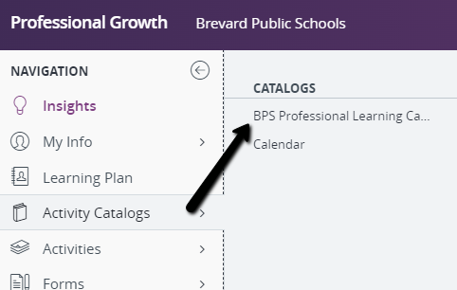
Step 4- Click on BPS Professional Learning Catalog, then in the Search Options type in the name of the training in Search Item. You can search many different ways. Then click SEARCH
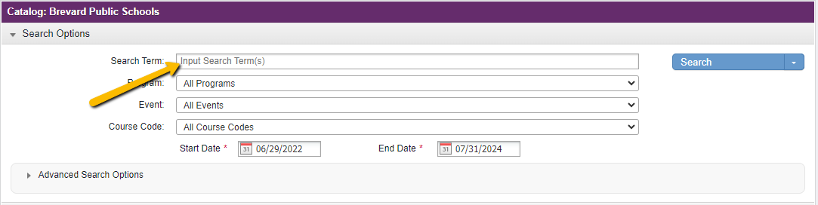
Step 5- When the course comes up you will see a blue hyperlink to enroll in the course.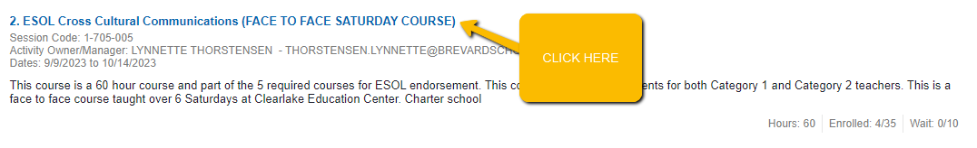

Step 6- Once you are in the course you will see a button at the bottom that says SIGN UP NOW. Click this button.
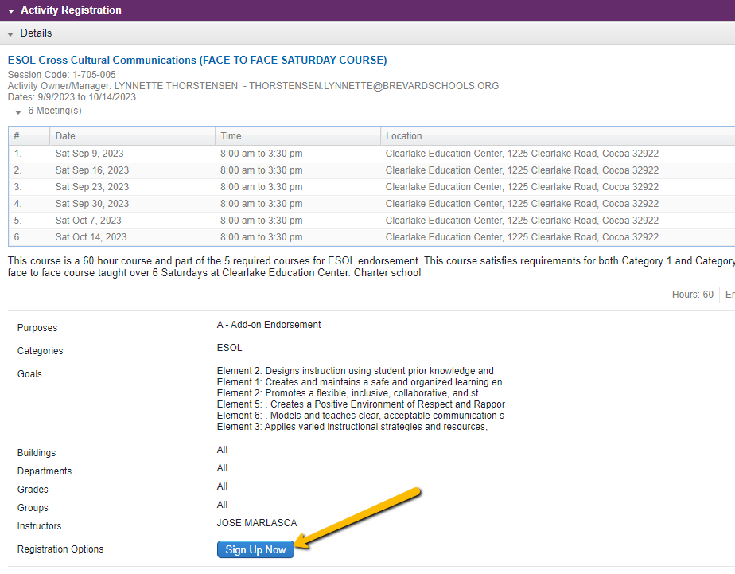
Step 7- You are enrolled. You can return to the Learning Plan (left navigation) to access the course. It will be listed under Approved and/or In-Progress. Click on the manage button to see details about the course. If the instructor has created a Team Room, you will find the room in here.
