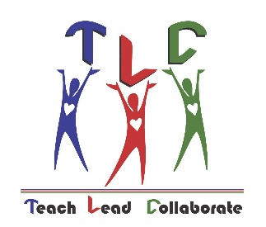Brevard’s Teacher Leadership Council

The Brevard Public Schools Teacher Leadership Council works to promote teacher advocacy, leadership, communication, and service throughout the school district.  The Leadership Council works behind the scenes to accomplish these goals by sponsoring special events, communicating with teachers, district leadership, and supporting pre-service and novice teachers.

Communication

Advocacy

* Facilitate communication between the district office and teachers within local schools
* Inform and educate local teachers and the community about the mission and goals of the Teacher Leadership Council
* Provide opportunities to represent the educational profession and Brevard Public Schools
* Increase teacher awareness of educational policies, legislation and methods of communicating with local and state policy-makers
* Support novice and pre-service teachers through working with first-year teachers, teacher cadets, college student teachers, and veteran teachers
* Promote internal and external support for veteran teachers and the teaching profession as a whole

* Support community programs that benefit students in Brevard Public Schools
* Support the Initiatives of Brevard Foundations Board
* Support district departments not limited to: Teacher Recruitment, Teacher Leadership, Professional Development, Teacher Mentoring, and Teacher of the Year activities

Outreach

Leadership

* Promote teacher leadership within local schools
* Provide leadership opportunities and training for local teachers
* Provide leadership opportunities within the community at local and state levels
* Provide leadership opportunities within the educational profession at local and state levels

Twitter pic #BrevardTLC