How To Award Credit For Inservice

Step 1- Go to ACTIVITIES in the left side navigation, then ENROLLMENT TOOLS and find the activity title for the course you are managing.
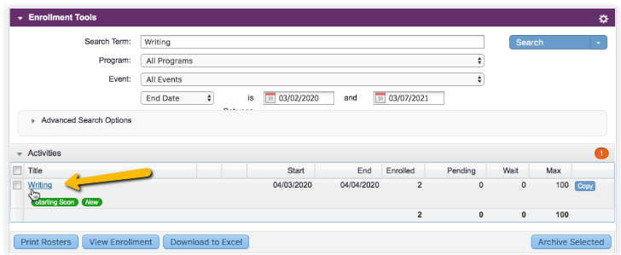

Step 2- Once you can see the different option, choose Confirm Attendance.
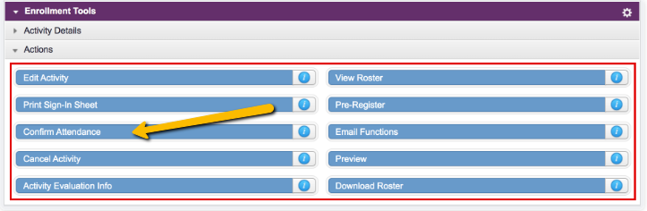

IF THIS IS YOUR FIRST TIME CONFIRMING ATTENDANCE FOR ANY TRAINING ACTIVITIY, YOU WILL FIRST NEED TO SET UP YOUR VIEW OF THE ROSTER. You will do this by going to Change Settings and entering the following:
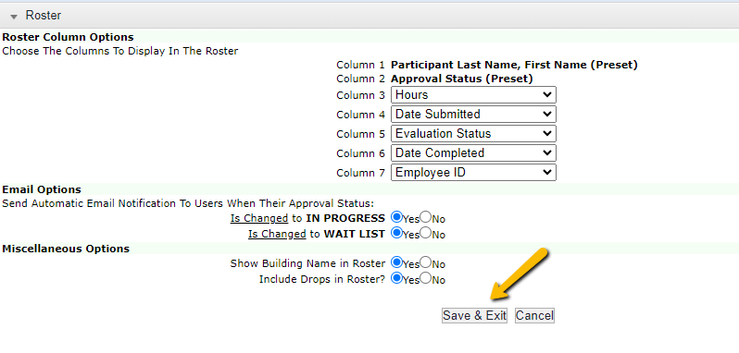
Then you will click SAVE & EXIT. You will NEVER need to do this again. This is how ALL BPS Rosters should be set for completion of credit.
Step 3- After setting up your roster view, you are now ready to complete participants. Before adding credits please make sure ALL participants are accounted for on the roster. If people need to be added, simply search their name at the top and press ADD SELECTED.
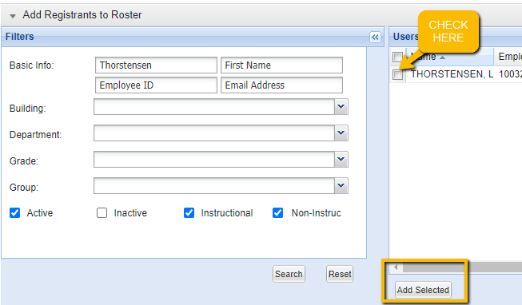

Please do not delete people from the roster, unless they are no longer at your school or never signed themselves up (You added them). Otherwise, they will be marked as a REMOVED or NO SHOW. Removed means you knew they would not be attending, but never took them out. No show means you were expecting them, but they did not attend the course. Please marked as No Show will appear on the roster as “Absent” once they are saved.
Step 4- If everyone is on the roster that should be, it is time to award credit. First go to CHECK ALL at the bottom of the roster. It will place a checkmark next to EVERYONE on the roster. Uncheck anyone that will NOT be receiving credit.
Step 5- Then at the bottom Set Status to COMPLETE and Set Checked to AWARD HOURS, then type in the total number of hours to be award for the training. Then click SAVE.
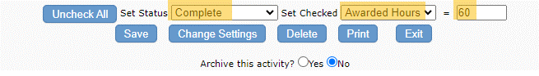
You will then see everyone checked with have a date in their Completed column.
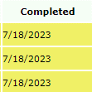
Then go back and repeat the step for NO SHOWS or REMOVED. This time you will place the check mark next to their name then go to the bottom and mark them accordingly. Make sure to place a ZERO in the box next to Awarded Hours.
