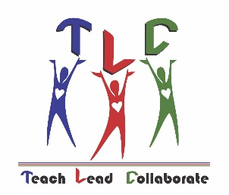
Teacher Leadership Council
“Teach- Lead- Collaborate”
Council Meeting December 13, 2018
5:00 P.M. Facilities Conference Room

Teacher Leadership Council
Overarching Competencies:
- Personal Effectiveness-defines new learning based on individual strengths, styles, and leadership passion;
Nurturing credible and trusting communities of lifelong learners.
Instructional Leadership Competencies:
- Facilitating Collaborative Relationships-Reflects on his or her leadership and its impact on colleagues bringing together diverse perspectives and contexts.
Association Leadership Competencies:
* Building Capacity of Others-Helps others discover their greater potential, and envision and achieve unimagined knowledge and skills, and extends responsibility to others
Main Objective for Today’s Meeting:
Plan for Summit and Meeting with Dr. Mullins
 | Item | Facilitator | Time | Reason
 | Review minutes from November and accept- (Minutes are on Google Drive) | Shruti Raman | 4 min | To identify items for addressing from previous meeting.
 | Dr. Mullins Visit | All | 10 min. | January 17th
 | ABC Awards | Lucy Haddock  Janice Kershaw | 10 min | Review Ambassador Instructions  Teacher of the Year Finalist  Kimberly Heming- Meadowlane Int.  Melissa Vincent- Ralph Williams Elem  Angela Barrons- Challenger 7 Elem  Megan McGivney- Madison Middle  Shannon Kraeling- Eau Gallie High  Carrie Friday- Southwest Middle School  Employee of the Year Finalist  Jessica Abreu- Sunrise Elem  Jeffery Brown- Meadowlane Pri  Carmen Martin- Gemini Elem  Jennifer Lumpkin- Astronaut High  Heather Spinneweber- Rockledge High
 | TLC Summit | Christina Donohue  Lucy Haddock | 20 min | Speakers, Invites, Printing, Agenda, Activities, business partner donations, etc.
 | New Teacher Meet Ups | Linda Buffum | 10 min | Update on program – Replacement for Jessica
 | Adjourn | Lucy Haddock | 1 min | Questions/closure  Rookie Teacher of the Year
Upcoming Events:
Next TLC Board Meeting: January 17, 2019 5:00; Facilities Conference Room
Dr. Mullins Visit with TLC- January 17, 2019
ABC Awards January 23, 2019 King Center
2019 Spring Summit Date: February 28, 2019

