How to Request Out of District In-service in Frontline
Use these directions to request out of district professional learning to be added to your in-service record. Please log into Frontline through the BPS Launchpad if you are a BPS employee. Charter School teachers will use their URL to log into the system.
Step 1- Go to MY INFO in the left side navigation and click on My File Library under the My Information Section
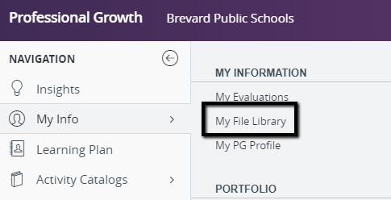

Step 2- Go to My Files, then to the far right you will see Upload a File. Upload supporting documents from your professional learning experience. This includes evidence of the training. You must upload something that shows the hours in attendance. If the certificate of completion contains the points earned, that is all you will need to upload. If the certificate does not specify the hours, you will need to include an agenda marked with the specific sessions attended. If there is no certificate, then you will need to submit an agenda that includes the specific sessions attended. You will also need to include evidence of student impact (the work completed as a result of the training) Evidence of impact could include a lesson plan, an action plan, or some product outlining the impact it has had or will have on student learning.
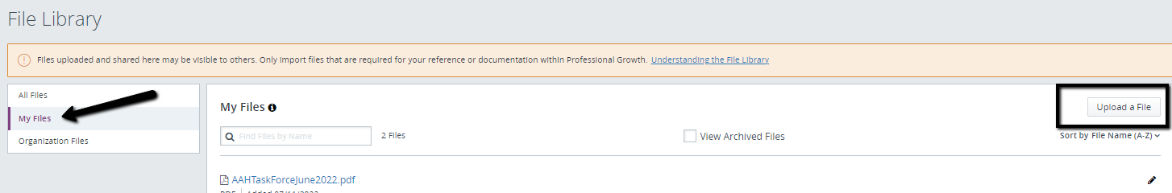

Step 3- Go to FORMS in the left side navigation, the choose Out of District Credit Request
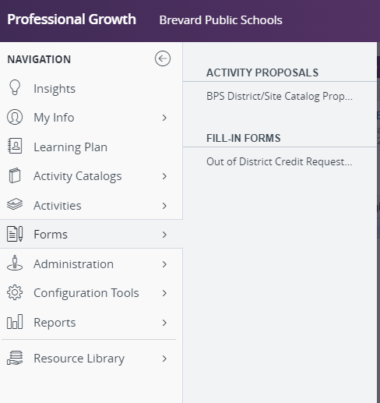
Step 4- Before starting the form, check off the document you loaded so it will be attached to the form.
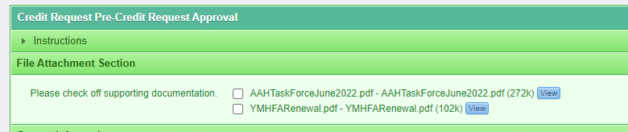
Step 5- Then you will complete the form, you must complete everything highlighted in RED. Once all fields are completed, it can be submitted for approval.
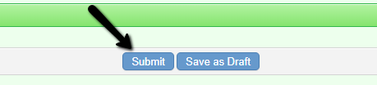
Final approval or denial will appear on the LEARNING PLAN dashboard. All approval requests are routed to Itzel Copley at Copley.delia@brevardschools.org. If changes need to be made to the form, they can either be made by Itzel or they will be denied if further information is required.

