Launch Compass

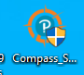
Enter: User Name and Password
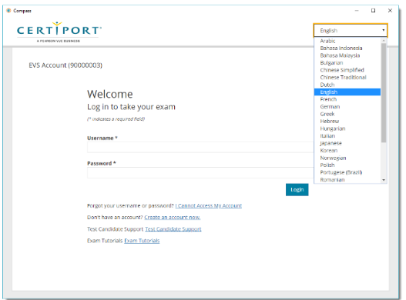
User Name
Password
Select the Program: Microsoft Office Specialist
Exam Group: YES
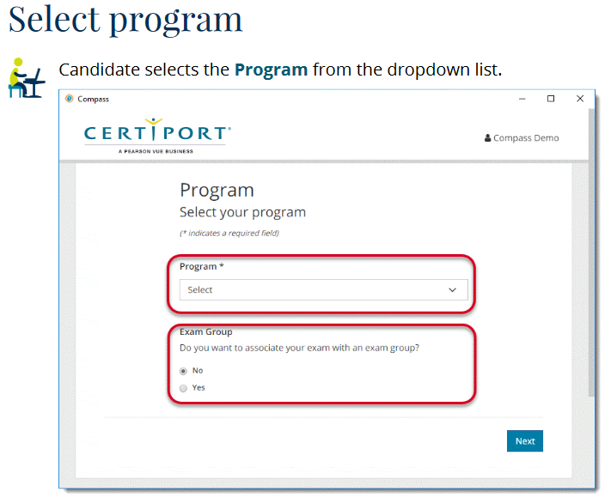
YES
Microsoft Office Specialist
Exam Group: Type the Exam Group Code from your Certiport Log-in Paper.
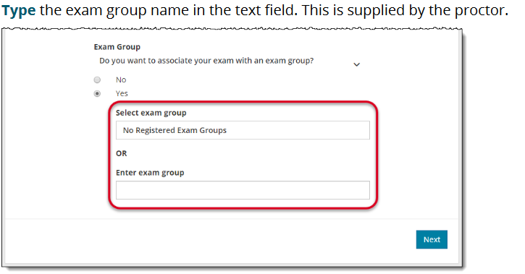
Enter Exam GROUP CODE
From your sheet

NON-Disclosure Agreement: Click YES
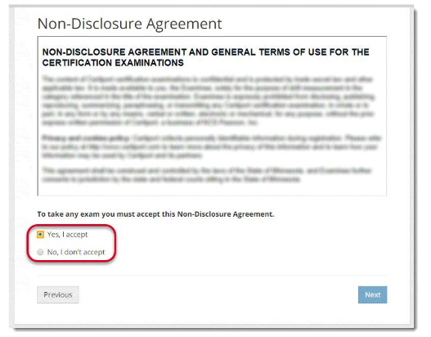
YES
Select Exam: Microsoft Office WORD
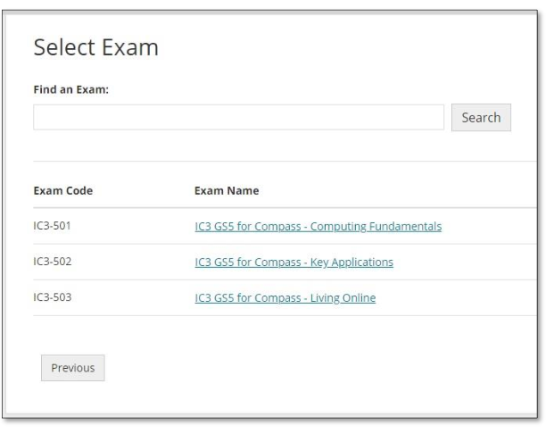
Microsoft WORD 2016
Payment Method: Inventory /Site Licenses
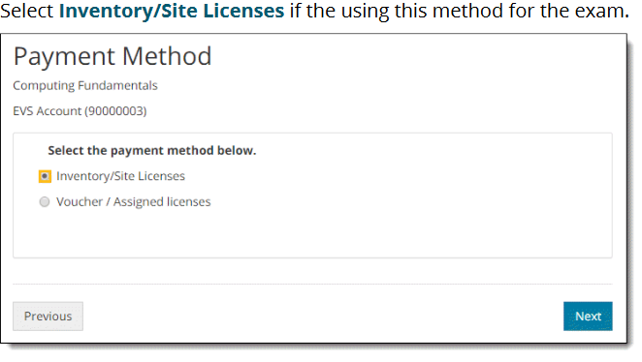
Inventory/Site Licenses
Verify Information: Double check the Test: MICROSFOT WORD
Verify Language is ENGLISH
Proctor must type in Username and Password:
Raise your Hand!
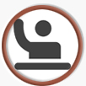
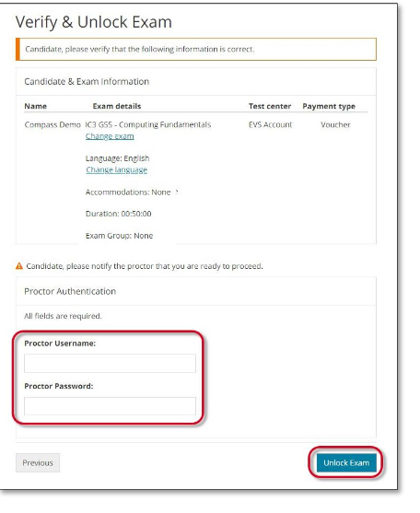
Click Next, Click Next, Next, Next, Next until Exam starts.

