Step 1: Go to https://flcertify.fldoe.org/datamart/login.do

Step 2: Sign into your account or create a new account if you’ve never logged into the new system.
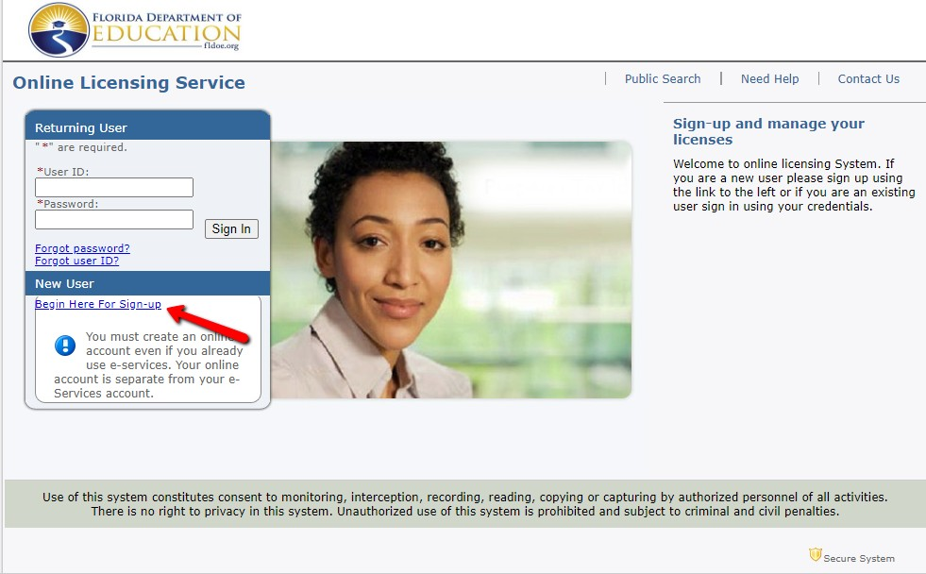
For those completing a new registration, the system will send you an email with a temporary password. You will need to use that to go back into your account and complete the process.
Step 3: Select the application you will need -DISTRICT ADD ON
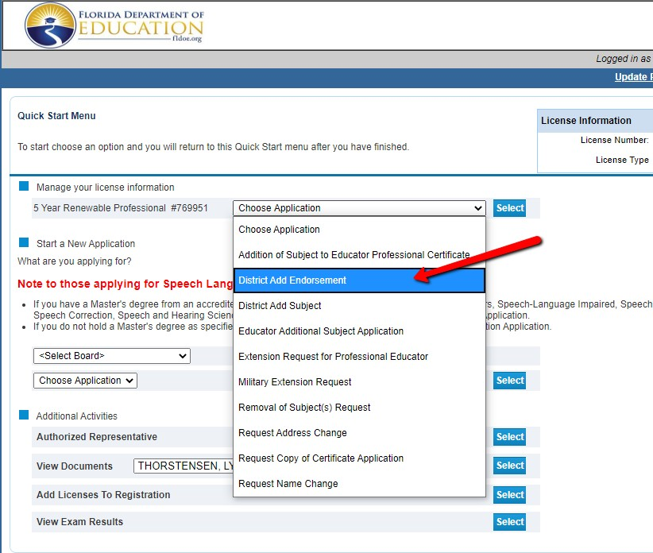

Step 4: Continue through the application, you will be addressing each one of the sections displayed on the left side of the application.
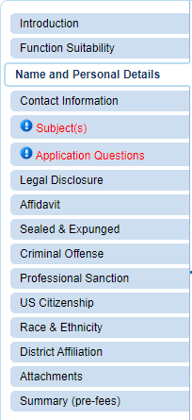
When you go to the SUBJECT(S) page you will go to the section labeled Add New Subject(s) and you will choose E- ENDORSEMENT then in the Subject pull down select the endorsement you are adding.

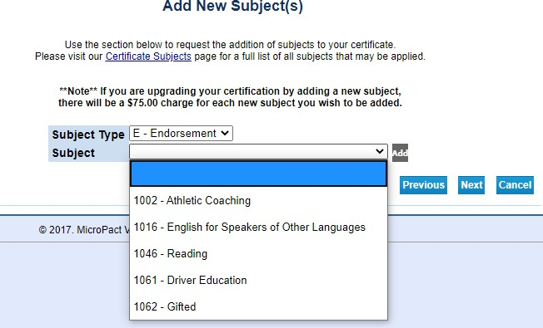
If you are adding more than one endorsement, then you would need to click the ADD link just to the right of the subject pull down. It will populate your first selection right above and allow you to make a second choice. Click ADD after any selection you make before clicking NEXT.

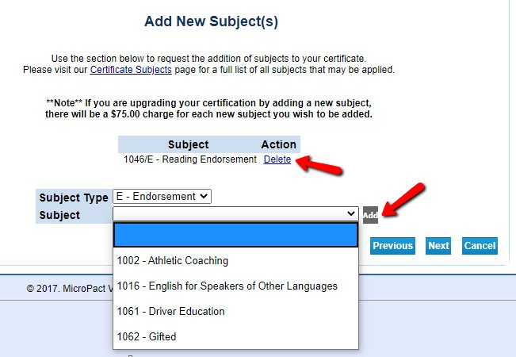

The 8th page of the application is an affidavit. On the PAYMENT AFFIDAVIT please click yes. For district applications you will use our payroll deduction form. If you are adding ESOL or Reading, you will NOT need to submit a payroll deduction. For all other endorsements complete the payroll form and send it to our office using the following email address: certificationdept@brevardschools.org
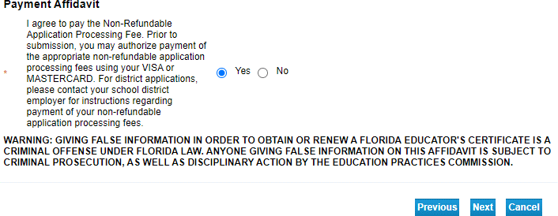
The remainder of the application will be completed, many of the pages will be automatically populated with information from your professional certificate. You should not need to update the district affiliation unless you are new to Brevard. We are BREVARD-District 5 Registered.

You will not need to add anything to the Attachments page. If you took courses through our county add on program, completion will be verified online through our certification office. If you are using test scores (reading endorsement) that will be verified through our office once the scores have been posted to your DOE account.
Look closely at the final summary screen and then click submit.
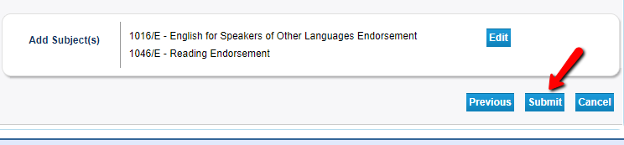
Please email one of the following people once your add on application is complete:

Senior Human Resource Partner
Sharon M. Doran
Doucett-Doran.Sharon@Brevardschools.org

Human Resource Partner
Raquel Figueroa
Figueroa.Raquel@Brevardschools.org

