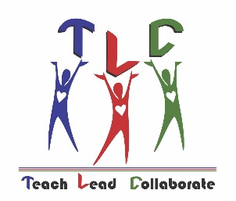
Teacher Leadership Council
“Teach- Lead- Collaborate”
Council Meeting October 11, 2018
5:00 P.M. Facilities Conference Room
Teacher Leadership Council
Overarching Competencies:
- Personal Effectiveness-defines new learning based on individual strengths, styles, and leadership passion;
Nurturing credible and trusting communities of lifelong learners.
Instructional Leadership Competencies:
- Facilitating Collaborative Relationships-Reflects on his or her leadership and its impact on colleagues bringing together diverse perspectives and contexts.
Association Leadership Competencies:
* Building Capacity of Others-Helps others discover their greater potential, and envision and achieve unimagined knowledge and skills, and extends responsibility to others
Main Objective for Today’s Meeting:
Begin to plan summit and clarify roles
 | Item | Facilitator | Time | Reason
 | Review minutes from August and accept | Shruti Raman | 4 min | To identify items for addressing from previous meeting.
 | Member Roles and Expectations | Christina Donohue  Lucy Haddock | 10 min | Communicate role opportunities and revisit committees
 | Roundtable Reflection | All | 10 min. | Determine future changes and next steps to wrap up event
 | Correspondence Protocols | Lucy Haddock | 5 min | Determine process for exiting members, including retirement
 | TLC Summit | Christina Donohue  Lucy Haddock  Janice Kershaw | 15 min | Brainstorm Keynote speaker and formats  Discuss event details needed
 | New Teacher Meet Ups | Jessica Davis-King  Shruti Raman  Linda Buffum | 10 min | Update on program
 | New Business |  | 5 min | Any concerns or questions
 | Adjourn | Lucy Haddock | 1 min | Questions/closure

Upcoming Events:
Next TLC Board Meeting: November 8, 5:00; Facilities Conference Room
2019 Spring Summit Date: February 28th

