Brevard Public Schools
Career & Technical Education

Industry Certification Manual
2021-22

Division of Curriculum & Instruction
Dr. Stephanie Soliven
Assistant Superintendent

Career & Technical Education
Rachel Rutledge
Director

Career & Technical Education Content Specialists/Resource Teachers
Cathy Bramlett
James Johnson
Jenny King
Dennis Soboleski
Michele Thomas

Website: www.CTEbrevard.com

2700 Judge Fran Jamieson Way
Viera, FL 32940-6601

Contents
Purpose 4
- Introduction 4
Federal Requirements 5
- Carl D. Perkins Act 5
- Accountability (Section 113) 5
  - Secondary Indicators 5
  - Post-Secondary Indicators 6
  - State Adjusted Levels of Performance 6
  - Local Adjusted Levels of Performance 6
  - Local Reporting 6
State Requirements 7
- CAPE Academies 7
- Diploma Designation 8
District Requirements 8
FLDOE CAPE Industry Certification Requirements 9
- Teacher Industry Certification Requirements 9
- Test Administration Procedures 9
Process for Identifying Industry Certification Exams and Students 11
- District Level Responsibilities 11
Process for Validating District-Identified Students for Assessments 12
- School Level Responsibilities 12
- Criteria for Changes to the List of Identified Students 12
School Responsibilities for Industry Certification Testing 13
- Scheduling Tests 13
- Proctors 13
- Technical Requirements 13
CTE Dept Chair Responsibilities for Industry Certification Testing 14
- Student Validation 14
- Scheduling Tests 14
- Reporting and Validating Results 14
Teacher Responsibilities for Industry Certification Testing 15
- Student Validation 15
- Scheduling Tests 15
- Administering Tests 15
- Reporting and Validating Results 15

Counselor Responsibilities for Industry Certification Testing 16
- Accommodations 16
Proctor Responsibilities for Industry Certification Testing 17
- Protocol for Breach of Testing Procedures 17
CTE Content Specialist/Resource Teacher Responsibilities for Industry Certification Testing 18
- Teacher and Proctor Training 18
- Scheduling Tests 18
- Administering Tests 18
- Reporting and Validating Results 18
CTE Industry Certification Coordinator Responsibilities for Industry Certification Testing 19
- Student Validation 19
- Reporting and Validating Results 19
- General Related Duties 19
Industry Certification Assessments by Course 20
Industry Certification and Digital Tool Codes 23
Allowable Accommodations for Industry Certification 26
Appendix A – Updates to Rule 6A-6.0573, Industry Certification Process 27
Appendix B - Proctor Agreement 31
Appendix C - Industry Certification Exam Security Log 32
Appendix D - Industry Certification Testing in Progress Sign 33
Appendix E - Process for Verifying Industry Certification Results – AS400/Presto 34
Appendix F - Process for Verifying Industry Certification Results – Performance Matters/Baseball Card 39
Appendix F* - Score Submission Cutoff and Reports Available Chart 39

Purpose
Introduction
In 2007, the Florida Legislature passed the Career and Professional Education Act. The purpose of the act was to provide a statewide planning partnership between the business and education communities to attract, expand, and retain targeted, high-value industry and to sustain a strong, knowledge-based economy. The objectives of the act are as follows:
- To improve middle and high school academic performance by providing rigorous and relevant curriculum opportunities
- To provide rigorous and relevant career-themed courses that articulate to postsecondary level coursework and lead to industry certification
- To support local and regional economic development
- To respond to Florida's critical workforce needs
- To provide state residents with access to high-wage and high-demand careers
To implement the act, the Florida Department of Education (FDOE), the Department of Economic Opportunity (DEO), and CareerSource Florida are partnered together. At the local level, the act mandates the development of a local strategic plan prepared by school districts with the participation of regional workforce boards and postsecondary institutions.
A key component of this act is a list of state-approved industry certifications that are critical to Florida’s employers. The legislation originally tasked the Agency for Workforce Innovation (AWI) with defining “Industry Certification.” The agency has provided FDOE with the following definition:
A voluntary process, through which individuals are assessed by an independent, third-party certifying entity using predetermined standards for knowledge, skills, and competencies, resulting in the award of a time-limited credential that is nationally recognized and applicable to an occupation that is included in the workforce system’s targeted occupation list or determined to be an occupation that is critical, emerging, or addresses a local need.
In 2014, Senate Bill 850 amended s. 1003.492(2), F.S., to include the following definition of industry certification:
Industry certification, as used in this section, is a voluntary process through which students are assessed by an independent, third-party certifying entity using predetermined standards for knowledge, skills, and competencies, resulting in the award of a credential that is nationally recognized and must be at least one of the following:
- Within an industry that addresses a critical local or statewide economic need
- Linked to an occupation that is included in the workforce system’s targeted occupation list OR
- Linked to an occupation that is identified as emerging

Federal Requirements

Carl D. Perkins Act
The purpose of this Carl D. Perkins Act is to develop more fully the academic and career and technical skills of secondary education students and postsecondary education students who elect to enroll in career and technical education programs, by:
- building on the efforts of states and localities to develop challenging academic and technical standards and to assist students in meeting such standards, including preparation for high-skill, high-wage, or high-demand occupations in current or emerging professions
- promoting the development of services and activities that integrate rigorous and challenging academic and career and technical instruction, and that link secondary education and postsecondary education for participating career and technical education students
- increasing state and local flexibility in providing services and activities designed to develop, implement, and improve career and technical education
- conducting and disseminating national research and disseminating information on best practices that improve career and technical education programs, services, and activities
- providing technical assistance that promotes leadership, initial preparation, and professional development at the state and local levels; and improves the quality of career and technical education teachers, faculty, administrators, and counselors
- supporting partnerships among secondary schools, postsecondary institutions, baccalaureate degree granting institutions, area career and technical education schools, local workforce investment boards, business and industry, and intermediaries
- providing individuals with opportunities throughout their lifetimes to develop, in conjunction with other education and training programs, the knowledge and skills needed to keep the United States competitive

Accountability (Section 113)
The Act supports a state and local performance accountability system designed to assess the effectiveness of the state and local funding recipients in achieving progress in CTE secondary and postsecondary student performance.
The state-developed performance measures must consist of core indicators, any additional indicators that the state determines, and the “state adjusted levels of performance” for all the indicators. They must be developed with input from local recipients. States are required to develop performance measures for the following required core indicators identified in section 113 of the Act:

Secondary Indicators
- Academic attainment in reading/language arts, and mathematics as measured by the Florida statewide assessments identified in statute
- Technical skill attainment, including achievement on technical assessments, that are aligned with industry-recognized standards, if available and appropriate
- Student graduation rates
- Student placement in postsecondary education or advanced learning, in military service, or in employment
- Student participation in and completion of CTE programs that lead to nontraditional fields

Postsecondary Indicators
- Technical skill attainment, including achievement on technical assessments, that are aligned with industry-recognized standards, if available and appropriate
- Student completion of an industry-recognized credential, a certificate, or a degree
- Student retention in postsecondary education or transfer to a baccalaureate degree program
- Student placement in military service or apprenticeship programs or placement in high-skill, high-wage, or high-demand occupations or professions
- Student participation in and completion of CTE programs that lead to nontraditional fields

State Adjusted Levels of Performance
The Secretary of the U. S. Department of Education (USDOE) and the state eligible agency will reach agreement on the levels of performance for each of the secondary and postsecondary indicators. With input from the eligible recipients, the state must establish and include in the state plan, levels of performance for each of the core indicators of performance above, as well as any additional indicators. These levels of performance must be expressed in percentage or numerical form and must require continual improvement in the performance of CTE students.

Local Adjusted Levels of Performance
In a manner, similar to the adjusted performance level negotiations between the Secretary of Education and states, local recipients must also establish performance goals. Each local recipient must agree to accept the state adjusted levels of performance as their own local adjusted levels of performance or negotiate with the state for new levels for each of the core indicators established by the state. Local levels must also be expressed in percentage or numerical form and require continuous improvement. Local levels must be identified in the local plan submitted under Section 134. Local Adjusted Levels of Performance for the 2021- 2022 year will be determined once the state has negotiated state performance levels with the USDOE.

Local Reporting
Each local recipient must submit a report to the state each year regarding the progress the recipient has made in achieving its performance levels, including the performance of special populations. Data must be disaggregated for each indicator of performance by specified subcategories of students and the categories of special populations identified in Perkins.

State Requirements

CAPE Academies

State Legislation
- Designation of School Grade – Florida Administrative Code 6A-1.09981 Participation and performance of students taking industry certification examinations on the CAPE Industry Certification list shall be calculated in school grade
- Standard High School Diploma Designation – Florida Statute 1003.4285 established a new Scholar and Merit diploma designation for current and future high school students earning a standard high school diploma:
  - Students may earn a Scholar designation if they satisfy course and testing requirements above-and-beyond those required for a standard diploma (e.g., earn credit in Algebra II and Chemistry or Physics and an equally rigorous science course, pass the Biology I end-of-course (EOC) assessment, and pass future English Language Arts and Algebra II assessments as applicable).
  - Students pursuing a Merit designation must attain one or more industry certifications from the CAPE Industry Certification list. Rigorous industry certifications that articulate to college credit may satisfy up to two math credits and one science credit.
- Calculation of additional full-time equivalent (FTE) membership - Florida Statute 1011.62 Bonus FTE is based on successful completion of a career-themed course or courses with embedded CAPE industry certifications or CAPE Digital Tool certificates, and issuance of industry certification identified on the CAPE Industry Certification Funding List pursuant to rules adopted by the State Board of Education or CAPE Digital Tool certificates pursuant to ss. 1003.4203.and 1011.62
  - A value of 0.025 full-time equivalent student membership shall be calculated for CAPE Digital Tool certificates earned by students in elementary and middle school grades
  - A value of 0.1 or 0.2 full-time equivalent student membership shall be calculated for each student who completes a career-themed course as defined in ss. 1003.493(1)(b) or courses with embedded CAPE industry certifications and who is issued an industry certification identified annually on the CAPE Industry Certification Funding List approved under rules adopted by the State Board of Education.
  - A value of 0.2 full-time equivalent membership shall be calculated for each student who is issued a CAPE industry certification that has a statewide articulation agreement for college credit approved by the State Board of Education. For CAPE industry certifications that do not articulate for college credit, the Department of Education shall assign a fulltime equivalent value of 0.1 for each certification.
  - A value of 0.5 full-time equivalent student membership shall be calculated for CAPE Acceleration Industry Certifications that articulate for 15 to 29 college credit hours, and 1.0 full-time equivalent student membership shall be calculated for CAPE Acceleration Industry Certifications that articulate for 30 or more college credit hours pursuant to CAPE Acceleration Industry Certifications approved by the commissioner.
  - Creates a bonus program for teachers of industry certification courses
- Career-themed education programs - Florida Statutes: 1003.492 – Career-themed courses and professional academies shall be coordinated with the appropriate industry indicating that all components of the program are relevant and appropriate to prepare the student for further education or for employment in that industry.

Diploma Designation
Florida Statute 1003.4285 established a new Scholar and Merit diploma designation for current and future high school students earning a standard high school diploma.

- Scholar Designation – Students may earn a Scholar designation if they satisfy course and testing requirements above-and-beyond those required for a standard diploma (e.g., earn credit in Algebra II and Chemistry or Physics and an equally rigorous science course, pass the Biology I end-of-course (EOC) assessment, and pass future English Language Arts and Algebra II assessments as applicable)
- Merit Designation – Students pursuing a Merit designation must attain one or more industry certifications from the CAPE Industry Certification list. Rigorous industry certifications that articulate to college credit may satisfy up to two math credits and one science credit.

District Requirements
BPS increased graduation requirements beginning with the class of 2011, to include a minimum of 3 credits in one of the following areas:
- Approved dual enrollment, AP, IB, AICE or approved Honors Courses
or
- Sequential CTE program of study resulting in a credential endorsed by a national, state, or local industry.

FLDOE CAPE Industry Certification requirements

Teacher Industry Certification Requirements
F.S. 1003.493 (4.b.1) Each career and professional academy and secondary school providing a career-themed course must include one or more partnerships with postsecondary institutions, businesses, industry, employers, economic development organizations, or other appropriate partners from the local community. Such partnerships with postsecondary institutions shall be delineated in articulation agreements and include any career and professional academy courses or career-themed courses that earn postsecondary credit. Such agreements may include articulation between the secondary school and public or private 2-year and 4-year postsecondary institutions and technical centers. The Department of Education, in consultation with the Board of Governors, shall establish a mechanism to ensure articulation and transfer of credits to postsecondary institutions in this state. Such partnerships must provide opportunities for instruction from highly skilled professionals who possess industry-certification credentials for courses they are teaching.

Test Administration Procedures
For additional guidance on Test Administration procedures, refer to State Rule 6A-6.0573.

- Are teachers allowed to proctor the certificate and certification written exam administrations of their own students? No, with one exception. The only condition under which a teacher may serve as a proctor is when he or she is the only individual approved by the certifying agency to serve as a proctor at the school. In extremely rare cases where only one individual is eligible to be approved as a proctor, the teacher may proctor the exams and must be independently monitored by a second individual who does not provide direct instruction for the industry certification content to the individuals taking the test(s).

- Is there a standard waiting period between test administrations? Yes. State Board of Education states, “The exams leading to the industry certification must not have been administered to a student more than three (3) times during the academic year with a minimum of twenty (20) calendar days between test administrations.” The only exception to this rule is if the exam attempt is invalidated by the certifying agency due to a testing irregularity.

- Is there a maximum number of times during an academic year that industry certification exams can be administered? Yes. State Board of Education states, “The exams leading to the industry certification must not have been administered to a student more than three (3) times during the academic year with a minimum of twenty (20) calendar days between test administrations.” There are no exceptions to this rule.

- A student took and failed an industry certification exam on October 1. What is the earliest date this student is eligible to retake the exam under the minimum 20-day waiting period? A minimum of 20 calendar days is required between test administrations. The student is eligible to retake that industry certification/certificate exam on October 22. There is no exception should this date fall on a weekend.

- If a student fails an industry certification exam then retakes and passes it before the minimum 20-day waiting period, what should the district do? The student attainment of the industry certification/certificate may not be reported to the FLDOE as it does not comply with the test administration procedures as outlined in Rule 6A-6.0573(13)(c), F.A.C.

- There was a technical glitch during test administration. Does the 20-day waiting period apply to situations in which an exam was invalidated by the certifying agency? No. Since the results of that exam were invalidated by the certifying agency, it does not count as one of the three allowable exam administrations and is not subject to the language in Rule 6A6.0573. FLDOE recommends that the district obtain a letter from the certifying agency explaining the technical glitch for audit purposes.

- An industry certification awarded to a student was invalidated or revoked by the certifying agency. May the original award of the certification be used to award mathematics and science credit under the provision of s. 1003.4282? No. A credential would be invalidated by a certifying agency under circumstances in which the test was not administered in accordance with testing requirements of the certifying agency. Districts are not allowed to report data on certifications that were not earned in accordance with test administration procedures.

- The district has identified testing irregularities in which exams were not administrated in accordance with the procedures specified by the certification agency. May the district report the student’s certification outcomes for these irregular test administrations? Districts are not permitted to report industry certification outcomes if the test administration does not comply with the requirements or if the certifying agency invalidated test results and/or revoked a credential.

Process for Identifying Industry Certification Exams and Students

District Level Responsibilities
- Work with CTE teachers to determine which assessment is appropriate for students in specific content areas
- Determine if assessment allows accommodations and what specific accommodations are available
- Identify course(s) in each CTE program where assessment should be administered
- Obtain a listing of students, from AS400, enrolled in identified courses
- Identify advanced courses where students are enrolled that also need to take the assessment
- Obtain the list of students, from AS400, enrolled in these advanced level courses
- Save list of identified students, by high school and program

Process for Validating District-Identified Students for Assessments

School Level Responsibilities
- The list of student names will be sent to the high school CTE department chairs and middle school teachers via e-mail
- The school CTE department chair and CTE teacher are to verify student names/numbers for the assessment list – Additions/Deletions may be made based on the criteria listed below
- Identify students needing accommodations for each assessment, verify in student’s IEP, 504, or other documentation, and provide documentation when required by assessment vendor
- Handle student information with confidentiality
- CTE department chair will email changes to the student list to the CTE Industry Certification Coordinator at huffman.vicki@brevardschools.org

Criteria for Changes to the List of Identified Students
- Recommend additional students for testing
  - Student is proficient and the assessment impacts school grade, diploma designation
  - Student is proficient and there are no additional costs for assessment
  - Student is proficient and transferred into the class
- Recommend students be deleted from the list
  - Student already passed assessment in a prior year
  - Student transferred out of the class
  - Student withdrew from school

School Responsibilities for Industry Certification Testing

Scheduling Tests
- Each school is to have a Testing Coordinator responsible for CTE Industry Certification Testing
- Industry Certification Exam Testing should not occur during the same testing window as state FSA, EOC’s, or AP/IB exams
- CTE department chair will coordinate test schedules and work collaboratively with the school's testing coordinator
- Provide CTE Content Specialist/Resource Teacher with school’s CTE testing dates
- All CAPE industry certification requirements must be followed, see F.S. 1003.493 and State Rule 6A-6.0573 for details
- The school must have plans to address the following situations:
  - Late arrivals – Students arriving after the test has begun
  - Early Completers – Students completing the test before the end of the test session
  - Non-testing students – Students that for a variety of reasons cannot test

Proctors
- Schools are responsible for securing test proctors prior to scheduling testing and notifying the CTE Content Specialist/Resource Teacher who will upload proctor information into the testing system
- Proctors may be school personnel or registered parent volunteers as long as there is no family relationship to any student testing in that test session
- All proctors will meet vendor requirements (verify with the CTE Content Specialist/Resource Teacher) and exam-specific proctor training will be provided by the CTE Content Specialist/Resource Teacher
- The school’s testing coordinator/school tech should meet with the test proctor(s) at the beginning of the testing day to verify computer readiness and/or distribute paper/pencil testing materials and at the end of the testing day to collect paper/pencil testing materials if used

Technical Requirements
- Schools are responsible for ensuring that all computers (including laptops) used for industry certification testing have the required internet connection, software, and updates
- Computers should be checked to make sure all updates have been run and errors have been resolved the day before testing
- School Techs should be available during all testing sessions
- All IT issues must be reported to the School Tech with administrative rights - CTE Content Specialists/Resource Teachers and proctors will not have administrative computer privileges

CTE Dept Chair Responsibilities for Industry Certification Testing

Student Validation
- Distribute district-identified list of students provided by the CTE Industry Certification Coordinator to each CTE teacher
- Assist teachers as needed in using the Process for Validating District-Identified Students for Assessments (p 12) to verify lists
- Collect validated District-Identified Students lists from CTE teachers and return to the CTE Industry Certification Coordinator

Scheduling Tests
- Ensure school administration and testing coordinator are fully aware of CTE industry certification dates, as well as vendor-specific requirements and procedures
- Verify a Test Proctor, other than the teacher of record, is scheduled and has the necessary login privileges to administer the exam
- Coordinate with the school tech to make sure all computer labs are available for testing and that computers meet the requirements for all web-based testing

Reporting and Validating Results
- Distribute Industry Certification Results lists provided by the CTE Industry Certification Coordinator to each CTE teacher
- Assist teachers as needed to verify lists
- Collect validated Industry Certification Results lists from CTE teachers and return to the CTE Industry Certification Coordinator

Teacher Responsibilities for Industry Certification Testing

Student Validation
- Verify district-identified list of students provided by the CTE Industry Certification Coordinator using the process for Validating District-Identified Students for Assessments (p 12)
- If the list is correct, write ALL OK, sign, date, and return to the CTE Dept Chair – If there are changes, mark the appropriate additions/deletions, sign, date, and return to the CTE Dept Chair

Scheduling Tests
- If appropriate, distribute and collect vendor parental permission forms and ensure parent has signed the form - This must be completed at least 30 days prior to the scheduled test date and students 18+ do not require a form
- Review Allowable Accommodations for Industry Certification
- Provide students and parents information on the test vendor’s process to request accommodations at least 30 days prior to the scheduled test date - advise students to complete the form with their parents and their counselor if IEP/504 information is needed
- Register students for testing and submit test accommodations requests following the vendor’s guidelines and timeframes
- Provide a list of students and test(s) to the school’s testing coordinator and the CTE Content Specialist/Resource Teacher
- Verify with the testing coordinator proctor(s) have been obtained and forward proctor information to the CTE Content Specialist/Resource Teacher to verify vendor proctor requirements have been met and any necessary proctor training is completed
- Schedule the industry certification exam through the testing coordinator during an approved testing window which does not overlap with state FSA, EOC, or AP/IB exams

Administering Tests
- Ensure proctor is familiar with testing procedures for industry certification vendor in your content area.
- Review testing protocols with students the day before the testing event.

Reporting and Validating Results
- Print Industry Certification Results/Certificates for students
- Verify industry certification results in a timely manner when requested

Counselor Responsibilities for Industry Certification Testing

Accommodations
- Provide a copy of the student’s IEP/504 for submission along with testing vendor’s accommodation request form
- Assist the parent and student in completing the vendor required form(s) for testing accommodations and form submission
- Work with the school testing coordinator to setup test sessions for students with approved accommodations

Proctor Responsibilities for Industry Certification Testing
These responsibilities are to be used in addition to any specific instructions and responsibilities provided by the vendor of the CTE assessments. Proctor Training is located at https://www.brevardschools.org/Page/7421.
Proctor duties include:
- Set up proctor account with test vendor and attend proctor training as needed
- Inventory testing materials/vouchers before and after the assessment
- Distribute and collect testing materials
- Provide instructions to test takers as directed in testing materials
- Keep track of time
- Maintain a presence in the testing room to discourage talking or cheating
- Protect the participants from disturbances and distractions
- Refrain from assisting students with any questions relative to the meaning or intent of test items
- Report any irregularities or suspected breach of security to the school testing coordinator and the Director of CTE
- Review and follow prescribed procedures for exam-specific test administration
- Verify if any accommodations will be needed during administration for special needs students
- Verify that non-programmable calculators, scratch paper, and pencils will be available to the students during the assessment session as allowed by assessment vendor
- Be aware of participants who may be experiencing problems with equipment, connectivity, or any other technical difficulty, if a problem occurs contact the School Tech
- Complete end of assessment requirements if required by vendor
- Collect written assessments, answer sheets, or verify electronic tests have been completed properly
- Notify the school administration if behavior issues disrupt the testing environment
- If results are provided upon completion of testing, instruct students to print two copies
- Follow all rules as outlined in F.S. 1003.493 and State Rule 6A-6.0573

Protocol for Breach of Testing Procedures
In the event of any incident during a testing session, the following procedure is to be followed:
- All incidents should be reported to the CTE Content Specialist/Resource Teacher in writing ASAP
- The CTE Content Specialist/Resource Teacher will notify the CTE Director who will begin an investigation communicating with teachers, proctors, students, and the vendor as appropriate
- The CTE Director will notify Human Resources if disciplinary action may be required
- Upon completion of the investigation, the CTE Director will notify appropriate district personnel, the vendor, and the FLDOE of the findings as appropriate

CTE Content Specialist/Resource Teacher Responsibilities for Industry Certification Testing

Teacher and Proctor Training
- Be the expert on the industry certification exam process for your teachers
- Provide exam-specific teacher and proctor training

Scheduling Tests
- Serve as district/site administrator for vendor
- Assist teacher in submitting test accommodation requests to vendor
- Order Industry Certification exams or transfer funds to schools if ordering is handled on-site (NOTE: All Certiport exams are ordered by Michele Thomas and all NOCTI exams are ordered by Cathy Bramlett)
- Verify receipt of testing materials prior to test dates
- Add qualified proctors to vendor’s testing platform

Administering Tests
- If proctoring, assist students in calling the vendor’s tech support line if a username or password is forgotten – do not have them create a new account
- Assist the Test Proctor with the administration of the exam
- Assist the Test Proctor in reporting all technology issues to the school tech
- Assist the Test Proctor in reporting any test irregularities to the appropriate CTE Content Specialist/Resource Teacher ASAP in writing – include the name of the additional proctor in the room
- Follow all rules as outlined in F.S. 1003.493 and State Rule 6A-6.0573

Reporting and Validating Results
- Obtain test results directly from testing vendor or licensing agency
- Submit test results to the CTE Industry Certification Coordinator for recording in the Master Industry Certification Database
- Facilitate data chats with teachers and administrators as appropriate for the purpose of improving test scores
- Order and distribute Industry Certification pins to CTE Department Chairs for graduating seniors who passed an industry certification
- Compile current list of required industry certification EOC exams and distribute to the appropriate staff at the start of each school year

CTE Industry Certification Coordinator Responsibilities for Industry Certification Testing

Student Validation
- Compile Master Industry Certification Database using the Process for Identifying Industry Certification Exams and Students (p 11)
- Print and submit school-specific list of students from the Master Industry Certification Database to CTE Dept Chairs
- Collect validated student lists from CTE Dept Chairs and make corrections to the Master Industry Certification Database as indicated

Reporting and Validating Results
- Collect industry certification scores from CTE Content Specialists/Resource Teachers and update the Master Industry Certification Database
- Submit Master Industry Certification Database to Educational Technology Dept for upload into the AS400 system at the end of each semester and following Spring Break
- Reconcile Educational Technology Data Upload error report with the Master Industry Certification Database
- Print and submit school-specific industry certification results from the Master Industry Certification Database to CTE Dept Chairs
- Collect validated school-specific industry certification results from CTE Dept Chairs and make corrections to the Master Industry Certification Database as indicated
- Request state reports for the verification of industry certification data upload on the first of every month between July and October and then weekly in October (email Melody Stevens)
- Reconcile state reports with the Master Industry Certification Database
- Compile and share annual district-wide performance data with appropriate personnel throughout the district

General Related Duties
- Compile current list of CAPE funded industry certifications and distribute to appropriate staff at the start of each school year
- Notify Educational Technology of any new industry certifications which will need to be added to the drop-down lists in AS400
- Notify John Carr of any new or phased out industry certifications or categories which will need to be changed on the IC Lookup Table in Performance Matters

Industry Certification Assessments by Course
Course # | Course Name | Specific Designated Assessment
8713010 | A/C Refrigeration and Heating Technology 1 | EPA Exam
8713020 | A/C Refrigeration and Heating Technology 2 | HBI PACT Core
8713030 | A/C Refrigeration and Heating Technology 3 | Any appropriate not already earned
8713040 | A/C Refrigeration and Heating Technology 4 | Any appropriate not already earned
8713050 | A/C Refrigeration and Heating Technology 5 | OSHA 10
8203310 | Accounting Applications 1 | QuickBooks Online
8007210 | Advanced Environmental Water Reclamation Tech | Wastewater Treatment C
8007130 | Advanced Environmental Water Technology | Water Treatment C
9200230 | Advanced Manufacturing Technology 3 | Solidworks
8401130 | Applied Engineering Technology 3 | Solidworks
9514030 | Auto Collision Paint and Refinishing Assistant 2 | ASE Entry-Level - Collision: Painting and Refinishing (PR)
9514040 | Auto Collision Paint and Refinishing Assistant 3 | ASE Entry-Level - Collision: Non-structural Analysis and Damage Repair (NS)
9514050 | Auto Collision Non-structural Assistant 1 | ASE Entry-Level - Collision: Structural Analysis and Damnage Repair (SR)
9504130 | Automotive Maintenance and Light Repair 3 | ASE Entry-Level - Auto: Brakes (BR), Suspension and Steering (SS)
9504140 | Automotive Maintenance and Light Repair 4 | ASE Entry-Level - Auto: Automatic Transmission/Transaxle (AT)
9504150 | Automotive Maintenance and Light Repair 5 | ASE Entry-Level - Auto: Electrical/Electronic Systems (EE), Engine Repair (ER)
9504160 | Automotive Maintenance and Light Repair 6 | ASE Entry-Level - Auto: Heating & Air Conditioning (AC)
9540730 | Aviation Assembly Technician 3 | ASTM - NCATT AAA (Aerospace Aircraft Assembly)
8720320 | Building Construction Technologies 2 | PACT Core
8720330 | Building Construction Technologies 3 | OSHA 10
9009200 | Coding Fundamentals | ICT Gaming Essentials
8200520 | Computer Applications in Business 1 | ICT - Word Processing Essentials
8200210 | Computer Applications in Business 2 | ICT - Spreadsheet Essentials
8200211 | Computer Applications in Business 3 | ICT - Multimedia Essentials
9003410 | Computer Fundamentals | MTA OS Fundamentals
9001320 | Computer & Network Security Fundamentals | MTA Networking Fundamentals
8918030 | Criminal Justice Operations 3 | NOCTI-Criminal Justice
8300430 | CTE Internship | CDA/Exam Appropriate to Content
8800540 | Culinary and Hospitality Management | ProStart COA
8800520 | Culinary Arts 2 | ProStart Year 1 & ServSafe
8800530 | Culinary Arts 3 | Prostart Year 2
Course # | Course Name | Specific Designated Assessment
9001330 | Cybersecurity Essentials | MTA Security Fundamentals
8417141 | Dental Aide 3 | CMAA
8209510 | Digital Design 1 | Photoshop CC2019
8209520 | Digital Design 2 | Adobe Certified Professional in Visual Design (ADOBE024)
8209540 | Digital Design 4 | Adobe Certified Professional in Web Design (ADOBE025)
8207310 | Digital Information Technology | MTA OS Fundamentals
8201210 | Digital Media/Multimedia Foundations 1 | Photoshop CC2019
8201220 | Digital Media/Multimedia Foundations 2 | Adobe Certified Professional in Visual Design (ADOBE024)
8201610 | Digital Media/Multimedia Web Production | Adobe Certified Professional in Web Design (ADOBE025)
8201620 | Digital Media/Multimedia Motion Graphics Production | Adobe Certified Professional in Video Design (ADOBE023)
8201420 | Digital Video Technology 2 | Premiere Pro
9101100 | Dispatcher: Police, Fire, Ambulance | 911 Public Safety Telecommunicator
8725030 | Drafting 3 | Autodesk AutoCAD
8725040 | Drafting 4 | Autodesk Inventor
8405120 | Early Childhood Education 2 or Dual Enrollment | DCF
8405130 | Early Childhood Education 3 or Dual Enrollment | FCCPC
8405140 | Early Childhood Education 4 | Child Development Associate - CDA
8417171 | Emergency Medical Responder 3 | Emergency Medical Technician
8417120 | Exercise Science | CMAA
8909030 | Foundations of Curriculum and Instruction | ParaPro
9007210 | Foundations of Programming | MTA Intro to Programming Using Python
8208110 | Game & Simulation Foundations | Autodesk Maya
8208120 | Game & Simulation Design | Unity Certified User: Artist
8208330 | Game & Simulation Programming | Unity Certified User: Programmer
8400100 | Health Science Education Directed Study | CNA
8703120 | Hospitality & Tourism Marketing & Management | CIW – Social Media Strategist
9001160 | Interactivity Essentials | Adobe Certified Professional in Web Design (ADOBE025)
8506550 | Interior Design Techniques | Chief Architect
9007520 | JavaScript Programming | MTA Intro to Programming Using JavaScript
9202110 | Machining Technology 1 | NIMS – CNC Milling Programming Setup & Operations
9202120 | Machining Technology 2 | NIMS – Drillpress 1
9202130 | Machining Technology 3 | NIMS – Lathe Programming Setup & Operations
8404130 | Maritime 3 | MSSC Certified Logistics Technician
8827130 | Marketing Management | CIW Social Media Strategist
Course # | Course Name | 2020-21 Specific Designated Assessment
8212202 | Medical Office Technology 2 | CMAA
9504220 | Outboard Marine Service 2 | ASE Entry-Level - Auto: Engine Performance (EP)
9504230 | Outboard Marine Service 3 | ASE Entry-Level - Auto: Electrical/Electronic Systems (EE)
8506420 | Pattern Design Techniques | NOCTI -Apparel and Textile Production & Merchandising
9540610 | Private Pilot Ground School | FAA Ground School
9003450 | Programming Essentials | MTA Introduction to Programming Using Python
9410130 | Robotic Systems | Inventor
8401030 | Technical Design 3 | Autodesk AutoCAD
8201520 | Television Production Technology 2 | Premiere Pro
8201530 | Television Production Technology 3 | Adobe Certified Professional in Video Design (ADOBE023)
9007510 | Web Programming | MTA Intro to Programming Using HTML and CSS & MTA HTML 5 Application Developer Fundamentals
9204420 | Welding Technology Fundamentals 2 | HBI PACT Core

Industry Certification and Digital Tool Codes
Code | Long Name | Short Name | Sch Gr
ADESK002 | Autodesk Certified User – CAD | AutoCAD | Y
ADESK008 | Autodesk Certified User – Revit | Revit | Y
ADESK011 | Autodesk Certified User – Inv | Inventor | Y
ADESK021 | Autodesk Certified Professional – CAD | AutoCAD Professional | Y
ADESK024 | Autodesk Certified Professional – Inv | Inventor Professional | Y
ADESK025 | Autodesk Certified Professional – Revit | Revit Professional | Y
ADESK029 | Autodesk Certified Professional – 3ds Max | 3ds Max | Y
ADESK030 | Autodesk Certified User – Maya | Maya | Y
ADESK031 | Autodesk Certified User – 3ds Max | 3ds Max | Y
ADESK032 | Autodesk Certified User – Fusion 360 | Fusion 360 | Y
ADOBE023 | Adobe Certified Professional in Video Design | Premiere Pro + After Effects or PS | Y
ADOBE024 | Adobe Certified Professional in Visual Design | Photoshop + Illustrator or InDesign | Y
ADOBE025 | Adobe Certified Professional in Web Design | Dreamweaver + Animate or PS | Y
CARCH002 | Chief Architect Certified Apprentice | Chief Architect | Y
COMPT008 | CompTIA Security + | CompTIA Security | Y
CPREC001 | National Child Development Associate | CDA | Y
EDTSO001 | ParaPro Assessment | ParaPro | N
FDMQA002 | Certified Nursing Assistant | CNA | Y
FDMQA030 | 911 Public Safety Telecommunicator | 911 PST | Y
FEDAA013 | FAA Ground School | Ground School | Y
FLADA001 | Florida Automobile Association Technician | FADA | Y
FLDCF004 | Introduction to Childcare Certificate | DCF | N
FLDCF005 | Staff Credential | FCCPC/Staff Credential | N
FLDEP003 | Wastewater Treatment Plant Operator Level C | WTP Operator | Y
FLDEP006 | Water Treat Plant Oper Lvl C | Wtr Treat Lvl C | Y
FRALA001 | SafeStaff Employee Food Handler Training Certificate | SafeStaff | N
HBINS002 | Homebuilder’s PAC | HBI-PACT | Y
HBINS004 | HBI Pre-Apprenticeship Certificate Training (PACT), Core | HBI-PACT | Y
HVACE001 | HVAC/ESCO - Heat Pump | ESCO-Heat Pump | Y
HVACE002 | HVAC/ESCO - Air Conditioning | ESCO-AC | Y
HVACE011 | HVAC/ESCO - Electrical | ESCO-Electrical | Y
INTUT001 | QuickBooks | QuickBooks | Y
INTUT002 | Entrepreneurship & Small Business | Entrepreneur & Sm Bus | Y
INTUT003 | Master Entrepreneurship Certification | Master Entrepreneurship | Y
MICRO076 | Microsoft MTA – Windows OS Fundamentals | OS Fundamentals | Y
MICRO077 | Microsoft MTA – Security Fundamentals | Security Fundamentals | Y
Code | Long Name | Short Name |  | Sch Gr
MICRO078 | Microsoft MTA – Networking Fundamentals | Networking Fundamentals | Y
MICRO080 | Microsoft MTA – HTML5 Application Developer Fundamentals | HTML5 | Y
MICRO102 | Microsoft MTA – Mobility & Devices | Mobility & Devices | Y
MICRO104 | Microsoft MTA – Intro to Programming Using JavaScript | Intro to JavaScript | Y
MICRO105 | Microsoft MTA – Intro to Programming Using HTML & CSS | Intro to HTML | Y
MICRO112 | Microsoft MTA – Into to Programming Using Python | Intro to Python | Y
MICRO114 | Microsoft MTA – Intro to Programming Using Java | Intro to Java | Y
MICRO115 | Microsoft MTA – Windows Server Administration | Windows Server | Y
MSSCN001 | MSSC Certified Production Technician | CPT | Y
MSSCN002 | MSSC Certified Logistics Technician | CLT | Y
NATHA002 | Certified EKG Technician (CET) | EKG | Y
NATHA003 | Certified Medical Admin Assistant | CMAA | Y
NCATT003 | Aerospace/Aircraft Assembly | Aircraft Assembly | Y
NIASE076 | ASE: Maintenance & Light Repair, G-1 | ASE: MLR G1 | Y
NIASE077 | ASE Entry-level - Auto: Auto Transmission/Transaxle (AT) | ASE: ELA Auto Trmiss/Traxle | Y
NIASE078 | ASE Entry-level - Auto: Automobile Service Technology (AS) | ASE: ELA Auto Svc Tech | Y
NIASE079 | ASE: Entry-Level Auto-Brakes | ASE: ELA Brakes | Y
NIASE080 | ASE: Entry-Level Auto-Electrical/Electronic Systems | ASE: ELA Electronics | Y
NIASE081 | ASE: Entry-Level Auto-Engine Performance | ASE: ELA Eng Performance | Y
NIASE082 | ASE: Entry-Level Auto-Engine Repair | ASE: ELA Eng Repair | Y
NIASE083 | ASE: Entry-Level Auto-Heating & Air Conditioning | ASE: ELA Heat & A/C | Y
NIASE084 | ASE: Entry-Level Auto-Manual Drive Train & Axles | ASE: ELA Man Drive Train | Y
NIASE085 | ASE: Entry-Level Auto-Suspension & Steering | ASE: ELA Susp & Steer | Y
NIASE086 | ASE: Entry-Level Collision-Mechanical & Electrical | ASE: ELC Mech & Elec | Y
NIASE087 | ASE: Entry-Level Collision-Non-Struct Analysis & Dmg Rpr | ASE: ELC Non-Struc Repr | Y
NIASE088 | ASE: Entry-Level Collision-Painting & Refinishing | ASE: ELC Paint & Refinish | Y
NIASE089 | ASE: Entry-Level Collision-Structural Analysis & Dmg Rpr | ASE: ELC Struct Repair | Y
NIFMS001 | NIMS Machining Level I - CNC Milling: Program Setup & Ops | NIMS: CNC Milling Prgm Setup |  | Y
NIFMS013 | NIMS Machining Level I - Drill Press Skills I | NIMS: Drill Press |  | Y
NIFMS014 | NIMS Machining Level I - CNC Milling: Operations | NIMS: CNC Milling Ops |  | Y
NIFMS017 | NIMS Machining Level I - Manual Milling Skills I | NIMS: Manual Milling |  | Y
NOCTI003 | NOCTI-Apparel & Textiles Production | NOCTI-Fashion |  | N
NOCTI010 | NOCTI-Criminal Justice | NOCTI-Criminal Justice |  | N
NRAEF002 | National ProStart Certificate | ProStart COA |  | Y
NRAEF003 | ServSafe Certified Professional Food Service | ServSafe |  | Y
NREMT001 | Emergency Medical Technician | EMT |  | Y
PROSO017 | Certified Internet Web (CIW) JavaScript Specialist | CIW JavaScript Spc |  | Y
Code | Long Name | Short Name |  | Sch Gr
PROSO027 | Certified Internet Web (CIW) Adv HTML 5 & CSS3 Specialist | CIW Adv HTM5 & CSS3 |  | Y
PROSO031 | Certified Internet Web (CIW) Social Media Strategist | CIW Social Media Strategist |  | Y
RECFN001 | RECF Pre-Engineering Certification | RECF Pre-Engineering |  | Y
RECFN002 | RECF Robotics Certification | RECF Robotics |  | Y
SOLID003 | Certified Solidworks Associate-Academic | Solidworks |  | Y
SOLID004 | Certified Solidworks Professional -Academic | Solidworks |  | Y
UNITY001 | Unity Certified Associate | Unity Associate |  | Y
UNITY002 | Unity Certified User: Programmer | Unity Programmer |  | Y
UNITY003 | Unity Certified User: Artist | Unity Artist |  | Y
UNITY004 | Unity Certified User: VR Developer | Unity VR Developer |  | Y
USINS001 | Small UAS Safety Certification | UAS Safety |  | Y

Digital Tool Codes

Code | Long Name | Short Name | Sch Gr
MICRO801 | Microsoft Office Specialist - Microsoft Excel | Microsoft Excel | N
MICRO802 | Microsoft Office Specialist - Microsoft Word | Microsoft Word | N
MICRO803 | Microsoft Office Specialist - Microsoft PowerPoint | Microsoft PowerPoint | N
PROSO801 | ICT – Database Essentials | Database | N
PROSO802 | ICT – Gaming Essentials | Gaming | N
PROSO803 | ICT – Multimedia Essentials | Multimedia | N
PROSO804 | ICT – Programming & Logic Essentials | Programming & Logic | N
PROSO805 | ICT - Web Design Essentials | Web Design | N
PROSO806 | ICT – Communications Essentials | Communications | N
PROSO807 | ICT – Computing Essentials | Computing | N
PROSO808 | ICT – Cyber Security Essentials | Cyber Security | N
PROSO809 | ICT – Spreadsheet Essentials | Spreadsheet | N
PROSO810 | ICT – Word Processing Essentials | Word Processing | N
PROSO811 | ICT – Fundamentals | Fundamentals | N
PROSO812 | ICT – Digital Citizenship & Ethics | Digital Citizenship/Ethics | N

Allowable Accommodations for Industry Certification
Certification Title | Accommodations
Automotive Service  Excellence (ASE) | https://www.ase.com/dist/docs/ADA-Request-Form.pdf
Certified Internet Web (CIW) (Adv HTML5 & CSS3 Specialist, ICT Essentials, JavaScript Specialist, Social Media Strategist) | https://www.ciwcertified.com/ciw-certifications/exam-info/taking-an-exam
Certiport Testing (Adobe, AutoDesk, MOS, MTA, Quick Books, Unity) | https://certiport.pearsonvue.com/Educator-resources/Exam-policies/Accommodations
Child Development Associate (CDA) | http://www.cdacouncil.org/resources/downloadable-forms
Emergency Medical Technician (EMT) | https://www.nremt.org/Policies/Examination-Policies/ADA-Accommodations
MSSC Certified Production Technician (CPT) | https://www.msscusa.org/wp-content/uploads/2018/07/CPT-Candidate-Handbook_v14-Online-.pdf
National Healthcare Association (NHA) Certified Medical Administrative Assistant, Certified EKG Technician | https://www.nhanow.com/docs/default-source/pdfs/handbooks/nha-candidate-handbook4d5de88694956aeb8535ff0f00b0a11e.pdf?sfvrsn=2
NOCTI (Building Construction, Criminal Justice, Fashion Design) | https://www.nocti.org/TTS.cfm?m=3
ParaPro | https://www.ets.org/parapro/register/accommodations/
ServSafe Certified Professional Food Manager (NRAEF) | https://www.servsafe.com/ServSafe/media/ServSafe/Documents/ExamAccommodation_Foreign-Language-Forms-_May-2015_1.pdf
Staff Credential (DCF) | http://ccrain.fl-dcf.org/documents/-99/558.pdf#page=1
All Others | See Instructor

Updates to Rule 6A-6.0573, Industry Certification Process

The following is an overview of the major changes to rule 6A-6.0573 Industry Certification Process. To see the full text of the rule, visit https://www.flrules.org/gateway/RuleNo.asp?id=6A-6.0573.

Definitions
(e) “CAPE Industry Certifications” means certifications identified on the “CAPE Industry Certification Funding List” pursuant to the requirements in Sections 1003.4203(4) and 1008.44(1)(a), F.S. An industry certification is a voluntary process through which students are assessed by an independent, third-party certifying entity using predetermined standards for knowledge, skills, and competencies, resulting in the award of a credential that is nationally recognized, as specified in Section 1003.492(3), F.S., or an industry certification for farm occupations as specified in Sections 570.07(43) and 1003.492(3), F.S. These certifications either do not have a statewide articulation agreement for college credit or have a statewide articulation agreement for no more than fourteen (14) college credits in a related postsecondary associate degree program.
(h) “Career-themed course” means a course as defined in section 1003.493(1)(b), F.S., offered in secondary schools which meets the requirements in section 1003.493(4), F.S. This may be any course available to students in grades 6-12 with career education content related to an industry certification.
(k) “Monitor” is the individual assigned to independently observe the administration of an industry certification exam.
(l) “Proctor” is the individual assigned to administer industry certification exams.
(n) “Virtual proctor” is a live human who remotely watches the test taker during the exam. This person must see the test candidate and the exam synchronously, as well as the environment in which the test is taken.

Paragraph 7: Requirements for inclusion on the “CAPE Industry Certification Funding List
(a) To be included as a “CAPE Industry Certification” on the “CAPE Industry Certification Funding List,” a certification shall:
1. Be on the list of “CareerSource Florida Recommendations,”
2. Be achievable by students in a secondary level program; and,
3. Require a minimum of one hundred fifty (150) hours of instruction
(d) Requirements for “CAPE Digital Tool Certificates” on the “CAPE Industry Certification Funding List.” To be included as a “CAPE Digital Tool Certificate” on the “CAPE Industry Certification Funding List,” a certificate shall:
1. Be achievable by elementary school and middle grades students,
2. Assess at least one (1) of the following digital skills: word processing; spreadsheets; presentations including sound, motion, and color; digital arts; cybersecurity; and coding; and,
3. Be part of a career pathway leading to the attainment of a “CAPE Industry Certification” on the “CAPE Industry Certification Funding List.”

Paragraph 13: Conditions for Florida Education Finance Program (FEFP) calculation and reporting.
(b) Pursuant to Section 1011.62(1), F.S., middle grades students who earn additional FTE membership for a CAPE Digital Tool Certificate may not use the previously funded examination to satisfy the requirements for earning a “CAPE Industry Certification,” “CAPE Acceleration Industry Certification,” or “CAPE Innovation Course.” The district shall not report a certification for which a portion of the industry certification exams were previously funded as a “CAPE Digital Tool Certificate.”
(c) In order for the district to report successful attainment of certifications, certificates, and course completion on the “CAPE Industry Certification Funding List,” the following test administration procedures for all examinations associated with earning the industry certification must be followed:
1. The written exam is not proctored by the individual providing the direct instruction for the industry certification or certificate, except if the only individual permitted to be a proctor by the certifying agency is providing direct instruction for the industry certification and only one (1) eligible proctor is approved in a school. In this situation, all written tests are independently monitored by a second individual who does not provide direct instruction for the industry certification to the individuals taking the test(s).
5. The exams leading to the industry certification must not have been administered to a student more than three (3) times during the academic year with a minimum of twenty (20) calendar days between test administrations. If an exam attempt is invalidated by the certifying agency due to a testing irregularity, the district may administer a re-test before the twenty (20) day waiting period has elapsed.
(f) Exams may not be used to satisfy the requirements for more than one industry certification or certificate

Paragraph 16: Teacher and proctor conduct provisions for maintaining the validity of the industry certification credential.
Industry certifications are independent, third-party verification of technical skills achieved by students. Any practice that jeopardizes the validity of industry certifications disadvantages the students and prospective employers. Teachers who provide direct instruction leading to industry certification exams and proctors assigned to administer industry certification exams shall not engage in any conduct that jeopardizes the validity of the industry certification exam results. Only authorized proctors may be provided access to testing materials associated with industry certification exams.
- Teachers providing instruction leading to industry certification exams shall not:
- Assist students with answering exam questions during an active test administration.
- Create any study guide or other document that includes any exam questions that are part of a current test form for the industry certification.
- Administer an industry certification exam to students to whom they provide direct instruction for the certification, or to any student taking an industry certification exam for which the teacher provides direct instruction, except as specified in subparagraph (13)(c)1. of this rule.
- Administer an industry certification exam to themselves.
- Administer an industry certification exam to other staff members if they provide direct instruction for the certification.
- Administer any industry certification exam to a family member.
- Preview active exam content, even in the presence of a monitor or assigned proctor.
- Access any testing materials, either computer-based or paper-based, unless assigned as the only available proctor as specified in paragraph (13)(c) of this rule.
- Reveal, print, copy, screen capture or otherwise reproduce test questions that are part of an active version of an industry certification exam.
- Take any industry certification exam using any name other than their own legal name.
- Allow or entice another person to take an exam for a test candidate.
- Interfere in any way that jeopardizes the integrity of the test with persons assigned to administer or proctor industry certification exams.
- Provide answer keys to any student before, during or after test administration.
- Assist a certifying agency in reviewing and creating exam questions for an industry certification exam for which they provide direct instruction.
- Participate in, direct, aid, counsel, assist in, or engage in conduct or activity which could result in inaccurate measurement of student achievement on industry certification exams.
(b) Authorized proctors or monitors for the industry certification exams shall not:
  - Assist students with answering exam questions during an active test administration.
  - Create any study guide or other document that includes any exam questions that are part of a current test form for the industry certification.
  - Reveal, print, copy, screen capture or otherwise reproduce exam questions, unless expressly authorized by the certifying agency for the industry certification.
  - Provide access to an exam to any teacher or other district employee, except as part of any official administration of the exam for the purpose of that teacher or employee obtaining the industry certification.
  - Take any industry certification exam using any name other than their own legal name.
  - Allow or entice another person to take an exam for a test candidate.
  - Provide answer keys to any student before, during, or after test administration.
  - Share credentials provided by the certifying agency for the purpose of administering industry certification exams.
  - Administer any industry certification exam to a family member.
  - Participate in, direct, aid, counsel, assist in, or engage in conduct or activity which could result in inaccurate measurement of student achievement on industry certification exams.
Paragraph 17: Local test administration procedures and training for industry certification exam administration.
School districts shall create and maintain local test administration procedures for the administration of all industry certification exams.
(a) These test administration procedures must include the following:
1. Verification that each responsible teacher or proctor has received training on test security. Teachers and proctors must annually sign a statement of educational integrity which includes the detrimental and negative impact academic dishonesty brings upon a profession, as well as safety and security hazards which may result when candidates have not met the industry standard for acceptable training.
2. Notification of disciplinary actions and consequences for engaging in or allowing testing irregularities and compromises.
3. Notification of disciplinary actions and consequences for failure to abide by all security protocol.
4. Procedures for handling test interruptions, testing irregularities and technical abnormalities that occur during exam administration.
5. Annual training on Florida Statutes and State Board of Education Rules pertaining to industry certification.
(b) All teachers providing instruction, proctors administering industry certification exams, and monitors for industry certification exams must sign Form FCAPEA-04, Florida Career and Professional Education Act Industry Certification Test Administration and Security Agreement (http://www.flrules.org/Gateway/reference.asp?No=Ref-10029), which is hereby incorporated by reference in this rule to become effective November 2018. Form FCAPEA-04 may be found on the department’s website at: http://fldoe.org/academics/career-adult-edu/cape-secondary/resources.stml.

Paragraph 19: For students enrolled in the 2020-21 academic year and beyond, remote proctoring for industry certifications and digital tool certificates. Certifying agencies may elect to offer remotely proctored testing options.

(a) Remotely proctored exams must include:

1. Confirmation of student test taker’s identity,

2. Virtual proctor,

3. Secure delivery of electronic exam; and,

4. Process for identifying testing irregularities.

(b) The certifying agency must issue the same credential that would have been earned in the traditional proctoring setting.

(c) Certifications and certificates approved by the Department as meeting this criteria shall be posted on the following webpage: http://www.fldoe.org/academics/career-adult-edu/cape-secondary/cape-industry-cert-funding-list-current.stml.

School Year 2021-2022
FORM FCAPEA-04, Florida Administrative Code
Florida Career and Professional Education Act Industry
Certification Test Administration and Security Agreement

Industry certifications are independent, third-party verification of technical skills achieved by students. Any practice that jeopardizes the validity of industry certifications disadvantages the students and prospective employers. Florida State Board of Education Rule 6A-6.0573 prohibits conduct that may threaten the integrity of the industry certification exams. Examples of prohibited conduct are provided in paragraph (16) of this rule, which may be accessed at www.flrules.org. Teachers providing instruction leading to industry certification exams shall not administer an industry certification exam to students for which they provide direct instruction for the certification, except as noted in section (13)(c) of this rule. I have reviewed all test administration and conduct provisions for industry certification exams. I agree to follow all test administration and security procedures outlined in the Rule. Further, I will not reveal or disclose any information about the test items or engage in any acts that would violate the security of industry certification exams or cause student achievement to be inaccurately represented.

_______________________________________ ________________________________________
School District School Name

Print Name

___________________________________________________________ _______________
Signature Date

Effective November 28, 2018

Industry Certification Exam
Security Log
Room # _________________________________________________ Test Name(s): _________________________________________________
School Name / Number: ___________________________________ Teacher of Record: _____________________________________________
Date: __________________________________ Start Time of Test: ________________________ End Time of Test: ________________________

Personnel (e.g. test administrator, proctor) assigned to monitor the room for any length of time must complete this log when entering and exiting the room. Please be sure to indicate your assigned area of the testing room (e.g. first three rows, back of the room, entire room)

Date | Time In | Time Out | Assigned Area | Name (Printed) | Name (Signature)

Do Not Disturb
Industry Certification
Testing
In Progress
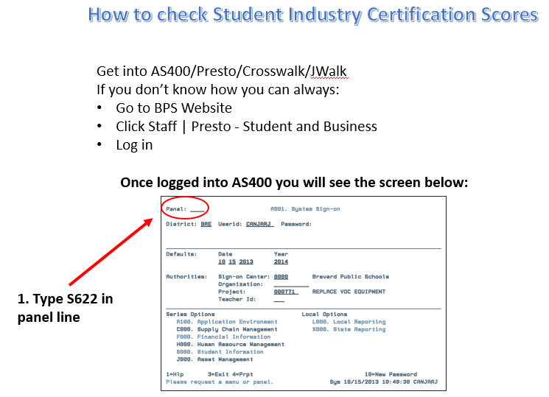
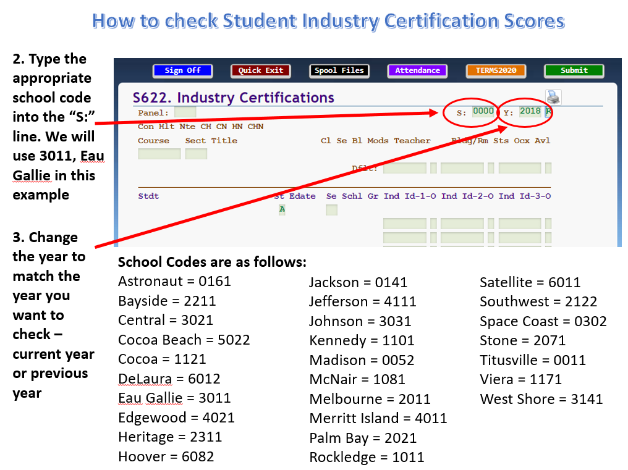
How to check Student Industry Certification Scores
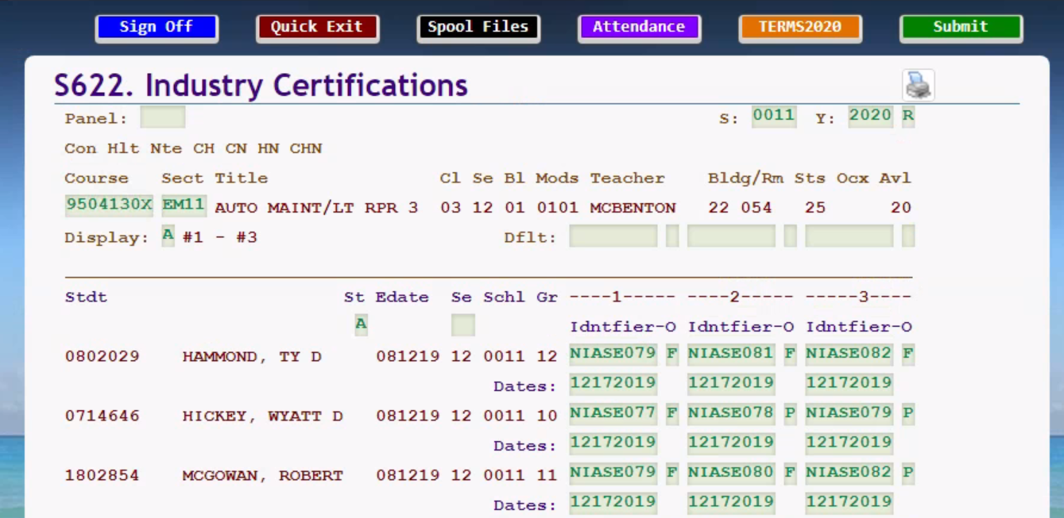
4. It is now time to enter the course # & section #

Helpful Hint: If you don’t have the course code list provided by CTE, hit F4 for a complete listing of courses offered at the school. All CTE courses start with either an 8 or a 9.

Remove the A to see a list of all enrolled students.

How to check Student Industry Certification Scores
5. Student Industry Certification scores appear here along with the Industry Certification ID for an entire class. Verify all entries match what you have in your classroom records.

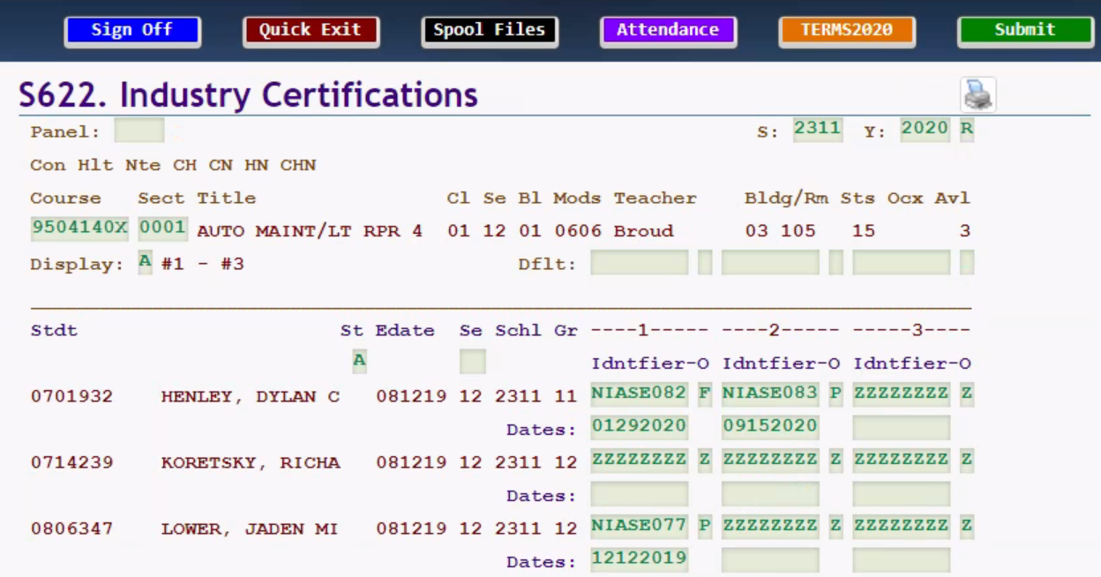
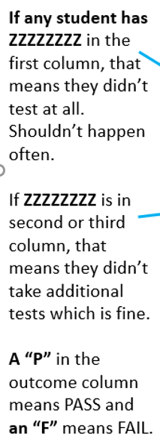
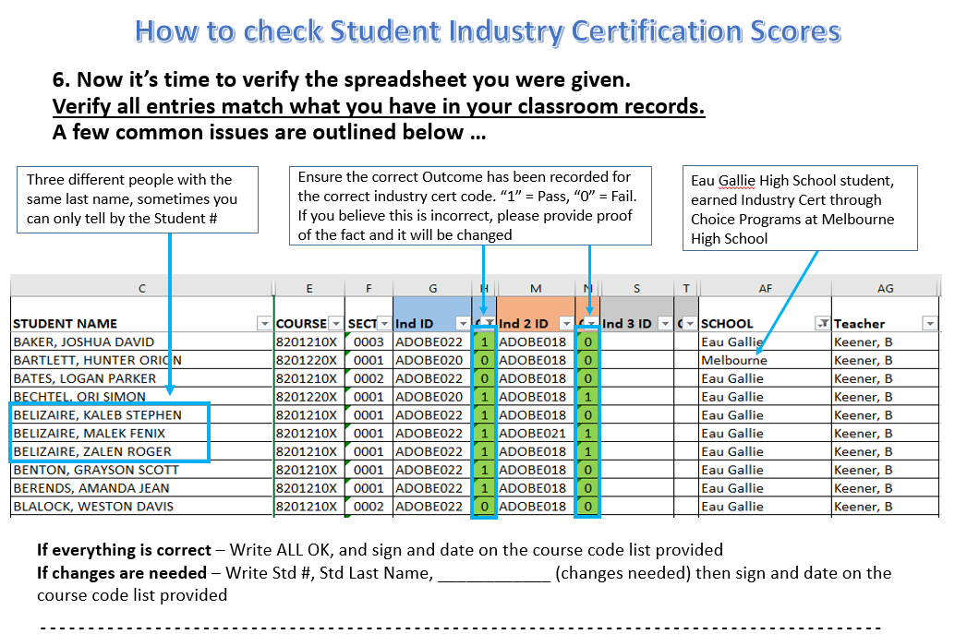
After all sections have been verified on S622 and the spreadsheet has been verified, sign and date both the course code list and the student certifications list and return it to your content specialist/resource teacher or to the district Industry Certification Coordinator.
TEACHER INSTRUCTIONS
How to Check Industry Certification Scores in Baseball Card

You can run this report at any time. However, it’s outdated the minute you give another certification exam. Here is the schedule for report updates.
Semester | Score Cutoff | Scores Uploaded | Pull Report
First | 1/14/22 | 1/21/22 | 1/28/22
Second A | 3/22/22 | 4/1/22 | 4/8/22
Second B | 4/29/22 | 5/6/22 | 5/13/22
Second C | 6/3/22 | 6/10/22 | 6/17/22

Note: Any senior who passes a certification exam after Spring Break may need to be hand counted for the purposes of graduation programs as they may not appear on your Baseball Card Report in time.

*************************************************************************************

Identify Students in Performance Matters
Open Unify/Performance Matters (found on BPS Website/Links/LaunchPad)
Under Reports, open the Baseball Card Report
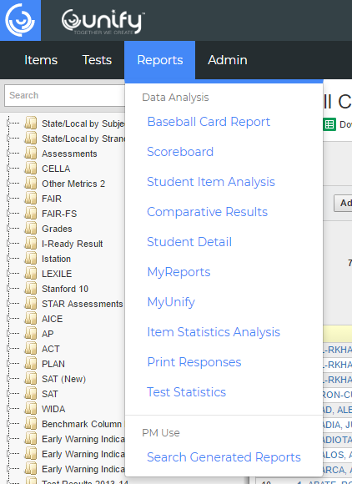

If you need just a certain grade (graduation pins/cords, etc) Add a student filter for that grade (Add Student Filter, Demographics, Current Grade, XX)
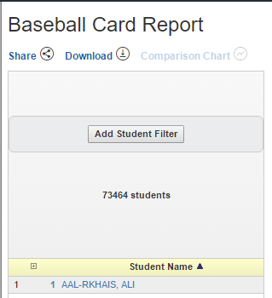

In the Left Column, choose Other Metrics 2 and CTE

You will see up to 5 categorical folders depending on which programs you teach - Open each of the Categorical folders (Ex: Adobe) and each Certification folder inside them (Ex: ADOBE021 - ACA InDesign)

Click the grey box next to any years listed for which you want data. (this shows you the number of that certification earned in a particular year)

Students with a P in ANY column earned a certification during their time at your school.
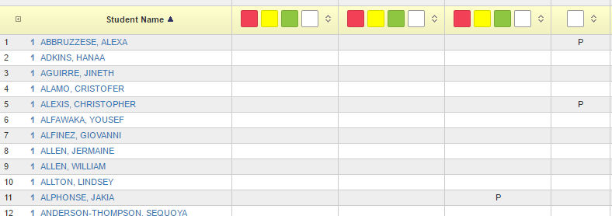

NOTE: If you are not familiar with EXCEL spreadsheets, you can stop at this point and manually pull out the names of your students who have a P in any certification column.

Create List in Excel
Download the Baseball Card Report (Directly beneath Baseball Card Report title)
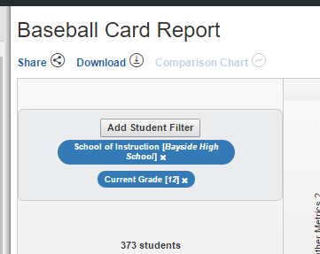

Open the file in Excel (you should see the downloaded file on the lower left side of your screen - if you don’t, you can Open Excel, select Open, and find the file in the Download Folder on your computer
Add a column to the right of the Name column (Right-Click on the letter B at the top of the second column, then click on Insert)

Title the new column PASS and resize it to fit (double click on the vertical line between the letter B & C)

Highlight Row 1 and Freeze it (Click on the number 1 to highlight then select View, Freeze Panes, Freeze Top Row)
Scroll to the right until you get to the last column of data. Make a note of the column letters. (ie AI2) Copy & Paste the following formula =COUNTIF(D2:AI2,"P") into Column B for your first student (Highlight the formula above. Try not to highlight the additional space after the final parenthesis. Adjust the last column reference to reflect whatever column you found was the last one with data.) Hit Ctrl+C to copy. Then go to Excel and click in the cell directly below PASS in Column B. Hit Ctrl+V to paste.
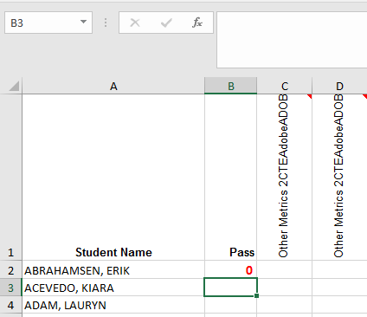

Copy this formula down Column B for all students (click on the small dot in the lower right corner of the cell and drag it down column B wherever a name appears in column A.) Column B should populate with a 1, 2, 3, 4, etc. for any student where a P is visible in any of the certification columns or a 0 for any student where no P is visible in any certification columns
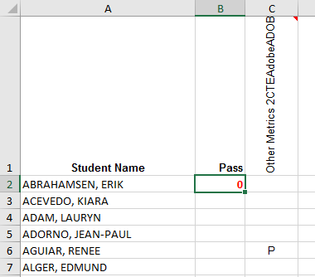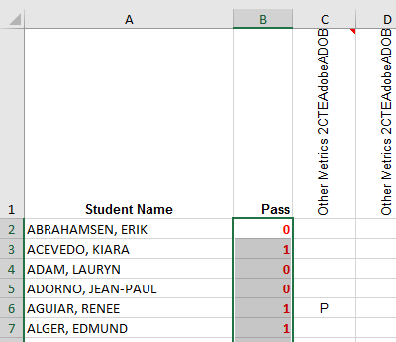

Highlight the entire spreadsheet (Click on the Select All box in the upper left corner of the spreadsheet at the intersection of Column A and Row 1. The entire spreadsheet will turn grey to indicate it is highlighted)
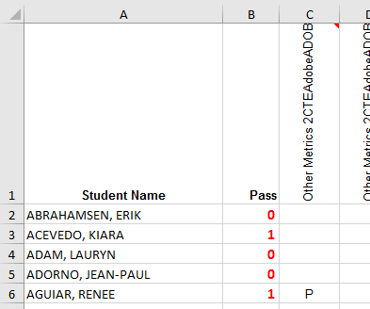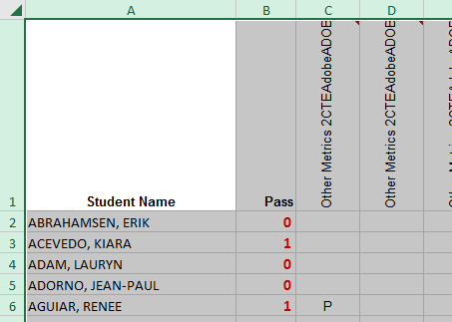

Sort by the Pass column from Largest to Smallest. (Click Data, Sort. Click the box showing My data has headers. Then choose to Sort by PASS and change the Order to Largest to Smallest)
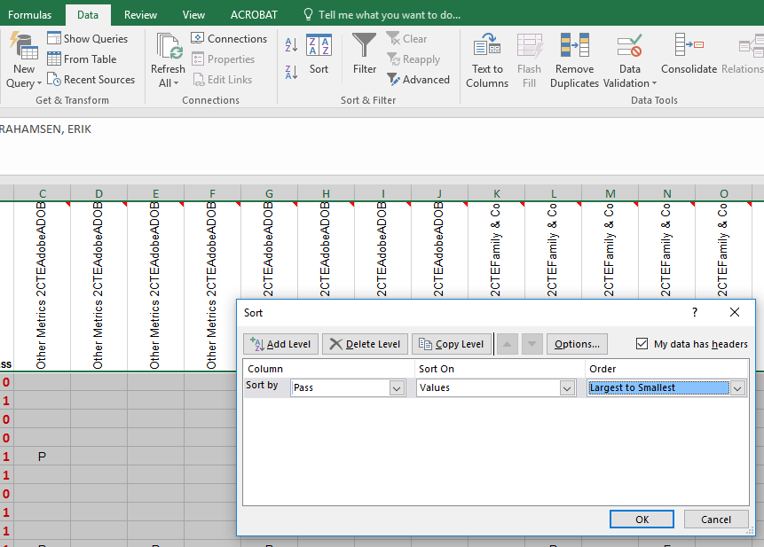

Your spreadsheet will now be sorted with all your numbers (earned a certification) at the top and your 0s (didn’t earn a certification) at the bottom.
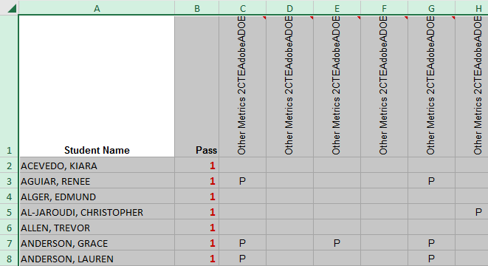

Remove all lines with a 0 in the Pass column - these students did not earn a certification (Scroll down to the first student with a 0 in the Pass column. Highlight all lines with a 0 in in the Pass column by clicking on the row number and dragging your cursor down through the remaining lines with a 0 to highlight them. Hit the Delete key.)
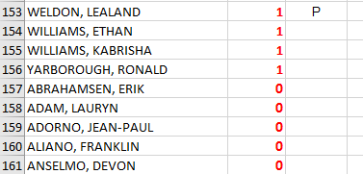

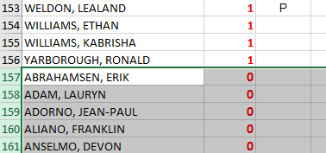

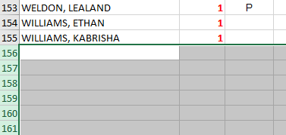

The remaining names are the students who have earned a certification at any time while in your school. The number indicates how many certifications they earned.
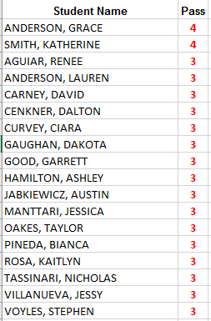

You will need to do an additional sort by Student Name to get them in alphabetical order.
Highlight the entire spreadsheet (Click on the Select All box in the upper left corner of the spreadsheet at the intersection of Column A and Row 1. The entire spreadsheet will turn grey to indicate it is highlighted)

Sort by the Student Name column from A to Z. (Click Data, Sort. Click the box showing My data has headers. Then choose to Sort by STUDENT NAME and change the Order to A to Z)
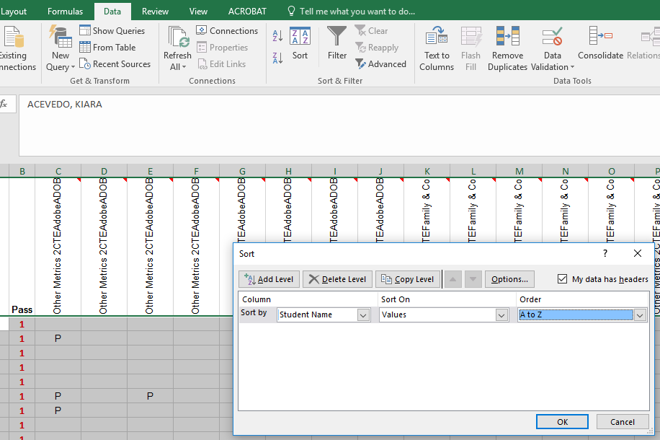

Your spreadsheet will now be sorted in alpha order by Student Name.
