Certiport Proctor Information
- All Certiport Proctors must create an account at Certiport.com
  - You may wish to tell them to make their UserName and Password rather short since they will be entering both multiple times in a hurry.
- Once they create an account, they will sign up to be a proctor
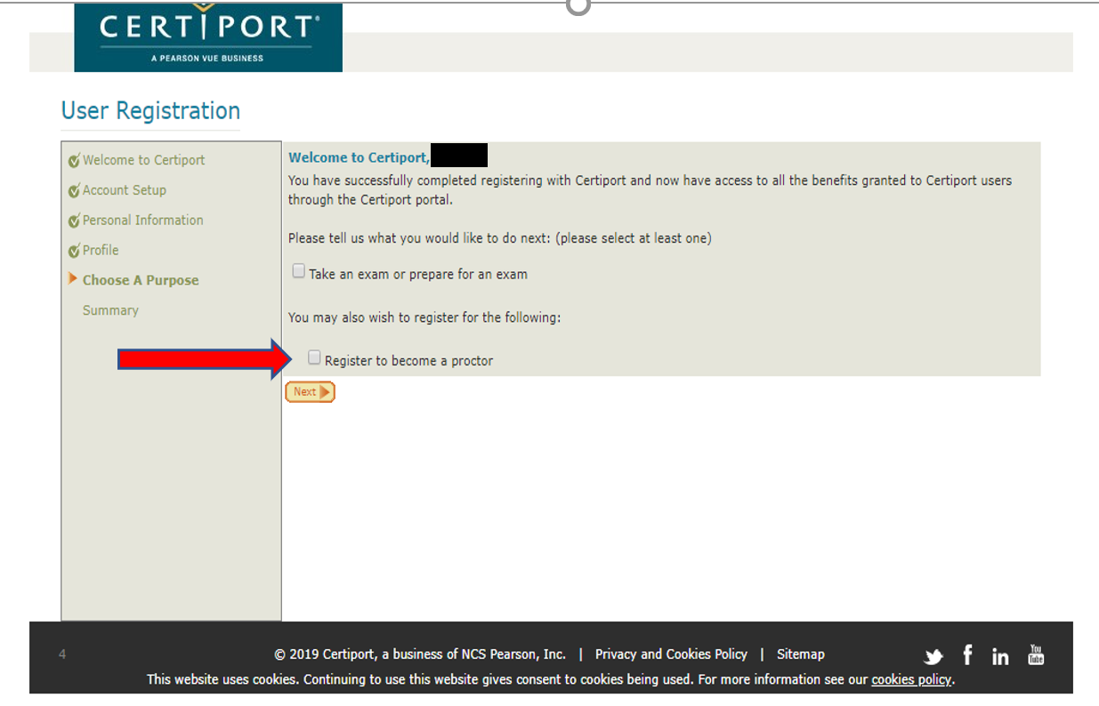
- In case they already have an account, they can go into their Profile and sign up to be a proctor. 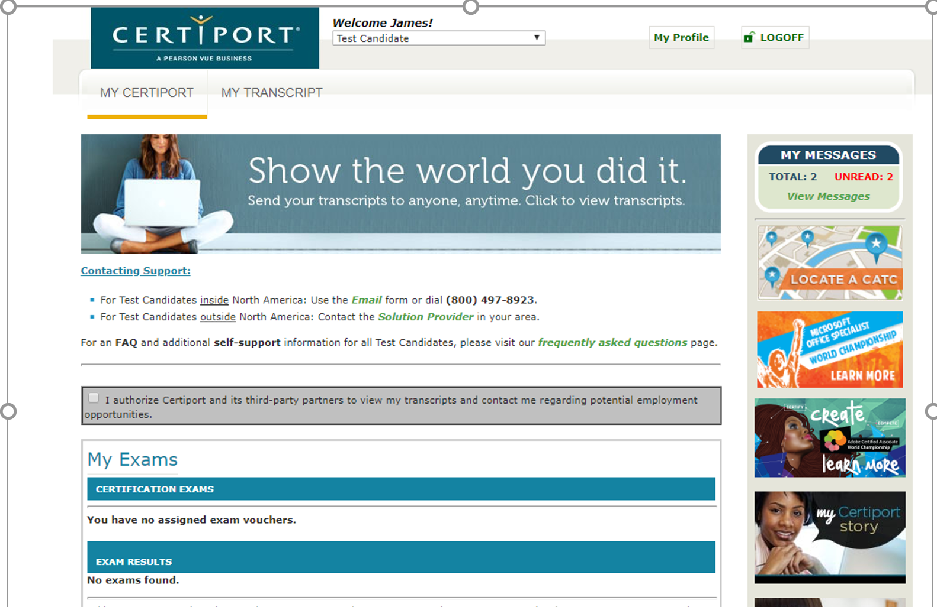

- Click on the Roles Tab, and click “Become a Proctor”
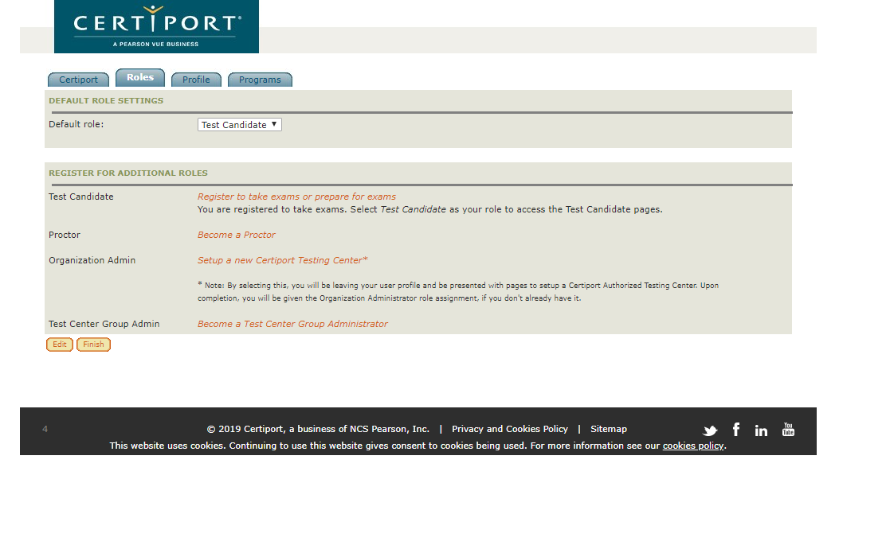
- Once that is finished, please email me and let me know what the proctor’s NAME and USERNAME are. I will add them to your school’s association.
- Then have proctor fill out the Proctor Agreement, write your school’s name somewhere on the sheet and mail to me in the courier.
- Also, you should be keeping a Log Sheet (for your records – no need to send to us).

School Year 2019-2020
FORM FCAPEA-04, Florida Administrative Code
Florida Career and Professional Education Act Industry
Certification Test Administration and Security Agreement

Industry certifications are independent, third-party verification of technical skills achieved by students. Any practice that jeopardizes the validity of industry certifications disadvantages the students and prospective employers. Florida State Board of Education Rule 6A-6.0573 prohibits conduct that may threaten the integrity of the industry certification exams. Examples of prohibited conduct are provided in paragraph (16) of this rule, which may be accessed at www.flrules.org.
Teachers providing instruction leading to industry certification exams shall not administer an industry certification exam to students for which they provide direct instruction for the certification, except as noted in section (13)(c) of this rule.

I have reviewed all test administration and conduct provisions for industry certification exams. I agree to follow all test administration and security procedures outlined in the Rule.
Further, I will not reveal or disclose any information about the test items or engage in any acts that would violate the security of industry certification exams or cause student achievement to be inaccurately represented.
Brevard Public Schools ________________________________________
School District School Name

Print Name

___________________________________________________________ _______________
Signature Date

Effective August 2019 through June 2020

