Create Exam Groups
- Sign into www.certiport.com , select the “org administrator” role
- Click on the “Exam Group” tab
- Click on “Add Exam Group” and complete the form.
- Once form is complete, click on “update” and the system will generate Group number.
- You may edit the exam group number details later by following steps 1 and 2, then click on your group number, and click on “edit” at the bottom of page.
“Information” section- Complete Teacher, Name, and number of students field. everything else defaulted as shown below.
USE the following format for your exam groups:
Course#-Section#-Teacher last name
Under the description:
Name of Course – Period – Teacher – Year
Example: 8207310-0101-Thomas
DIT-1st period-M.Thomas
It does NOT matter WHICH exam the student takes – it is recorded under the COURSE!
We NEED the teacher last name in the Name

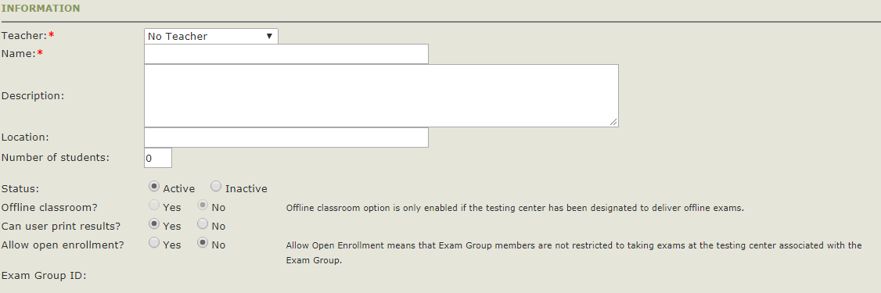
“Assign Exam” section- *Keep defaulted as shown below.
“Practice Exam- Take at Home” section - *Keep defaulted as shown below because practice exams no longer offered within the Certiport portal.
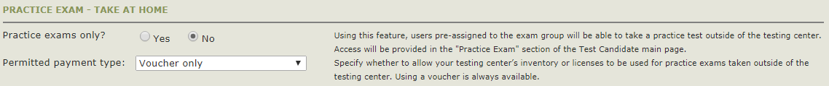
“Proctors” section- *Keep defaulted as shown below.
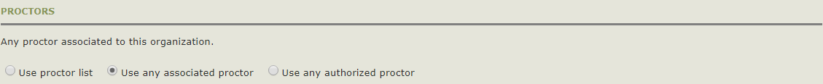
“Access Rights” section- *Keep defaulted to teacher name as “owner”

