Brevard County Public Schools CTE (Career & Technical Education)
Adopt a CTE Program

Brevard County Public Schools make an impact on workforce needs through career and technical education in public middle and high schools. We strive to provide teachers and students with the best guidance, support, and opportunities through enrichment programs including teacher training, scholarships, competitions, job shadowing, job training and internships. Our department partners with the local business community to provide students with postsecondary options and experiences.

How it Works: This program offers local businesses the opportunity to partner with Brevard County Public Schools to work with local public middle and high schools to prepare students for college and career opportunities in a variety of areas focusing on workforce education.

If you are interested in partnering with any of our schools, we encourage you to complete the application below.

Please submit completed application to rutledge.rachel@brevardschools.org

Once partnered, we hope that you will spread the word by telling your customers and clients. Celebrate your commitment to career and technical education by promoting the Adopt-A-CTE-Program on your website, social media and press releases!

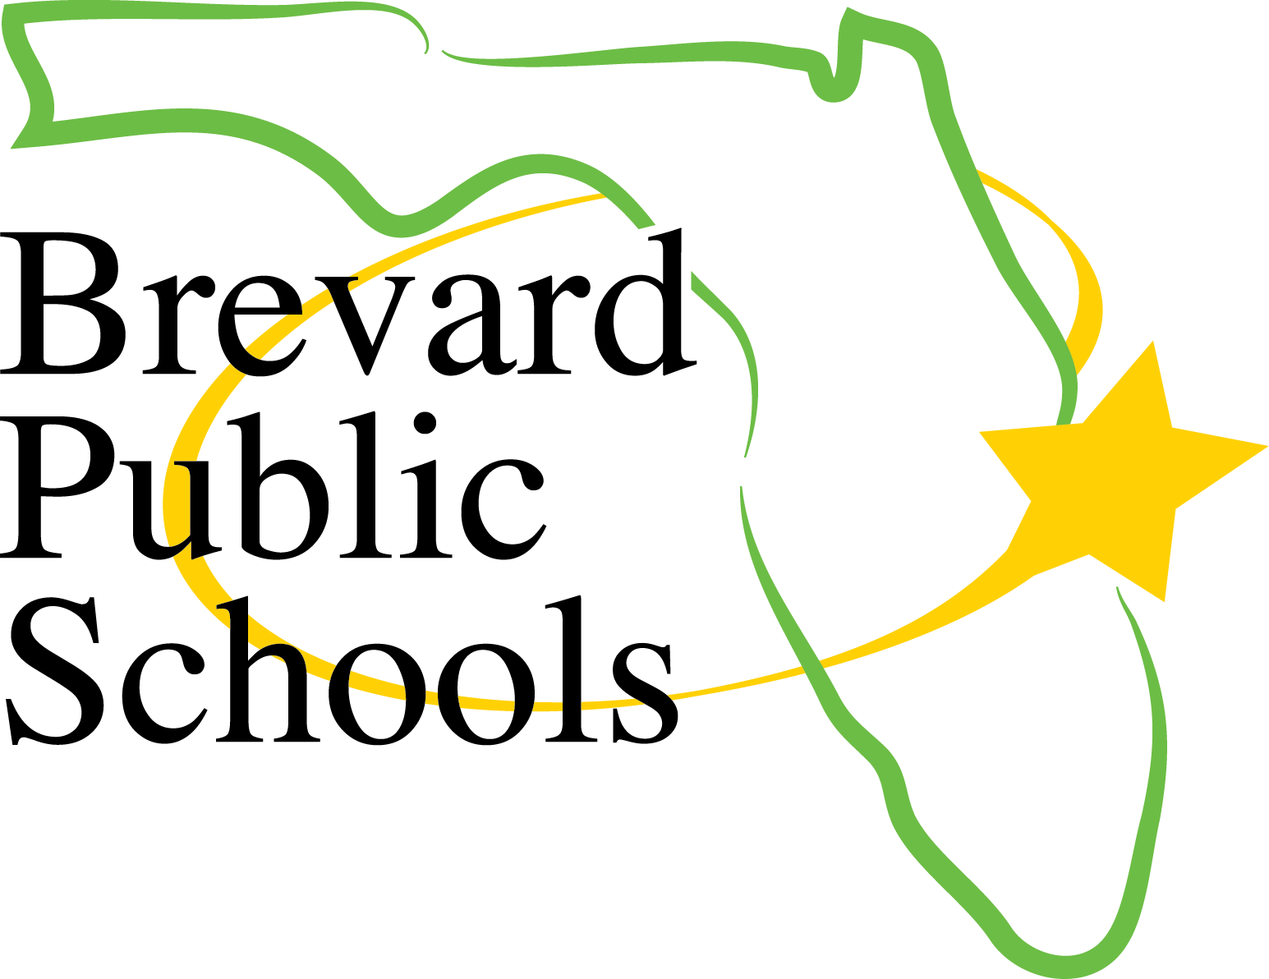

Brevard County Public Schools Career & Technical Education
Adopt a CTE Program
Application

Business Name: ________________________________
Business Lead Contact: __________________________
Lead Contact Email: ____________________________
Lead Contact Phone #: __________________________

Schools of Interest:
Option 1- _____________________________
Option 2- _____________________________

Programs of Interest:
Option 1- ____________________________
Option 2- ____________________________

Please describe the reason in which your company would like to partner with one of our schools:
_____________________________________________________________________________________________________________________________________________________________________________________________________________________________________________________________________________________________________________________________________________________________________________________________________________________________________________________________

Please identify a minimum of 3 areas that you are willing to get involved with, within our schools.
- Assigning a volunteer staff member to conduct guest speaking 2 times in one school year
- Will coordinate field trips to my company location for students to tour and engage with the various departments
- Provide job shadowing opportunities for students
- Make donations to the school for classroom activities and project-based learning
- Provide students with a summer or school year internship experience
- Mentor a group of students by collaborating with them on special projects, a minimum of 4 times per year (will need to coordinate through the teacher)
- Provide students with real-world concerns that you are facing in your company and allow them opportunities to create solutions to share with your team.
- Attend and judge or provide feedback to students regarding their classroom projects or competitions for Career & Technical Student Organizations
- Provide demonstrations of skills within a classroom
- Deliver content on entrepreneurship-related content in your industry
- Provide teachers and students with training spaces that they can utilize at your work site
- Provide students with uniforms to use in their program
- Provide teachers with externship opportunities
- Other (please specify): _________________________________________________________________

My signature below acknowledges that my staff is committing to adopting the agreed upon school for the 2023-2024, 2024-2025, and 2025-2026 school years and that we will engage with the school, students, and teachers in the areas checked off above. In addition, I agree that staff will apply for volunteer clearance at https://www.brevardschools.org/Page/11104 and that only cleared staff will engage with students at the school site.

_______________________
Business Contact Signature
To Be Completed By School

School Name: ______________________________________

Assistant Principal/Curriculum Contact Name: ______________________
Assistant Principal/Curriculum Email: _____________________________
Assistant Principal/Curriculum Phone #: ___________________________

Lead Teacher Name: _________________________________
Lead Teacher Email: _________________________________
Lead Teacher Phone #: _______________________________

We at ___________________________________________ high school accept the partnership with ___________________________________________.

Through this partnership, we commit to collaborating with the business partner, maintaining quarterly communication, and will include our business partner in relevant school initiatives. We will ensure that our business partner receives quarterly updates as they pertain to our program.

We also commit to keeping all students informed of opportunities provided by our business partner. We will prepare students prior to all guest speaking events and site visits, to the business partner’s location, whether virtual or face-to-face, so that learning opportunities are maximized.

__________________________________________
Lead Teacher Signature

___________________________________________
Assistant Principal/Curriculum Signature

___________________________________________
School Principal Signature

