How to Complete a BPS Course Survey

When you are registered in a course where this icon appears, it simply means you are required to take a BPS Course Survey. To take the survey, please do the following:
Step 1: Go to your LEARNING PLAN, you should find it under recently completed OR you may have it under awaiting final credit. The instructor can hold the credit until the evaluation has occurred. When you see the course click on MANAGE
Step 2: Once the course opens, you will click on BPS Course Survey.
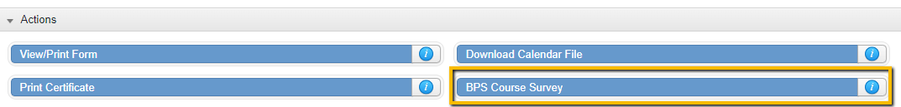
Step 3: Take the survey and click SAVE
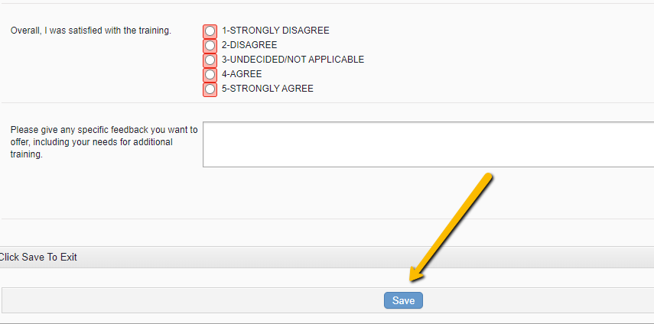
Step 4: Then you can go back to your course through the Learning Plan, click MANAGE again, and now you can mark your course COMPLETE
