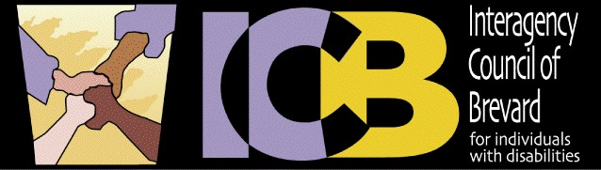
Host Schedule 2022-2023
Meetings are held from 8:45AM – 11:00AM

DATE | ADDRESS OF MEETING | HOST AGENCY
9/14/22 | 1845 Cogswell Street  Rockledge, FL 32955 | BAC
10/12/2022 | 1350 Hickory Street  Melbourne, FL 32901 | Project SEARCH  Holmes Regional Hospital
11/9/2022 | 2700 Judge Fran Jamieson Way  Viera, FL 32940 | Brevard Public Schools  FDLRS
12/14/2022 | 2700 Judge Fran Jamieson Way  Viera, FL 32940 | Brevard Public Schools  FDLRS
1/11/2023 | 571 Haverty Court Suite A  Rockledge, FL 32955 | Resource Center for Disability Solutions
2/25/2023 | TBD | START CONFERENCE
3/8/2023 |  | TBD
4/12/2023 |  | TBD
5/10/2023 |  | TBD

