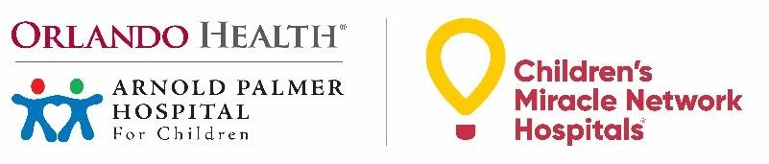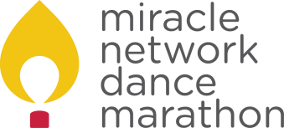

Fundraising For Your Dance Marathon: Participant Best Practices
We encourage students to utilize our online fundraising platform, Donor Drive, which creates individual fundraising pages for each registered participant. Students can set personal fundraising goals and share their page with friends and family to fundraise for Orlando Health Arnold Palmer Hospital for Children.

Set Yourself Up for Success
- Register on Donor Drive through your school’s Dance Marathon event page
- Customize your fundraising page with photos and a personal message
- Set a fundraising goal and use the milestone feature to break it down into smaller increments
- Create a Facebook Fundraiser in Donor Drive to sync your fundraising page to Facebook
- Download the Miracle Network Dance Marathon app for quick access to your fundraising tools

Make the Ask
- Write a letter or an email to family and friends explaining what Dance Marathon is and why you are participating. Include instructions on where to send a cash or check donation, as well as the link to your personal online fundraising page if you are registered on Donor Drive
- Text or call potential donors to tell them about your involvement in Dance Marathon and ask for their support
- Consider reaching out to immediate family, extended family, neighbors, family friends, or personal contacts at local businesses
- Post the link to your fundraising page on social media or ask family members to share it on your behalf
- Be sure to say thank you to every person who donates or shares your fundraising information

Get Creative
- Ask for donations in exchange for doing tasks or chores (ex: mowing the lawn)
- Start a coin jar at home to collect loose change throughout the year to donate
- Offer to do challenges for reaching fundraising milestones (ex: posting a funny video)
o You can create these using the incentive feature on Donor Drive
- Make and sell crafts or baked goods for donations

Templates for Donation Requests and Thank You Letters

Sample Messages or Social Media Posts (Donation Request)

- Hello friends and family! This year I am participating in Dance Marathon at Cocoa Beach Jr/Sr to help raise funds and awareness for Orlando Health Arnold Palmer Hospital for Children, our local Children’s Miracle Network Hospital. Every dollar truly makes a difference at the hospital – just $12 can help purchase a pack of preemie diapers for the tiniest patients! If you’d like to support me in my efforts, you can donate at the link below. [Insert fundraising link]

- Hey! I’m currently trying to raise [Insert fundraising goal] for Orlando Health Arnold Palmer Hospital Children as part of Dance Marathon at Cocoa Beach Jr/Sr High School. Can I count on you to help me reach my goal? [Insert fundraising link]

Sample Email or Letter (Donation Request)

Dear [Insert Name],
This year, I am participating in Dance Marathon at Cocoa Beach Jr/Sr High School, a year-long effort to raise funds and awareness for Orlando Health Arnold Palmer Hospital for Children, our local Children’s Miracle Network Hospital. On [insert this year’s DM date] our school will come together for a 6-hour event where we will stand, dance, celebrate, and honor the patients treated at Orlando Health Arnold Palmer.
All funds raised through Dance Marathon support the hospital’s area of greatest need, helping provide hope, healing and compassion to more than 135,000 patients and families each year.
I am so excited to be involved and have volunteered my time and energy throughout the year to raise money for this incredible cause. I would love for you to be a part of my success this year! Will you please consider supporting my efforts as I strive to reach my personal fundraising goal of [$X] to help change kids’ health, and change the future?
Donations can be made securely online at the link below [Insert fundraising link].
Sincerely,

[Insert Name]

Sample Email or Letter (Thank You)

Dear [Insert Name],
Thank you so much for your contribution to our Dance Marathon program benefitting Orlando Health Arnold Palmer Hospital for Children! With your help, I’ve raised over [$X] this year!
Your support means so much to me and will make a huge difference for the patients and families at the hospital. Together, we will ensure Orlando Health Arnold Palmer has the tools and resources needed to continue provide the best possible care for kids in our community.
Thank you for supporting me in my efforts and helping to make miracles possible, for each and every child impacted by Orlando Health Arnold Palmer.
Sincerely,

[Insert Name]

