Hey future Panthers! Are you still undecided about your future?
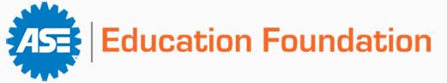
Look at what we have to offer!
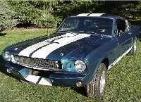
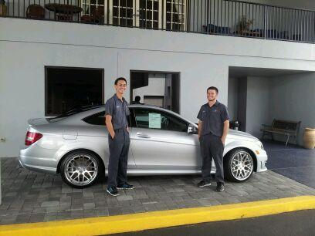
This program prepares our students for a career in Automotive Technology with emphasis on current and future trends in this career.
This program is nationally certified by A.S.E. in the training of young individuals as a foundation for a lifetime of employment opportunities. All students will have the opportunity to become certified in the Entry-Level ASE areas of STEERING/SUSPENSION, BRAKES, ELECTRICAL, & HVAC.
This course is not a replacement for post-secondary education, but rather offers a solid foundation in Maintenance & Light Repair (MLR). We teach the skills necessary for students to go straight out into the field & get an entry level position with a shop. The majority of our students choose to pursue an AS in automotive technology with an automotive college.
Our instructor is an A.S.E. Master Certified Technician with classroom experience in delivering material to students in a clear, concise and understandable format which promotes student comprehension and success.

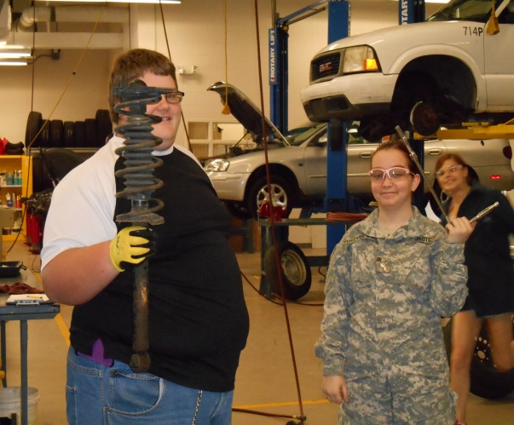
If you have questions please
contact Mr. Broud at
broud.michael@brevardschools.org
Automotive Technology
all automotive classes are year long
Course number | Description |  | Completion code
8709410X | Automotive MLR Technology I | *
8709420X | Automotive MLR Technology - Steering & Suspension | *
8709430X | Automotive MLR Technology - Brakes | *
8709440X | Automotive MLR Technology - Electrical/Electronics | *
8709450X | Automotive MLR Technology - Advanced 1 | *
8709460X | Automotive MLR Technology - Advanced 2 | *
* teacher signature required

Course Descriptions
All Courses meet ASE Education Foundation MLR Certification Standards
Automotive Technology 1:
The purpose of this course is to enable learners to develop skills in tools/equipment and safety regulations, O.S.H.A. and material S.D.S.'s, along with employ ability skills. The students will be taught tool identification and proper tool usage with correct shop procedures in minor repairs. There will also be a daily focus on PROFESSIONALISM. Professionals in any field will display these 5 traits known as the 5 P’s:
PROMPT – PREPARED - POLITE – POSITIVE - PRODUCTIVE
Students who have the best grades and display these traits of a professional will be invited to Auto 2/3.
This is a one period class with 75% of the training done in the classroom.
Automotive Technology 2 and 3:
All courses use the MLR Curriculum in automotive technology, stressing the P-1, P-2, &P-3 performance standards stated by the National Institute of Automotive Service Excellence (A.S.E) necessary for National Certification. The students are taught state of the art repair procedures in each area of instruction. Articulation agreements with UNOH, Nashville Auto/Diesel College, and Universal Technical Institute are available to course completers. This is a two-period block class with an emphasis on hands-on training. This marks the end of the three years of CTE training program. Students who excel and wish to pursue an automotive career or other similar fields must pass their ASE industry certifications, and apply for the advanced automotive classes of Auto 4-5.
Automotive Technology 4 and 5:
All courses use the MLR Curriculum in automotive technology, stressing the P-1, P-2, &P-3 performance standards stated by the National Institute of Automotive Service Excellence (A.S.E) necessary for National Certification. The students are taught state of the art repair procedures in each area of instruction. Articulation agreements with UNOH, Nashville Auto/Diesel College, and Universal Technical Institute are available to course completers. This is a two-period block class with an emphasis on hands-on training. Seniors will have an opportunity to apply for early release to an entry level automotive job for On the Job Training (OJT). All students in Auto 4-5 must be accepted into the program as well as be on track to graduate on time. In addition all students MUST have their Entry-Level ASE certifications to participate in this class.

