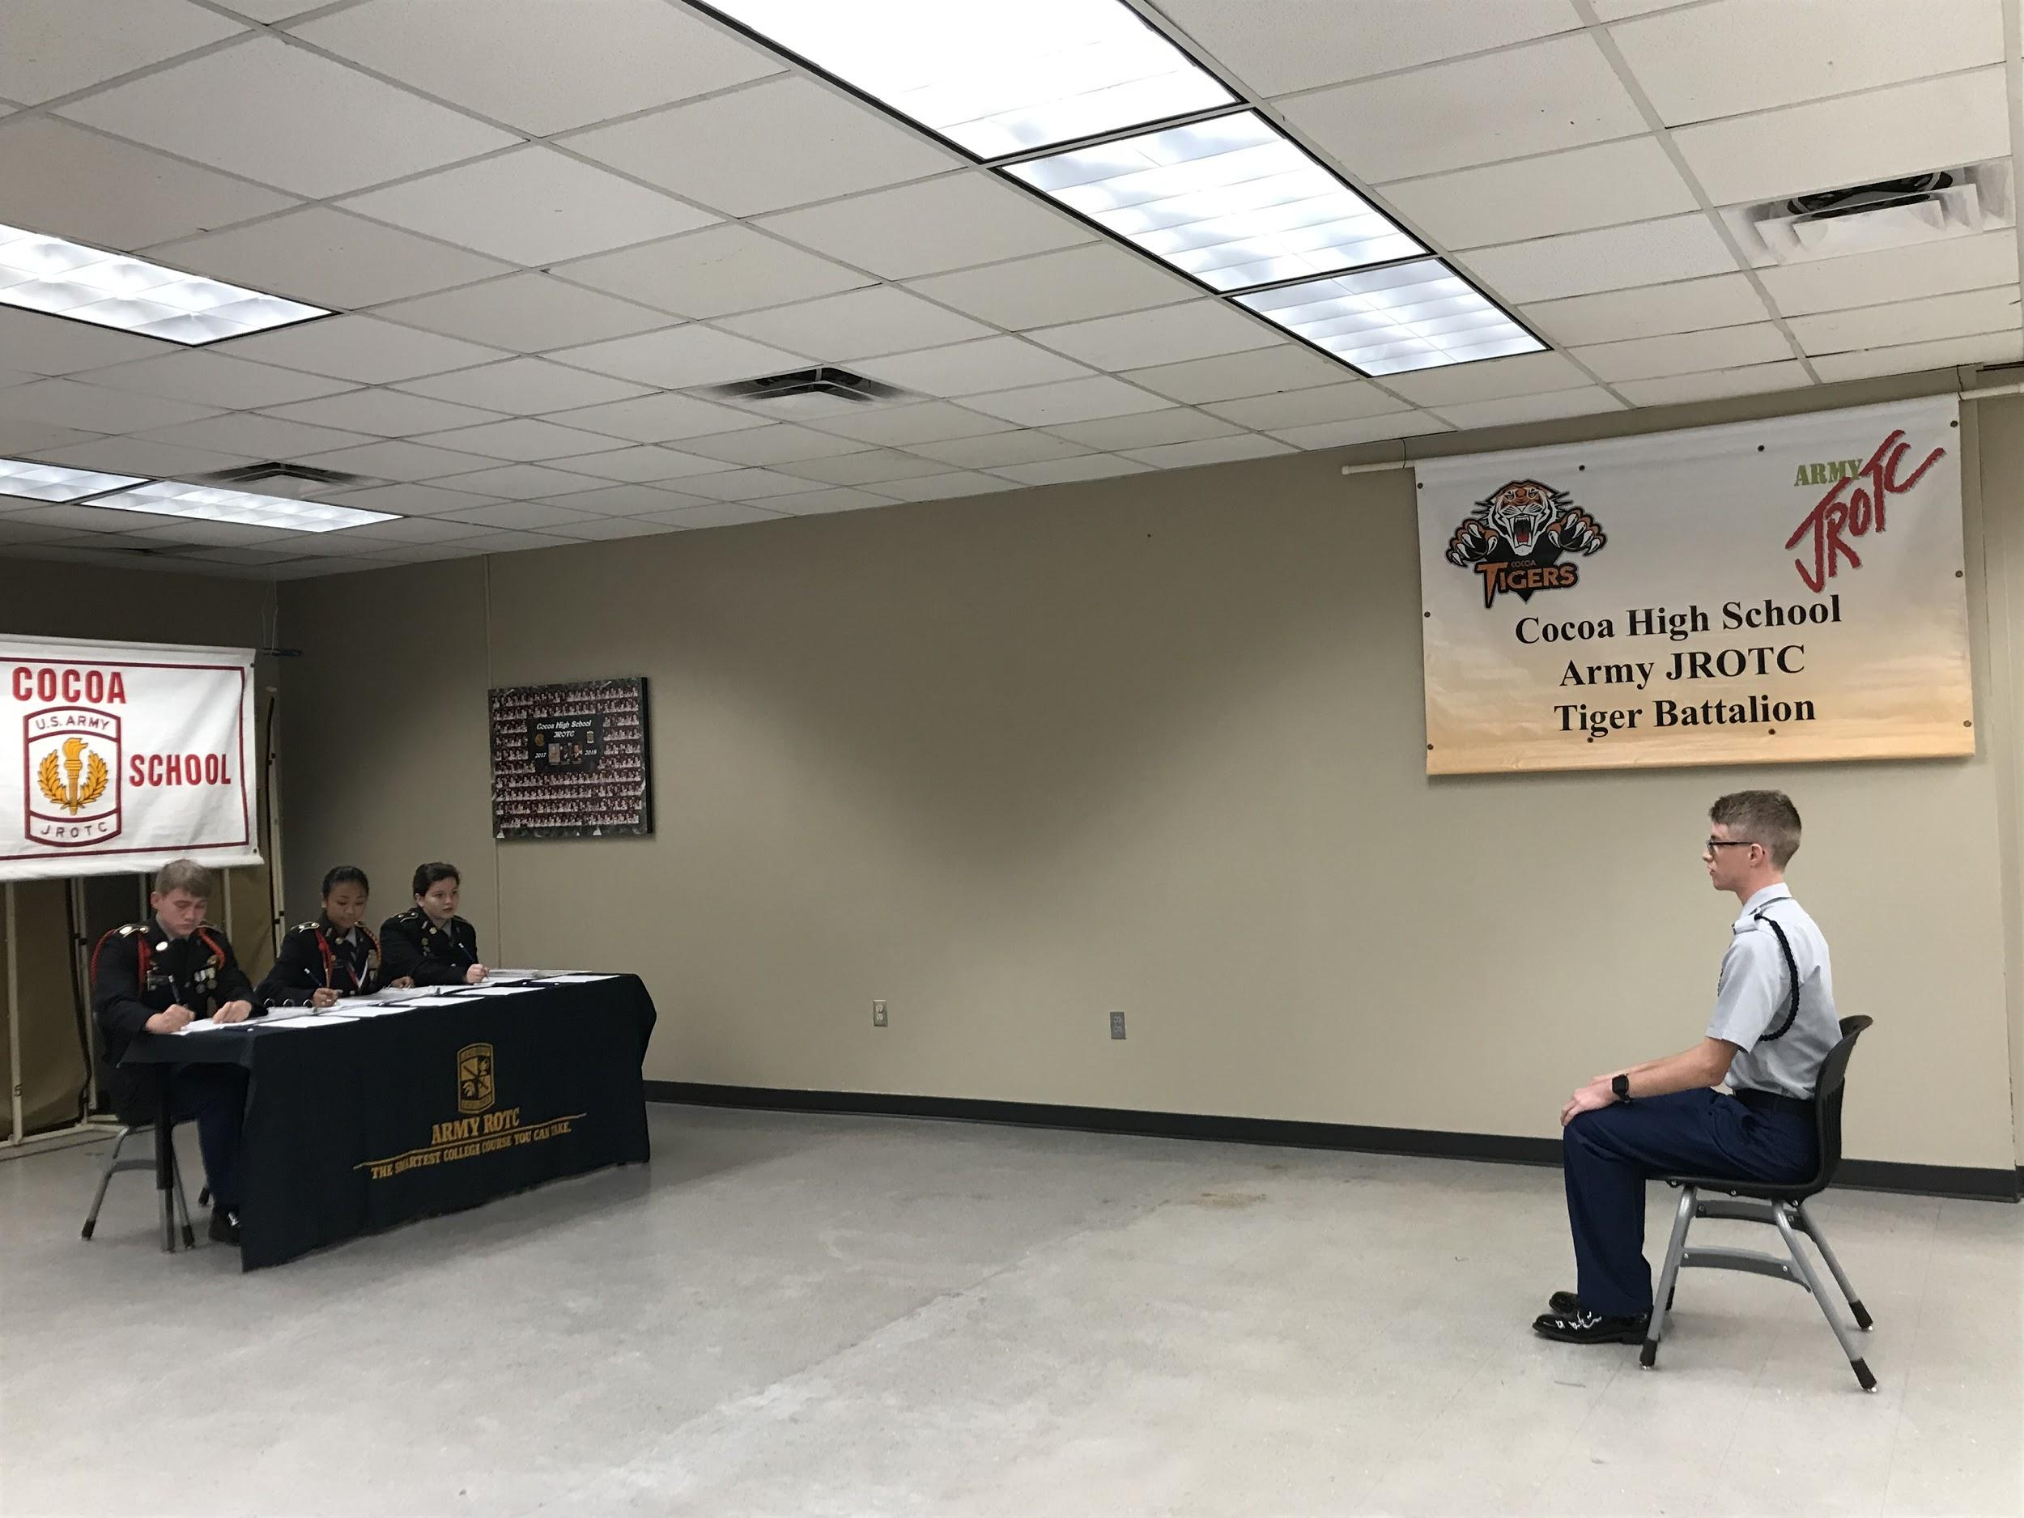
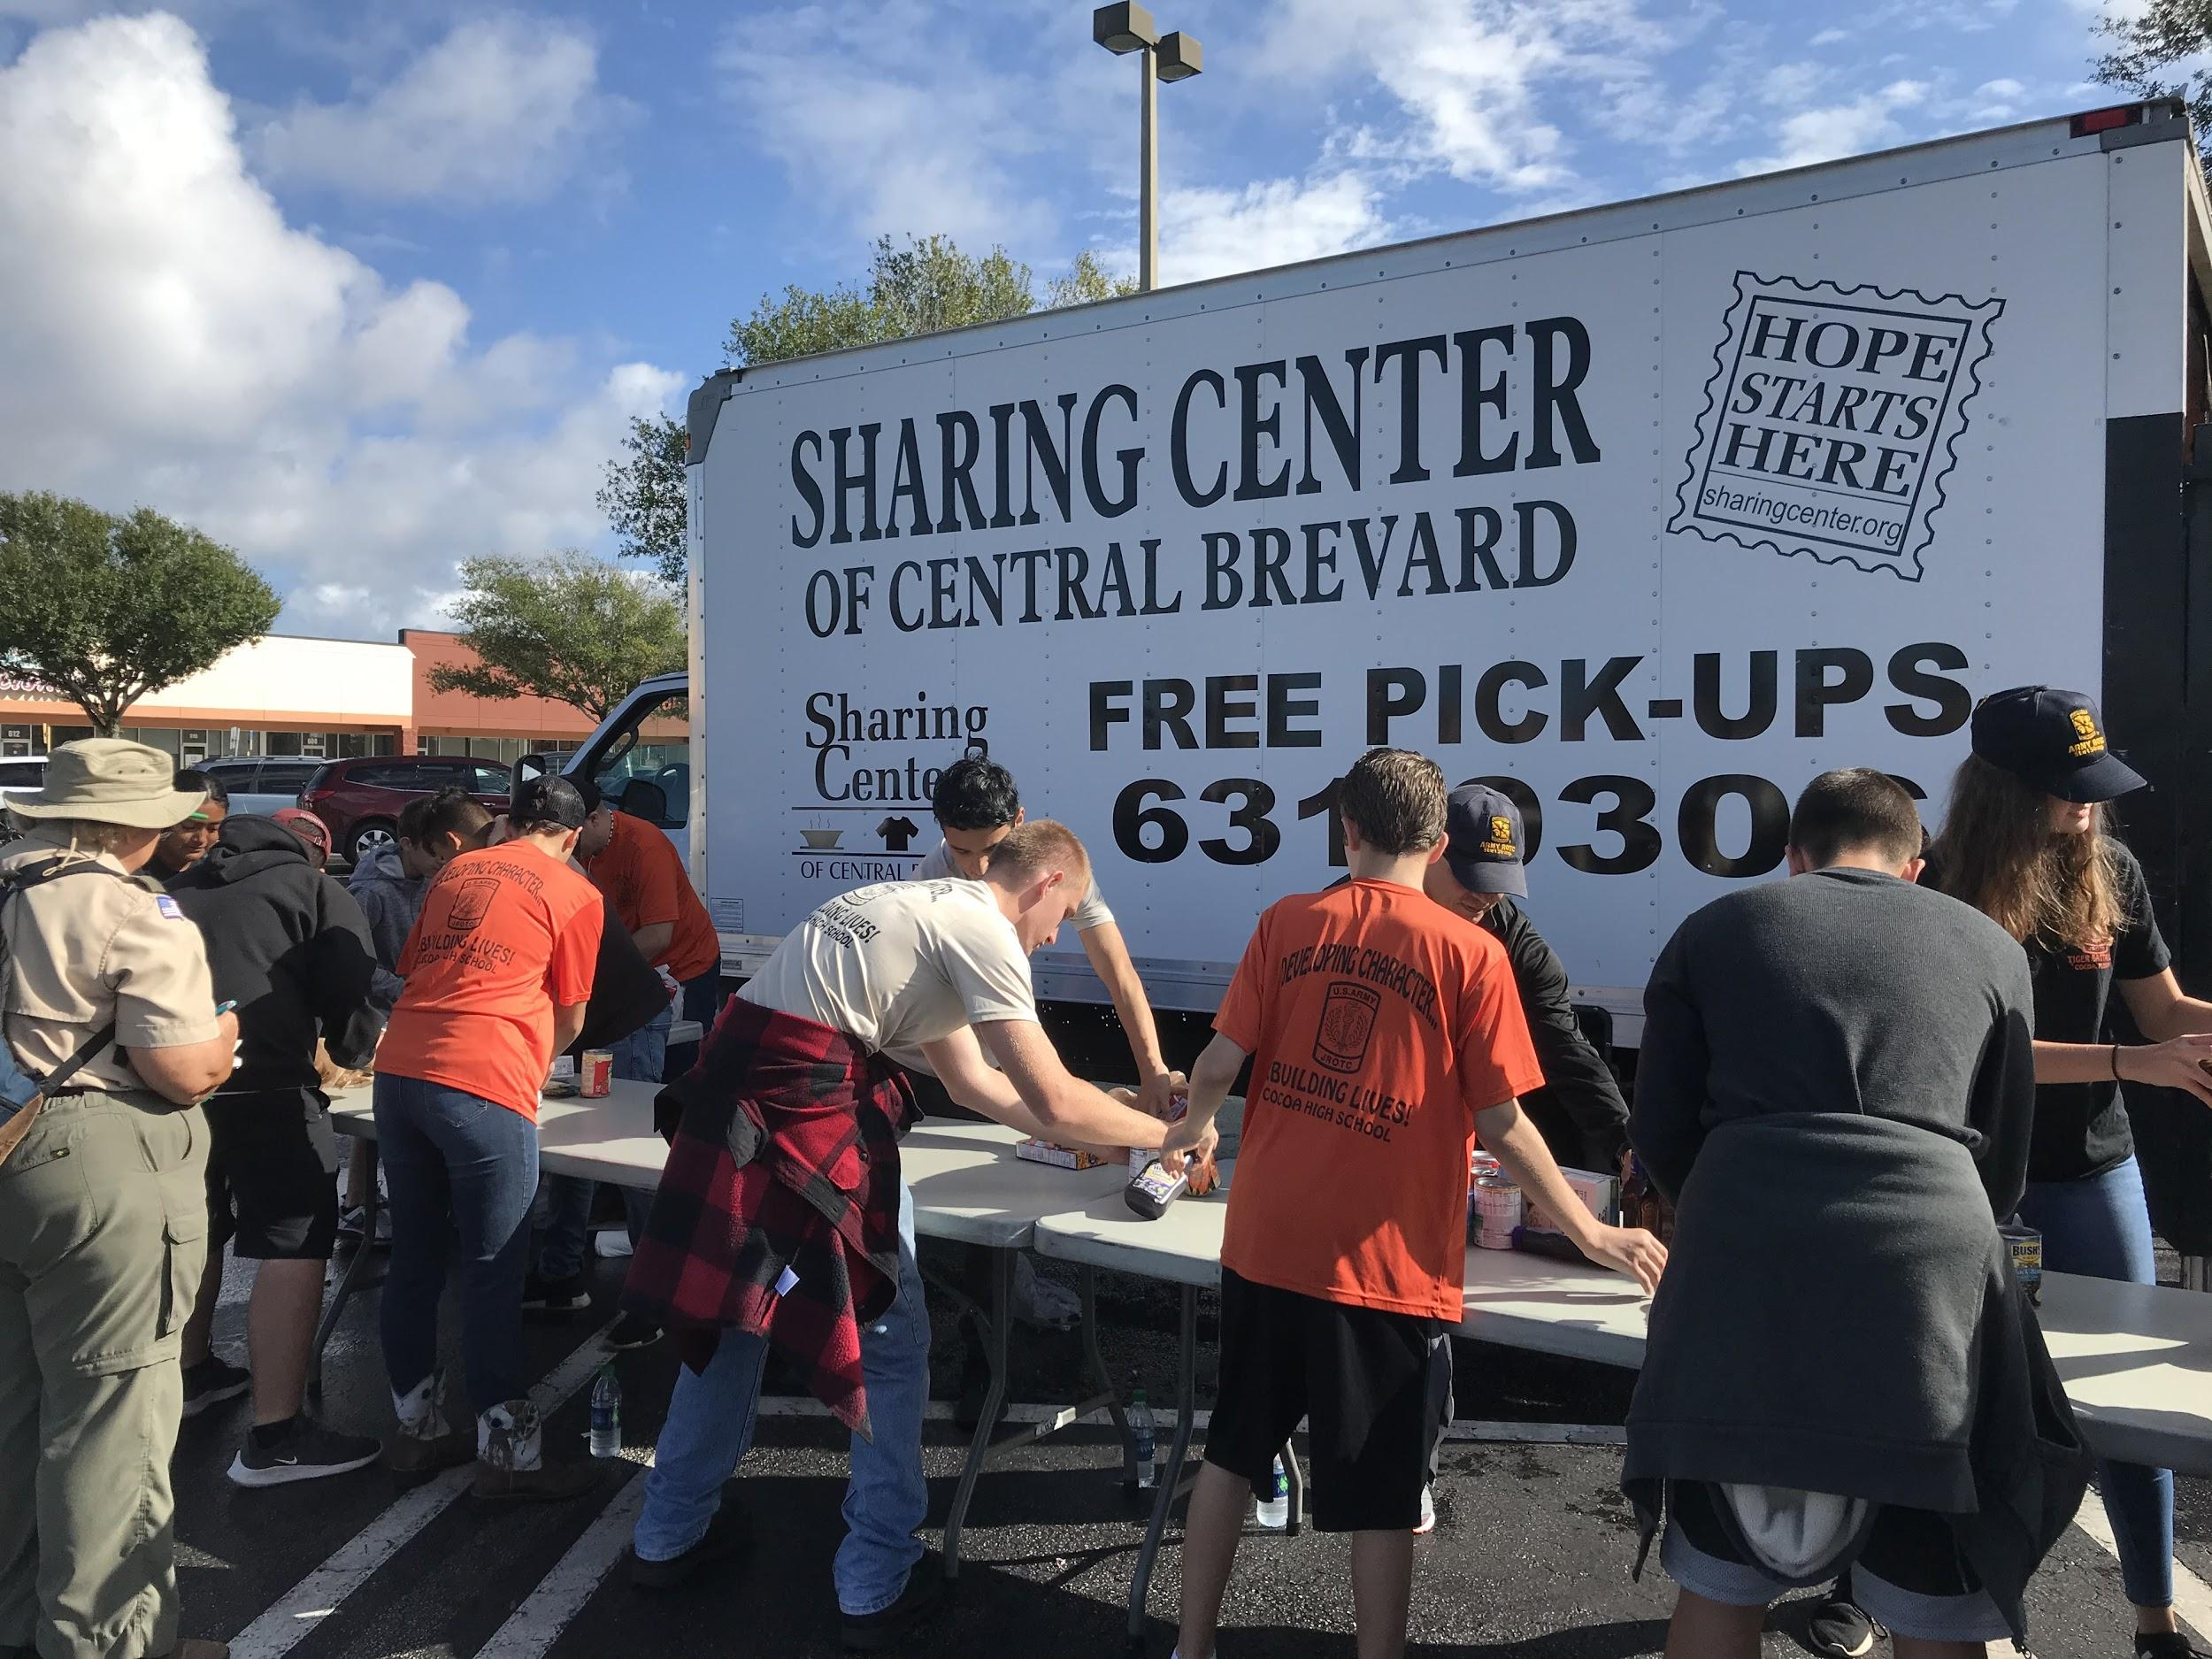
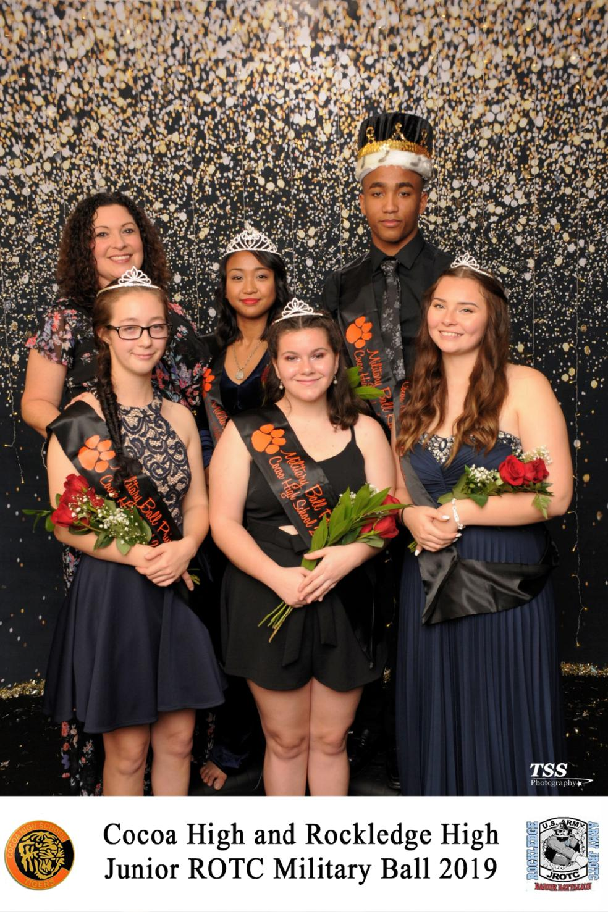
Welcome back to a new year in the JROTC Tiger Battalion. Our battalion had a successful second quarter thanks to the Boy Scouts Canned Food Drive, Let 1 Promotion Board, and our Military Ball. On November 9th, 35 cadets of the Tiger Battalion participated in the Boy Scouts Canned Food Drive where they each volunteered for 5 hours which means there was a total of 225 hours of volunteering from cadets that attended. In the end, cadets were able to collect, count, and store 8 tons of food goods accumulating over 16, 138 food items. In December, our Let 1’s completed their Promotion Board where they were graded on their cadet knowledge, uniform, confidence, and participation in the battalion. These scores determined what ranks the new Let 1’s would be receiving from a Cadet Private all the way to a Cadet Sergeant. On December 13th, the Tiger and Raider Battalion came together to have our annual Military Ball. There were a total of 107 Tiger Battalion cadets that attended the ball. The evening was full of excitement as both battalions enjoyed the food, dancing, and Military Ball Court. The following cadets won a spot on the Court were: Matthew Stickle as king, Michelle Retig as queen, Kaitlyn Willhite as the first princess, Tiffany Johns as the second princess, and Faith Presher as the third princess. Coming up in the Tiger Battalion for the New Year will be our volunteer event Operation Tiger Pride. This event will take place on February 1st and cadets will have the opportunity to clean up all around our school and earn community service hours. In February, cadets will also get to experience a career exploration tour at Patrick Air Force Base where they will get to learn more about the Air Force and life on a military base. Throughout this quarter, there will be practices for new special teams starting up. The Drill team will be practicing on Mondays and Wednesdays, while the Rifle team will hold their practice on Tuesdays and Thursdays. As a new year starts, our cadets will continue to improve on their cadet knowledge and leadership skills. Our program looks forward to another successful quarter in the Tiger Battalion.

Article By: S-5 Cadet 1LT Madison Bigger

Cocoa High School Tiger Battalion
BC: Cadet LTC Michelle Retig SAI: LTC Joseph Pavone
XO: Cadet MAJ Justinian Martin AI: SFC Freddy Moreno AI: SFC David Mercer

