On November 9th, 2019, 35 cadets of the Tiger Battalion participated in the annual Boy Scouts Canned Food Drive, and there was a total of 45 people including adults. We participate annually in this event to assist the Central Brevard Sharing Center and the Boy Scouts of America collect, count, and store food items that the local community donated. Each cadet volunteered for 5 hours, which means there was a total of 225 hours of volunteering from cadets that attended. All of this was possible thanks to the incredible amount of teamwork and effort put into this event among the cadets.
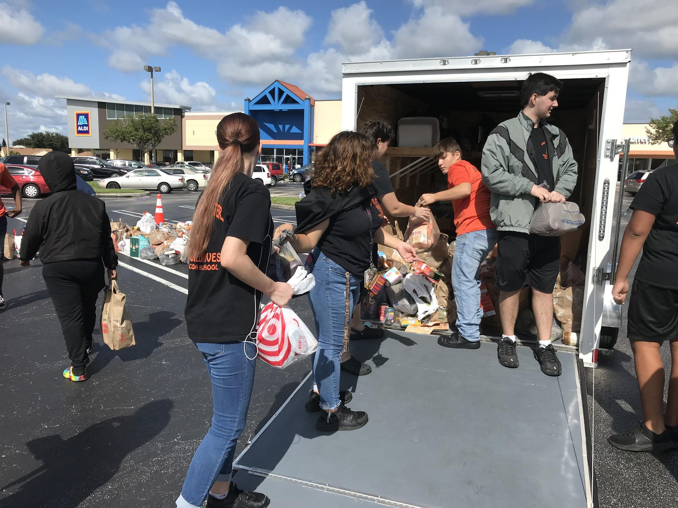
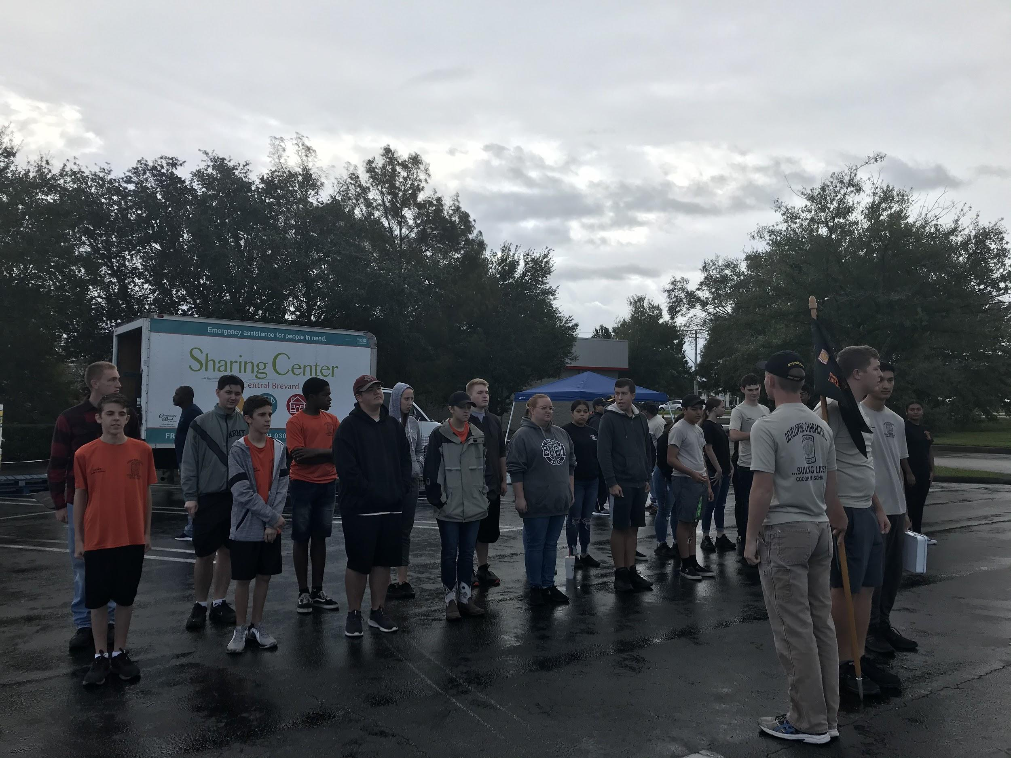
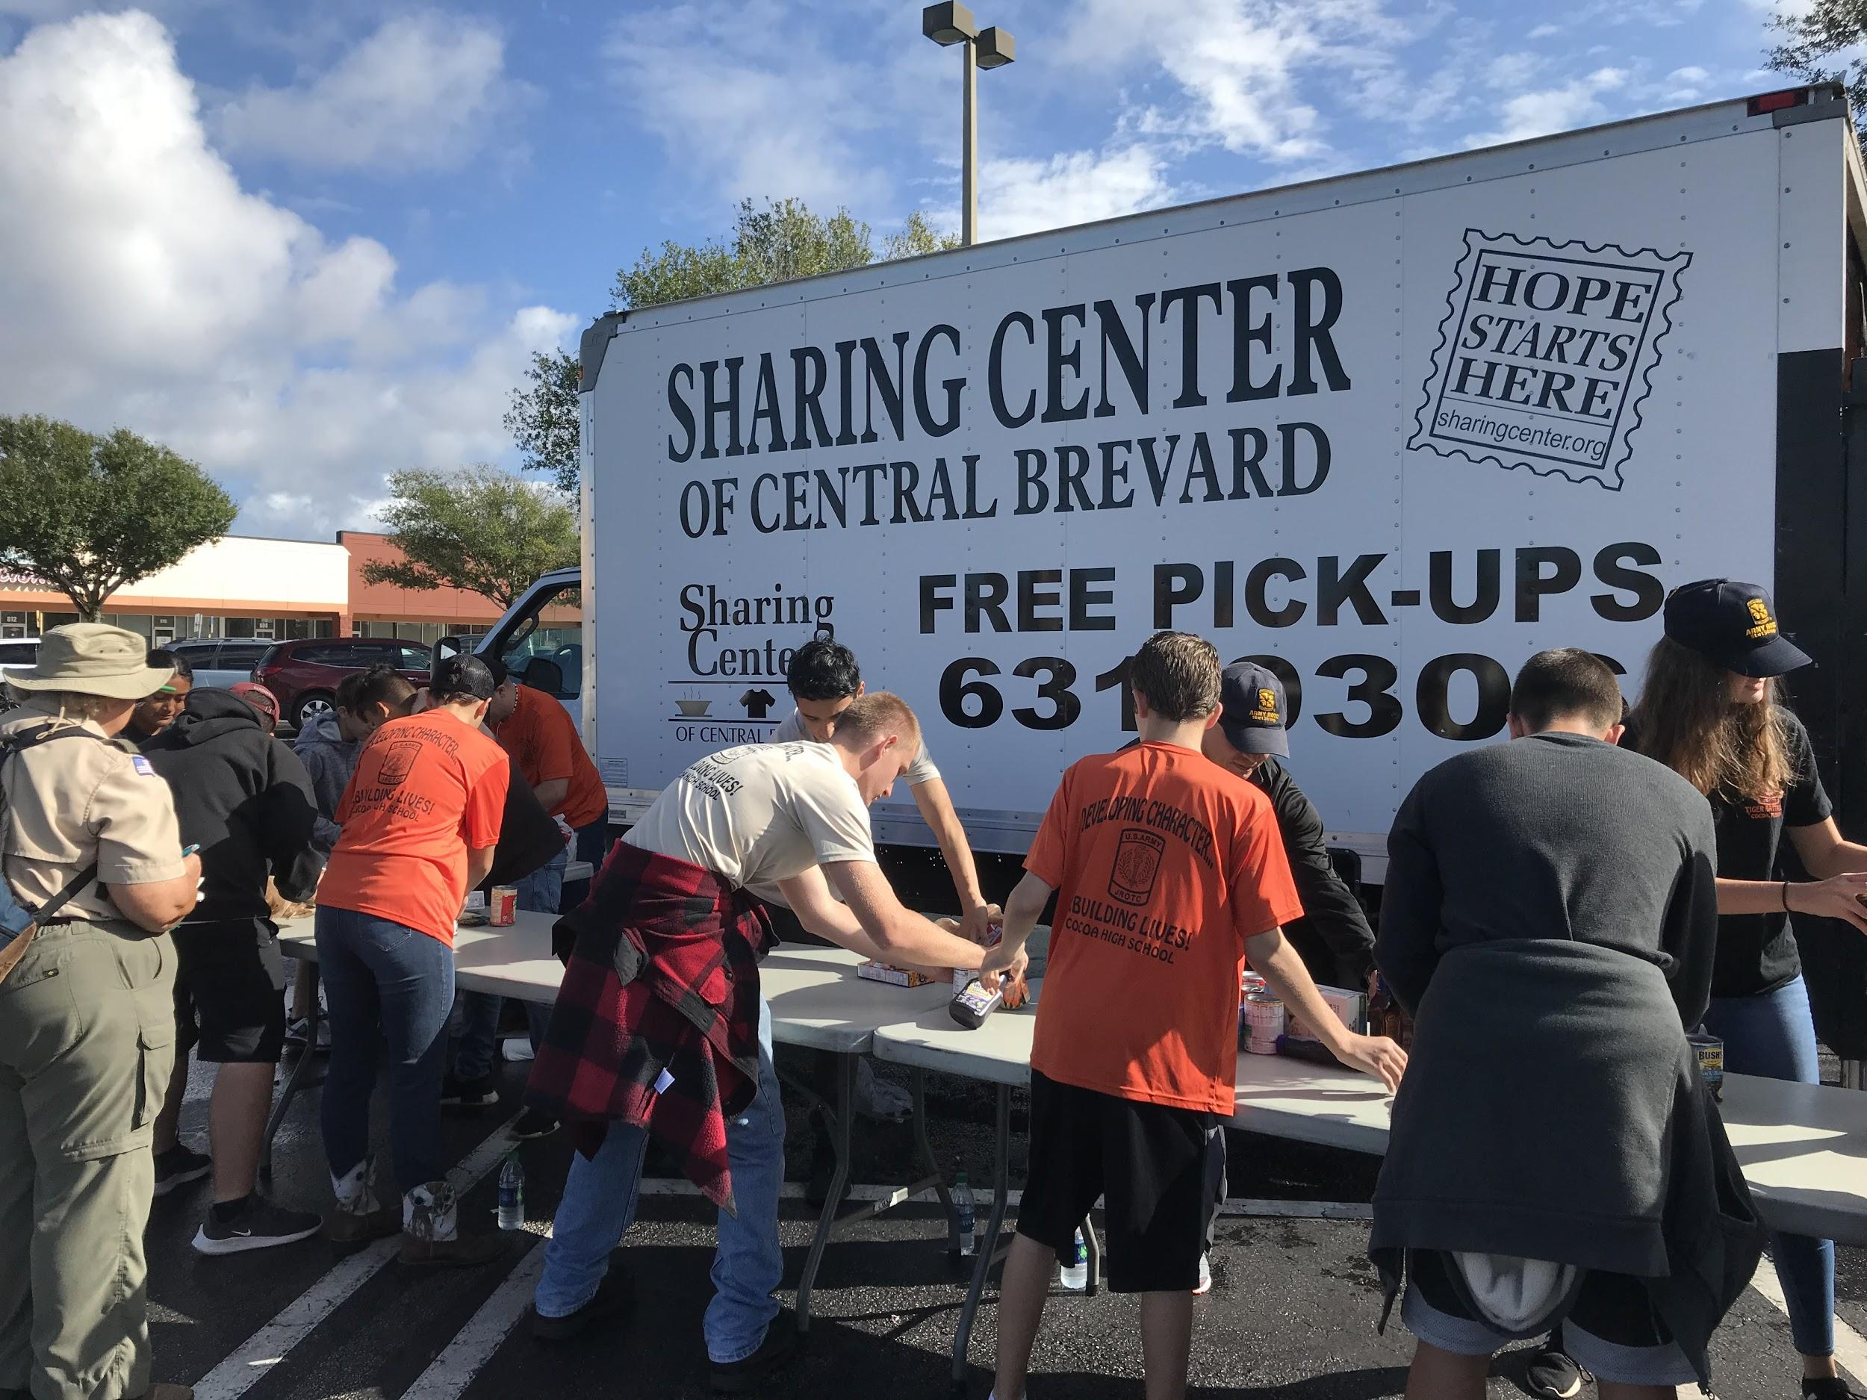
Upon arrival, cadets prepared the table set up and the cardboard boxes. The 35 cadets were split into 3 groups to organize the food items. The first group helped gather the incoming food goods from troop members and their parents that delivered carloads of food and sorted them into their respective troop number. Members of this group then handed these collected food items to the second group who unloaded and counted the food items. Food items were carefully counted and sorted into the type of food category they were. The items were grouped into canned goods, dry goods, and glass items and then packed separately into cardboard boxes that were handed off to the third group. Glass items were sure to be packed carefully to prevent any items from breaking. After sorting was done, the third group loaded the boxes of food carefully and neatly onto trucks. The cadets of the battalion worked extremely hard to get every food item collected, packed, and stored. Despite the gloomy weather, cadets stayed motivated and most importantly worked hard together. Mr. David Brubaker, CEO of the Brevard Sharing Center was extremely impressed by the 35 Cadets and their effort that collected, counted, and stored 8 tons of food goods accumulating over 16, 138 food items. This amount of food will have a positive impact on individuals and families in the Central Brevard area. Each cadet who participated will receive 25 merits, 5 hours of community service, a community service ribbon, and a certificate of appreciation from the Brevard Sharing Center. Every cadet demonstrated an excellent amount of Tiger Pride at this year’s food drive.

Cocoa High School Tiger Battalion
BC: Cadet MAJ Michelle Retig
Article By: S-5 Cadet 2LT Madison Bigger XO: Cadet CPT Justinian Martin
AI: SFC Freddy Moreno
AI: SFC David Mercer
SAI: LTC Joseph Pavone
