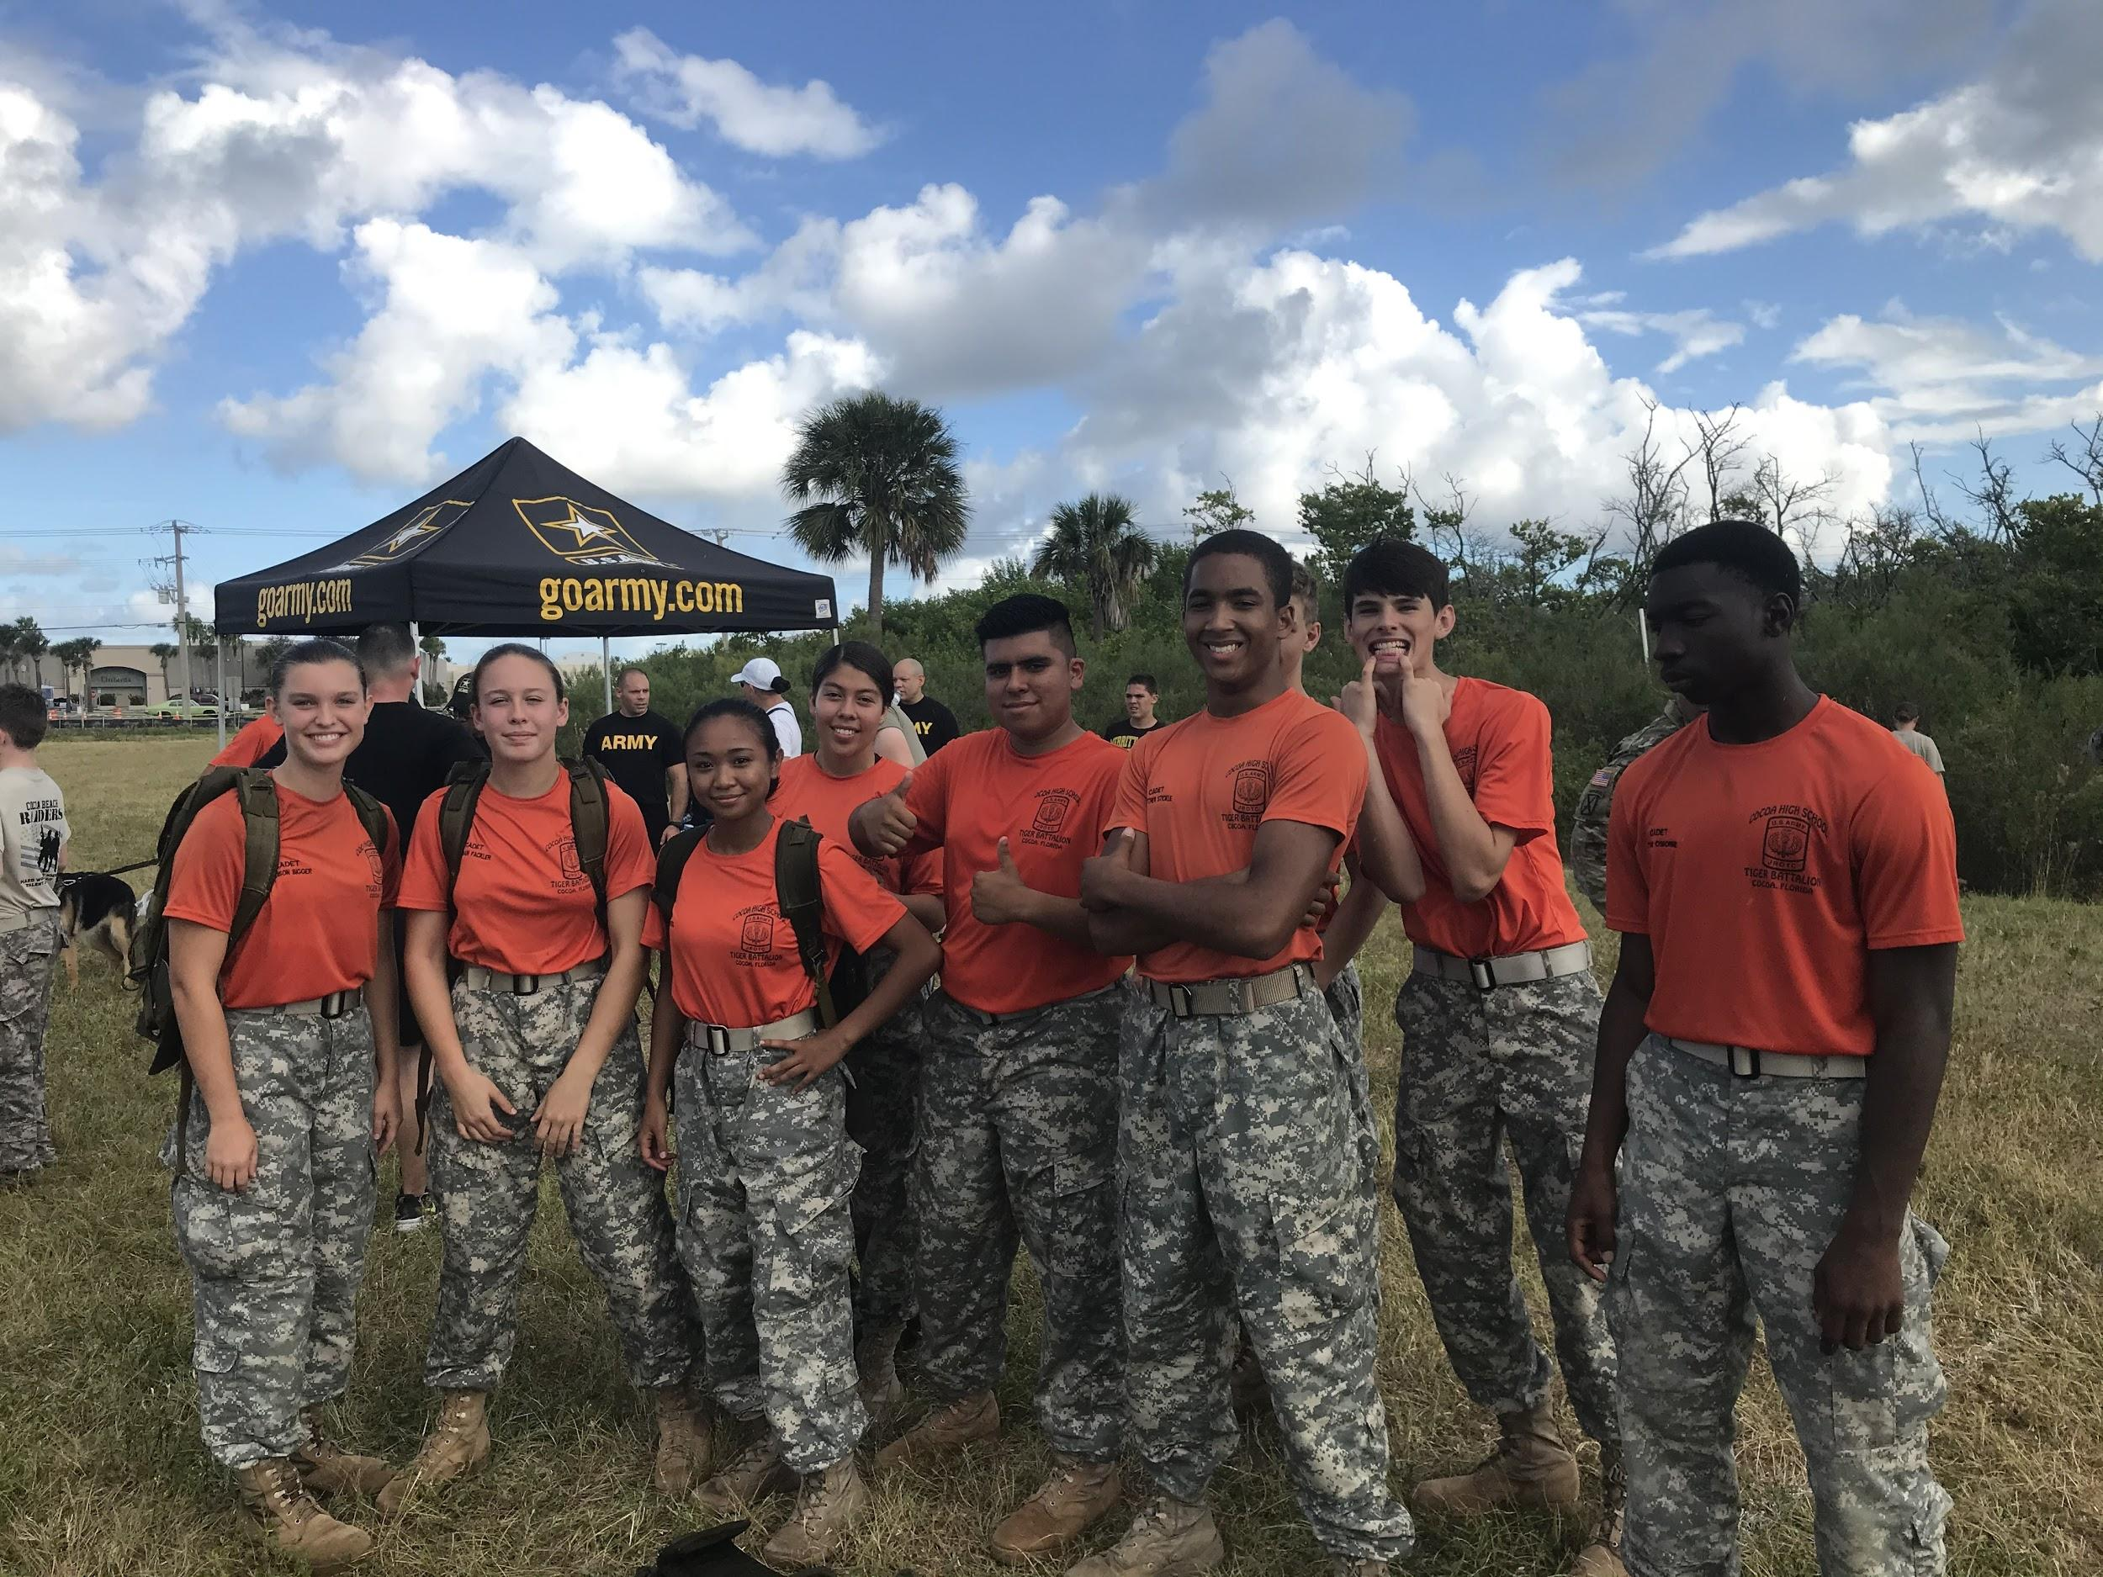
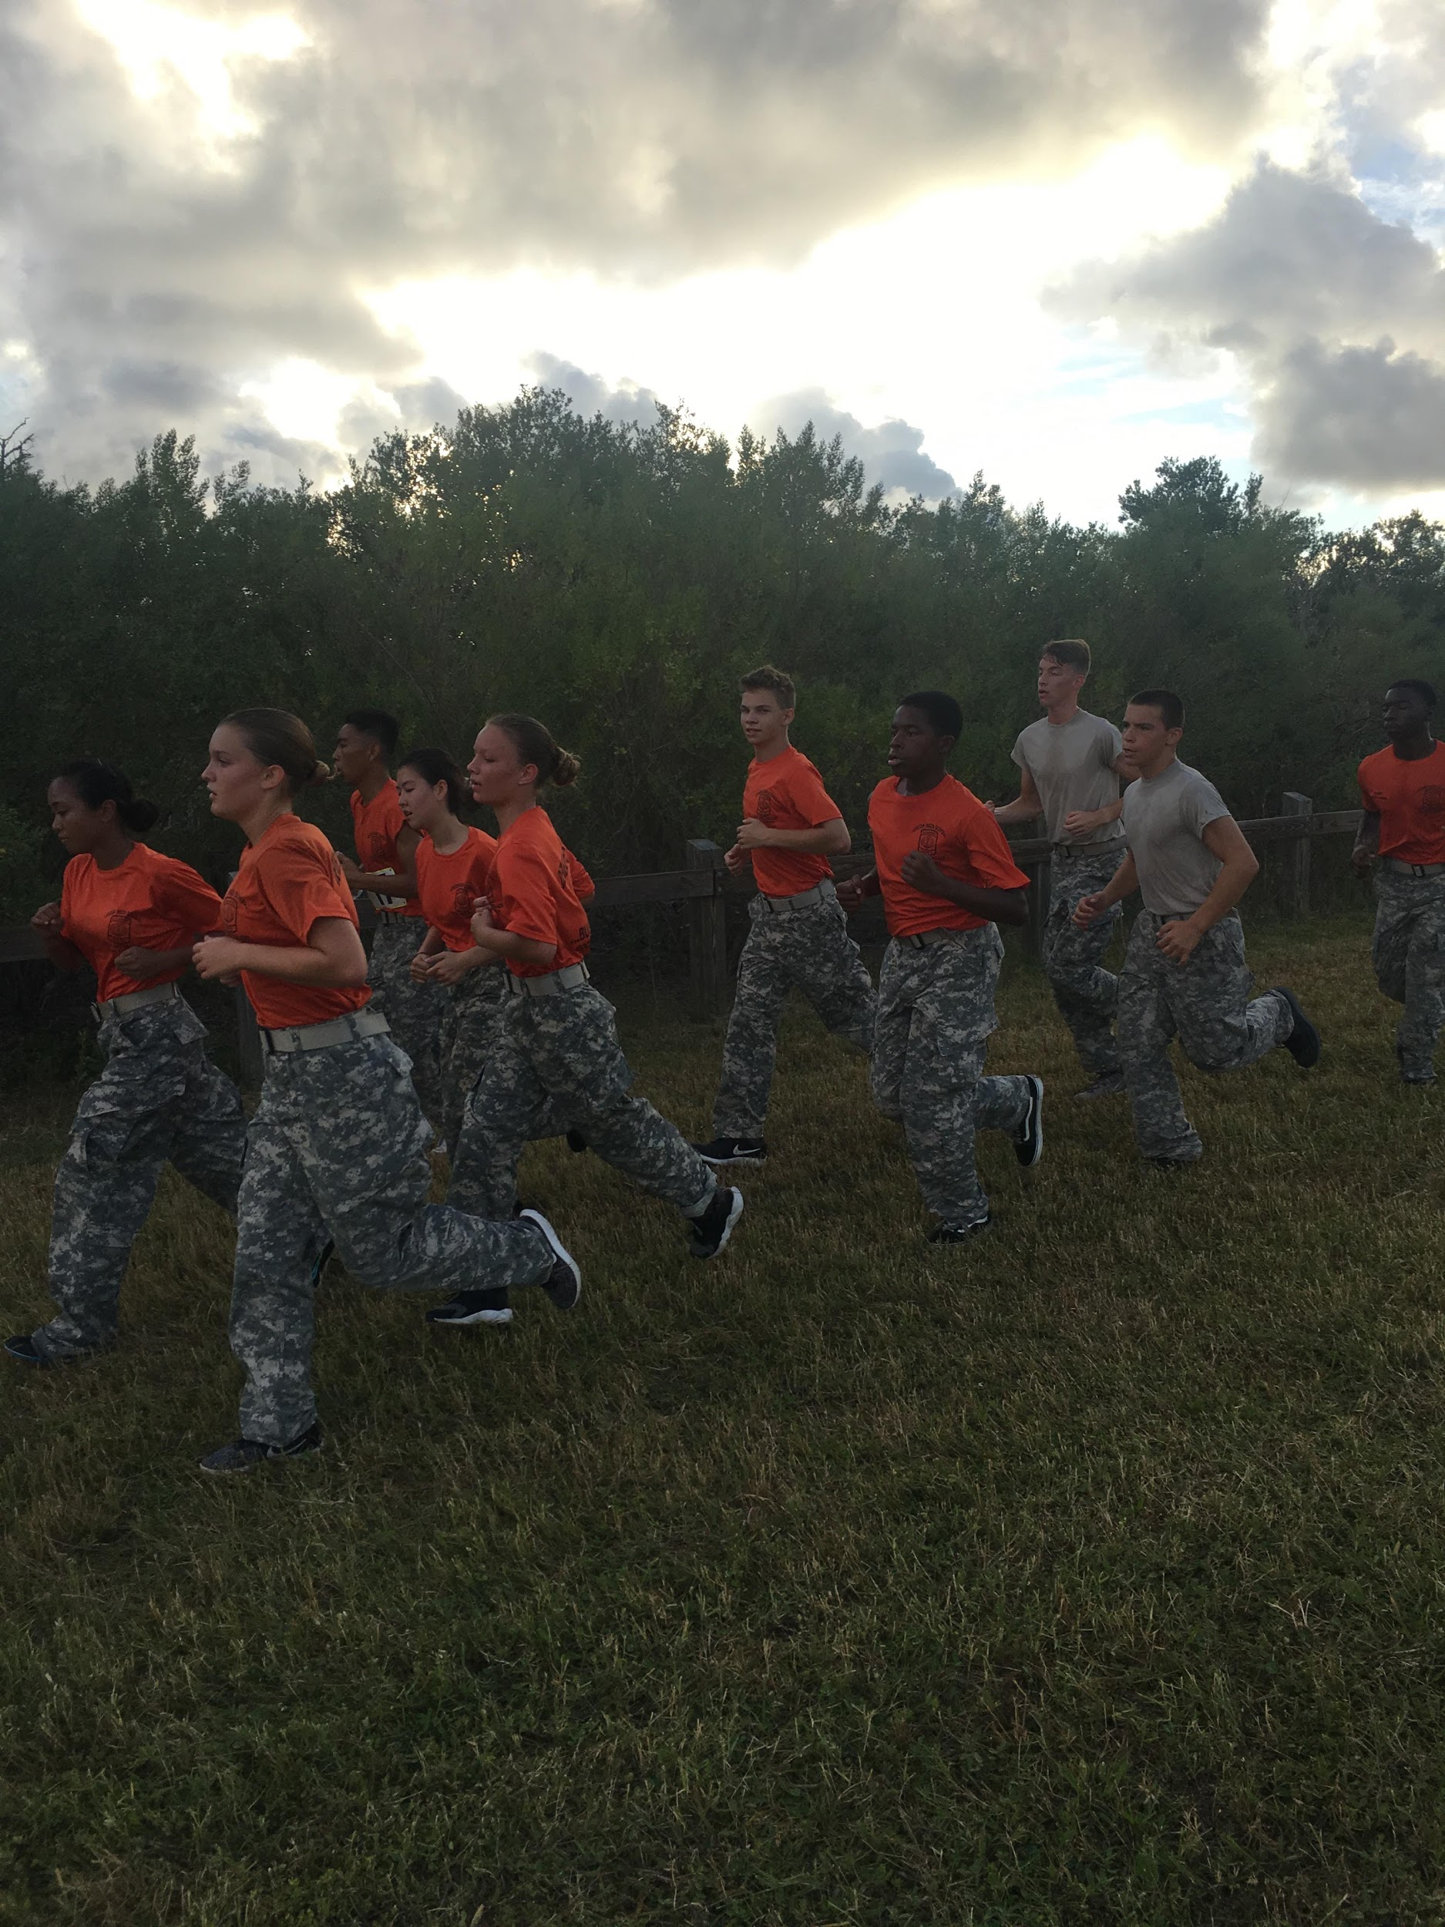
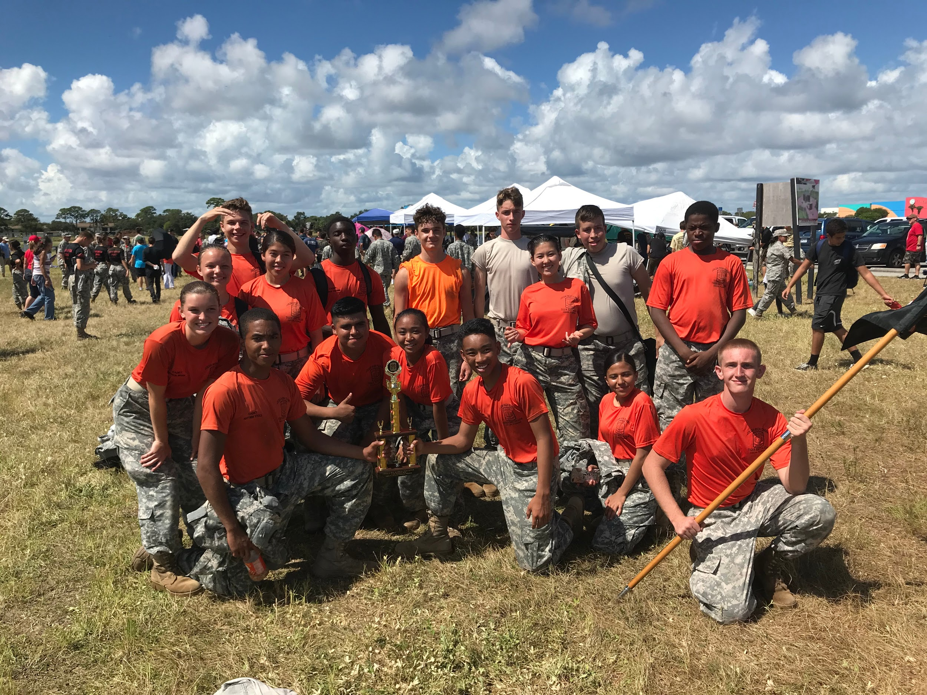
The Cocoa High JROTC Raiders participated in their first raider meet of the season last Saturday on October 5th, 2019. Motivated and ready to compete, this team showed up bright and early to the Brevard Veteran Center in Merritt Island where they would compete in the following five events: the 5k Team Run, Cross Country Rescue (CCR), First Aid quiz, a 25 meter Tire Flip, Rope Bridge, and a Kettlebell Fitness Test. There were two teams to compete: Mixed Team A and Mixed Team-B. Our Mixed Team-A won first place in the Cross Country Rescue event, which involves a one mile run carrying rucksacks and one weighted stretcher. The Mixed Team A consisting of ten cadets also placed third in the 5k Team Run. The hard work of our raiders paid off when they finished in third place overall in mixed team out of 21 teams. Even though we were one of the smallest teams there with only 24 cadets, participating, we were able to give it our all and beat teams larger than us. This just goes to show what dedication and teamwork can do. Our raider team will continue to practice harder every Monday and Wednesday so they can continue to improve in the events and come back stronger in our next meet. Congratulations to the following all cadets for participating in these events: Matthew Larracas; Matthew Stickle; Aaron Lutz; Luis Maldonado; Tyrese Osborne; Maximus Park; Jacob Perry; Arisa Bennett; Madison Bigger; Raistlin Morphew; Ronald Thailacker; Kylee Pritchett; Michelle Retig; Soledad Estrada; Leslie Lopez; Zoila Cruz; Daniel Garcia; James C. Pillow III; James Rathburn; Jordan Fackler; Wayne Brown; Kerlyn Valdez; Angely Lopez; and Kyra Marks. Our next meet will take place on Saturday, October 19th, 2019 at the Brevard Veteran Center in Merritt Island. After this meet we will compete in a state qualifying raider meet on November 2nd with hopes of attending the state competition.
Cocoa High School Tiger Battalion
BC: Cadet MAJ Michelle Retig SAI: LTC Joseph Pavone
XO: Cadet CPT Justinian Martin AI: SFC Freddy Moreno
Article By: S-5 Cadet 2LT Madison Bigger AI:SFC David Mercer

